**Effects of soybean isoflavones on the growth performance, intestinal morphology and antioxidative properties in pigs**

Y. P. Li, X. R. Jiang, Z. X. Wei, L. Cai, J. D. Yin and X. L. Li

*animal* journal

Determination of soybean isoflavones by high performance liquid chromatography (HPLC) with ultraviolet detection

*Apparatus and reagents*

This experiment used the Shimadzu Prominence LC-20A HPLC system. Isoflavone standards (daidzin, genistin, daidzein and genistein) were obtained from Sigma (St. Louis, MO, USA). HPLC-grade methanol, acetonitrile and water (Thermo Fisher Scientific, MA, USA) were used.

*Chromatographic conditions*

Chromatographic experiments were performed with a C18 column (150 mm × 4.6 mm, 5 μm) (Shimadzu, Kyoto, Japan). Mobile phase A was water, mobile phase B was acetonitrile, the flow rate was 1.0 mL/min, the column temperature was 40°C, the injection volume was 10 μL and the detection wavelength was 260 nm. The gradient elution program is presented in Supplementary Table S1.

**Supplementary Table S1** *The gradient elution program of HPLC used to detect the soybean isoflavones fed to pigs*

|  |  |  |  |
| --- | --- | --- | --- |
| Time (min) | Module | Action | Value (%) |
| 5.00 | Pumps | B.Conc | 20 |
| 13.00 | Pumps | B.Conc | 85 |
| 17.00 | Pumps | B.Conc | 85 |
| 17.01 | Pumps | B.Conc | 20 |
| 25.00 | Controller | Stop |  |

HPLC = high performance liquid chromatography.

*Preparation of the standard solution and sample pretreatment*

Ten milligrams each of daidzin, genistin, daidzein and genistein were added to 8 mL of acetonitrile, followed by dilution to 10 mL to obtain a 1 mg/mL standard mixture. The standard mixture was diluted with 20% acetonitrile (initial mobile phase) to different concentrations (0.2, 1, 2, 10, and 20 μg/mL).

The method of sample pretreatment was ultrasonic extraction: 1) First,1 g of sample was added to 25 mL of 80% methanol; 2) ultrasonic extraction for 30 min at room temperature; 3) the liquid was collected after filtering through filter paper (Jinteng, Tianjin, China); 4) the supernatant was obtained after centrifugation at 5 000 g for 10 minutes at room temperature; 5) fill to a constant volume with water to 25 mL; and 6) the sample extract was filtered through a 0.22 μm micropore membrane (Jinteng, Tianjin, China) prior to HPLC.

**Supplementary Table S2** *Quantitative real-time PCR reaction system used to detect related gene expression of porcine jejunal mucosa*

|  |  |
| --- | --- |
| Reagents | Volume, μL |
| cDNA template | 2 |
| Forward primer | 0.5 |
| Reverse primer | 0.5 |
| SYBR Green | 10 |
| H2O | 7 |
| Total volume | 20 |

**Supplementary Table S3** *Quantitative real-time PCR reaction stages used to detect related gene expression of porcine jejunal mucosa*

|  |  |  |  |
| --- | --- | --- | --- |
| Stage | Temperature, °C | Time | Cycles |
| Denature | 50 | 2 min | - |
| 95 | 10 min |
| Extension | 95 | 15 s | 40 |
| 60 | 1 min |
| Melt Curve | 95 | 15 s | - |
| 60 | 1 min |
| 95 | 15 s |

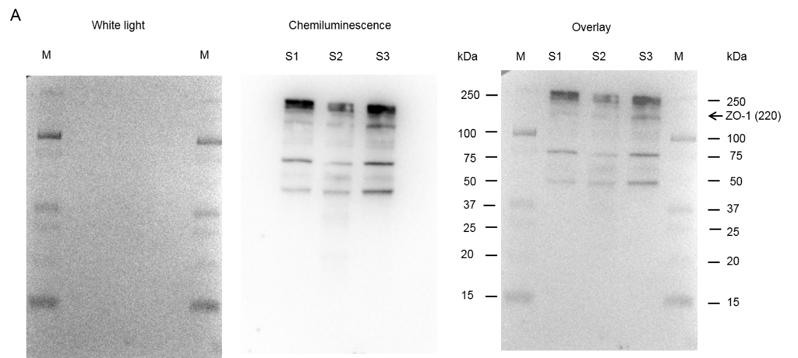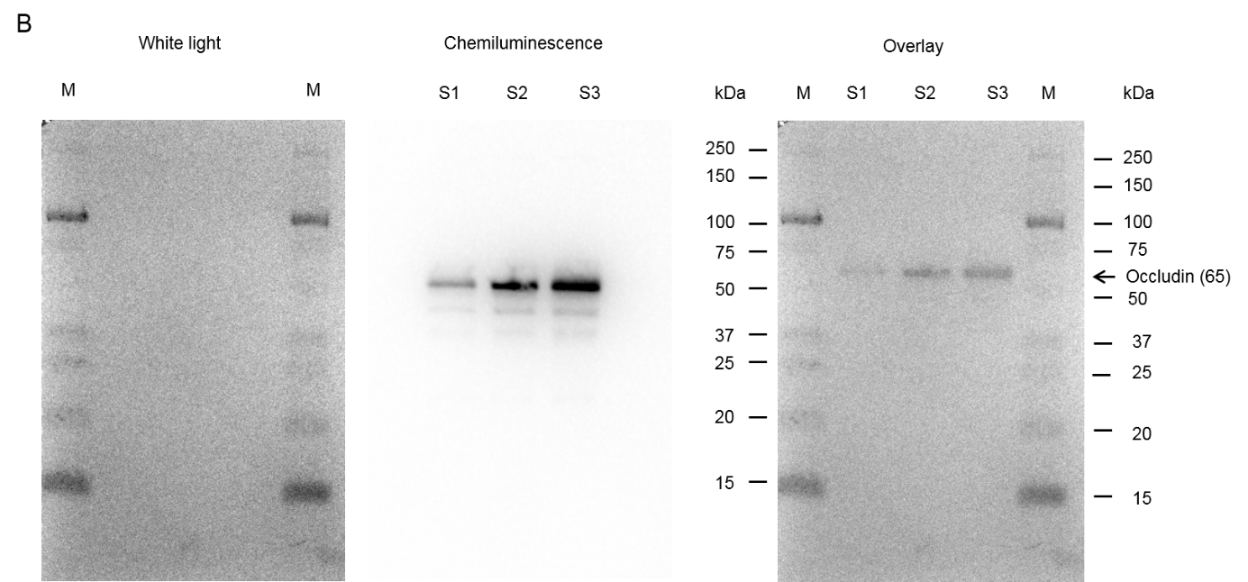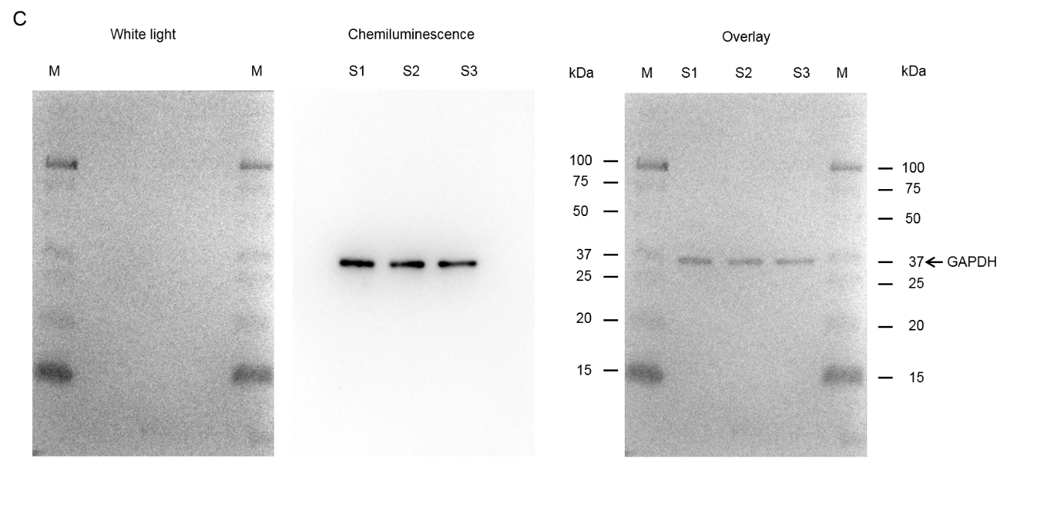

**Supplementary Figure S1** Validation of the primary antibodies with porcine jejunal mucosa lysates. A: Validation of ZO-1 antibody; B: Validation of occludin antibody; C: Validation of GAPDH antibody. M = Prestained protein marker; S1, S2, S3 = Jejunal mucosa lysates samples; GAPDH = glyceraldehyde-3-phosphate dehydrogenase; ZO-1 = zonula occludens-1.