Live animal predictions of carcass components and marble score in beef cattle: Model development and evaluation

M. J. McPhee, B. J. Walmsley, H.C. Dougherty, W. A. McKiernan and V. H. Oddy
animal journal

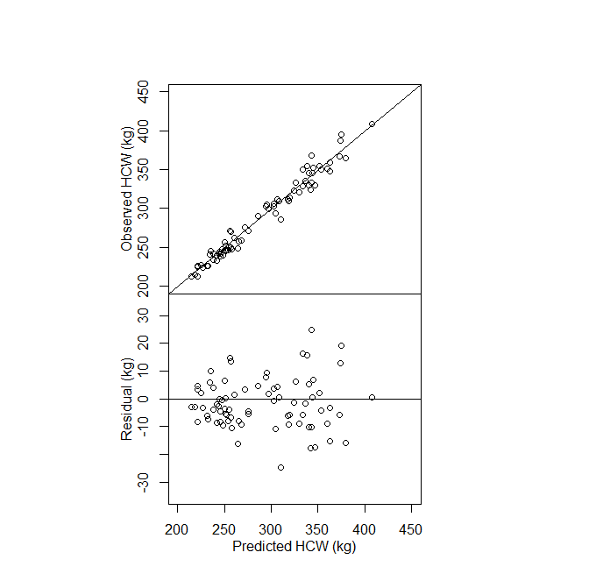
Figure S1. Observed versus predicted with 1:1 (solid) line and residuals (observed – predicted) of hot carcass weight (HCW, kg) from evaluation dataset 1 (Angus steers)

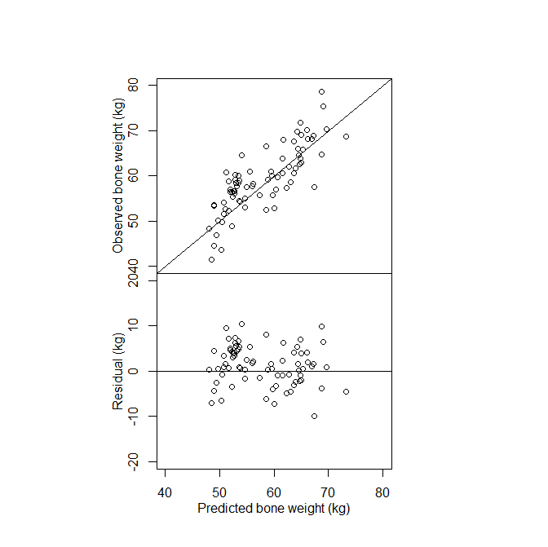
Figure S2. Observed versus predicted with 1:1 (solid) line and residuals of bone weight (kg) from evaluation dataset 1 (Angus steers)
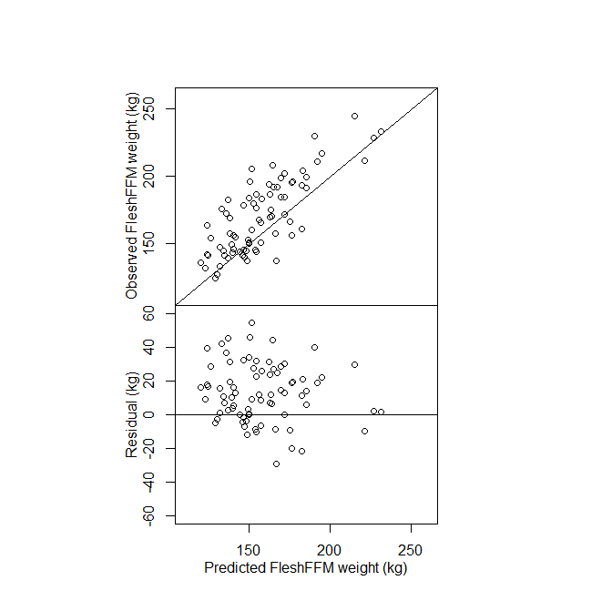
Figure S3. Observed versus predicted with 1:1 (solid) line and residuals of flesh fat-free mass (FleshFFM, kg) from evaluation dataset 1 (Angus steers)

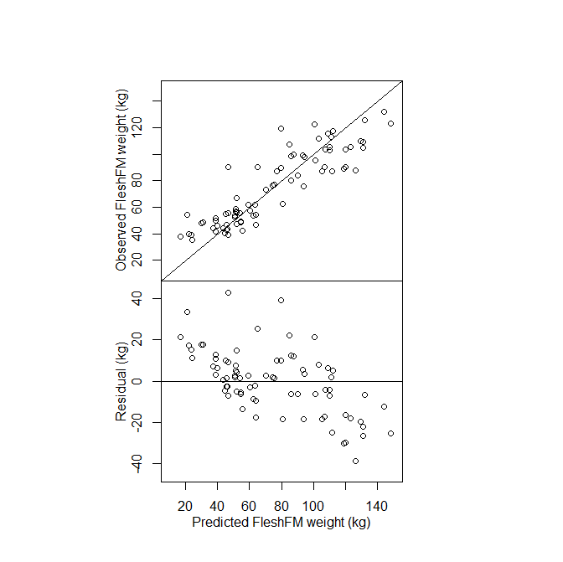Figure S4. Observed versus predicted with 1:1 (solid) line and residuals of flesh fat mass (FleshFM, kg) from evaluation dataset 1 (Angus steers)

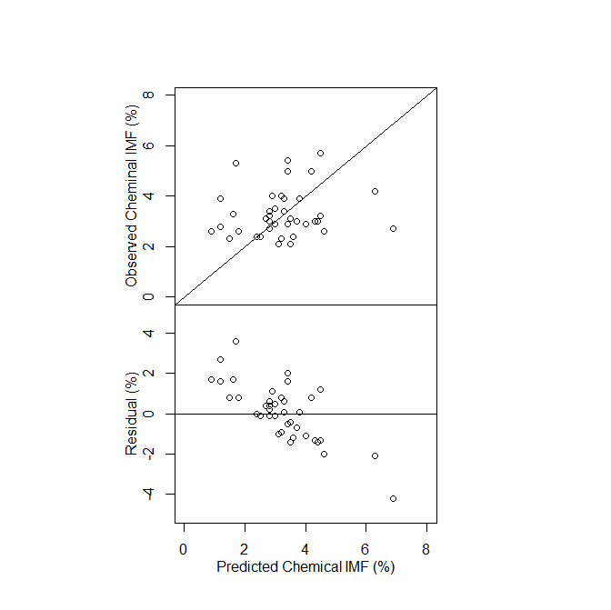
Figure S5. Observed versus predicted with 1:1 (solid) line and residuals of chemical intramuscular fat (Chemical IMF, %) from evaluation dataset 1 (Angus steers)

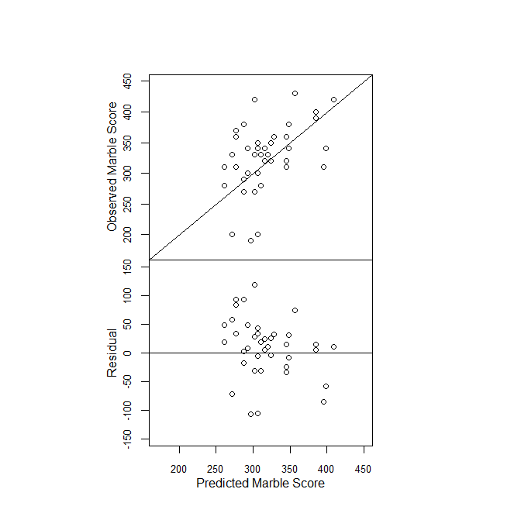
Figure S6. Observed versus predicted with 1:1 (solid) line and residuals of marble score from evaluation dataset 1 (Angus steers)
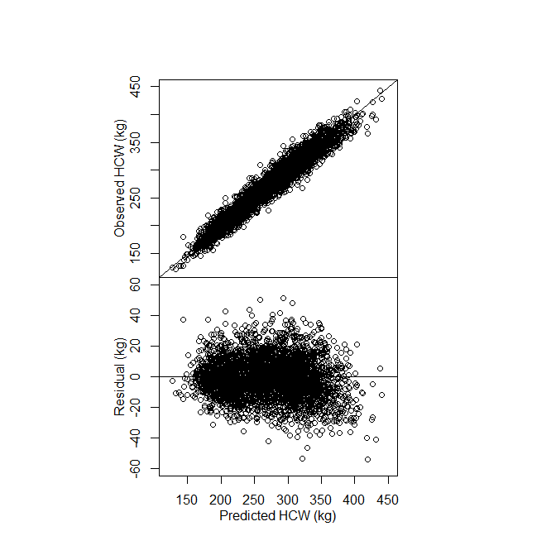

Figure S7. Observed versus predicted with 1:1 (solid) line and residuals of hot carcass weight (HCW, kg) from evaluation dataset 2 (Angus, Hereford, Murray Grey and Brahman heifers and steers)

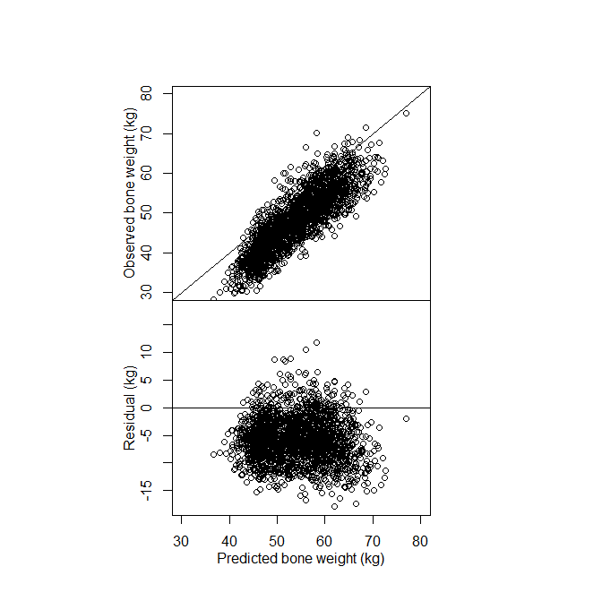
Figure S8. Observed versus predicted with 1:1 (solid) line and residuals of bone weight (kg) from evaluation dataset 2 (Angus, Hereford, Murray Grey and Brahman heifers and steers)

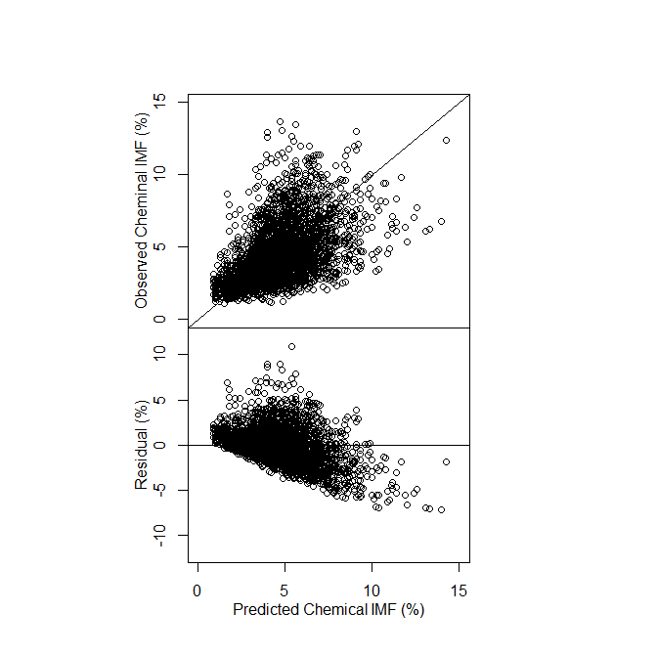
Figure S9. Observed versus predicted with 1:1 (solid) line and residuals of chemical intramuscular fat (Chemical IMF, %) from evaluation dataset 2 (Angus, Hereford, Murray Grey and Brahman heifers and steers)

