Effects of body condition score on direct and indirect measurements of insulin sensitivity in periparturient dairy cows.
S. Saed Samii ^{1, a}, J. E. Rico ^{1,2, b}, A. T. Mathews ^{1, c}, A. N. Davis ^{1, b}, C. L. Orndorff ^{1, b}, L. O. Aromeh ¹ and J. W. McFadden ^{1, 2, b}.
¹Division of Animal and Nutritional Sciences, West Virginia University, Morgantown, WV, USA
²Department of Animal Science, Cornell University, Ithaca, NY, USA
ª Present address: Animal Nutrition Systems, Chandler, AZ, USA
^{b} Present address: Department of Animal Science, Cornell University, Ithaca, NY, USA
^{c} Present address: Department of Animal Biology, University of California, Davis, CA, USA

animal journal

Supplementary material

Supplementary Table S1. Ingredient and nutrient composition of dairy cow diets.
 | Diets
Item | Gestation | Lactation
Ingredient (% DM)
Corn silage | 30.7 | 42.4
Grass haylage | 28.4 | 7.0
Grass hay | 13.2 | 2.1
Dry ground corn | – | 14.4
Prepartum mix¹ | 13.9 | –
Lactation mix A² | – | 14.0
Soybean meal | 9.0 | 4.7
Cottonseed with lint | – | 4.5
Sugar cane syrup | – | 3.6
Lactation mix B³ | – | 4.5
Close-up supplement⁴ | 4.8 | 2.7
Rumensin mix⁵ | – | 0.1
Nutrient composition
DM, % | 55.5 | 51.6
NDF | 48.3 | 37.6
Forage NDF | 43.7 | 25.1
Forage NDF, % of NDF | 90.5 | 66.7
ADF | 32.0 | 25.2
CP | 12.2 | 16.5
Starch | 14.1 | 21.2
Crude fat | 3.16 | 4.33
Ash | 7.5 | 7.3
NE_{l}⁶, Mcal/kg DM | 1.44 | 1.61
¹Mix contained 27% commercial dry cow mix with Animate (Phibro Animal Health Corp., Teaneck, NJ), 17.3% ground corn, 17.3% crimped oats, 13% corn distillers, 12.9% soybean meal, 4.3% calcium carbonate, 4.3% calcium sulfate, 2.6% Omnigen AF (Phibro Animal Health Corp.), 1.1 Monocalcium phosphate, and <1% of each of the following: Sel-plex 600 (Alltech Biotechnology, Nicholasville, KY) and vitamin E.
²Mix contained 33.6% citrus pulp, 19% soybean meal, 15.6% canola meal, 14% soybean hulls, 4.5% calcium carbonate, 4.5% sodium bicarbonate, 2.8% urea, 2.7% fat, 2.4% sodium chloride, and <1% from each of the following: Monocalcium phosphate, biotin, and Rumensin 90 (Elanco Animal Health, Greenfield, IN).
³Mix contained 43.6% Fermenten (Church and Dwight Co., Princeton, NJ), 21.8% calcium carbonate, 10.8% soybean hulls, 7.8% Mintrex blend (Novus International Inc., St. Charles, MO), 5.2% blood meal, 3.5% magnesium oxide, 2.6% Celmanax (Vi-COR, Mason City, IA), 2.6% Omnigen (Phibro Animal Health Corp.), and <1% of each of the following: vitamin E, selenium selenite, and selenium yeast 600.
⁴Mix contained 74.5% ground oats, 15.3% commercial amino acid, 8% Reashure (Balchem Encapsulates, Slate Hill, NY), and <1% of each of the following: vitamin E and Niashure (Balchem Corporation, New Hampton, NY).
⁵Rumensin for dairy included at 4 890 mg/kg.
⁶Net energy for lactation.

Supplementary Table S2. Comparison of tolerance testing glucose parameters and surrogate indices of insulin sensitivity in peripartal dairy cows.¹
 | RQUICKI² |  | HOMA-IR³ |  | QUICKI⁴ |  | RQUICKI_{BHB}⁵
Item | ρ⁶ | P-value | ρ | P-value | ρ | P-value | ρ | P-value
Insulin tolerance⁷
Glucose CR 0-10 min (%/min)⁸ | 0.35 | 0.05 | -0.22 | 0.20 | 0.21 | 0.22 | 0.28 | 0.10
Glucose CR 0-20 min (%/min) | 0.27 | 0.13 | 0.03 | 0.88 | -0.03 | 0.85 | 0.17 | 0.35
Glucose CR 0-30 min (%/min) | 0.31 | 0.08 | -0.05 | 0.79 | 0.03 | 0.87 | 0.21 | 0.23
Glucose CR 0-40 min (%/min) | 0.07 | 0.72 | 0.13 | 0.44 | -0.13 | 0.44 | 0.07 | 0.71
ISRG⁹ | 0.04 | 0.85 | 0.06 | 0.75 | -0.06 | 0.72 | -0.03 | 0.87
Glucose AUC (mg 0-40 min/dL)¹⁰ | -0.11 | 0.54 | 0.04 | 0.83 | -0.04 | 0.81 | -0.06 | 0.75
Glucose tolerance¹¹
Glucose CR 0-30 min (%/min) | 0.19 | 0.29 | 0.06 | 0.74 | -0.08 | 0.64 | 0.42 | 0.01
Glucose CR 0-60 min (%/min) | 0.25 | 0.17 | -0.02 | 0.92 | 0.00 | 0.98 | 0.39 | 0.02
T_{1/2} (min)¹² | -0.25 | 0.17 | 0.01 | 0.94 | 0.00 | 1.00 | -0.38 | 0.02
T_{basal} (min)¹³ | 0.10 | 0.58 | -0.05 | 0.77 | 0.05 | 0.77 | 0.02 | 0.89
Glucose AUC (mg 0-180 min/dL) | 0.04 | 0.81 | 0.27 | 0.11 | -0.26 | 0.13 | -0.09 | 0.61
FA¹⁴ CR 0-10 min (%/min) | 0.15 | 0.40 | -0.29 | 0.08 | 0.29 | 0.08 | 0.18 | 0.32
FA CR 0-20 min (%/min) | 0.29 | 0.10 | -0.21 | 0.22 | 0.22 | 0.20 | 0.30 | 0.09
FA CR 0-30 min (%/min) | 0.01 | 0.99 | -0.08 | 0.66 | 0.08 | 0.65 | 0.07 | 0.67
FA CR 0-40 min (%/min) | 0.04 | 0.84 | -0.03 | 0.85 | 0.05 | 0.78 | 0.05 | 0.77
FA AUC (mg 0-20 min/dL) | -0.08 | 0.67 | -0.37 | 0.03 | 0.39 | 0.02 | -0.32 | 0.07
FA AUC (mg 0-30 min/dL) | -0.08 | 0.67 | -0.35 | 0.04 | 0.37 | 0.03 | -0.33 | 0.05
FA AUC (mg 0-40 min/dL) | -0.07 | 0.69 | -0.34 | 0.04 | 0.36 | 0.03 | -0.34 | 0.05
¹Description of abbreviation can be found within table 1.
²RQUICKI = revised quantitative insulin sensitivity check index.
³HOMA-IR = homeostasis model of insulin resistance.
⁴QUICKI = quantitative insulin sensitivity check.
⁵RQUICKI_{BHB} = RQUICKI including BHB, BHB = β-hydroxybutyrate.
⁶Non-parametric Spearman’s rank-order correlation
⁷Data reflect samples collected at d 26 and 13 prepartum, and d 5 postpartum.
⁸CR = clearance rate.
⁹ISRG = insulin-stimulated reductions in glucose.
¹⁰AUC = area under the curve.
¹¹Data reflect samples collected at d 25 and 12 prepartum, and d 6 postpartum.
¹²T_{1/2} = time to reach half maximal glucose concentration.
¹³T_{basal} = time to reach basal glucose concentration.
¹⁴FA = fatty acids.

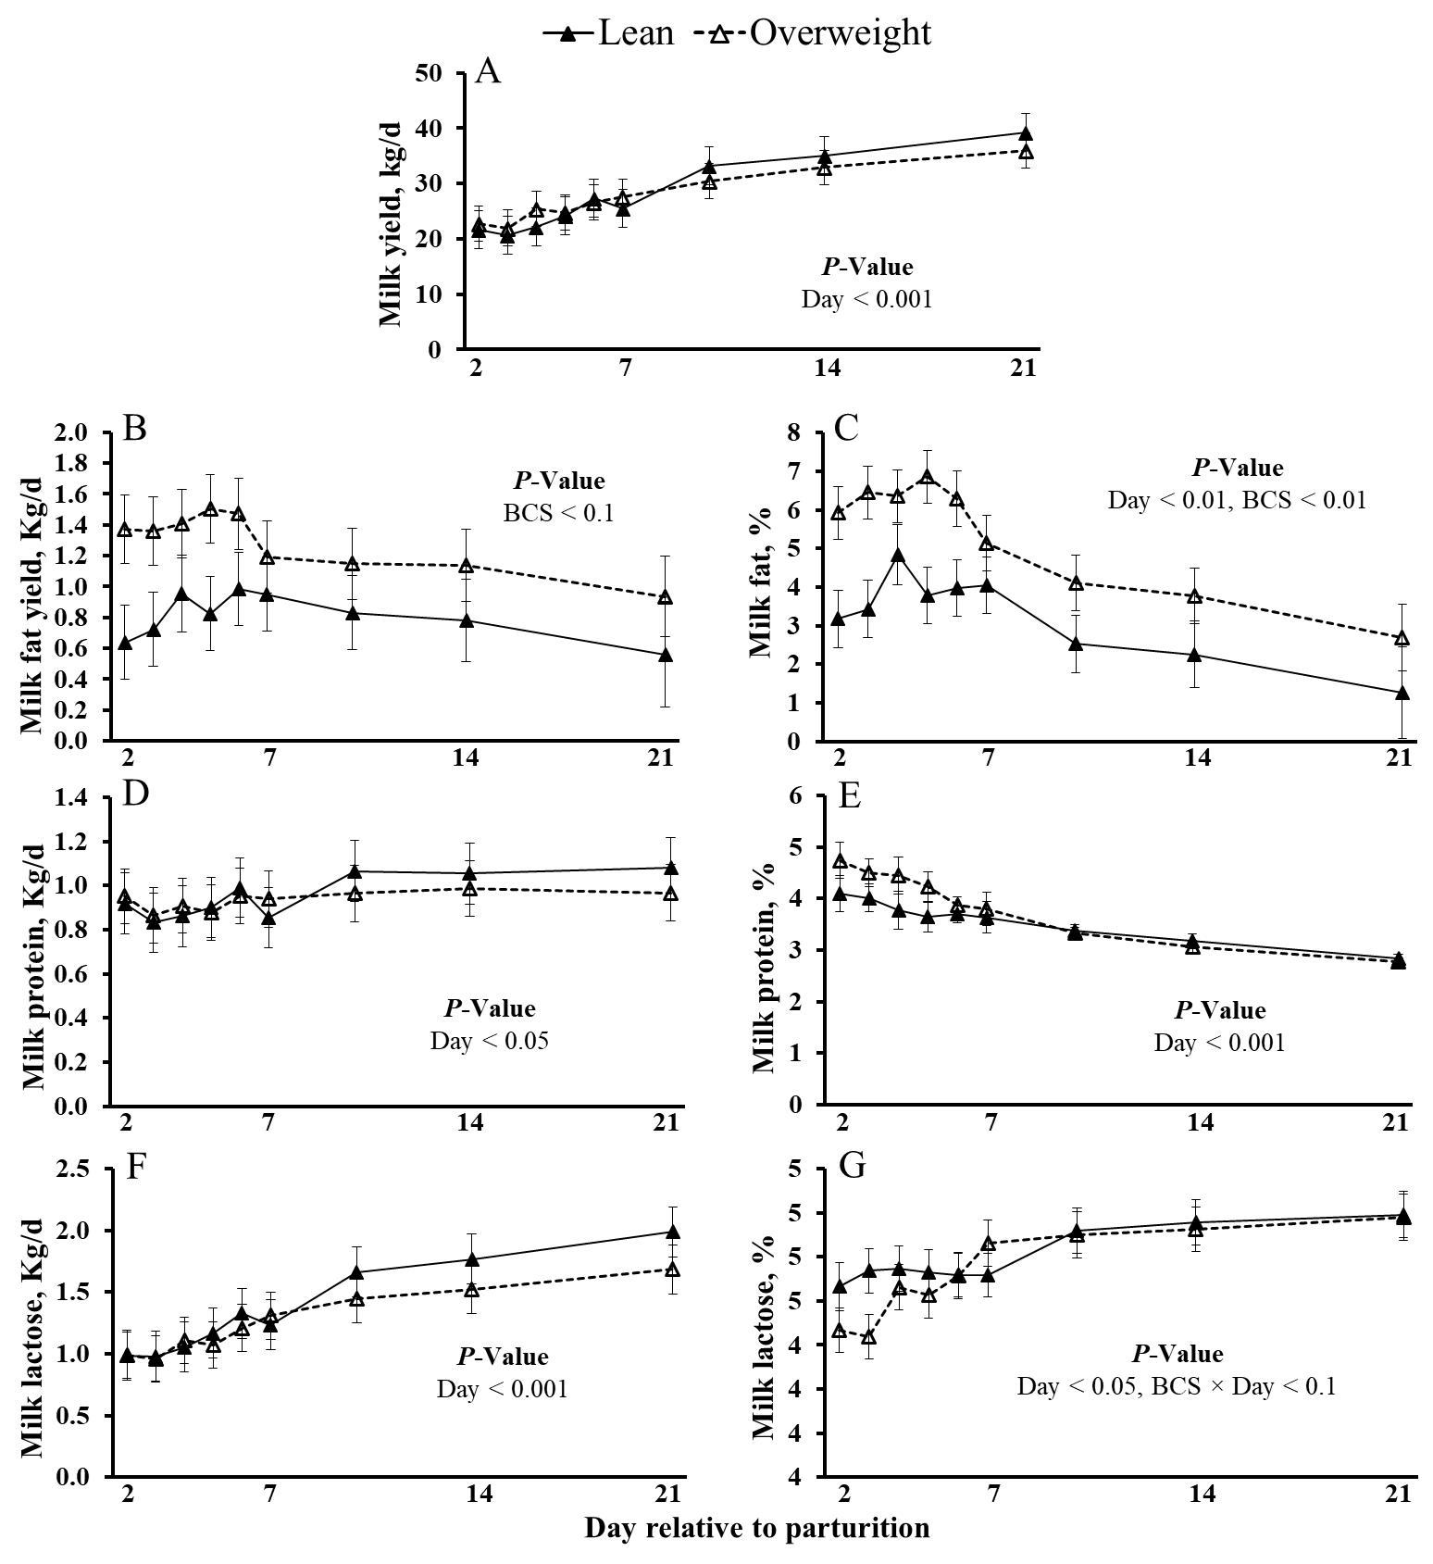
Supplemental Figure S1. Effect of prepartum body condition score (BCS) on milk production of dairy cows. Milk production data collected from postpartum lean and overweight dairy cows transitioning from gestation to lactation. (A) The continuous evaluation of milk yield. Early lactation milk (B) fat yield (kg/d), (C) fat %, (D) protein (kg/d), (E) protein %, (F) lactose (kg/d), and (G) lactose %, in cows assigned as lean or overweight -28 d prior to expected parturition. Data are represented as least squares means and their standard errors.

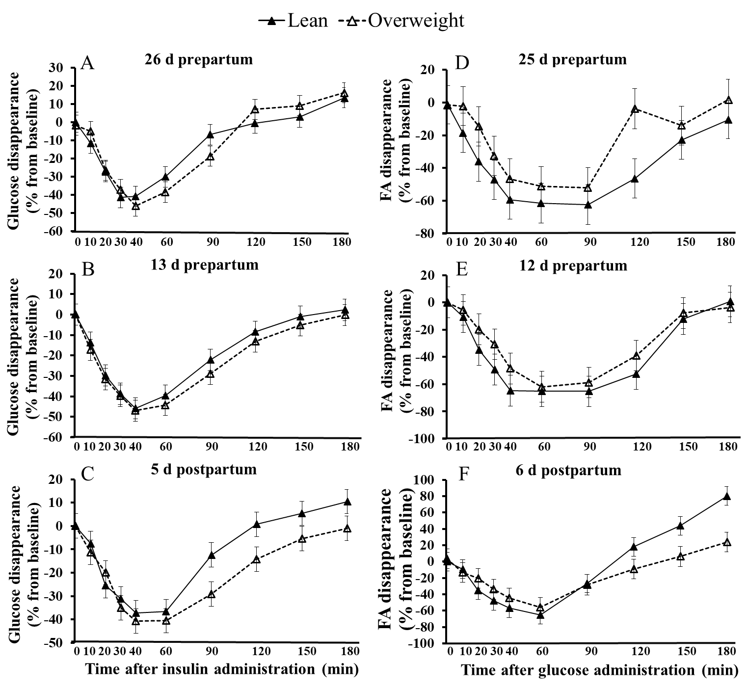

Supplemental Figure S2. Effect of prepartum body condition score (BCS) on percent glucose and fatty acids (FA) removal from baseline during an intravenous insulin tolerance test (ITT) and intravenous glucose tolerance test (GTT) performed in peripartal cows. Insulin tolerance testing was completed at (A) 26 and (B) 13 d prepartum, and (C) 5 d postpartum. Glucose tolerance testing was completed at (D) 25 and (E) 12 d prepartum, and (F) 6 d postpartum. Baseline measurements represent the average of samples collected at -10 and 0 min relative to intravenous administration of 0.01 IU of insulin per kg of BW, and intravenous administration of 300 mg of dextrose per kg of BW. Fixed effects in model for ITT: BCS (not significant), and Day < 0.05. Fixed effects in model for GTT: BCS (not significant), Day < 0.1, BCS × Minute < 0.1, and Day × Minute < 0.001. Data are represented as least squares means and their standard errors.

