animal journal

Response of rumen microbiota, and metabolic profiles of rumen fluid, liver and serum of goats to high-grain diets
R. Y. Zhang^{1a}, Y. J. Liu^{2a}, Y. Y. Yin², W. Jin², S. Y. Mao², J. H. Liu^{2†}

1 Key Laboratory of Zoonosis of Liaoning Province, College of Animal Science and Veterinary Medicine, Shenyang Agricultural University, Shenyang, 110866, China
2 Jiangsu Key Laboratory of Gastrointestinal Nutrition and Animal Health, Laboratory of Gastrointestinal Microbiology, College of Animal Science and Technology, Nanjing Agricultural University, Nanjing, 210095, China

ª These two authors contributed equally to this work.
† Corresponding author: Junhua Liu. Email: liujunhua0011@163.com.

Short title: Rumen microbiota and systemic metabolism of goats

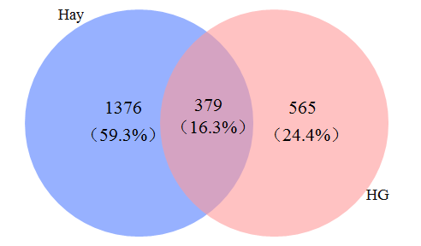
Figure S1 A venn diagram illustrating shared and unique operational taxonomic units (OTUs) at 3% dissimilarity level of the rumen microbiota in goats fed the hay and high-grain (HG) diet.

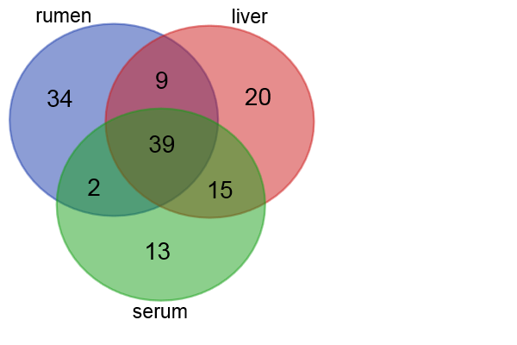
Figure S2 Unique and mutual metabolites identified in the rumen, liver and serum of goats fed hay or high-grain (HG) diet.

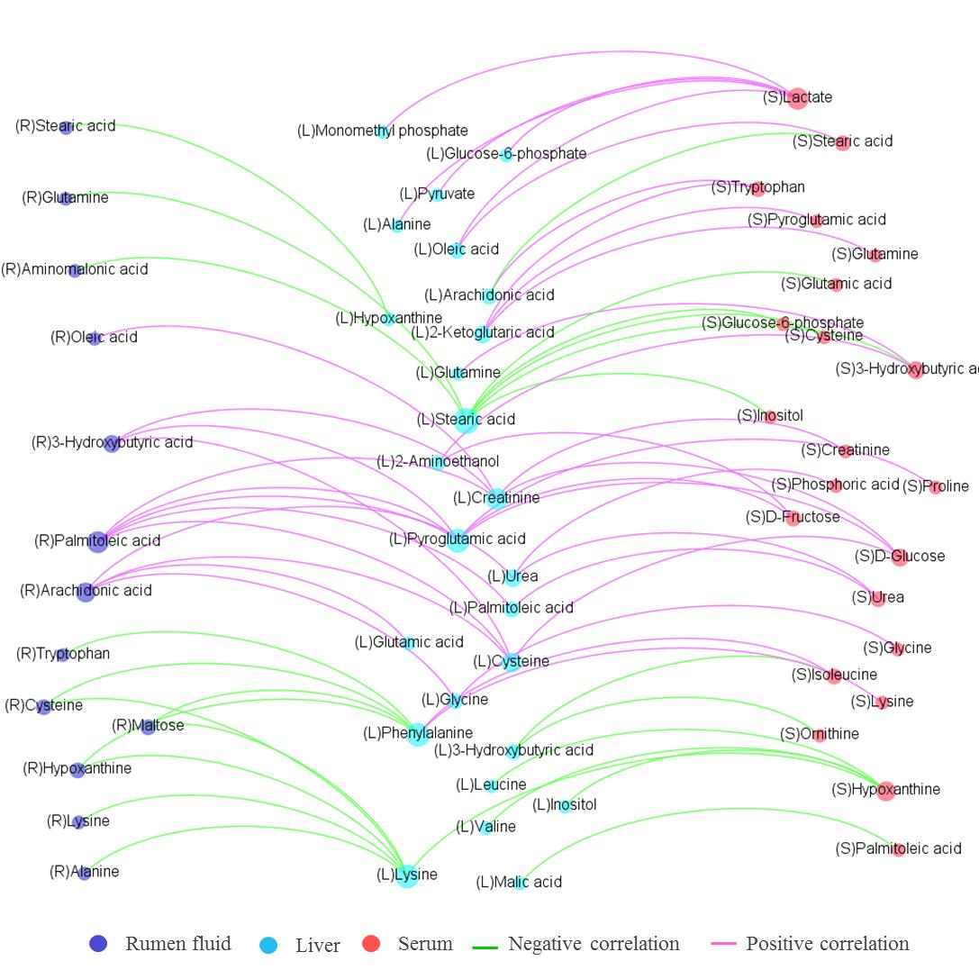

Figure S3 The correlations between the common metabolites of rumen fluid, liver and serum in goats of fed the hay and high-grain diets. The green line between metabolites and bacterial genera indicated negative correlation and the pink line indicated positive correlation. The correlation coefficients that with a statistical P value less than 0.05 and the absolute value greater than 0.7 were used to construct the network graph.

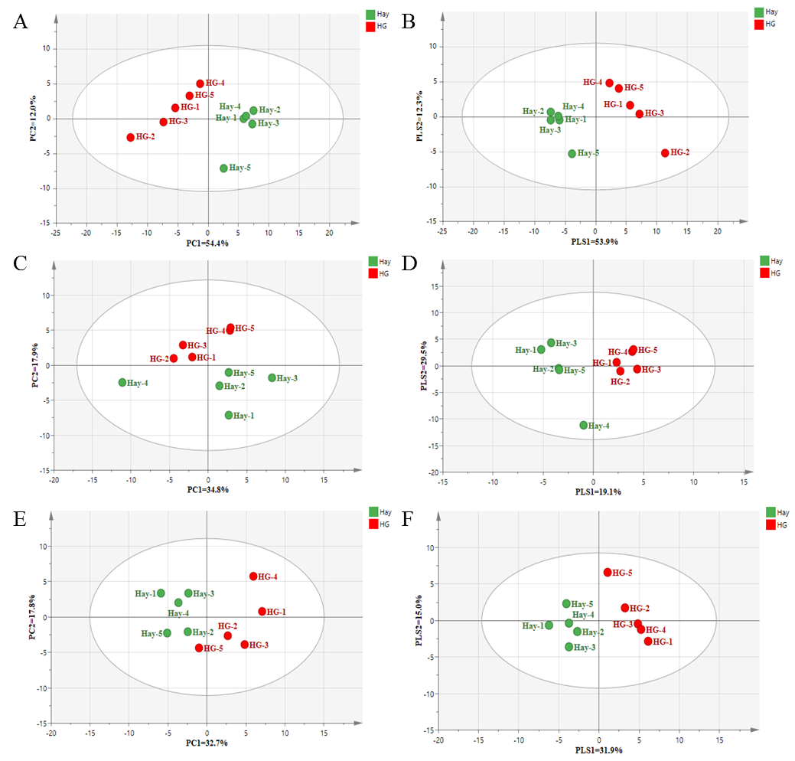

Figure S4. The principal component analysis (PCA) and the partial least squares discriminant analysis (PLS-DA) of rumen fluid (A and B), liver (C and D) and serum (E and F) in goats fed hay and high-grain (HG) diets. Each point represents one sample in each group (red = HG group; green = hay group).

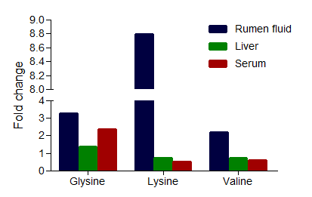

Figure S5 The alterations in fold changes (the ratio of mean value of peak area obtained from the high-grain group and the hay group) of three amino acids in common pathway in rumen fluid, liver and serum of goats.

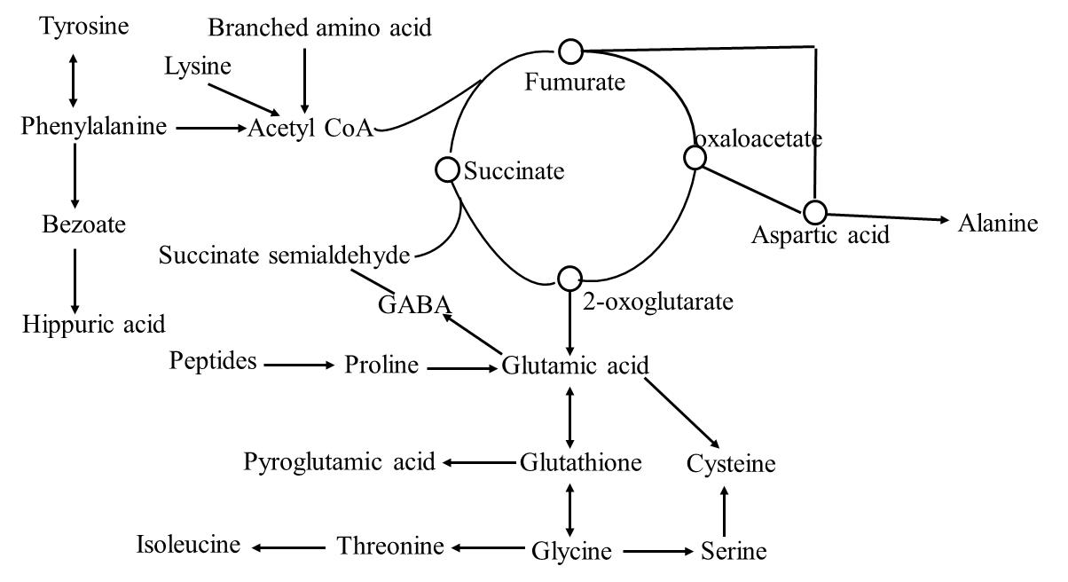
Figure S6 Proposed map illustrates significantly different main metabolites in the rumen fluid, liver and serum of the high-grain-fed goats compared to the hay-fed goats. GABA, γ-aminobutyric acid.

Table S1 The effects of high grain diet on ruminal fermentation parameters in goats
Item | Hay | High-grain | P-value
Ruminal parameters
pH | 6.12 ±0.09 | 5.33±0.09 | <0.001
Total VFA, (mM) | 93.90±1.25 | 116.16±4.25 | 0.001
Acetate, (mM) | 70.24±0.88 | 63.12±1.89 | 0.009
Propionate, (mM) | 14.57±0.29 | 34.12±2.24 | <0.001
Butyrate, (mM) | 7.15±0.39 | 15.81±0.94 | <0.001
Isobutyrate, (mM) | 1.09±0.10 | 1.43±0.15 | 0.089
Valerate, (mM) | 0.45±0.04 | 0.74±0.05 | 0.002
Isovalerate, (mM) | 0.41±0.12 | 0.94±0.14 | 0.019
Ace:Pro | 4.82±0.05 | 1.88±0.10 | <0.001
Acetate, (mol%) | 74.81±0.48 | 54.40±0.48 | <0.001
Propionate, (mol%) | 15.51±0.18 | 29.29±1.30 | <0.001
Butyrate, (mol%) | 7.61±0.39 | 13.62±0.66 | <0.001
Isobutyrate, (mol%) | 1.16±0.09 | 1.24±0.14 | 0.646
Valerate, (mol%) | 0.47±0.04 | 0.64±0.05 | 0.022
Isovalerate, (mol%) | 0.43±0.12 | 0.82±0.14 | 0.066
Free lipopolysaccharide, (EU/mL) | 22,547±1,065 | 64,628 ±1,685 | <0.001
VFA = volatile fatty acids; Ace:Pro = the ration of acetate to propionate.

Table S2 Ingredient and nutrient composition of the diets of the experimental goats.
 | Diet
Item | Hay | High-grain
Diet ingredient, % DM
Chinese wildrye | 81 | 30
Alfalfa | 15 | 0
Corn | 0 | 45
Wheat | 0 | 20
Soybean meal | 0 | 1.1
Limestone | 0.5 | 0.95
Salt | 0.8 | 0.65
Calcium monohydrogen phosphate | 1.7 | 1.2
Premix | 1 | 1
Sodium Bicarbonate | 0 | 0.1
Nutrient levels
Metabolic energy , MJ/kg DM | 8.31 | 11.31
Crude protein, % DM | 10.06 | 10.06
Crude fat, % DM | 3.55 | 3.59
Neutral detergent fiber , % DM | 57.01 | 25.23
Acid detergent fiber , % DM | 35.72 | 13.55
Crude ash, % DM | 10.62 | 6.52
Starch, % DM | —* | 58.23
*Not determined, but considered equal to 0.

Table S3 Identified metabolomics of rumen fluid, liver and serum from goats fed the hay diet and the high-grain diet
unique in rumen | unique in liver | rumen & liver & serum | rumen & liver
1-Monopalmitin | 2-Aminoethylphosphonic acid | 2-Ketoglutaric acid | 3-Hydroxypyridine
2,5-Diaminovalerolactam | 2-Keto-L-gluconic acid | 3-Hydroxybutyric acid | 4-Aminobutyric acid
2-Glycerophosphate | 5'-Adenosine monophosphate | Aminomalonic acid | Asparagine
2-Hydroxybutyric acid | Beta-Aminoisobutyric acid | Arachidonic acid | Aspartic acid
2-Hydroxyisovaleric acid | Beta-Glycerophospate | Creatinine | Beta-Alanine
2-Keto-gluconic acid | Chlorphentermine | Cysteine | Glycerol
3-Glycerophosphate | D-Arabinose | D-Fructose | Glycolic acid
5-Hydroxyhexanoic acid | D-Galactonic acid lactone | D-Glucose | Hexadecanoic acid
9,12-Octadecadienoic acid | D-Galactose | Glucose-6-phosphate | Inosine
9H-Purin-6-amine | D-Glucitol | Glutamic acid | rumen & serum
Allonic acid lactone | Histidine | Glyceric acid | Glucuronic acid
Alpha-Aminobutyric acid | Inositol-3-phosphate | Glycine | Uracil
Azelaic acid | Lactose | Hypoxanthine | liver & serum
Benzoate | Mannonic acid-lactone | Inositol | 1,3-Propanediol
Cadaverine | Mercaptoacetic acid | Isoleucine | 2-Ethylhydracrylic acid
Caproic acid | Methyl-alpha-D-glucopyranoside | Lactate | Alpha-Aminoisobutyric acid
Chenodeoxycholic acid | N-Heptadecane | Leucine | Alpha-Glycerophosphate
Dodecanedioic acid | O-Phosphorylethanolamine | Lysine | Alpha-Hydroxy-N-butyric acid
Gluconic acid-1,4-lactone | Pipecolic acid | Malic acid | Cholesterol
Homoserine | Ribitol | Maltose | Fumaric acid
Hydrocinnamic acid | unique in serum | Mannose | Heptadecanoic acid
Lyxose | 2-Iodoethyl laurate | Monomethyl phosphate | Linoleic acid
Monostearin | 3,7,11,15-Tetramethyl-hexadecanoic acid | Oleic acid | Phosphoric acid
Myo-inositol-2-phosphate | 3-Phenylpropionic acid | Ornithine | Pyrophosphoric acid
N-Acetyl glucosamine | Carbamic acid 2-dimethylamino-ethyl ester | Palmitoleic acid | Tricarballylic acid
Nicotinic acid | Cis-9-hexadecenoic acid ester | Phenylalanine | Uric acid
Nonanoic acid | Citric acid | Proline | Cystine
Oxalate | Gulono-1,4-lactone | Pyroglutamic acid | N-Heptadecane
Phenylethanolamine | Hexanoic acid | Pyruvate
Phosphate | Hippuric acid | Stearic acid
Putrescine | Hormone | Threonine
Thymine | Methionine | Tryptophan
Uridine | Palmitic acid | Tyrosine
Xanthine | Scyllo-inositol | Urea
 |  | Valine
 |  | Ethanolamine
 |  | Glutamine
 |  | Serine
 |  | Alanine
Table S4 Identification of significantly different metabolites in rumen, liver and serum between goats fed the hay diet or high-grain diet
ID | RT | M/Z | VIP | P value | FC
rumen
Organic acid
Acetate | -- | -- | 1.147 | 0.015 | 0.899
Benzoate | 6.89 | 179 | 1.204 | 0.005 | 0.337
Butyrate | -- | -- | 1.412 | 0.000 | 2.212
Dodecanedioic acid | 11.96 | 359 | 1.360 | 0.003 | 0.064
Hydrocinnamic acid | 8.21 | 207 | 1.177 | 0.006 | 0.298
Propionate | -- | -- | 1.414 | 0.001 | 2.342
Valerate | -- | -- | 1.281 | 0.001 | 1.676
Isovalerate | -- | -- | 1.067 | 0.020 | 2.302
2-Ketoglutaric acid | 9.24 | 198 | 1.093 | 0.036 | 3.797
Nicotinic acid | 7.28 | 180 | 1.361 | 0.000 | 3.412
Amino acids and derivatives
Alanine | 5.54 | 190 | 1.307 | 0.001 | 3.962
Alpha-Aminobutyric acid | 6.25 | 130 | 1.351 | 0.001 | 4.753
Aminomalonic acid | 8.6 | 320 | 1.098 | 0.015 | 4.008
Cysteine | 9.15 | 220 | 1.142 | 0.010 | 3.192
Glutamic acid | 9.53 | 246 | 1.273 | 0.002 | 4.691
Glutamine | 10.42 | 156 | 1.145 | 0.009 | 9.289
Glycine | 5.7 | 204 | 1.229 | 0.008 | 3.289
Homoserine | 8.44 | 292 | 1.155 | 0.008 | 4.916
Isoleucine | 7.32 | 218 | 1.092 | 0.016 | 2.048
Leucine | 7.13 | 158 | 1.085 | 0.017 | 2.643
Lysine | 11.22 | 434 | 1.356 | 0.000 | 8.790
Ornithine | 9.48 | 142 | 1.221 | 0.004 | 3.697
Phenylalanine | 9.61 | 218 | 1.190 | 0.005 | 3.669
Pyroglutamic acid | 8.96 | 230 | 1.266 | 0.002 | 3.106
Serine | 7.83 | 218 | 1.092 | 0.032 | 3.071
Threonine | 8.025 | 218 | 1.278 | 0.001 | 3.544
Tryptophan | 12.71 | 202 | 1.206 | 0.004 | 9.681
Tyrosine | 11.33 | 218 | 1.222 | 0.004 | 4.034
Valine | 6.66 | 218 | 1.106 | 0.014 | 2.198
Amines
Ethanolamine | 7.09 | 174 | 1.038 | 0.043 | 2.793
Putrescine | 10.26 | 174 | 1.187 | 0.020 | 7.957
Nucleosides and derivatives
Hypoxanthine | 10.63 | 265 | 1.149 | 0.009 | 2.505
Sugars
D-Fructose | 11.04 | 307 | 1.288 | 0.001 | 5.627
D-Glucose | 11.15 | 319 | 1.191 | 0.005 | 3.664
Maltose | 14.85 | 361 | 1.376 | 0.000 | 42.273
Mannose | 11.11 | 319 | 1.184 | 0.006 | 4.754
Others
2,5-Diaminovalerolactam | 8.51 | 243 | 1.232 | 0.003 | 2.391
2-Glycerophosphate | 10.38 | 299 | 1.157 | 0.008 | 7.377
3-Hydroxypyridine | 4.78 | 152 | 1.185 | 0.017 | 0.542
9H-Purin-6-amine | 10.95 | 264 | 1.302 | 0.001 | 6.946
Glycerol | 7.13 | 205 | 1.419 | 0.000 | 3.859
Inositol | 12.15 | 318 | 1.228 | 0.013 | 5.273
LPS | -- | -- | 1.474 | <0.0001 | 2.866
Myo-inositol-2-phosphate | 13.63 | 318 | 1.246 | 0.002 | 3.554
N-Acetyl glucosamine | 12.19 | 319 | 1.232 | 0.014 | 7.390
Phosphate | 7.15 | 314 | 1.393 | 0.001 | 4.277
Glucose-6-phosphate | 13.15 | 387 | 1.226 | 0.011 | 3.997
liver
Organic acids
Heptadecanoic acid | 12.22 | 327 | 1.771 | 0.022 | 0.719
Amino acids and derivatives
Alpha-Aminoisobutyric acid | 6.25 | 130 | 1.636 | 0.041 | 0.565
Cystine | 12.99 | 218 | 1.693 | 0.032 | 3.231
GABA | 8.98 | 174 | 1.757 | 0.048 | 2.793
Glycine | 5.70 | 204 | 1.727 | 0.028 | 1.369
Lysine | 11.22 | 174 | 1.633 | 0.041 | 0.733
Pyroglutamic acid | 8.95 | 156 | 1.783 | 0.021 | 1.306
Valine | 6.65 | 144 | 1.622 | 0.043 | 0.726
Others
Adenosine monophosphate | 16.9 | 315 | 1.618 | 0.044 | 0.540
Glycerol | 7.14 | 205 | 1.715 | 0.029 | 1.234
serum
Organic acids
3-Phenylpropionic acid | 8.21 | 104 | 1.708 | 0.001 | 0.308
Tricarballylic acid | 10.15 | 377 | 1.287 | 0.034 | 2.999
Amino acids and derivatives
2-Ethylhydracrylic acid | 6.74 | 177 | 1.266 | 0.038 | 1.822
Alpha-Aminoisobutyric acid | 6.25 | 130 | 1.284 | 0.034 | 0.576
Aminomalonic acid | 8.6 | 320 | 1.666 | 0.007 | 4.052
Glycine | 5.70 | 204 | 1.744 | 0.001 | 2.367
Hippuric acid | 10.61 | 105 | 1.615 | 0.011 | 0.255
Isoleucine | 7.31 | 158 | 1.580 | 0.003 | 0.658
Lysine | 11.22 | 156 | 1.433 | 0.013 | 0.520
Proline | 7.34 | 142 | 1.283 | 0.035 | 1.406
Threonine | 8.02 | 219 | 1.317 | 0.028 | 0.716
Tyrosine | 11.32 | 218 | 1.244 | 0.043 | 1.659
Valine | 6.65 | 144 | 1.488 | 0.008 | 0.603
Sugars
D-Fructose | 11.03 | 217 | 1.374 | 0.020 | 1.610
Lipids
Cholesterol | 17.7 | 458 | 1.217 | 0.049 | 1.221
Nucleosides
Hypoxanthine | 10.61 | 265 | 1.226 | 0.047 | 1.613
Others
Phosphoric acid | 7.16 | 299 | 1.322 | 0.028 | 1.508
RT = retention time; M/Z = mass-to-charge ratio; VIP = the variable importance for the projection; FC = fold change, the ratio of mean value of peak area obtained from goats fed the high-grain diet and the mean value of peak area obtained from goats fed the hay diet; LPS = lipopolysaccharide; GABA =γ-aminobutyric acid.
Note: volatile fatty acid (--) and LPS (--) are detected by gas chromatography and assay kit respectively.

