Animal journal
Coupling a reproductive function model to a productive function model to simulate lifetime performance in dairy cows
Olivier Martin1, Pierre Blavy1, Marjolein Derks1,2,3,a, Nicolas Friggens1 and Fabienne Blanc2

1 UMR 0791 Modélisation Systémique Appliquée aux Ruminants, INRA,
AgroParisTech, Université Paris-Saclay, 75005 Paris, France
2 Université Clermont Auvergne, UMR 1213 Herbivores, VetAgro Sup, INRA, 63122 Saint-Genès-Champanelle, France
3 Swedish University of Agricultural Science, SE-75007 Uppsala, Sweden

a Present address: Farm Technology Group, Wageningen University, Droevendaalsesteeg 1, 6708 PB, Wageningen, The Netherlands

Corresponding author: Olivier Martin. Email: olivier.martin@agroparistech.fr

Supplementary material
Supplementary tables
Table S1 Dairy cow Reproductive Function Model (RFM): differential system
Table S2 Dairy cow Reproductive Function Model (RFM): variables and flows
Table S3 Dairy cow Reproductive Function model (RFM): events
Table S4 Dairy cow Reproductive Function Model (RFM): parameters
Table S5 Random distributions of genetic-scaling parameters of the dairy cow productive function model (GARUNS) and reproductive function model (RFM)
Table S6 Farm System Model (FSM): Predefined triggers
Table S7 Farm System Model (FSM): Predefined conditions
Table S8 Farm System Model (FSM): Variables
Table S9 Farm System Model (FSM): Predefined actions

Supplementary figures
Figure S1 Model simulation: dynamics of progesterone (P4) and estradiol (E2) over 3000d lifetime of an individual dairy cow.
Figure S2 Model simulation: dynamics of progesterone (P4) and estradiol (E2) over 250d between the 2nd and 3rd gestations of an individual dairy cow.
Figure S3 Model simulation: dynamics of progesterone (P4) and estradiol (E2) over 40 days around one estrous cycle of an individual dairy cow.
Figure S4 Model simulation: dynamics of competence stages (PRPB: prepubertal, ANST: anestrous, PREO: pre-ovulating, OVUL: ovulating, PSTO: post-ovulating, LUTZ: luteinizing, LUTL: luteal, ANOV: anovulatory, GEST: gestant) over 3000d lifetime of an individual dairy cow.
Figure S5 Model simulation: dynamics of competence stages (PRPB: prepubertal, ANST: anestrous, PREO: pre-ovulating, OVUL: ovulating, PSTO: post-ovulating, LUTZ: luteinizing, LUTL: luteal, ANOV: anovulatory, GEST: gestant) over 250d between the 2nd and 3rd gestations of an individual dairy cow.
Figure S6. Model simulation: dynamics of competence stages (PRPB: prepubertal, ANST: anestrous, PREO: pre-ovulating, OVUL: ovulating, PSTO: post-ovulating, LUTZ: luteinizing, LUTL: luteal, ANOV: anovulatory, GEST: gestant) over 40 days around one estrous cycle of an individual dairy cow.
Figure S7 Model simulation: dynamics of the regulation variable fertilization (defined as a linear combination of competence stages PREO: pre-ovulating, OVUL: ovulating, and PSTO: post-ovulating) and of the random variable fertility (corresponding to the probability of conception and drawn in an uniform law with minimum zero and maximum fertilization) around ovulation (P4: progesterone and E2: estradiol shown for physiological time reference of an individual dairy cow).
Figure S8 Growth in Body Weight (kg) with age (days). A: literature data in dairy cattle (60 references). B: Model simulation over 5000d lifetime for 30 random individual cows.
Figure S9 Changes in Body Condition Score (BCS, [0-5]) with age (days). A: literature data in dairy cattle (10 references). B: Model simulation over 5000d lifetime for 30 random individual cows.
Figure S10 Body Weight (kg) dynamics over lactation according to parity. A: literature data in dairy cattle (37 references). B: Model simulation over 320 days in milk for 30 random individual cows from parity 1 to 5 (130 lactations).
Figure S11 Milk Yield (MY, kg/d) dynamics over lactation according to parity. A: literature data in dairy cattle (37 references). B: Model simulation over 320 days in milk for 30 random individual cows from parity 1 to 5 (130 lactations).
Figure S12 Dry Matter Intake (DMI, kg/d) dynamics over lactation according to parity. A: literature data in dairy cattle (37 references). B: Model simulation over 320 days in milk for 30 random individual cows from parity 1 to 5 (130 lactations).
Figure S13 Fetal growth during gestation. A: literature data in dairy cattle (27 references). B: Model simulation for 30 random individual cows performing 296 gestations over 5000d-lifetime.
Figure S14 Relationship between Calf Birth Weight (kg) and Post-Partum BW (kg). A: literature data in dairy cattle (32 references). B: Model simulation for 30 random individual cows performing 296 calvings over 5000d-lifetime.
Figure S15 Relationship between Gestation Length (d) and Calf Birth Weight (kg). A: literature data in dairy cattle (74 references). B: Model simulation for 30 random individual cows performing 296 calvings over 5000d-lifetime.
Figure S16 Gestation Length (d) according to parity. A: literature data in dairy cattle (15 references). B: Distribution of model simulation for 30 random individual cows performing 296 calvings over 5000d-lifetime.
Figure S17 Calving interval (d) according to parity. A: literature data in dairy cattle (8 references). B: Distribution of model simulation for 30 random individual cows performing 296 calvings over 5000d-lifetime.
Figure S18 Distribution of calving interval (d). A: data in Pryce et al., 2000 (N = 19042 calvings). B: Distribution of model simulation for 1000 random individual cows performing 9761 calvings over 5000d-lifetime.
Figure S19 Model simulation over 3000d lifetime for the individual cow with highest calving interval (mean calving interval of 795±199 days; 3 calvings).
Figure S20 Model simulation over 3000d lifetime for the individual cow with lowest calving interval (mean calving interval of 318±14 days ; 8 calvings).
Figure S21 Dairy cow Estrous Behavior Model (EBM): estrous expression function.
Figure S22 Dairy cow Estrous Behavior Model (EBM): memory function.

Supplementary materials
Material S1 Farm management

Table S1 Dairy cow Reproductive Function Model (RFM): differential system (see Table S2 for variables and flows definitions)
Abbreviation | Variable | Differential equation |  |  |  |  |  |  |  |  |  |  |  | Initial
Competence stage
PRPB | Prepubertal | −r₀ |  |  |  |  |  |  |  |  |  |  |  | 0.999
ANST | Anestrous | +r₀ | −r₁ |  |  |  |  | +r_{6a} | +r_{6b} | +r_{6c} |  | −r₈ |  | 0.001
PREO | Pre-ovulating |  | +r₁ | −r₂ |  |  |  |  |  |  |  |  |  | 0.000
OVUL | Ovulating |  |  | +r₂ | −r₃ |  |  |  |  |  |  |  |  | 0.000
PSTO | Post-ovulating |  |  |  | +r₃ | −r₄ |  |  |  | −r_{6c} |  |  |  | 0.000
LUTZ | Luteinizing |  |  |  |  | +r₄ | −r₅ |  | −r_{6b} |  |  |  |  | 0.000
LUTL | Luteal |  |  |  |  |  | +r₅ | −r_{6a} |  |  | −r₇ |  | +r₉ | 0.000
GEST | Gestating |  |  |  |  |  |  |  |  |  | +r₇ |  |  | 0.000
ANOV | Anovulatory |  |  |  |  |  |  |  |  |  |  | +r₈ | −r₉ | 0.000
Hormonal signal
E2 | Estradiol | ω_{E2[1]}·[OVU+0.3∙PREO+0.1∙(ANST+PSTO+LUTZ+LUTL+GEST) - Clearance·ω_{E2[2]}·E2] |  |  |  |  |  |  |  |  |  |  |  | 0.200
P4 | Progesterone | ω_{P4[1]}·[LUTL+GEST - ω_{P4[2]}·P4 ] |  |  |  |  |  |  |  |  |  |  |  | 0.100
Physiological time
dip¹ | Days in pregnancy | 1·pregnancy |  |  |  |  |  |  |  |  |  |  |  | 0.000
¹ dip is reset to zero by events parturition and death (of embryo or fetus)

Table S2 Dairy cow Reproductive Function Model (RFM): variables and flows (see Table S1 for differential system definition)
Equation | Definition | Unit¹
Variable derived from GARUNS²
EB= I−(M+Y+P+A_{W})+150 | Net Energy Balance | MJ ME/d
EB*=EB+150 | transformed net Energy Balance | MJ ME/d
TPEW=(I+C_{X})/W | Total Processed Energy per Weight | MJ ME/d/kg
Boolean variable of physiological status
pregnancy=1 if pregnant; 0 if not | Pregnancy status indicator | du
Regulation variable
cyclicity=(EB*)⁵⁰/[(EB*)⁵⁰+(B+150)⁵⁰] | Control of cyclicity resumption | du
ovulation=1−ANST⁵⁰/(ANST⁵⁰+0.01⁵⁰) | Control of ovulation induction | du
luteolysis=1−PSTO⁵⁰/(PSTO⁵⁰+0.001⁵⁰) | Control of luteolysis induction | du
impregnation=P4¹⁰/(P4¹⁰+0.4¹⁰) | Control of estrous intensity | du
clearance=1+0.4·TPEW⁵⁰/(TPEW⁵⁰+0.5⁵⁰) | Control of estradiol clearance | du
fertilization=0.3·PREO+OVUL+0.1·PSTO | Control of fertilization potential | du
survival | Control of embryonic/fetal death | du
= M1 if dip<16
= M2 if dip∈ [16; 45]
= M3 if dip>45
Random variable³
fertility ∼ U[0 ; fertilization] | Probability of conception | du
mortality ∼ U[0 ; 1] | Probability of embryonic/fetal death | du
Transition flows between competence stages
r₀ = ν_{B}∙k₀∙PRPB∙ANST | Prepubertal to Anestrous | d⁻¹
r₁ = ν_{Z}∙k₁∙cyclicity∙ANST | Anestrous to Pre-ovulating | d⁻¹
r₂ = ν_{Z}∙k₂∙ovulation∙PREO | Pre-ovulating to Ovulating | d⁻¹
r₃ = ν_{Z}∙k₃∙OVUL | Ovulating to Post-ovulating | d⁻¹
r₄ = ν_{Z}∙k₄∙PSTO | Post-ovulating to Luteinizing | d⁻¹
r₅ = ν_{Z}∙k₅∙LUTZ | Luteinizing to Luteal | d⁻¹
r_{6a}= ν_{Z}∙k₆∙luteolysis∙LUTL | Luteal to Anestrous | d⁻¹
r_{6b}= ν_{Z}∙k₆∙luteolysis∙LUTZ | Luteinizing to Anestrous | d⁻¹
r_{6c}= ν_{Z}∙k₆∙luteolysis∙PSTO | Post-ovulating to Anestrous | d⁻¹
r₇ = ν_{Z}∙k₇∙pregnancy∙LUTL∙GEST | Luteal to Gestating | d⁻¹
r₈ = ν_{Z}∙k₈∙ANST | Anestrous to Anovulatory | d⁻¹
r₉ = ν_{Z}∙k₉∙impregnation∙ANOV | Anovulatory to Luteal | d⁻¹
Event time⁴
t_{ovulation} | Time of ovulation | d
t_{insemination} | Time of insemination | d
t_{conception} | Time of conception | d
t_{death} | Time of embryo/fetus death | d
t_{parturition} | Time of parturition | d
¹ ME: metabolizable energy; du: dimensionless unit
² Use of metabolizable energy flows from GARUNS model: I: intake, M: maintenance, Y: milk yield, P: pregnancy, AW: anabolism of non-labile body mass W, CX: catabolism of labile body mass X
³ Random numbers are drawn in U[m ;M]: Uniform distribution between m and M
⁴ Times are recorded for each successive events
Table S3 Dairy cow Reproductive Function model (RFM): events (see Table S1 for differential system definition)
Event | Trigger condition | Action¹
Ovulation | OVUL=max(PRPB;ANST;PREO;  OVUL;PSTO;LUTZ;  LUTL;GEST;ANOV) | t_{ovulation} = t
Insemination | Estrous detected  t > 450  pregnancy = 0 | t_{insemination} = t  t_{conception} = t + 1
Conception | t = t_{conception}  pregnancy = 0  fertility > ν_{I} | OVUL = OVUL − 0.001  GEST = GEST + 0.001  t_{conception} = t  pregnancy = 1
Parturition | t = t_{parturition} | LUTL = LUTL + GEST  GEST = 0  t_{parturition} = t  pregnancy = 0  dip = 0
Abortion | mortality > 1 − e ^{- survival⋅dt} | LUTL = LUTL + GEST  GEST = 0  t_{death} = t  pregnancy = 0  dip = 0
¹ t: simulation time = age of the individual cow

Table S4 Dairy cow Reproductive Function Model (RFM): parameters
Symbol | Unit | Value
Genetic-scaling parameter¹
ν_{B} | - | 1.700
ν_{Z} | - | 1.000
ν_{I} | - | 0.020
Fractional rate
k₀ | d⁻¹ | 1.000
k₁ | d⁻¹ | 4.555
k₂ | d⁻¹ | 4.513
k₃ | d⁻¹ | 1.093
k₄ | d⁻¹ | 0.417
k₅ | d⁻¹ | 0.210
k₆ | d⁻¹ | 1.233
k₇ | d⁻¹ | 4.500
k₈ | d⁻¹ | 0.050
k₉ | d⁻¹ | 0.240
Signal release and clearance
ω_{E2[1]} | - | 3.573
ω_{E2[2]} | - | 0.588
ω_{P4[1]} | - | 0.714
ω_{P4[2]} | - | 0.923
Embryo and fetus mortality thresholds
M₁ | probability | 0.0230
M₂ | probability | 0.0096
M₃ | probability | 0.0004
Energy balance threshold
B | MJ ME²/d | -10
¹ Standard values (mean of random distributions; see Table S5)
² ME: metabolizable energy

Table S5 Random distributions of genetic-scaling parameters of the dairy cow productive function model (GARUNS) and reproductive function model (RFM)
 |  |  |  | Random¹ N (μ, σ)
Symbol | Definition | Unit | Range² | μ | σ | Proxy for
GARUNS
W_{M} | mature non labile body mass | kg | [200-800] | 450 | 25 | Format
ν_{M} | target labile:non-labile mass ratio | [0-1] | [0.1-0.6] | 0.33 | 0.03 | Body fatness
b₀ | reserves storage rate | d⁻¹ | [0.8-2.4] | 1.6 | 0.2 | Reserve lability
ν_{X} | labile body mass mobilization index | - | [0.2-1.8] | 1.0 | 0.1 | Maternal reserve investment in reproduction
ν_{Y} | milk yield index | - | [0.2-1.8] | 1.0 | 0.1 | Milk potential
ν_{F} | milk fat secretion index | - | [0.5-1.5] | 1.00 | 0.02 | Milk fat content
ν_{P} | milk protein secretion index | - | [0.5-1.5] | 1.00 | 0.02 | Milk protein content
e_{D}* | optimal³ diet energy content | MJ.kg DM⁻¹ | [9.0-15.0] | 12.3 | 0.5 | Intake capacity
RFM
ν_{I} | fertilization probability threshold | - | [0.0-0.2] | 0.026 | 0.007 | Fertility
ν_{B} | puberty index | - | [1.2-2.2] | 1.70 | 0.25 | Age at 1st ovulation
ν_{Z} | follicular dynamics rate | - | [0.9-1.1] | 1.00 | 0.05 | Estrous duration
¹ Variability for a Holstein cow
² Cattle theoretical calculable range
³ Diet energy content maximizing intake and covering energy requirement

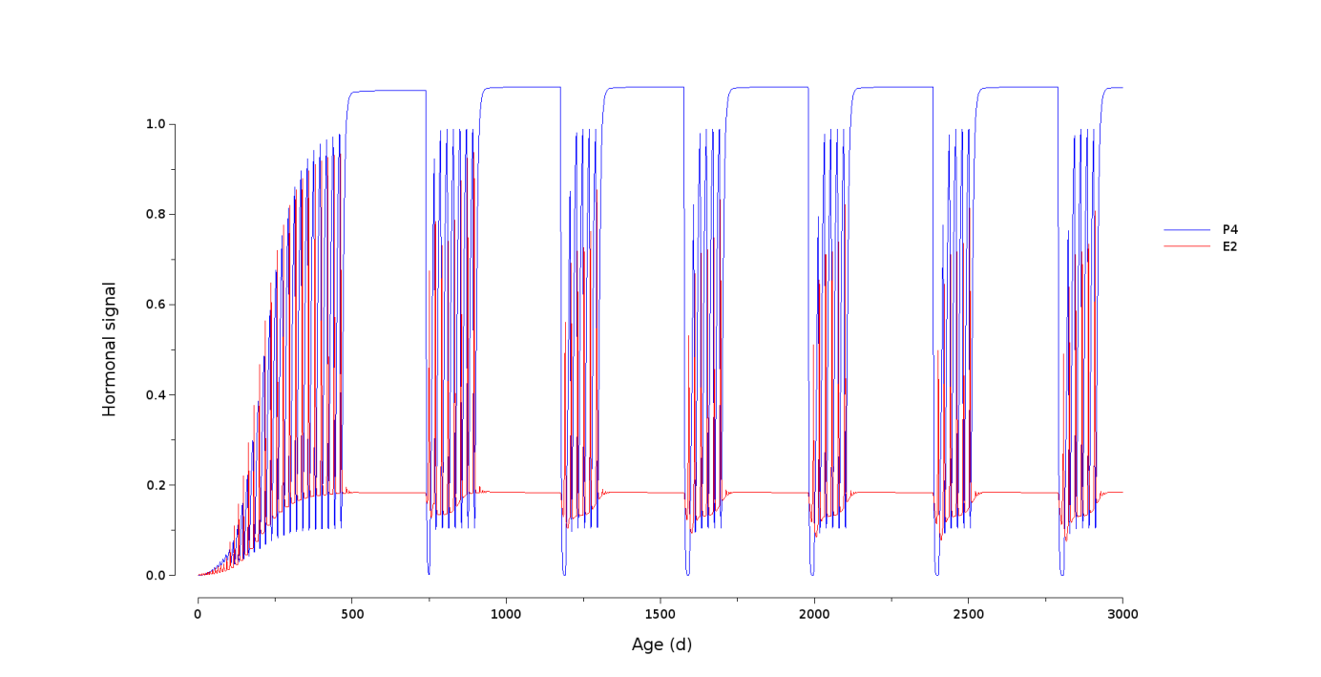
Figure S1 Model simulation: dynamics of progesterone (P4) and estradiol (E2) over 3000d lifetime of an individual dairy cow.

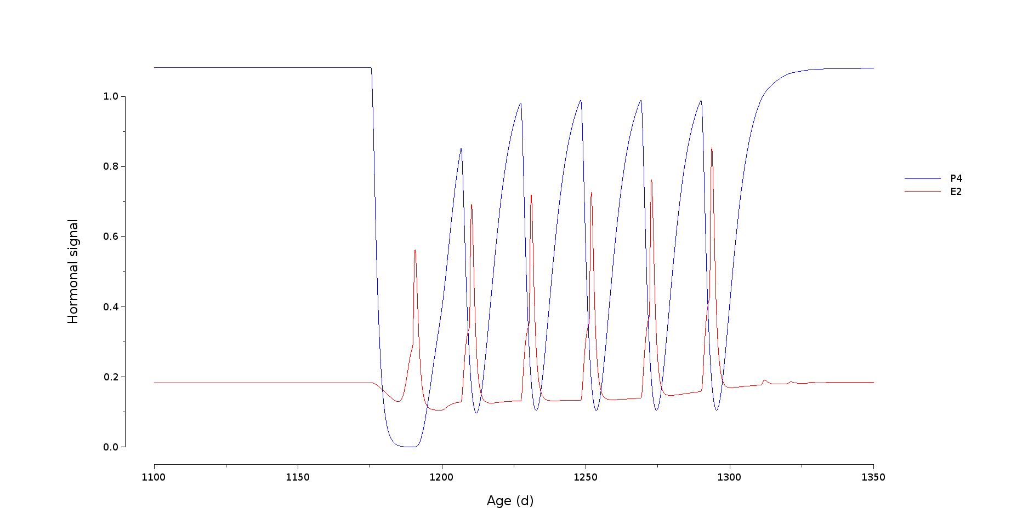
Figure S2 Model simulation: dynamics of progesterone (P4) and estradiol (E2) over 250d between the 2nd and 3rd gestations of an individual dairy cow.

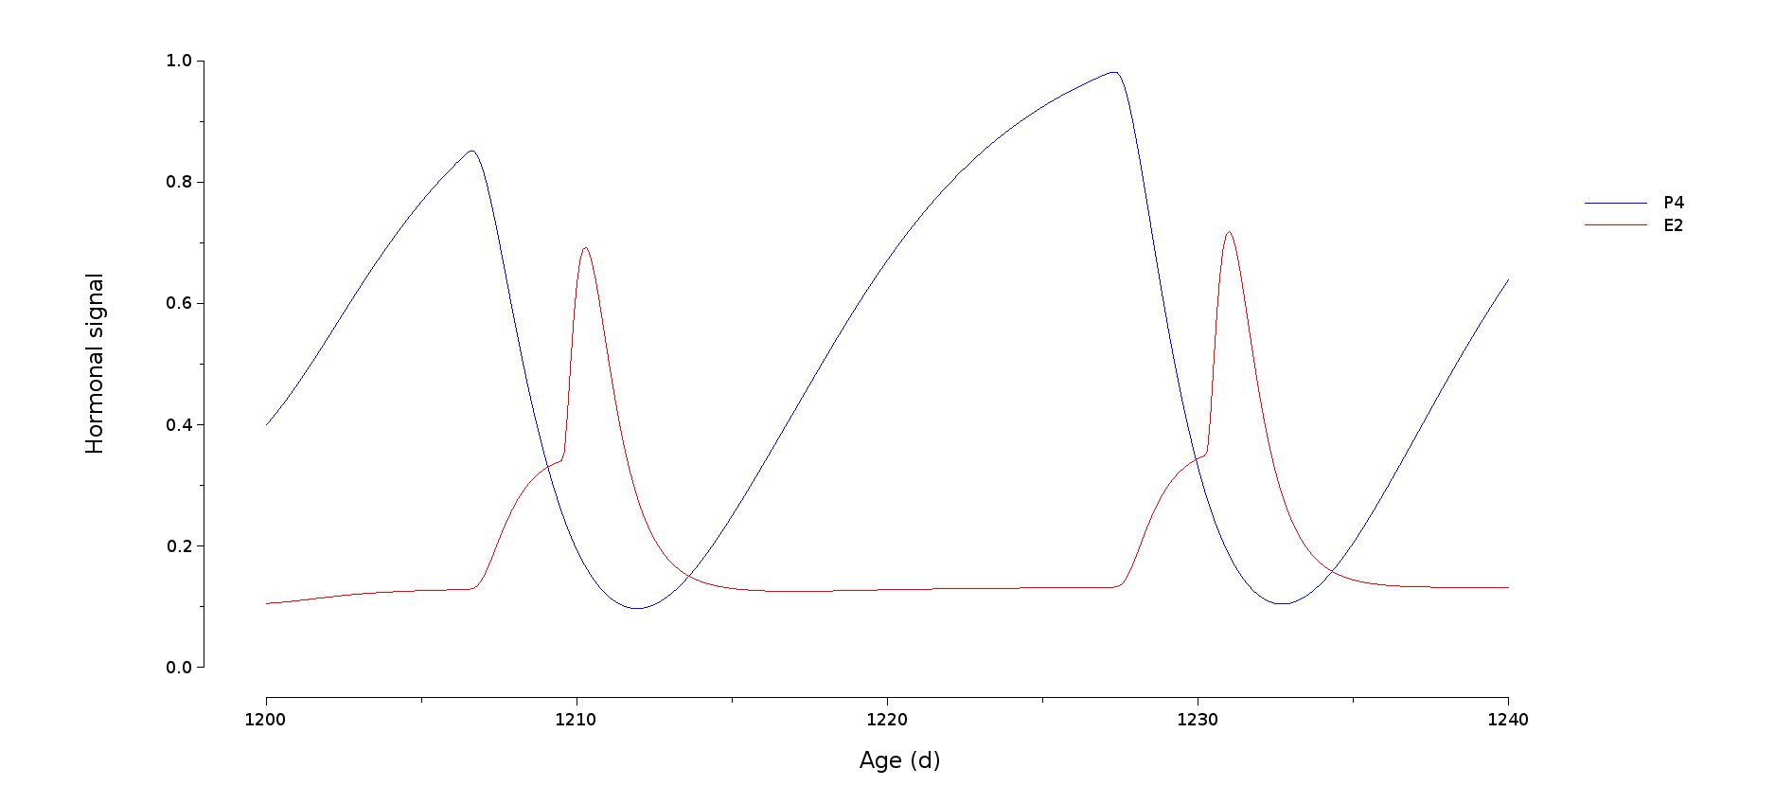
Figure S3 Model simulation: dynamics of progesterone (P4) and estradiol (E2) over 40 days around one estrous cycle of an individual dairy cow.

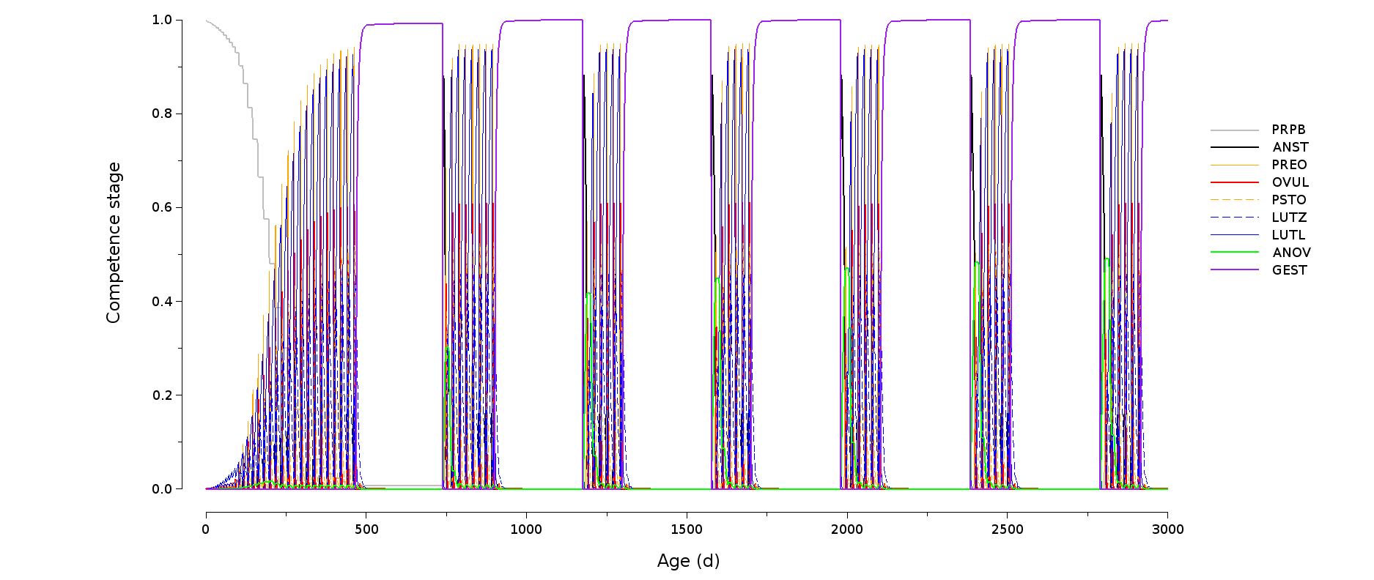
Figure S4 Model simulation: dynamics of competence stages (PRPB: prepubertal, ANST: anestrous, PREO: pre-ovulating, OVUL: ovulating, PSTO: post-ovulating, LUTZ: luteinizing, LUTL: luteal, ANOV: anovulatory, GEST: gestant) over 3000d lifetime of an individual dairy cow.

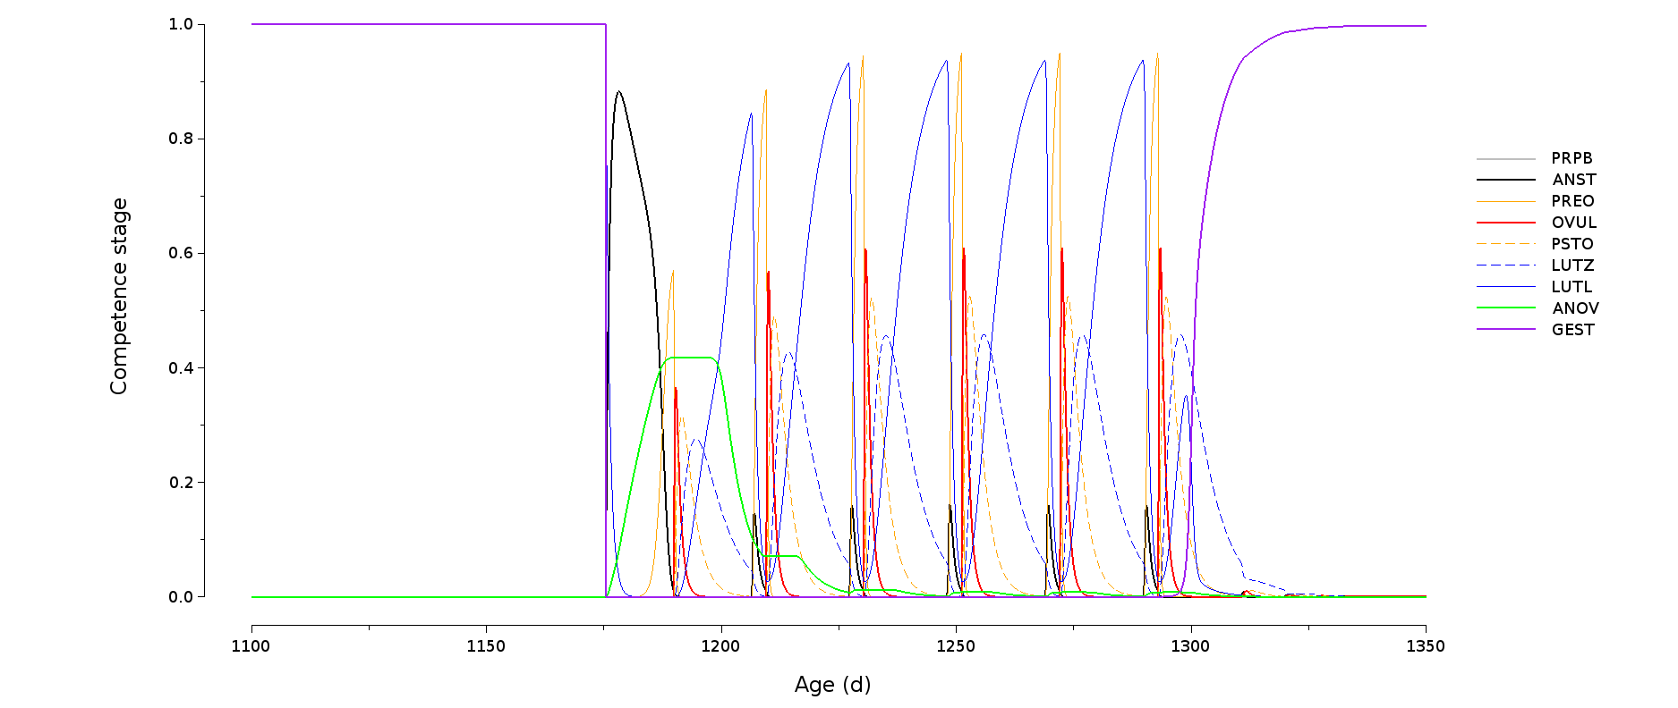
Figure S5 Model simulation: dynamics of competence stages (PRPB: prepubertal, ANST: anestrous, PREO: pre-ovulating, OVUL: ovulating, PSTO: post-ovulating, LUTZ: luteinizing, LUTL: luteal, ANOV: anovulatory, GEST: gestant) over 250d between the 2nd and 3rd gestations of an individual dairy cow.

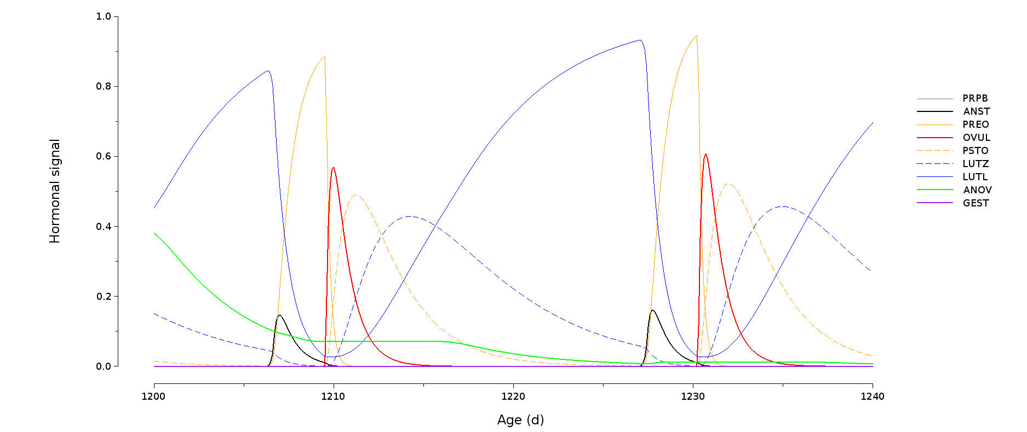
Figure S6. Model simulation: dynamics of competence stages (PRPB: prepubertal, ANST: anestrous, PREO: pre-ovulating, OVUL: ovulating, PSTO: post-ovulating, LUTZ: luteinizing, LUTL: luteal, ANOV: anovulatory, GEST: gestant) over 40 days around one estrous cycle of an individual dairy cow.

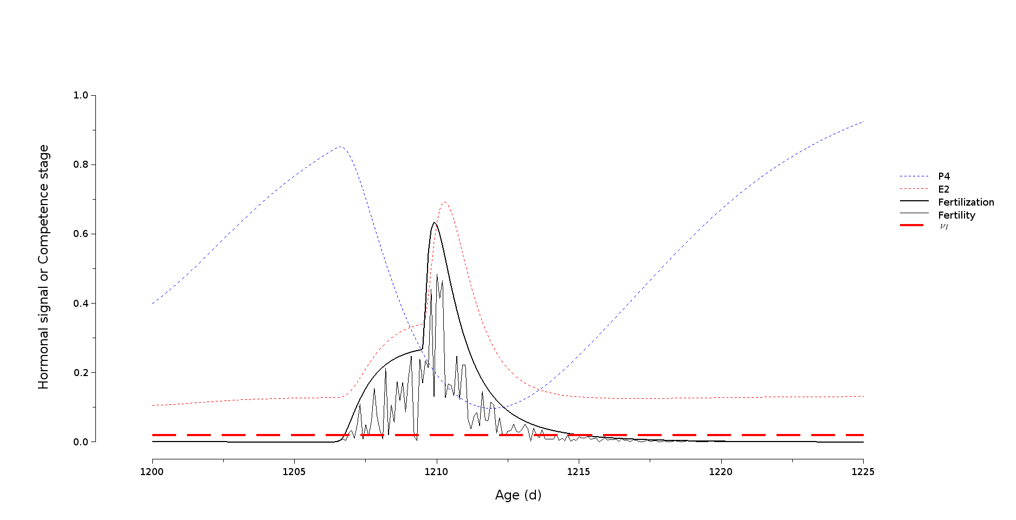
Figure S7 Model simulation: dynamics of the regulation variable fertilization (defined as a linear combination of competence stages PREO: pre-ovulating, OVUL: ovulating, and PSTO: post-ovulating) and of the random variable fertility (corresponding to the probability of conception and drawn in an uniform law with minimum zero and maximum fertilization) around ovulation (P4: progesterone and E2: estradiol shown for physiological time reference of an individual dairy cow).

An insemination at a time t within this so-called “fertility windows” leads to conception at time t + 24 hours if fertility > $ν_{I}$, where $ν_{I}$ is a genetic-scaling parameter representing the fertilization probability threshold of an individual cow.

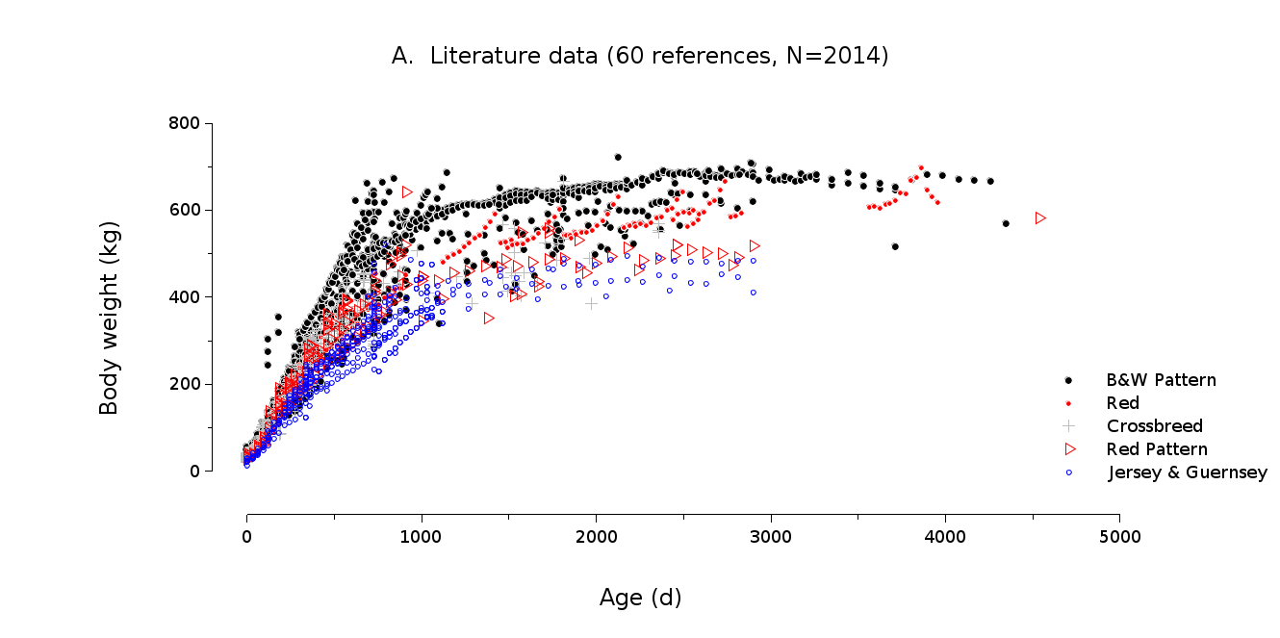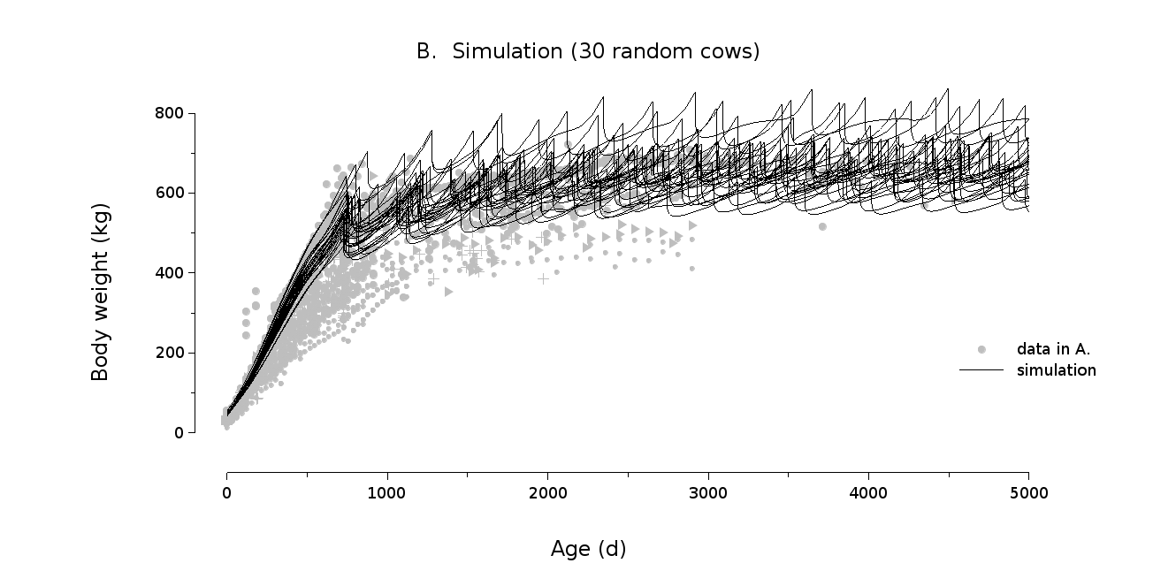

Figure S8 Growth in Body Weight (kg) with age (days). A: literature data in dairy cattle (60 references). B: Model simulation over 5000d lifetime for 30 random individual cows.
Comment on Fig. S8: The model is relevant to simulate growth in Holstein cows.
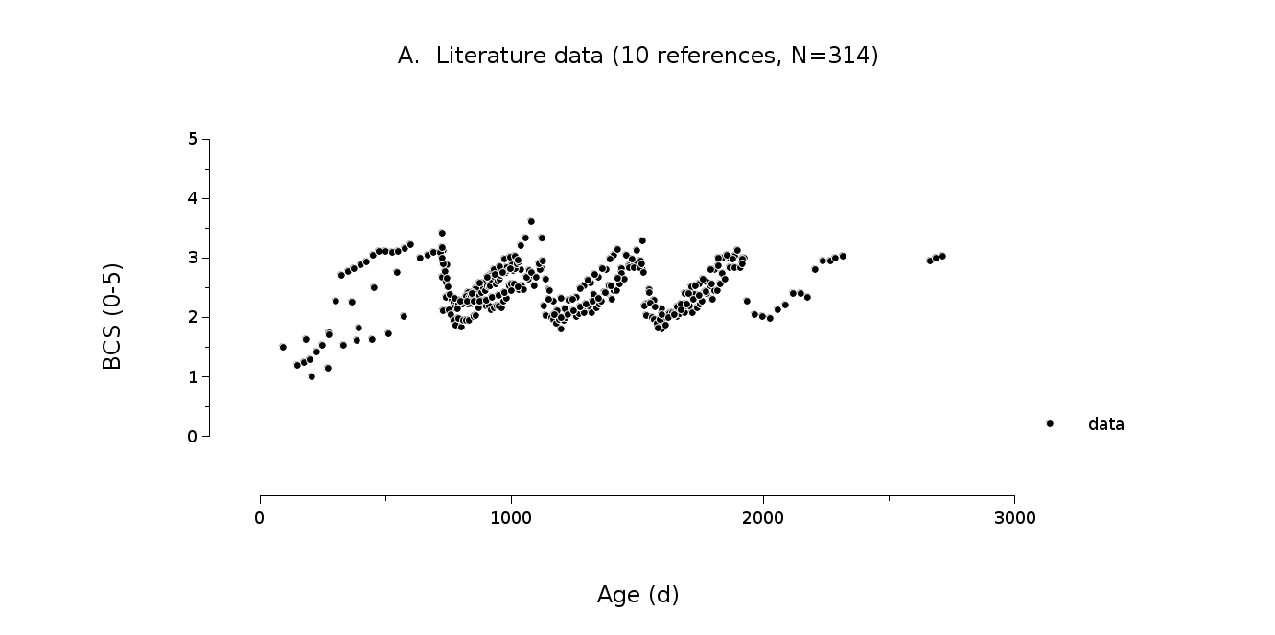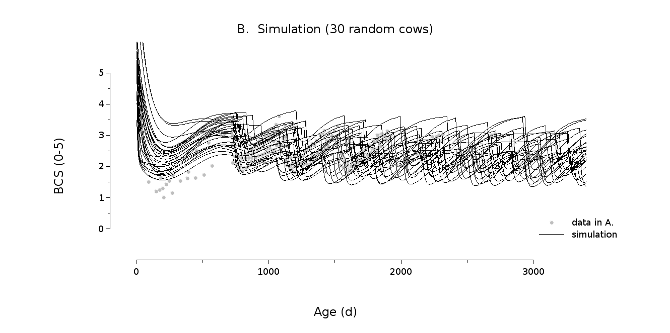

Figure S9 Changes in Body Condition Score (BCS, [0-5]) with age (days). A: literature data in dairy cattle (10 references). B: Model simulation over 5000d lifetime for 30 random individual cows.

Comment on Fig. S9. The model provides realistic simulations of BCS except in early stage of life since the formula used to compute BCS has not been specifically validated for young stock.

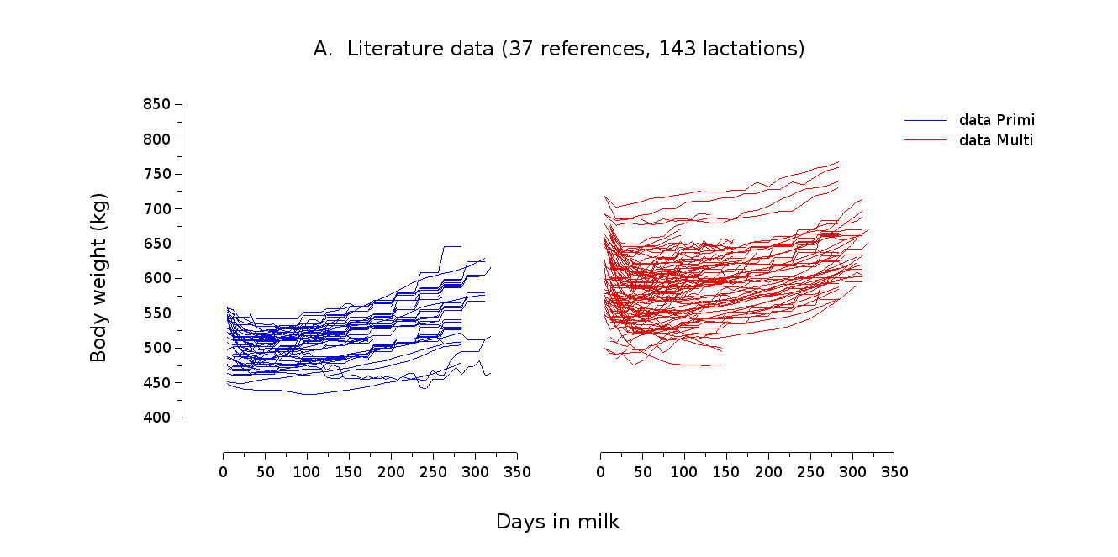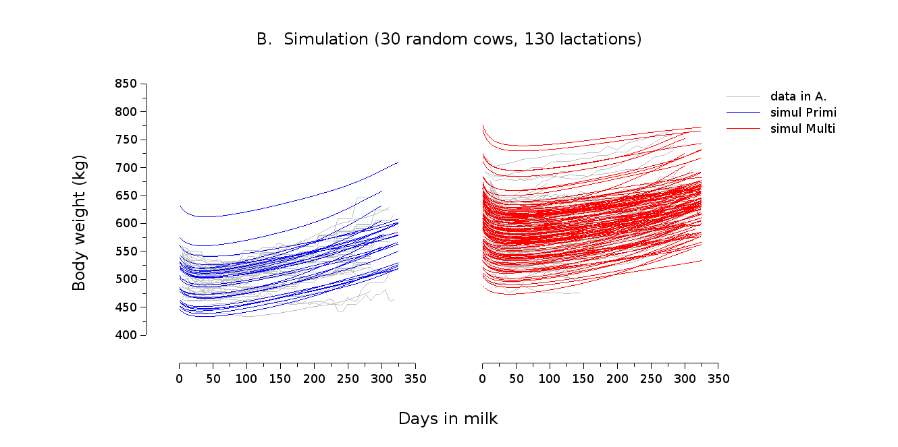

Figure S10 Body Weight (kg) dynamics over lactation according to parity. A: literature data in dairy cattle (37 references). B: Model simulation over 320 days in milk for 30 random individual cows from parity 1 to 5 (130 lactations).

Comment on Figure S10. Model simulations of BW over lactation are consistent with literature data.

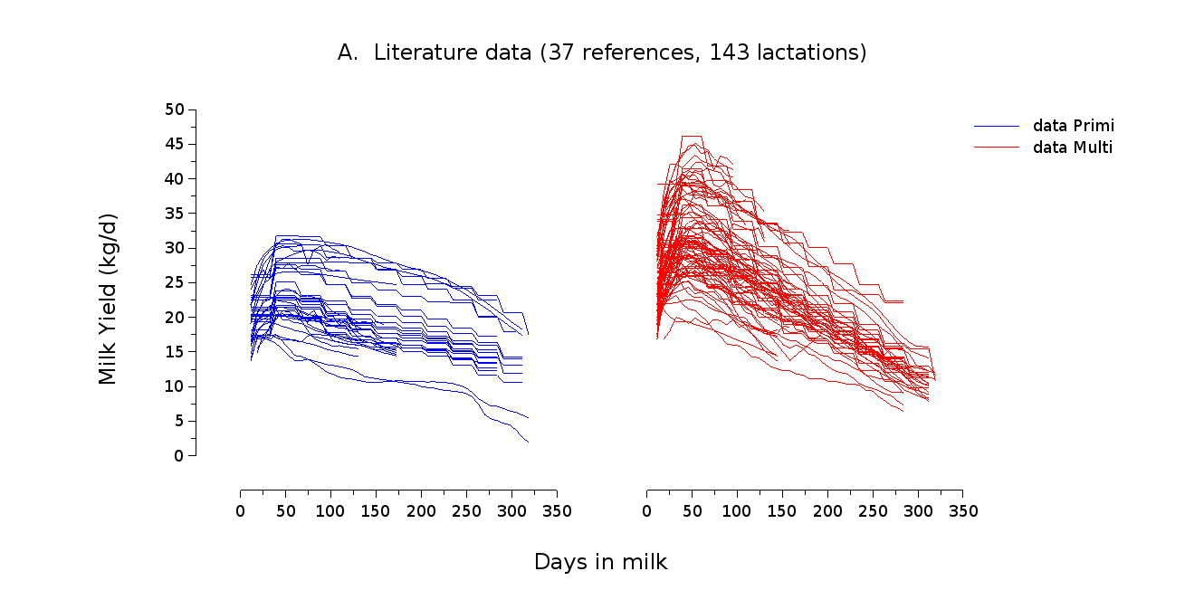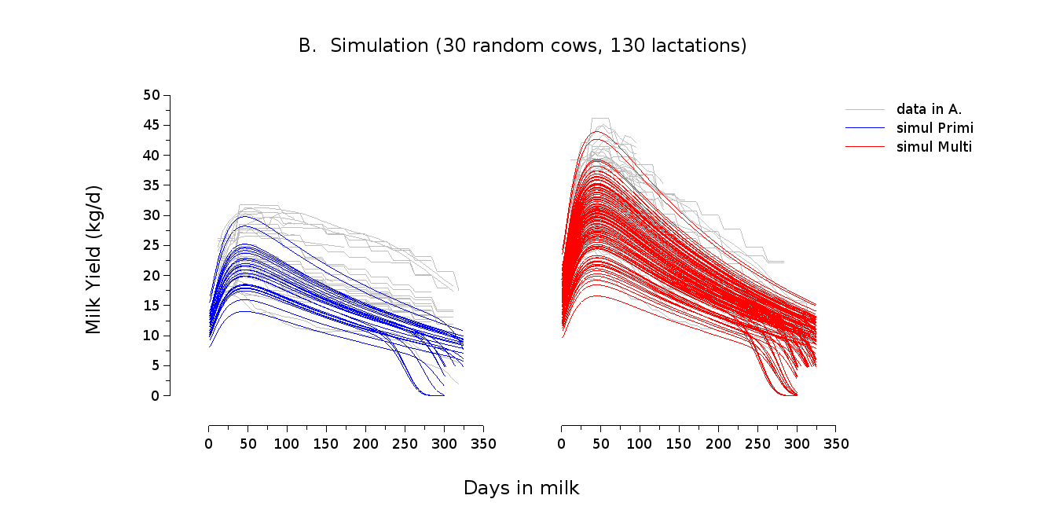

Figure S11 Milk Yield (MY, kg/d) dynamics over lactation according to parity. A: literature data in dairy cattle (37 references). B: Model simulation over 320 days in milk for 30 random individual cows from parity 1 to 5 (130 lactations).

Comment on Figure S11. Model simulations of MY over lactation are globally consistent with literature data, but the model underestimates MY in primiparous cows.
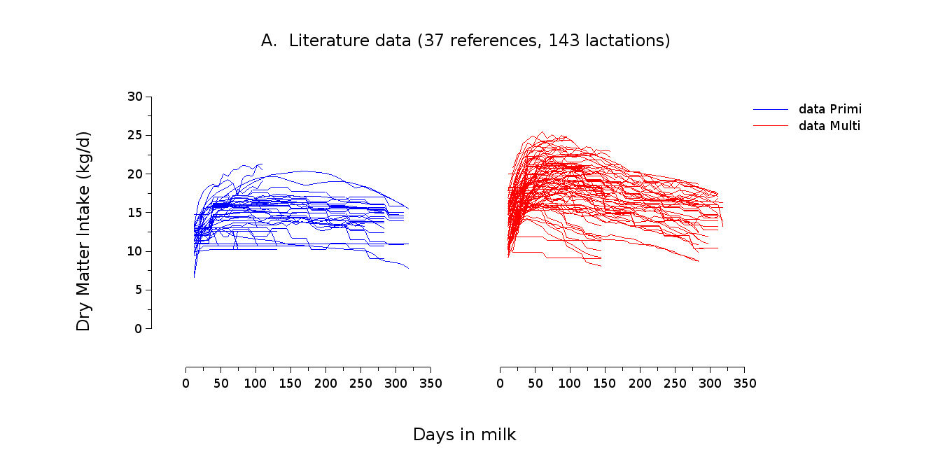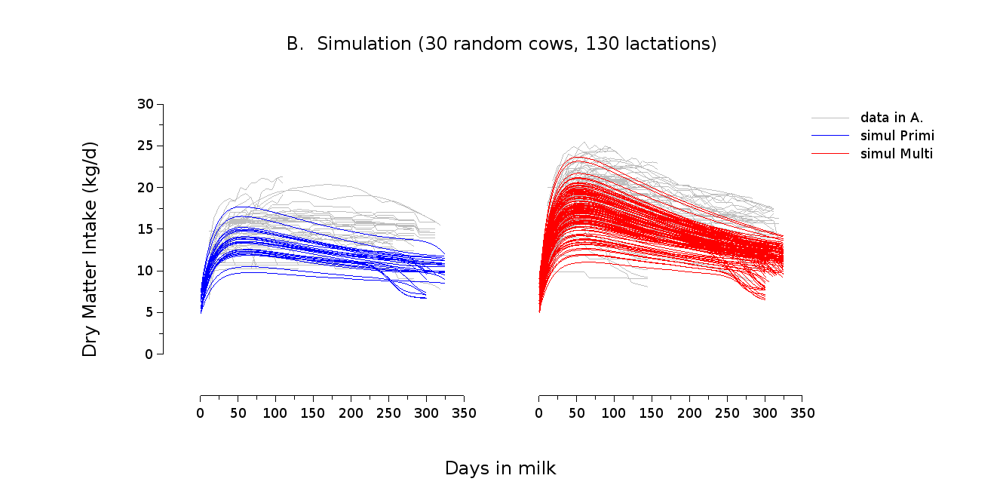

Figure S12 Dry Matter Intake (DMI, kg/d) dynamics over lactation according to parity. A: literature data in dairy cattle (37 references). B: Model simulation over 320 days in milk for 30 random individual cows from parity 1 to 5 (130 lactations).
Comment on Figure S12. The model underestimates DMI in primiparous cows, which is consistent with the underestimation of MY. Globally, the model slightly underestimates DMI which is consistent with the lower diet energy content in literature data (eD=11.3 MJ/kg DM) compared to simulations (eD=12.3 MJ/kg DM).
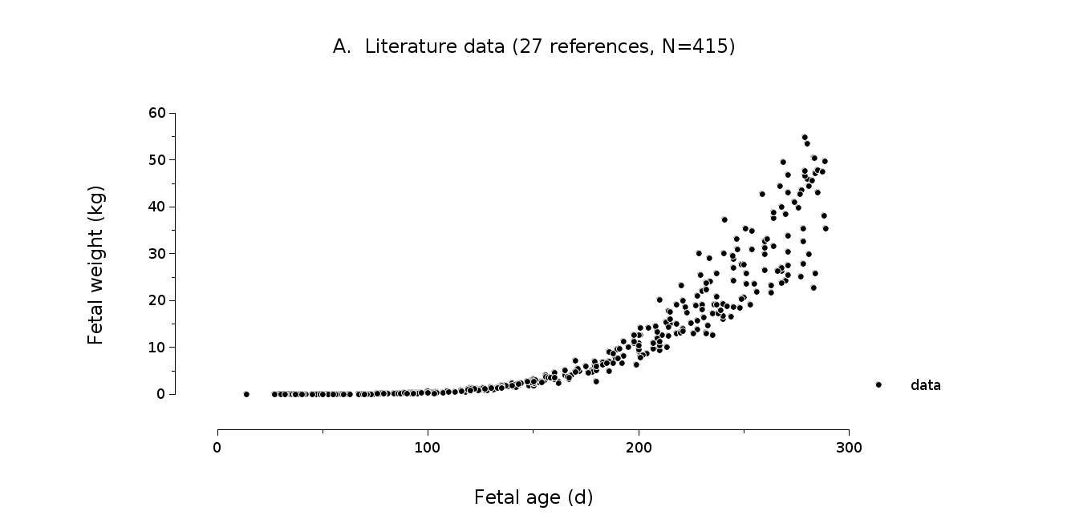
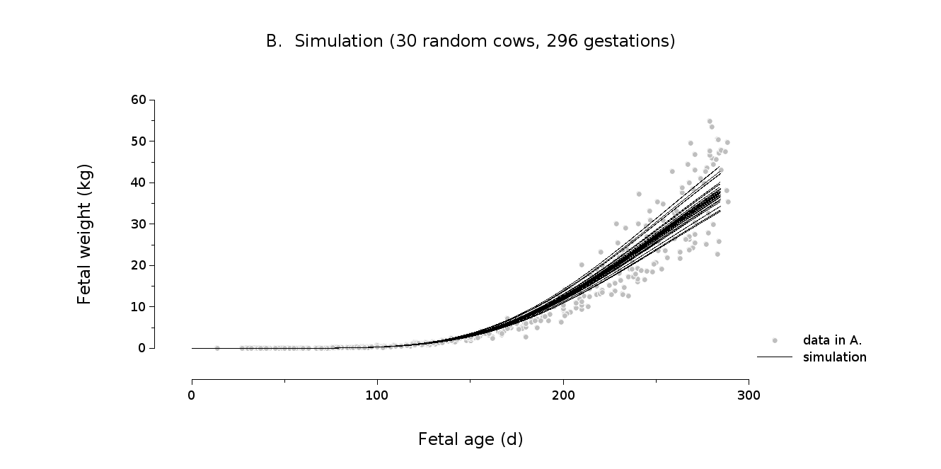

Figure S13 Fetal growth during gestation. A: literature data in dairy cattle (27 references). B: Model simulation for 30 random individual cows performing 296 gestations over 5000d-lifetime.

Comment on Figure S13. Model simulations of fetal growth are consistent with literature data.
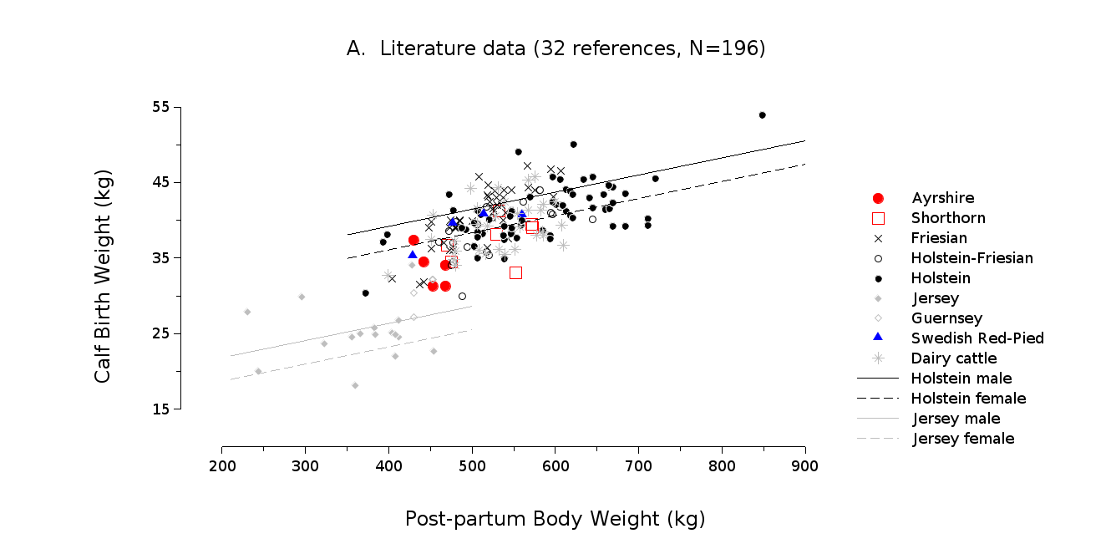
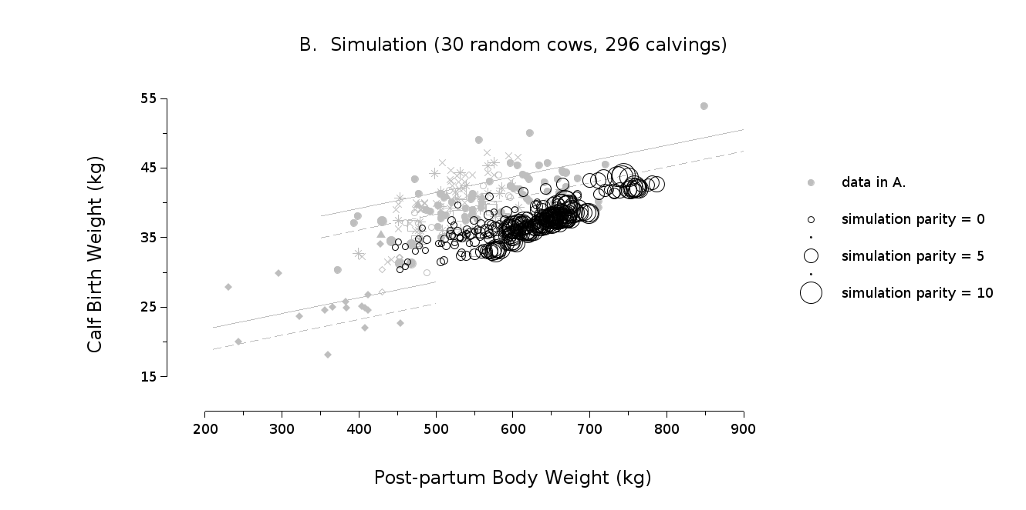

Figure S14 Relationship between Calf Birth Weight (kg) and Post-Partum BW (kg). A: literature data in dairy cattle (32 references). B: Model simulation for 30 random individual cows performing 296 calvings over 5000d-lifetime.

Comment on Figure S14. The model slightly underestimates calf birth weight.
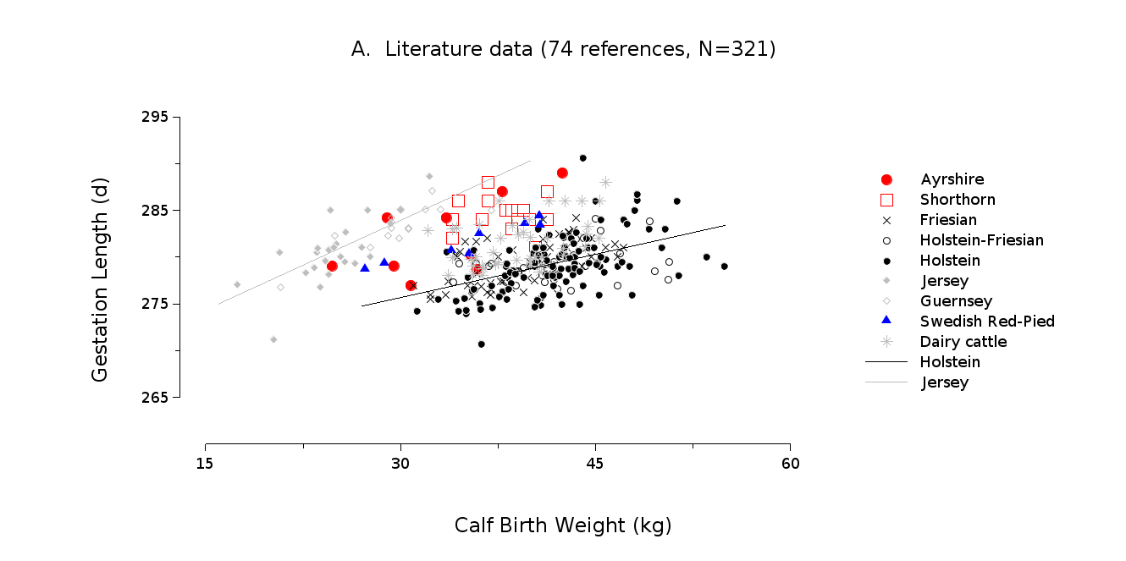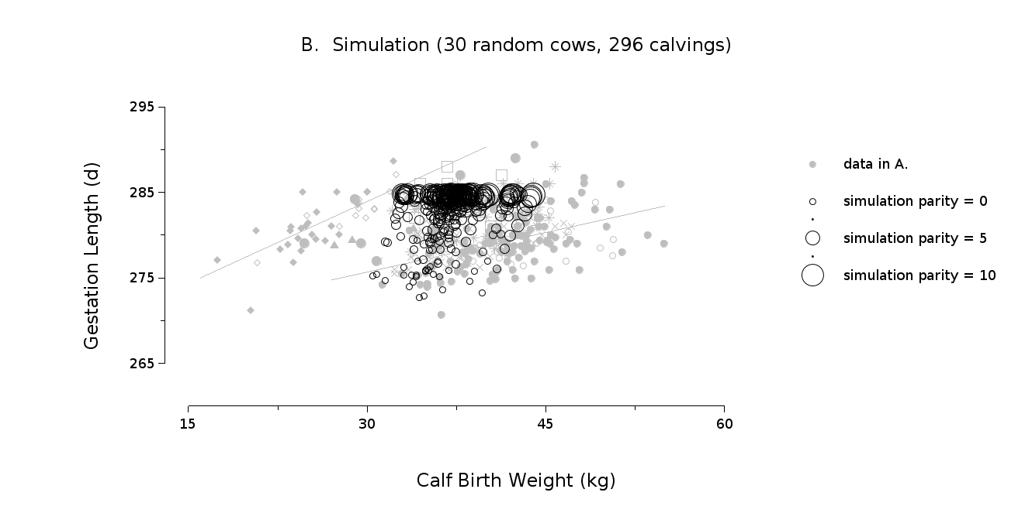
Figure S15 Relationship between Gestation Length (d) and Calf Birth Weight (kg). A: literature data in dairy cattle (74 references). B: Model simulation for 30 random individual cows performing 296 calvings over 5000d-lifetime.
Comment on Figure S15. Model simulations are in the range of literature data (Gestation lengths are limited to a theoretical value of 285 days in the model).
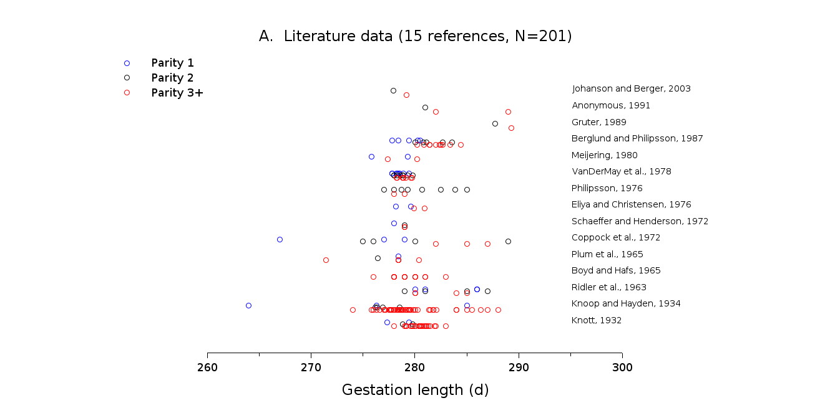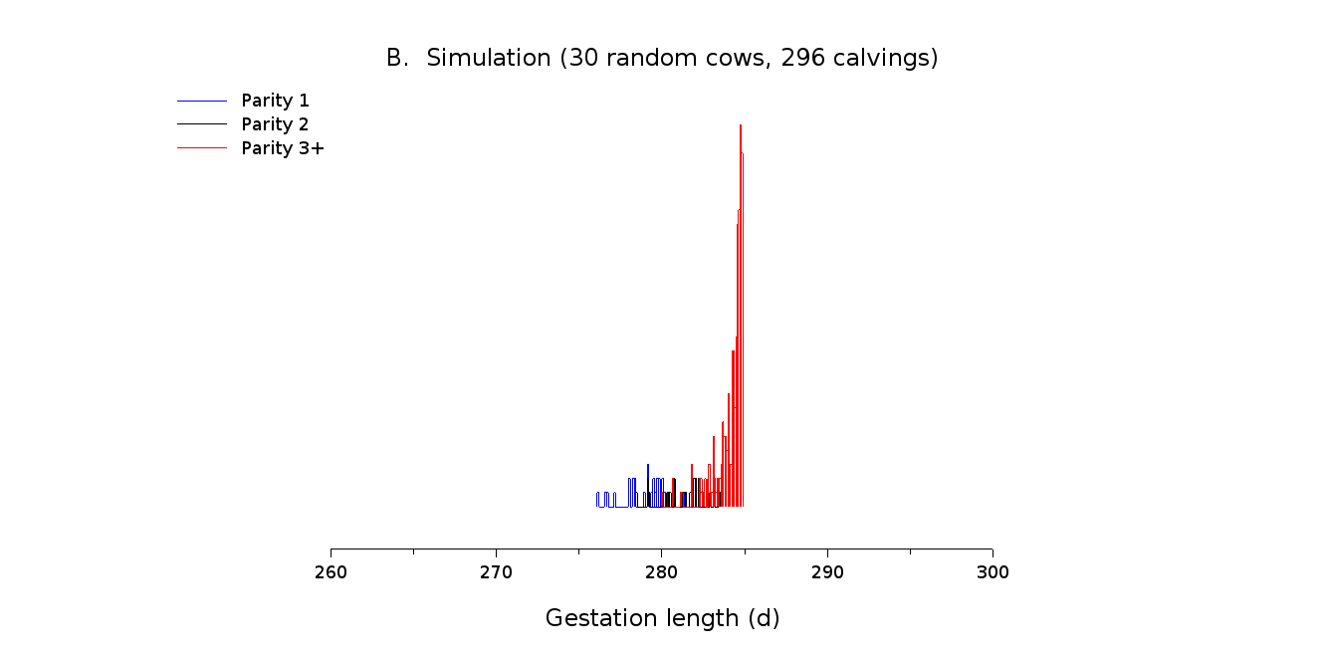

Figure S16 Gestation Length (d) according to parity. A: literature data in dairy cattle (15 references). B: Distribution of model simulation for 30 random individual cows performing 296 calvings over 5000d-lifetime.

Comment on Figure S16. Model simulations exhibit a lower gestation length in multiparous cows, which is a trend often observable within reference in literature data. (Gestation lengths are limited to a theoretical value of 285 days in the model)
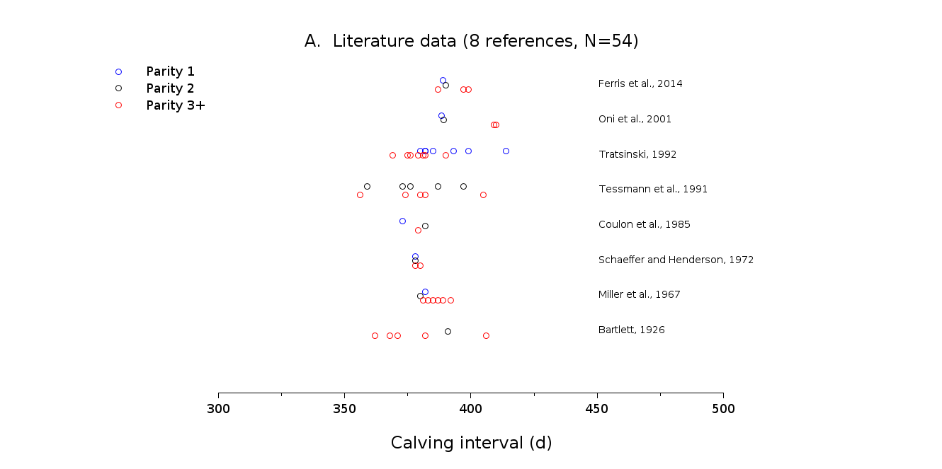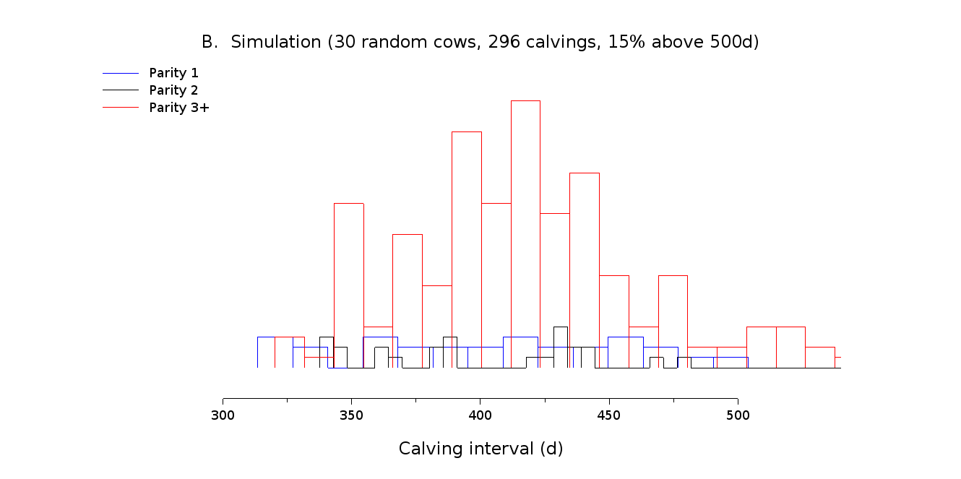

Figure S17 Calving interval (d) according to parity. A: literature data in dairy cattle (8 references). B: Distribution of model simulation for 30 random individual cows performing 296 calvings over 5000d-lifetime.

Comment on Figure S17. Model simulations exhibit longer calving interval as compare to literature data. Model simulations exhibit shorter intervals for primiparous cows than for multiparous cows, which is not clearly observable in literature data, but which is globally consistent with the tendency of alteration of fertility with age.
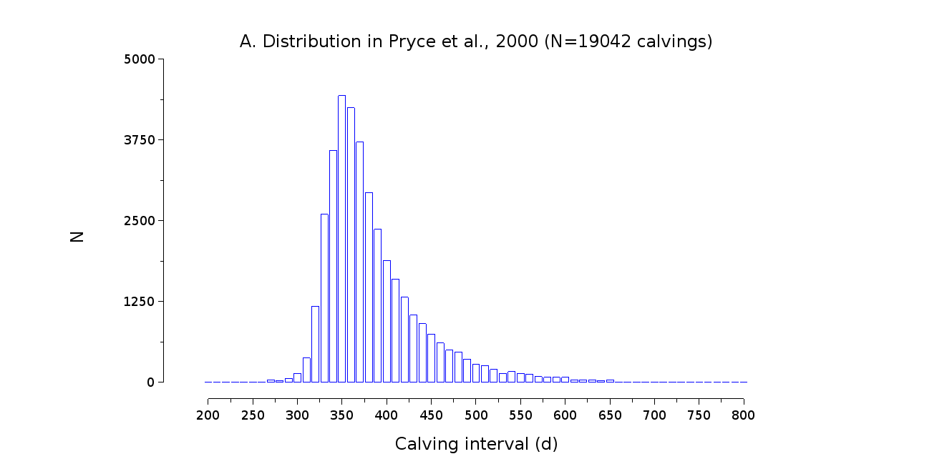
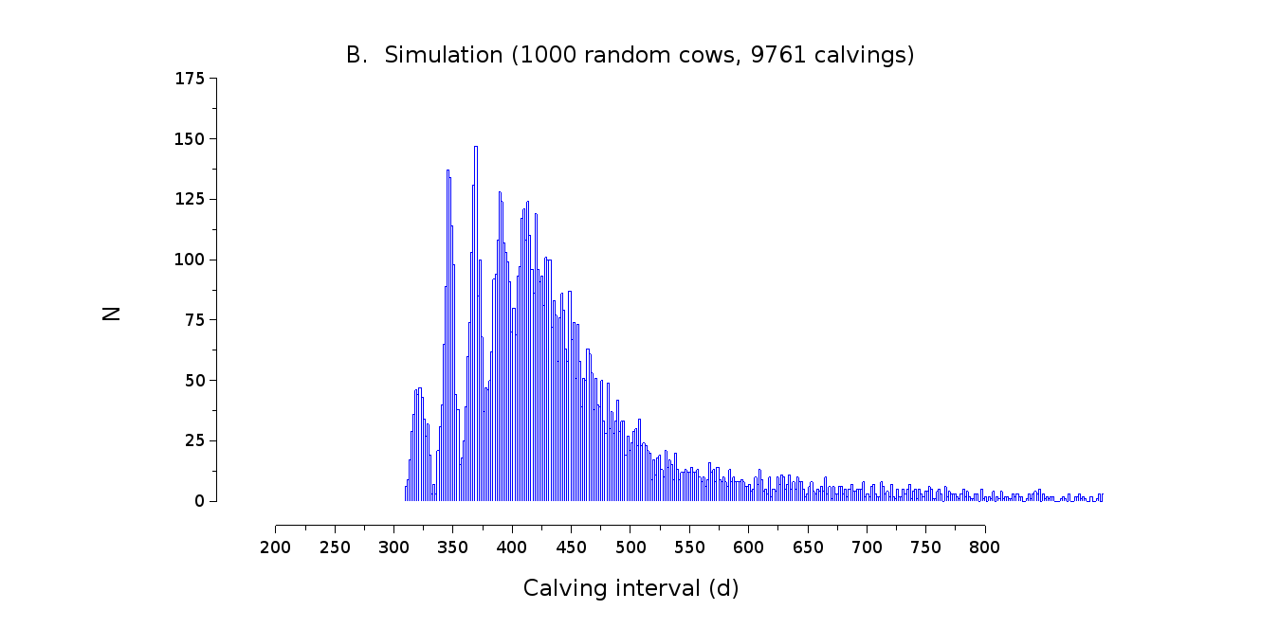

Figure S18 Distribution of calving interval (d). A: data in Pryce et al., 2000 (N = 19042 calvings). B: Distribution of model simulation for 1000 random individual cows performing 9761 calvings over 5000d-lifetime.

Comment on Figure S18. Model simulations exhibit a globally consistent distribution but longer calving interval as compare to this dataset. Model simulations exhibit a pattern with a series of approximatively 21d-spaced peaks. This emergent result is consistent with the cyclic nature of the model. This pattern is the trace the number of estrous cycles before cows get pregnant. The model also exhibit an extended occurrence of rare events of very long calving intervals more pronounced than in the dataset.
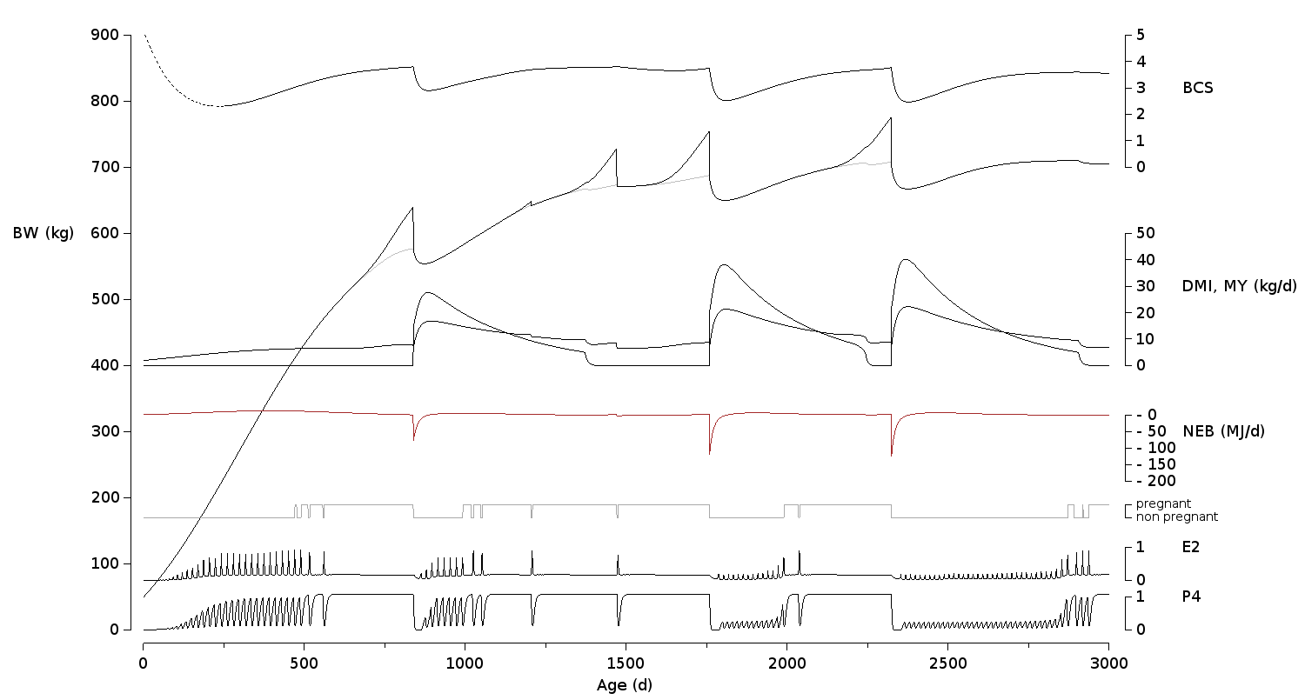
Figure S19 Model simulation (BW, BCS: Body Condition Score, DMI: Dry matter intake, MY: Milk Yield, NEB: Net Energy Balance, E2: Estradiol, P4: Progesterone) over 3000d lifetime for the individual cow with highest calving interval (mean calving interval of 795±199 days; 3 calvings).

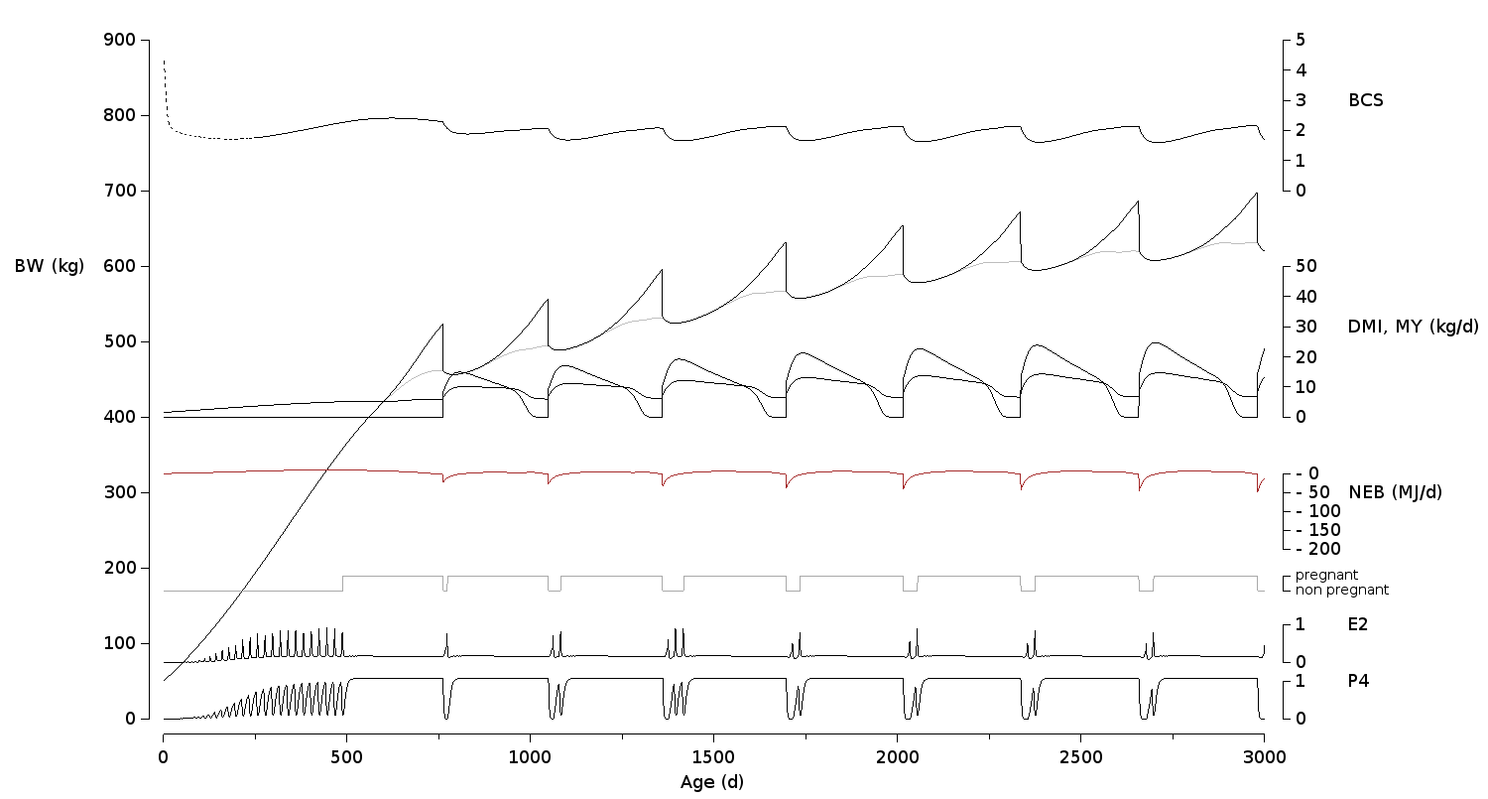
Figure S20 Model simulation (BW, BCS: Body Condition Score, DMI: Dry matter intake, MY: Milk Yield, NEB: Net Energy Balance, E2: Estradiol, P4: Progesterone) over 3000d lifetime for the individual cow with lowest calving interval (mean calving interval of 318±14 days ; 8 calvings).

Material S1 Farm management

Introduction
As described in the paper, the simulation model simulates multiple individual cows to create a herd. To be able to regulate the herd dynamically through time, it is necessary to define a set of herd management rules (what is the voluntary waiting period, what method of estrous detection is used, etc.). Since these rules are likely to differ between farms, a specific language was written to be able to model farmers’ decisions. The language is based on TCA: a formalism that defines links between Triggers, Conditions and Actions. In this formalism, a set of conditions is checked when something happens (i.e., a trigger occurs). If all conditions are true, specific actions are performed. As TCA may model any decision making process, a language specific to farm management was defined to model the farmers’ decisions and actions.
A configuration file is used to describe the different pieces of code that can be adjusted to simulate a specific farm.

Farm System Model (FSM)

Initialization
The init block (Textbox 1) defines the parameters of the simulators. Begin_date and end_date define the range of the simulation. Dates must be written as year-month-day hours:minutes:seconds. Note that the time system is monotonous, and never uses daylight saving time.

init{
name = simulation_test #usefull for tracking only (can be omitted)
output_db = out/test.sqlite3 #path to the output database
begin_date = 2015-01-01 00:00:00 #yyyy-mm-dd hh:mm:ss
end_date = 2020-01-01 00:00:00 #yyyy-mm-dd hh:mm:ss
}
Textbox 1 Example of init{ } code block for initialization.

States
Cows can be assigned to user defined states (i.e., groups of cows) with the state block (Textbox 2). By default, the program defines the states herd, heifers and not_heifers. Individuals are automatically added/removed from these states at the appropriate time. Herd contains all cows, heifers contains all cows that have never had a parturition, and not_heifers all the cows that already had at least one calving.
A cow can be moved from a state xxx to an other state yyy, with the action move xxx yyy. If the cow is not originally in xxx, the action move is not performed. A cow can be added to a state xxx with the action state_add xxx, and removed from a state xxx with the action state_delete xxx.
When a cow is added to a state xxx where she doesn’t belong, enter xxx is triggered. When a cow is removed from a state she’s in, the action quit xxx is triggered.
Whether a cow is currently in state xxx is checked with the condition is_in xxx.

state{
state = a_group_name
state = an_other_name
}
Textbox 2 Example of state{ } code block to define groups of cows.

Insemination breed
Breeds of semen used for insemination must be declared in a breed block (Textbox 3). Such breeds are used later to define insemination methods and to check the condition is_breed. A breed block can contain any number of breeds.

breed{
breed = pure
breed = crossed
}
Textbox 3 Example of breed{ } code block to define breed of semen.

Insemination method
Different insemination methods (e.g., bull, artificial insemination with regular semen, artificial insemination with sexed semen) influence the chance of an insemination being successful through differences in sperm quality. Therefore, insemination methods including sperm quality and ratio of female spermatozoa needs to be defined (Textbox 4).

insemination_method{
name =my_insemination
breed=xx # optional, default = "unknown"
sperm_quality = 0.9 # default = 1
female_ratio = 0.5 # 0.5 for regular, 0.9 for sexed semen
}
Textbox 4 Example of insemination_method{ } code block.

The sperm quality is multiplied with the probability of insemination success as computed by the reproduction model to decide whether an insemination is successful. Therefore, a sperm quality of 0 will never be successful, and a quality of 1 means successful only if the other variables in reproduction are favorable.
Insemination methods can be mixed within the herd (e.g., sexed semen in 10% of the cows, and regular semen in the other 90%). Proportions can be defined with the insemination_proportions block code (Textbox 5).

insemination_proportions{
name =my_insemination
#AInumber method proportion
proportion = 1 aaa 0.9
proportion = 1 xxx 0.1
proportion = 2 yyy 1.0
}
Textbox 5 Example of insemination_proportions{ } code block.

The insemination_proportion table is used in the same way insemination_method is, by referencing its name. The number in the proportion line defines the AI number (1 for first AI, this number is reset at parturition). Method is the name of the previously defined insemination method, and proportion defines how often this method is used for this AI number.
Note that when the AI number is higher than the maximum number defined in this table, we use the maximum number defined, for example, AI number 3 will automatically be inseminated with yyy.

Feeding method
Feeding methods are defined by setting an energy density (input parameter e_{D} in MJ/kg DM). Any number of feeding_method can be defined by duplicating the example block (Textbox 6). Feeding methods are used with the action change_food xxx, where xxx is a feeding method name.

feeding_method{
name = standard_diet
eD = 12.3 # default energy density in MJ/kg DM
}
Textbox 6 Example of feeding_method{ } code block.

Estrous Behavior Model (EBM)
The Estrous Behavior Model generates and provides observed_estrous events to the Farm System Model (FSM). True observed_estrous events are generated from the estradiol (E2) curve provided by the Reproductive Function Model (RFM). False observed_estrous events are generated randomly. From the point of view of FSM, true and false observed_estrous cannot be distinguished. The estrous detection methods are configured in an estrous_detection_method block (Textbox 7).

estrous_detection_method{
name=watch_cow

#estradiol is transformed to an expression using a sigmoid function
expression_threshold=0.75; #default 0.75
expression_stiffness=7; #default 7

#When do we observe oestruses
#Expression outside a time slice is considered as null
time_slice = 08:00:00 09:00:00 #observation times : from 08am to 09 am
time_slice = 16:00:00 17:30:00 #observation times : from 04pm to 05:30pm

#When we decide that expression is strong enough
detection_threshold=0.104 #1.0*(2.5/24), as we observe 2.5 hours.

#then, the estrus is truly detected with a chance of
sensitivity = 0.95;

#Independently, an average of wrong_estrus_per_day are generated
wrong_estrus_per_day = 0.002;
}
Textbox 7 Example of estrous_detection_method{ } code block.

Generating true observed_estrous
From E2 to estrous_expression. EBM receives an E2 value from RFM every 15 minutes. This value is converted to an estrous expression by applying a sigmoid function to it (Figure S21). From a biological point of view this can be seen as a smooth threshold function: low E2 values leads to no expression, while high E2 values leads to strong expression.
The sigmoid curve can be parametrized by changing the expression_threshold and expression_stiffness parameters of the estrous_detection_method.

From estrous_expression to observed_expression. Some estrous detection methods like accelerometers work all day long, some others, like visual detection, work only during predefined periods. To define when expression is actually observed, we define observation time slices. The observed expression is equal to estrous_expression when in a time slice, and to 0 outside the slice.
Time slices can be configured by writing time_slice=hh:mm:ss hh:mm:ss lines in the estrous_detection_method block.

From observed_expression to potential_observed_estrous. The farmer concludes that there is an estrous if he observes many weak expression signs in a small time period, or a single strong sign. This is modeled by storing the history of observed_expressions, and multiplying the observed_expression by a time dependent function called the memory_function (Figure S22 ). The older the observed_expression is, the lower the memory_function is. The memory function is forced to 0 for observed_expression older than 48 hours, linearly increases between 48 hours to 24 hours, and is equal to 1 for observed_expression no older than 24 hours.
Then observed_expression*memory_function is integrated through time from 48 hours ago to current time. The result of this integral describes how strongly the decision maker (farmer, accelerometer algorithms, …) believes that there is an estrous. When this value is above the detection_threshold, there is a potential_observed_estrous. As this value may stay high for a while, the estrous detection model will not generate any new potential_observed_estrous during 10 days. Note that the detection_threshold has to be adjusted according to time_slices.

From potential_observed_estrous to observed_estrous. A potential estrous has a probability of sensitivity of being detected. When detected, the observed_estrous event is triggered by the model. When not detected, a missed_estrous event is triggered. This last event is never seen by the farmer, and is useful only for logging and diagnosis.

Generating false observed_estrous
An independent model randomly generates false observed_estrous events with an average of wrong_oestrus_per_day. Note that this model is totally independent of the true observed_estrous models, and will therefore ignore time_slices.
When no estrous detection method is used, no false observed_estrous is generated.
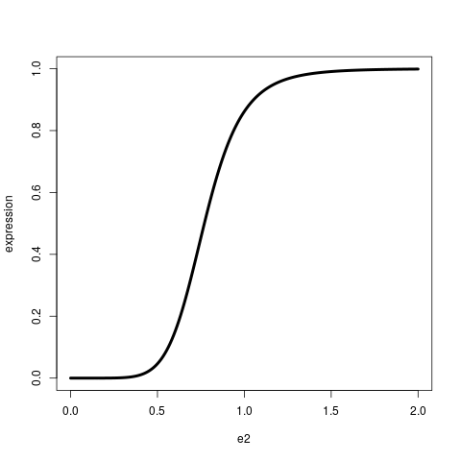
Figure S21 Dairy cow Estrous Behavior Model (EBM): estrous expression function.
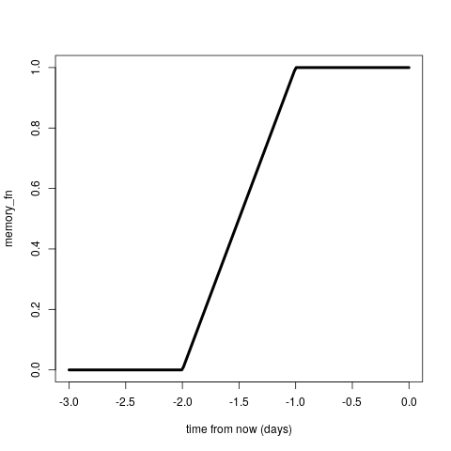
Figure S22 Dairy cow Estrous Behavior Model (EBM): memory function.

Triggers, conditions and actions

Triggers

Predefined triggers are already defined for the model, and the model triggers them at the appropriate timing for each cow (Table S6 ).

Custom delay triggers. Delays are generated some days after the after_trigger trigger (Textbox 8). They simply pass the original message, to the right destination, but at a later moment in time. They can therefore be mixed with the same kind of actions and conditions as the ones compatible with the after_trigger trigger.

trigger{
type = delay
name = 12h_later
after_trigger = an_other_trigger
duration = 0.5 #0.5days
}
Textbox 8 Example of trigger{ } code block with custom delay.

Custom chron triggers. Chron triggers are broadcasted to all cows in a state according to a time scheme. A time scheme is a date, in format yyyy-mm-dd hh:mm:mm, where some digits can be replaced by * to indicate ‘every’. For example, every 3rd of the month at 8h00 is *-*-03 08:00:00.

trigger{
type = chron
name = every_day
state = xxx #broadcast this trigger to all cow in this state
scheme = *-*-* 08:00:00 #every day at 08h00
}
Textbox 9 Example trigger{ } code block with custom time scheme.

Conditions

Conditions are used to test something, for instance the age of a cow, the sex of a newborn calf or the size of the herd. For each defined condition xxx, not xxx, defines the opposite condition. Threshold conditions allow to compare a variable of a cow (i.e., type = one cow) to a threshold. These conditions are expressed as: a_variable op value, where a_variable is the variable to check, op an operator (>, <, >=, <= , ==) and value any number. Missing values (i.e., NaN : Not a Number) always return false for all conditions they are used for.
Triggers, conditions and actions are associated by writing links (Textbox 10). When any trigger occurs, all conditions are checked. If all of them are true, all actions are performed.

#Example : remove non pregnant heifers older than 600 days
link{
trigger = every_day
condition = is_in heifers
condition = age >= 600
condition = not_pregnant
action = delete_cow
}
Textbox 10 Example of link{ } code block.

Predefined conditions are already defined in the program (Table S7 ). Like all conditions, they are tested when the associated trigger occurs. Note that the type of the trigger has to be compatible with the type of the condition. The main variables that can be used in threshold conditions are given in Table S8 .

Actions
The list of predefined actions performed by the model is given in Table S9.

Mix compatible triggers, conditions and actions

When a trigger occurs, it generates a message that is passed to the conditions and the actions. In order to write links that make sense, compatible messages must be used. For example the triggers of type one cow will generate a message that includes a cow_id. This cow_id is required by the conditions that check something on the cow and by the actions that perform something on this cow.

Some conditions and actions noted by a type doesn't read any message, and can therefore be linked to any trigger. Nevertheless, even if the code should work they probably make sense only in a particular context. This is the case, for example, for the actions buy_cow and buy_calf that should be associated to the trigger init, but that can be written anywhere.

Table S6 Farm System Model (FSM): Predefined triggers
Trigger | Type | Definition
Initialization
Init | Init | Triggered at start of simulation
Reproduction
Conception | one cow | Triggered when an insemination is successful
Parturition | one cow | Triggered when a viable calf is born
Abortion | one cow | Triggered when an embryo or fetus is lost
Mature | one cow | Triggered when the cow is sexually mature and starts cycling
Insemination | one cow | Triggered when the cow is inseminated
Estrous | one cow | Triggered when an estrous is observed. This event is triggered only if the estrous is strong enough to be inseminated
Milk production
start_milking | one cow | Triggered when milking starts
stop_milking | one cow | Triggered when milking stops
States
enter xxx | one cow | Triggered when a cow is added to the state xxx, if the cow is not already in the state xxx
quit xxx | one cow | Triggered when a cow is removed from the state xxx, if the cow is already in the state xxx
Miscellaneous
Death | one cow | Triggered when the cow dies
Calving | newborn calf | Triggered when a viable calf is born

Table S7 Farm System Model (FSM): Predefined conditions
Condition | Type | Help
States
is_in xxx | one cow | True if the cow is in state xxx, false otherwise
state_size xxx >= 45 | any | Compare the number of animals in state xxx to a number. Valid comparaison operators are <, >, <=, >=. Note that they must be separated from text with spaces
Cow status
is_pregnant | one cow | True if the cow is pregnant. Pregnancy starts at conception, and finishes at abortion or parturition
is_mature | one cow | True if the cow is sexually mature (and is therefore cycling)
is_milking | one cow | True if the cow is milked (i.e., tracks start_milking and stop_milking)
a_variable >= 45 | one cow | Compare to threshold
Calf status
calf_breed xxx yyy | newborn calf | True if the semen used to produce this calf was of breed xxx, or yyy
calf_sex xxx | newborn calf | True if the calf has the required sex (xxx is male or female). This condition makes sense only with the calving trigger. Note that males are never added to the herd, they disappear just after calving

Table S8 Farm System Model (FSM): Variables
Variable | Help
num_cycle | Cycle number. This number is reset at parturition
parity | Heifers have parity = 0. Primiparous have parity = 1, etc.  Parity increases by one at parturition
num_insemination | Insemination number. This number is set to 0 at parturition
milk_yield | Milk yield in kg/day. As low milk yields may happen before and after the peak, this condition is combined with a condition on the day from calving to detect the end of lactation
body_weight | Body weight in kg
body_condition_score  (or bcs) | 0 is the lowest score, 5 the highest one. Values out of the 0-5 range mean that the energy density of the ration is too far from a realistic cow ration
days_after_calving  (or dim) | This value is NaN for heifers. Starts at calving, set to 0 at parturition. Abortions are not considered as calving, and therefore do not change this value
days_in_pregnancy  (or dip) | This value is NaN when not pregnant. Start at conception, set to NaN at parturition
days_after conception | This value is NaN before the first conception. Starts at conception, set to 0 at conception
age | Age is in days after birth

Table S9 Farm System Model (FSM): Predefined actions
Action | Argument | Type | Help
Estrous detection
estrous_start | xxx | one cow | Start detecting oestrous using the xxx method (see estrous_detection_method)
estrous_stop | - | one cow | Stop detecting oestrous
Reproduction
inseminate | xxx | one cow | Inseminate the cow with an insemination method named xxx (see insemination_method) or according to insemination proportions (see insemination_proportions)
force_conception | breed_name  female_ratio | one cow | Generate a successful conception, as if the cow was inseminated with breed_xxx (see breed) with a female ratio of female_ratio (i.e., a number between 0 for all males, and 1 for all females)
Milking
start_milking | - | one cow | Start milking
stop_milking | - | one cow | Stop milking (with condition = is_milking)
Feeding
change_food | xxx | one cow | Change the current food to xxx (see feeding_method)
Population management
buy_cow | calf_breed  female_ratio  cow_age  dfc  cow_days_in_pregnancy  num_cows | any | Buy cows  - calf_breed is the breed of the semen used to inseminate this cow (see breed)  - female_ratio is the sex ratio of the semen used to inseminate this cow  - cow_age is the age of this cow in days from birth  - dfc is the number of days from conception of this cow, if the cow is not pregnant, write no_conception instead  - cow_days_in_pregnancy is the number of days in pregnancy of this cow  - num_cow is the number of cow to buy
buy_calf | calf_breed  number | any, init | Buy number of female calves of breed calf_breed (see breed ).
delete_cow | info | one cow | Delete this cow, info can be any message that has to be logged
delete_calf | info | newborn calf | Delete this calf, info can be any message that has to be logged. This action only makes sense with the calving trigger
Log
log | info | one cow | Log info to the default logger (here standard output)
log_cout | info | one cow | Log info to the standard output
log_db | info | one cow | Log info to the database

Eckles, 1920; McCandlish, 1922; Bartlett, 1926a; Bartlett, 1926b; Espe et al., 1932; Ragsdale, 1934; Hilder and Fohrman, 1949; Ellenberger et al., 1950; Reid et al., 1951; Campbell an Flux, 1952; Matthews and Fohrman, 1954; Davis and Hathaway, 1956; Morrison, 1956; Burt, 1957; Davis, 1957; Crichton et al., 1959; Crichton et al., 1960; Swanson, 1960; Martin et al., 1962; Wickersham and Schultz, 1963; Swanson and Hinton, 1964; Bath et al., 1965; McDaniel and Legates, 1965; Miller et al., 1967; Swanson, 1967; Hollon et al., 1972; Rakes and Davenport, 1972; Lamb and Barker, 1975; Grieve et al., 1976; Berglund et al., 1980; Herland and Wiktorsson, 1982; Lee et al., 1982; Fisher et al., 1983; Lebengarts et al, 1984; Butler-Hogg et al., 1985; Lin et al., 1985; Reddy and Basu, 1986; Ribas and Ponce de Leon, 1986; Heinrichs and Hargrove, 1987; Johnson et al., 1987; Pikina, 1987; Polyakov et al., 1987; Singh and Bath, 1987; Hocking et al., 1988; Moore et al., 1990; Akbulut et al., 1993; Berg and Ekern, 1993; Grabowski et al., 1993; Peri et al., 1993; Andrew et al., 1994; Dhour et al., 1995; Groen and Vos, 1995; Hoffman et al., 1996; Koenen and Groen, 1996; Kunzi et al., 1996; Colburn et al., 1997; Hoffman, 1997; Kertz et al., 1998; Vacek et al., 1999; Freetly et al., 2000
Waltner et al., 1993; Hoffman, 1997; Kertz et al., 1997; Van Amburgh et al., 1998; Drame et al., 1999; Abeni et al., 2000; Koenen et al., 2001; Mao et al., 2004; Shamay et al., 2005; Berry et al., 2006.
Broster et al., 1969; Broster et al., 1975; Cowan, 1970; Decaen, 1970; DePeters, 1985; DePeters, 1989; Everson et al., 1976; Garnsworthy and Topps, 1982; Holter et al., 1982; Holter et al., 1984; Holter et al., 1992; Holter et al., 1993; Johnson, 1977; Johnson, 1979; Johnson, 1983; Kertz et al., 1991; Kronfeld et al., 1980; Krohn et al., 1983; Llahr et al.,1983; Lodge et al., 1975; Mohrenweiser and Donker, 1967; Ostersen et al., 1997; Pinchasov et al., 1982; Rook and Campling, 1965; Soder and Holden, 1999; Staples et al., 1990; Swanson, 1967; Taylor and Leaver, 1984a; 1984b; Tolkamp et al., 1998; Vérité and Journet, 1977; Wallace, 1959; Wiktorsson, 1971; Wiktorsson, 1973; Wohlt and Clark, 1978; Wohlt et al., 1991.
Broster et al., 1969; Broster et al., 1975; Cowan, 1970; Decaen, 1970; DePeters, 1985; DePeters, 1989; Everson et al., 1976; Garnsworthy and Topps, 1982; Holter et al., 1982; Holter et al., 1984; Holter et al., 1992; Holter et al., 1993; Johnson, 1977; Johnson, 1979; Johnson, 1983; Kertz et al., 1991; Kronfeld et al., 1980; Krohn et al., 1983; Llahr et al.,1983; Lodge et al., 1975; Mohrenweiser and Donker, 1967; Ostersen et al., 1997; Pinchasov et al., 1982; Rook and Campling, 1965; Soder and Holden, 1999; Staples et al., 1990; Swanson, 1967; Taylor and Leaver, 1984a; 1984b; Tolkamp et al., 1998; Vérité and Journet, 1977; Wallace, 1959; Wiktorsson, 1971; Wiktorsson, 1973; Wohlt and Clark, 1978; Wohlt et al., 1991.
Broster et al., 1969; Broster et al., 1975; Cowan, 1970; Decaen, 1970; DePeters, 1985; DePeters, 1989; Everson et al., 1976; Garnsworthy and Topps, 1982; Holter et al., 1982; Holter et al., 1984; Holter et al., 1992; Holter et al., 1993; Johnson, 1977; Johnson, 1979; Johnson, 1983; Kertz et al., 1991; Kronfeld et al., 1980; Krohn et al., 1983; Llahr et al.,1983; Lodge et al., 1975; Mohrenweiser and Donker, 1967; Ostersen et al., 1997; Pinchasov et al., 1982; Rook and Campling, 1965; Soder and Holden, 1999; Staples et al., 1990; Swanson, 1967; Taylor and Leaver, 1984a; 1984b; Tolkamp et al., 1998; Vérité and Journet, 1977; Wallace, 1959; Wiktorsson, 1971; Wiktorsson, 1973; Wohlt and Clark, 1978; Wohlt et al., 1991.
Buchem, 1909; Bergmann, 1921; Hammond, 1927; Esskuchen, 1931; Swett et al., 1937; Hatch et al., 1941; Winters et al., 1942; Nichols, 1944; Swett et al., 1948; Ellenberger et al., 1950; Becker et al., 1951; Melton et al., 1951; Mäkelä, 1956; Joubert et Van Marle, 1959; Lyne, 1960; Hubbert et al., 1972; Ferrell et al., 1976; Eley et al., 1977; Chew et al., 1979; Anthony et al., 1986; Sultan et al., 1987; Bellows et al., 1990; Reynolds et al., 1990; Ferrell, 1991; House and Bell, 1993; Okano, 1994; Zhang et al., 1999.
.Eckles, 1916; Henry and Morrison, 1917; Eckles, 1919; Fitch et al., 1924; Joubert and Van Marle, 1959; Ridler et al., 1963; Wickersham and Schultz, 1963; Swanson and Hinton, 1964; Broster and Tuck, 1967; Gleeson, 1973; Lodge et al., 1975; Yadava et al., 1976; Gardner et al., 1977; Heitzman et al., 1979; Huth and Schmidt, 1979; Østergaard, 1979; Erb et al., 1981; Laird et al., 1981; Collier et al., 1982; Holter et al., 1986; Berglund and Philipsson, 1987; Stelwagen and Grieve, 1992; Kume and Bicoku, 1993; Lacasse et al., 1993; Troccon, 1993; Moore, 1994; Troccon et al., 1994; Kertz et al., 1997; Hansen et al., 1999; Negash, 1999; Keady et al., 2001; Johanson and Berger, 2003.
.Eckles, 1919; Fitch et al., 1924; Dinkhauser et al., 1944; Ellenberger et al., 1950; Brakel et al., 1952; Davis et al., 1954; Foote et al., 1959; Huth, 1962; Ridler et al., 1963; Andersen et al., 1965; Boyd and Hafs, 1965; Everett and Magee, 1965; Touchberry and Bereskin, 1966; DeTena Andreu, 1973; Romita, 1973; Beardsley et al., 1974; Gianola and Tyler, 1974; Hocking, 1974; Koubek, 1974; Muller and Owens, 1974; Oldenbroek, 1974; Anonymous, 1975; Dijkstra et al., 1975; Beardsley et al., 1976; Eliya and Christensen, 1976; Guaragna et al., 1976; Manrique et al., 1976; Osinga and Ogink, 1976; Philipsson, 1976; Serrano et al., 1976; Laurijsen and Oldenbroek, 1977; Morgan, 1977; Everitt et al., 1978; Fisher and Williams, 1978; Gaillard, 1978; Martinez et al., 1978; Veris, 1978; Arbaban-Ghafouri, 1980; Egbunike and Togun, 1980; Gaillard, 1980; Lazarevic and Novakovic, 1980; Meijering, 1980; Chew et al., 1981; Erb et al., 1981; Gaillard, 1981; Leeuwen and Ziljstra, 1981; Little and Harrison, 1981b; Gaillard, 1982; Das et al., 1984; Oldenbroek, 1984; Bhuyan and Mishra, 1985; Oferrall et al., 1985; VonKorn and Langholz, 1985; Holter et al., 1986; Sang et al., 1986; Shin et al., 1986; Berglund and Philipsson, 1987; Eppard et al., 1987; Trilk et al., 1988; Gravert et al., 1990; Guilbault et al., 1990; Hagger and Hofer, 1990; Oferrall and Ryan, 1990; Rooy et al., 1990a; Rooy et al., 1990b; Anonymous, 1991; Rémond et al., 1991; KB-Mitteilungen, 1993; Troccon, 1993; Kojima, 1999; Zhang et al., 1999; Jacobsen et al., 2000; Perfield et al., 2002; Johanson and Berger, 2003.
. Knott, 1932; Knoop and Hayden, 1934; Ridler et al., 1963; Boyd and Hafs, 1965; Plum et al., 1965; Coppock et al., 1972; Schaeffer and Henderson, 1972; Eliya and Christensen, 1976; Philipsson, 1976; VanDerMay et al., 1978; Meijering, 1980; Berglund and Philipsson, 1987; Gruter, 1989; Anonymous, 1991; Johanson and Berger, 2003.
. Bartlett, 1926; Miller et al., 1967; Schaeffer and Henderson, 1972; Coulon et al., 1985; Tessmann et al., 1991; Tratsinski, 1992; Oni et al., 2001; Ferris et al., 2014.

