Nurse sow strategies in the domestic pig: I. Consequences for selected measures of sow welfare

O. Schmitt1,2; E.M. Baxter3; L.A. Boyle1; K. O'Driscoll¹.
Animal

Table S1 Scoring system for body lesions of the sows (Calderon-Diaz et al., 2014)
Score | Description
0 | No lesion
1 | 1 small (approximately 2 cm), superficial lesion
2 | more than 1 small or just 1 red (deeper than score 1) but still superficial lesion
3 | 1 or several big (2 to 5 cm) and deep lesions
4 | 1 very big (> 5 cm), deep, red lesion or many big, deep, red lesions
5 | Many very big, deep, red lesions.

Table S2 Scoring system for limb lesions of the sows (Koning, 1985; as modified by Boyle et al., 2000)
Score | Description
0 | Normal
1 | Alopecia (hair loss) or callus (thickening of the epidermis and atrophy of glands)
2 | Swellings (abnormal enlargement of a part of the body, typically as a result of an accumulation of fluid)
3 | Wounds (where the epidermis is interrupted but not ulcerated and with no evidence of secondary infection) or bursitis (acquired fluid-filled sac that develops in the subcutaneous connective tissue, usually on the hind legs below the point of the hock or on the lateral sides of the elbow)
4 | Severe wounds (these ulcerated lesions may or may not be accompanied by infection) or severe swellings (characterized by redness and swelling accompanied by heat and pain)
5 | severe wounds plus severe swellings.

Table S3 Scoring system for shoulder lesions of the sows (Ocepek et al., 2016)
Score | Description
0 | Healthy skin. No reddening or swelling.
1 | Initial stage. Mild lesions on the skin, including reddening or swelling or minor non-bleeding scratches/wounds (diameter < 2 cm)
2 | Moderate lesions. The wounds include the entire skin thickness and cause bleeding. Crusts are common (diameter 2-3 cm). The amount of granulation tissue is very moderate.
3 | Serious lesions. These lesions include subcutaneous tissue, but not bone. Swelling around the wound and production of granulation tissue are common (diameter 3-5 cm)
4 | Very serious lesions. Involve the scapula bone. The tissue around the lesion is thickened and often adherent to the underlying bone. Granulation tissue is common (diameter > 5 cm)
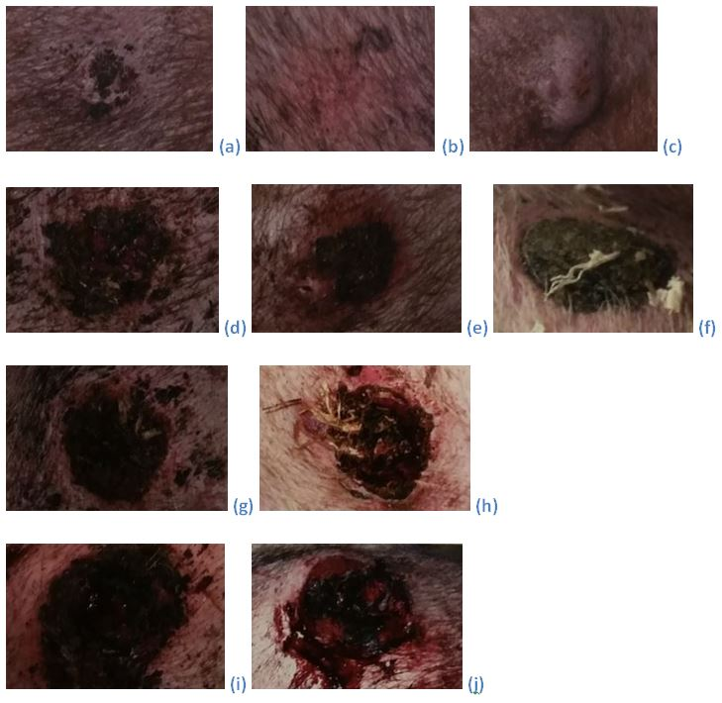
Figure S1 Sow shoulder lesions scoring system (Ocepek et al., 2016; pictures from Fredriksen et al., 2015). (a) to (c) = Score 1; (d) to (f) = Score 2; (g) and (h) = Score 3; (i) and (j) = Score 4

Table S4 Scoring system for locomotion of the sows (as per Calderon-Diaz et al., 2014; from Main et al., 2000)
Score | Description
0 | Even steps. Ability to accelerate and change direction
1 | Abnormal step length. Movements no longer fluent. Still able to accelerate and change direction
2 | Shortened steps. No hindrance in agility.
3 | Shortened steps, minimum weight bearing on the affected limb.
4 | May not place affected limb on the floor while moving
5 | Does not move

