Animal journal

Supplementary file

Temporary crate opening procedure affects immediate post-opening piglet mortality and sow behaviour
R.L. King¹, E.M. Baxter², S.M. Matheson¹ and S.A. Edwards¹

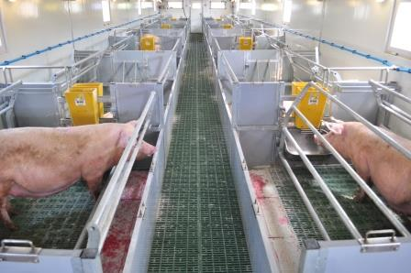
Supplementary Methods

Figure S1. Temporary sow confinement pens in the cabin arrangement, illustrating crates in both the open (left) and closed (right) position (image courtesy of EM Baxter).

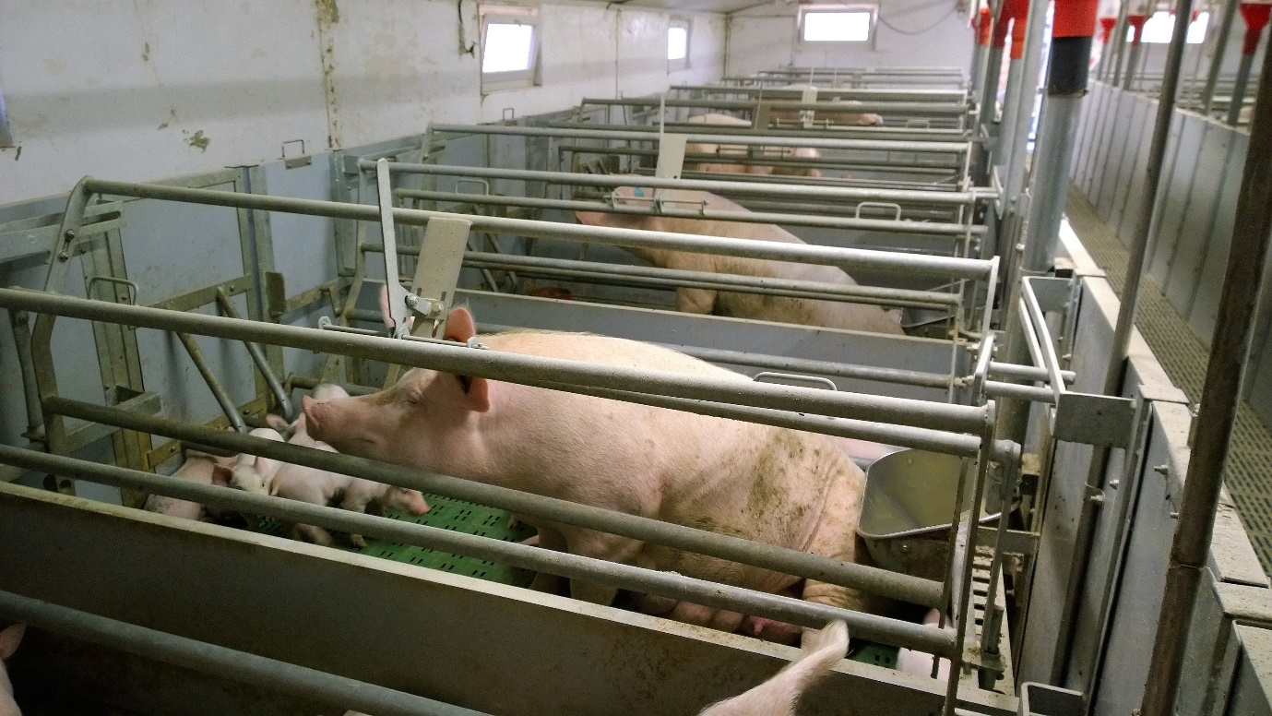
Figure S2. Temporary sow confinement pens in the room arrangement, illustrating crates in the open position, with the closest sows facing the rear of the pen (image courtesy of RL King).

Supplementary results
Supplementary Material S1. Results for average duration of sow posture changes.

Average duration of postures
Average bout duration of all postures by day and treatment are shown in Figure S2. Average duration of standing differed across days (P < 0.0001), being higher on the day of crate opening than the day before (P < 0.0001) or after (P < 0.001). Average duration of sitting was affected by treatment (P < 0.05), being higher for AM than both PM (P < 0.05) and ALL (P < 0.01). Average duration of ventral lying differed across days (P < 0.05), being higher on the day before than the day of crate opening (P = 0.01) and tending to be higher than the day after (P = 0.067).
Sow parity tended to affect the average duration of ventral lying (P < 0.069) and standing via a parity x day interaction (P = 0.059; Table S1). Average duration of ventral lying was lower for parity 1 sows (4.83mins ± 0.70) than parity 2-5 sows (6.28mins ± 0.61; P < 0.05) or parity 6+ sows (6.40mins ± 0.76; P = 0.058). Average duration of standing was increased on the day of crate opening than the day before or day after for parity 1 sows (before P < 0.0001; after P < 0.01) and parity 2-5 sows (before P < 0.001; after P < 0.01), but no different across days for parity 6+ sows. This meant that on the day of crate opening, average standing duration was lower for parity 6+ sows than both parity 1 sows (P < 0.01) and parity 2-5 sows (P = 0.057; Table S1).

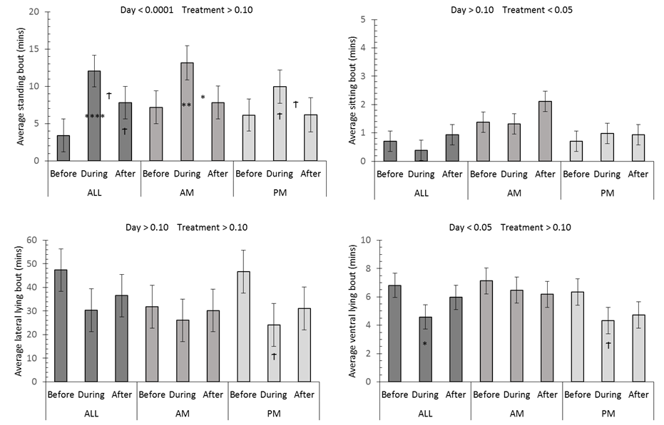
Figure S3. Least square means (± s.e.) for average duration of sow postures by day and crate opening treatment. Starting top left, clockwise: standing, sitting, ventral lying and lateral lying. Day effects within each treatment for Before-During and Before-After are indicated on the latter bar, with During-After differences indicated between bars ( ϯ(P < 0.10), *(P < 0.05), **(P < 0.01), ****(P < 0.0001)). Treatment effects within each day are indicated with different letters (P < 0.05).
A
B

Table S1. Least square means (± s.e.) of average sow standing bout duration (mins) by sow parity and day relative to crate opening.
Parity / Day | Before | During | After
1 | 4.35 ± 2.27ª | 15.23 ± 2.37^{b} | 8.10 ± 2.23ª
2-5 | 5.13 ± 2.01ª | 11.98 ± 2.07^{b} | 6.54 ± 1.96ª
6+ | 7.27 ± 2.23ª | 7.99 ± 2.26ª | 7.16 ± 2.25ª
^{a,b} Values within rows with different superscripts differ significantly (P < 0.05).

