Promising perspectives for ruminal protection of polyunsaturated fatty acids through polyphenol-oxidase-mediated cross-linking of interfacial protein in emulsions

Nympha De Neve, Bruno Vlaeminck, Frederik Gadeyne, Erik Claeys, Paul Van der Meeren, Veerle Fievez

Supplementary Figure S1
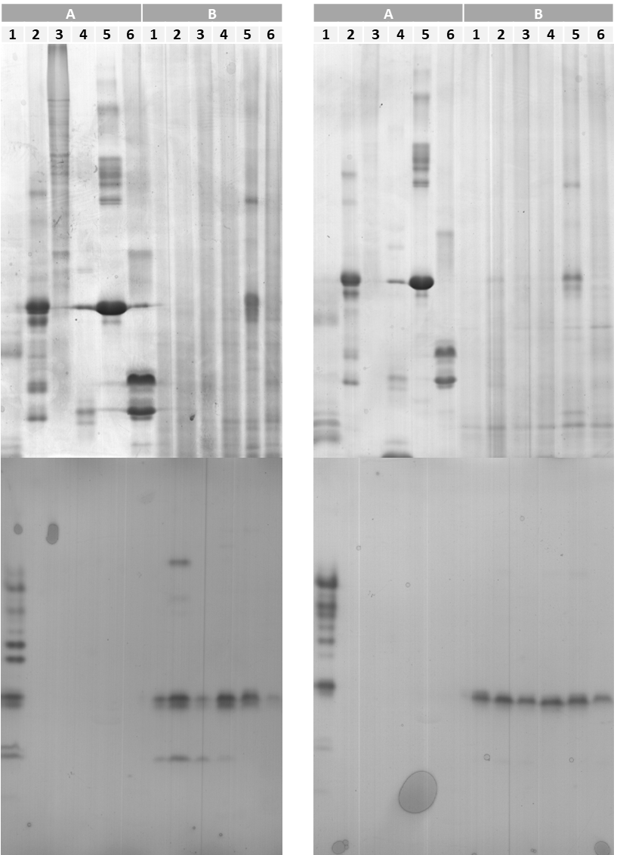
Figure S1: SDS-PAGE (top) and zymogram (bottom) of the original protein solutions (A) and the protein adsorbed to the droplet surface of the emulsions (B) of the statistical replicates of experiment 1. Emulsions were prepared with polyphenol oxidase extract (1; control) or with soy glycinin (2), gelatin (3), whey protein isolate (4), bovine serum albumin (5) or sodium caseinate (6) and diluted (4:1 w/w) with polyphenol oxidase extract before analysis.

Supplementary Material S1: Isolation of soy glycinin
Protocol adapted with slight modification from Isaschar-Ovdat et al. (2015)

Extruded soy bean meal was milled and sieved (212 µm mesh size). The fine meal was subsequently dispersed in distilled water (1:15, w/w), and the suspension was stirred for 1 h at pH 8.5. The sample was centrifuged for 30 min at 14000 g and 15°C and the supernatant was subjected to vacuum filtration. Dry sodium bisulfite (NaHSO3, 0.98 g L−1) was added and the pH was adjusted to 6.4. The mixture was kept overnight at 4°C, without stirring. The sample was centrifuged (7500 g for 20 min at 4°C) and the pellet was suspended in a small amount of distilled water and the pH adjusted to 7. The sample was dialyzed against distilled water for 24 h using a Visking dialysis membrane (molecular weight cut off of 12-14 kDa, Medicell International Ltd; London; United Kindom) and lyophilized.

References
Isaschar-Ovdat S, Rosenberg M, Lesmes U and Fishman A 2015. Characterization of oil-in-water emulsions stabilized by tyrosinase-crosslinked soy glycinin. Food Hydrocolloids 43, 493–500.

