*animal* journal

**High-grain diet feeding altered the composition and functions of the rumen bacterial community and caused the damage to the laminar tissues of goats**

**Ruiyang Zhang1, Wei jin2, Panfei Feng2, Junhua Liu2, Shengyong Mao2\***

1 Key Laboratory of Zoonosis of Liaoning Province, College of Animal Science and Veterinary Medicine, Shenyang Agricultural University, Shenyang, 110866, China

2 Jiangsu Key Laboratory of Gastrointestinal Nutrition and Animal Health, Laboratory of Gastrointestinal Microbiology, College of Animal Science and Technology, Nanjing Agricultural University, Nanjing, 210095, China

* Correspondence to: Shengyong Mao, Jiangsu Key Laboratory of Gastrointestinal Nutrition and Animal Health, Laboratory of Gastrointestinal Microbiology, College of Animal Science and Technology, Nanjing Agricultural University, Nanjing, 210095, China. Email: [maoshengyong@163.com](mailto:maoshengyong@163.com); Telephone: +86-25-84395523; Fax: +86-25-84395314.

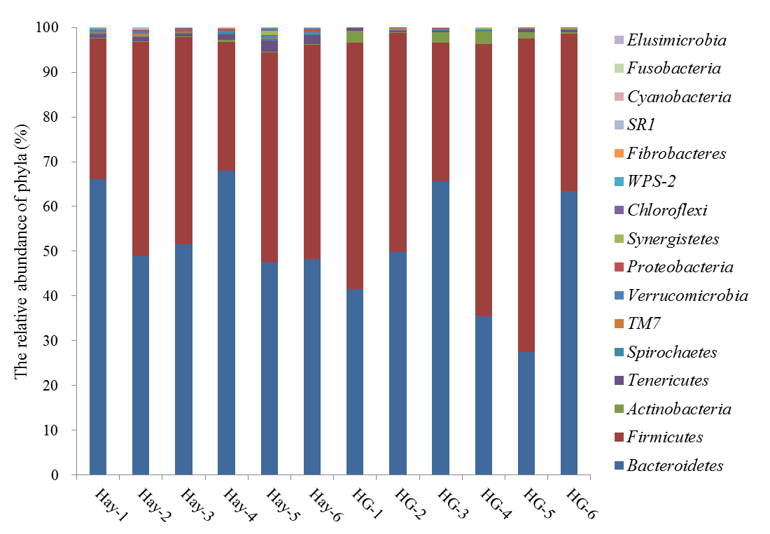

Figure S1 The distribution of phyla for each sample. HG, high-grain.



Figure S2 A double hierarchical analysis of the top 50 most abundant bacterial genera in the rumen of goats in the Hay-fed and high grain (HG) diet-fed samples.

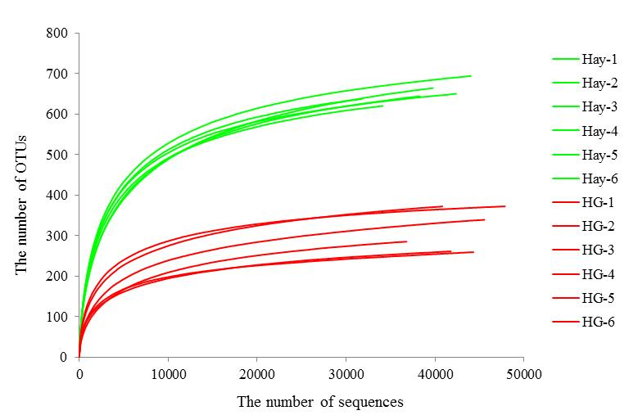

Figure S3 rarefaction results based on operational taxonomic unit (OTUs) (3% divergence). Hay group: Hay-1, Hay-2, Hay-3, Hay-4, Hay-5, Hay-6; High-grain group: HG-1, HG-2, HG-3, HG-4, HG-5, HG-6.

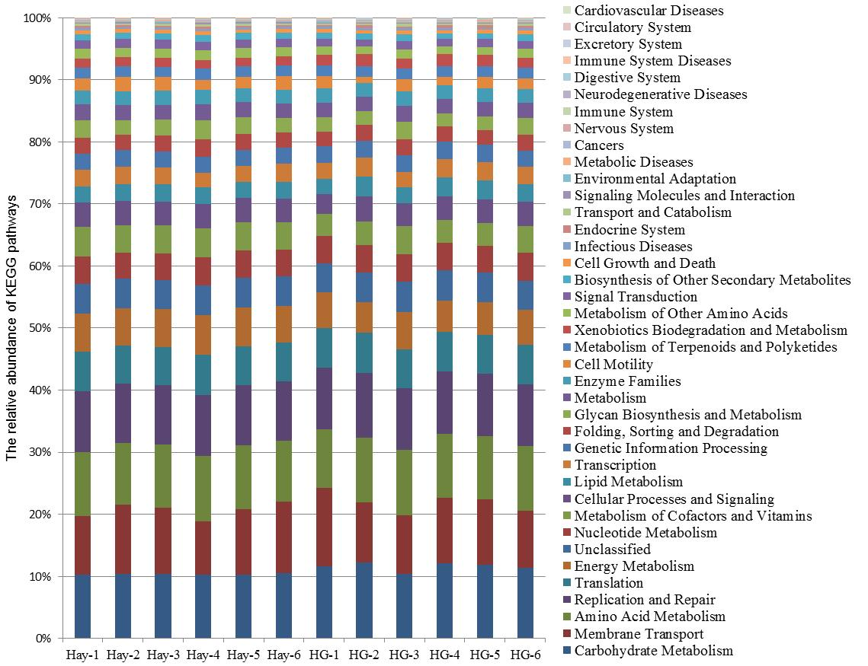

Figure S4 Variations in the abundance of Kyoto Encyclopedia of Genes and Genomes (KEGG) pathways in functional bacterial communities of all samples from goats. High-grain group: HG-1, HG-2, HG-3, HG-4, HG-5, HG-6.

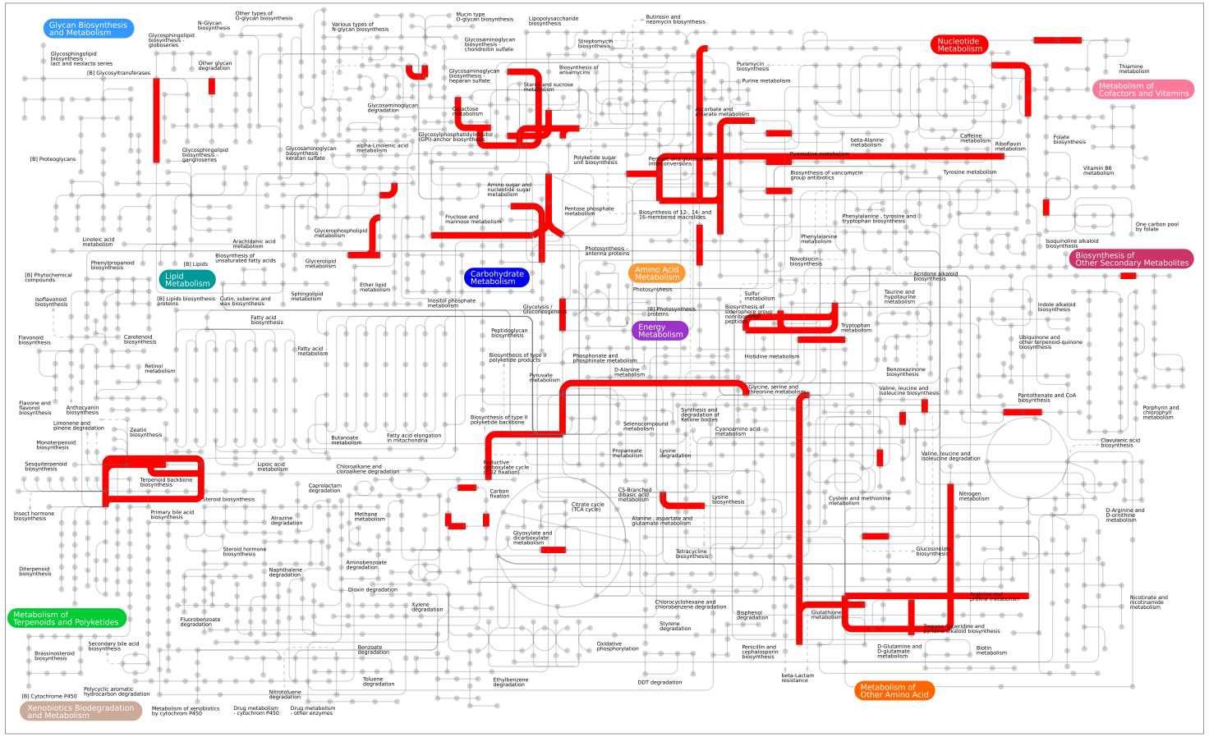

Figure S5 The overall metabolic map constructed using the significantly affected Kyoto Encyclopedia of Genes and Genomes( KEGG) orthology groups (the false discovery ration <0.05, and the relative abundance ≥0.1% at least in one group).

Table S1 *Ingredient and nutrient levels of the diets*

|  |  |  |
| --- | --- | --- |
| Item | Diet | |
| **Hay** | **HG** |
| *Ingredients composition*, % DM |  | |
| Chinese wildrye | 80.00 | 18.00 |
| Alfalfa | 16.00 | 7.00 |
| Corn meal | 0.00 | 20.00 |
| Wheat meal | 0.00 | 36.50 |
| Soybean | 0.00 | 15.00 |
| Limestone | 0.70 | 1.00 |
| Sodium chloride | 0.50 | 0.50 |
| Calcium phosphate dihydrate | 1.80 | 1.00 |
| Premix a | 1.00 | 1.00 |
| *Nutrient composition* |  | |
| Metabolic energy , MJ/Kg DM | 8.32 | 11.56 |
| Crude fat, % DM | 3.54 | 2.82 |
| Crude fiber , % DM | 30.13 | 10.13 |
| Crude protein, % DM | 10.16 | 17.19 |
| Acid detergent fiber, % DM | 35.70 | 12.78 |
| Neutral detergent fiber, % DM | 56.84 | 22.75 |
| Calcium, % DM | 1.24 | 0.82 |
| Phosphorus, % DM | 0.50 | 0.55 |

HG, high grain

a Goat premix contained (per kg as mixed): Mn, 10,000 mg; Zn, 20,000 mg; Fe, 5,000 mg; Co, 100 mg; I, 300 mg; Cu, 6,000 mg; Se, 100, 000IU; vitamin A, 5,00,000 IU; vitamin D, 110,000 IU, and vitamin E, 15,000 mg.

**Table S2** *Primer used in the present study.*

|  |  |  |  |
| --- | --- | --- | --- |
| Genes | Forward primer | Reverse primer | Amplicon size |
| IL-1β | CATGTGTGCTGAAGGCTCTC | AGTGTCGGCGTATCACCTTT | 173 |
| IL-6 | CCAATCTGGGTTCAATCAGG | ACCCACTCGTTTGAGGACTG | 241 |
| TNF-α | CAAGTAACAAGCCGGTAGCC | AGATGAGGTAAAGCCCGTCA | 155 |
| MMP-2 | TTCTCACCCCCACCTGGTAA | AGGCATCTCTTTGTGGGTGG | 143 |
| MMP-9 | GCACGCACGACATCTTTCAG | GGAACTCACACGCCAGAAGA | 74 |
| MT1-MMP | AGCACTGGGTGTTTGACGAA | GCATCCAGAAGAGAGCAGCA | 111 |
| TIMP-1 | ATGCTGCTGGTTGTGAGGAA | ATGAGTGTCGCTCTGCAGTT | 74 |
| GAPDH | GGGTCATCATCTCTGCACCT | GGTCATAAGTCCCTCCACGA | 180 |

IL-1β, interleukin-1 beta; IL-6, interleukin-6; TNF-α, tumour necrosis factor-alpha; MMP-2, matrix metalloproteinases 2; MMP-9, matrix metalloproteinases 9; MT1-MMP, membrane type-1 MMP; TIMP, tissue inhibitors of metalloproteinases; GAPDH, glyceraldehyde-3-phosphate dehydrogenase.

**Table S3** *Effects of high grain (HG) diet on estimators of rumen bacterial richness and diversity.*

|  |  |  |  |
| --- | --- | --- | --- |
|  | Hay | HG | *P* value |
| Ace | 708 ± 29 | 355 ± 57 | <0.001 |
| Chao 1 | 717 ± 37 | 367 ± 58 | <0.001 |
| Shannon index | 4.34 ± 0.10 | 3.30 ± 0.43 | 0.001 |
| Simpson index | 0.05 ± 0.02 | 0.09 ± 0.04 | 0.040 |

Values are means ± SE, *n* =6

**Table S4** *Effects of high grain (HG) diet feeding on the relative abundance of the predicted carbohydrate-active enzymes. Only the enzymes that were high-abundant (the relative abundance ≥0.1% at least in one group) and exhibited dramatic changes (False discovery ration <0.05 and the fold change >1.5 or <0.6) were presented.*

|  |  |  |  |  |  |
| --- | --- | --- | --- | --- | --- |
| KEGG Description | KEGG  orthology | Hay | HG | False discovery ration | Fold change |
| Two-component system, sensor histidine kinase YesM [EC:2.7.13.3] | K07718 | 0.10% | 0.18% | 0.020 | 1.77 |
| Alpha-N-arabinofuranosidase [EC:3.2.1.55] | K01209 | 0.09% | 0.17% | 0.037 | 1.85 |
| Ribose 5-phosphate isomerase B [EC:5.3.1.6] | K01808 | 0.11% | 0.17% | 0.049 | 1.57 |
| Orotate phosphoribosyltransferase [EC:2.4.2.10] | K00762 | 0.08% | 0.13% | 0.020 | 1.55 |
| Sortase B;sortase B [EC:3.4.22.70] | K08600 | 0.06% | 0.11% | 0.030 | 1.80 |
| DNA polymerase IV [EC:2.7.7.7] | K02346 | 0.06% | 0.11% | 0.026 | 1.96 |
| Asparagine synthase (glutamine-hydrolysing) [EC:6.3.5.4] | K01953 | 0.07% | 0.11% | 0.029 | 1.57 |
| Aspartyl-tRNA(Asn)/glutamyl-tRNA (Gln) amidotransferase subunit A [EC:6.3.5.6 6.3.5.7] | K02433 | 0.06% | 0.10% | 0.044 | 1.59 |
| Beta-galactosidase [EC:3.2.1.23] | K01190 | 0.25% | 0.14% | 0.034 | 0.57 |
| Carboxyl-terminal processing protease [EC:3.4.21.102] | K03797 | 0.16% | 0.09% | 0.048 | 0.60 |
| Phosphopantothenoylcysteine decarboxylase / phosphopantothenate--cysteine ligase [EC:4.1.1.36 6.3.2.5] | K13038 | 0.15% | 0.09% | 0.037 | 0.57 |
| Hexosaminidase [EC:3.2.1.52] | K12373 | 0.15% | 0.08% | 0.040 | 0.49 |
| 3,4-dihydroxy 2-butanone 4-phosphate synthase / GTP cyclohydrolase II [EC:4.1.99.12 3.5.4.25] | K14652 | 0.13% | 0.07% | 0.030 | 0.53 |
| Alpha-glucosidase [EC:3.2.1.20] | K01187 | 0.13% | 0.06% | 0.020 | 0.50 |
| L-serine dehydratase [EC:4.3.1.17] | K01752 | 0.11% | 0.06% | 0.040 | 0.57 |
| Dipeptidase D [EC:3.4.13.-] | K01270 | 0.11% | 0.06% | 0.037 | 0.58 |
| Diaminohydroxyphosphoribosylaminopyrimidine deaminase / 5-amino-6-(5-phosphoribosylamino)uracil Reductase [EC:3.5.4.26 1.1.1.193] | K11752 | 0.10% | 0.06% | 0.037 | 0.54 |
| Peptide methionine sulfoxide reductase msrA/msrB [EC:1.8.4.11 1.8.4.12] | K12267 | 0.10% | 0.06% | 0.046 | 0.60 |
| Lactoylglutathione lyase [EC:4.4.1.5] | K01759 | 0.10% | 0.06% | 0.026 | 0.54 |