Genome-wide association analysis reveals genomic regions on Chromosome 13 affecting litter size and candidate genes for uterine horn length in Erhualian pigs
X. Ma, P. H. Li, M. X. Zhu, L. C. He, S. P. Sui, S. Gao, G. S. Su, N. S. Ding, Y. Huang, Z. Q. Lu, X. G. Huang, and R. H. Huang
ANIMAL JOURNAL

Supplementary Table S1 Three populations for genotyping of rs81447100
Population | Farm | N¹
Erhualian | Changzhou Jiaoxi Cooperatives of Erhualian Pigs | 144
 | Changshu Animal Husbandry and Veterinary Station | 111
 | Sutai Enterprise Co., Ltd | 58
Sutai | Sutai Enterprise Co., Ltd | 173
Yorkshire | Laizhou farm of Fujian Yichun Corporation | 488
¹N, sows number

Supplementary Table S2 Significant SNP and genes identified in this study¹
Phenotypes² | Top SNP² | Chromosome | Position (bp) | Genes located within ±1 Mb³
TNB-2~7\NBA2~7 | rs80882306 | 7 | 11 531 743 | MCUR1, RNF182, JARID2, DTNBP1
NBA-2~7 | rs81447100 | 13 | 88 653 330 | MRPS22, COPB2, RBP2, RBP1, CLSTN2, TRIM42, SLC25A36,
TNB-2~7 | rs81406385 | 8 | 18 169 869 | DHX15
NBA-2~7 | rs81215583 | 13 | 79 276 382 | FBLN2, NUP210, IQSEC1, KIAA1257, ACAD9, EFCC1, RPN1, HMCES, COPG1, H1FX, RAB7A, DNAJB8, GATA2, SEC61A1, KBTBD12, TPRA1, MGLL, ABTB1, PODXL2, MCM2
TNB-2~7 | rs81260290 | 1 | 278 190 574 | RPS16, ZNF462, RAD23B, KLF4
NBA-2~7 | rs81447231 | 13 | 90433453 | SLC25A36, SPSB4, PXYLP1, ZBTB38, RASA2, RNF7, GRK7, GK5, XRN1, ATR, PLS1, TRPC1, PCOLCE2
NBA-2~7 | rs80952566 | 17 | 30 670 293 | PARD3, CUL2, CREB, CCNY, GJD4
NBA-1 | rs80890206 | 5 | 34 298 027 | IRAK3, HELB, GRIP1
TNB-1\NBA-1 | rs80927364 | 4 | 143 188 763 | CLCA2, ODF2L, ZNHIT6, CYR61, DDAH1, BCL10, SYDE2, MCOLN3, WDR63
TNB-2~7\NBA-2~7 | rs81274366 | 10 | 63 120 836 | PARD3, CUL2, CREB, CCNY, GJD4
TNB-2~7  TNB-2~7\NBA-2~7 | rs81289648  rs81434499 | 16  12 | 81 255 133  37 502 410 | MTRRR, FASTKD3, C5orf49, ADCY2, PAPD7, SDR5A1, NSUN2, UBE2QL1, MED10  TRIM37, CLTC, DHX40, GDPD1, SMG8, PRR11, SKA2, PTRH2, VMP1, TBX4, TBX2, TUBD1, RPS6KB1, RNDT1, MED13, INTS2
¹ SNP, single nucleotide polymorphisms.
¹ TNB-1, the 1st parity of total number born; NBA-1, the 1st parity of number born alive; TNB-2~7, the 2nd to 7th parity of total number born; NBA-2~7, the 2nd to 7th parity of number born alive.
³ Gene which is bolded represents the corresponding marker is in it, others mean the corresponding marker is not in it.

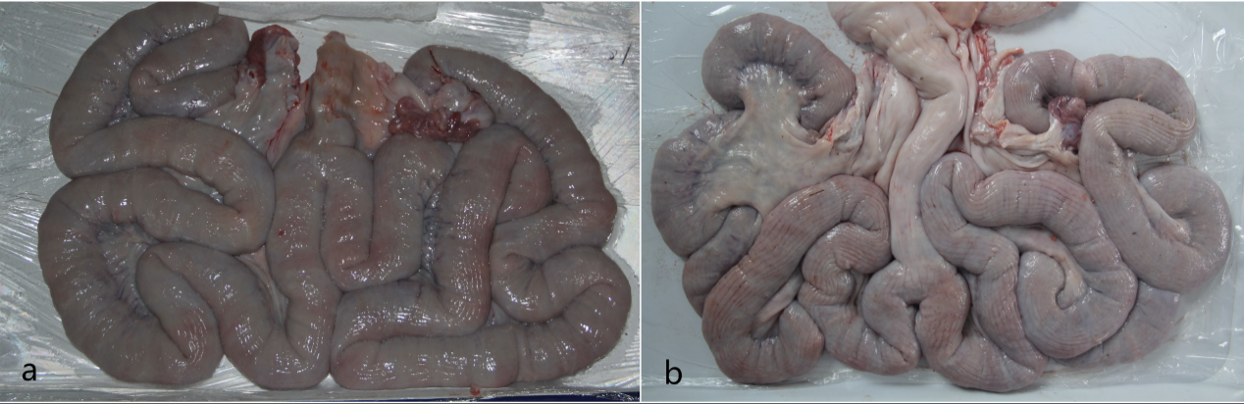
Supplementary Figure S1 Image of uterine collected from a high- EBV_{TNB} (a) and a low- EBV_{TNB} sow (b). (a) Total uterine horn length is 278 cm. (b) Total uterine horn length is 434 cm. ¹
¹ EBV_{TNB}, estimated breeding value of total number born

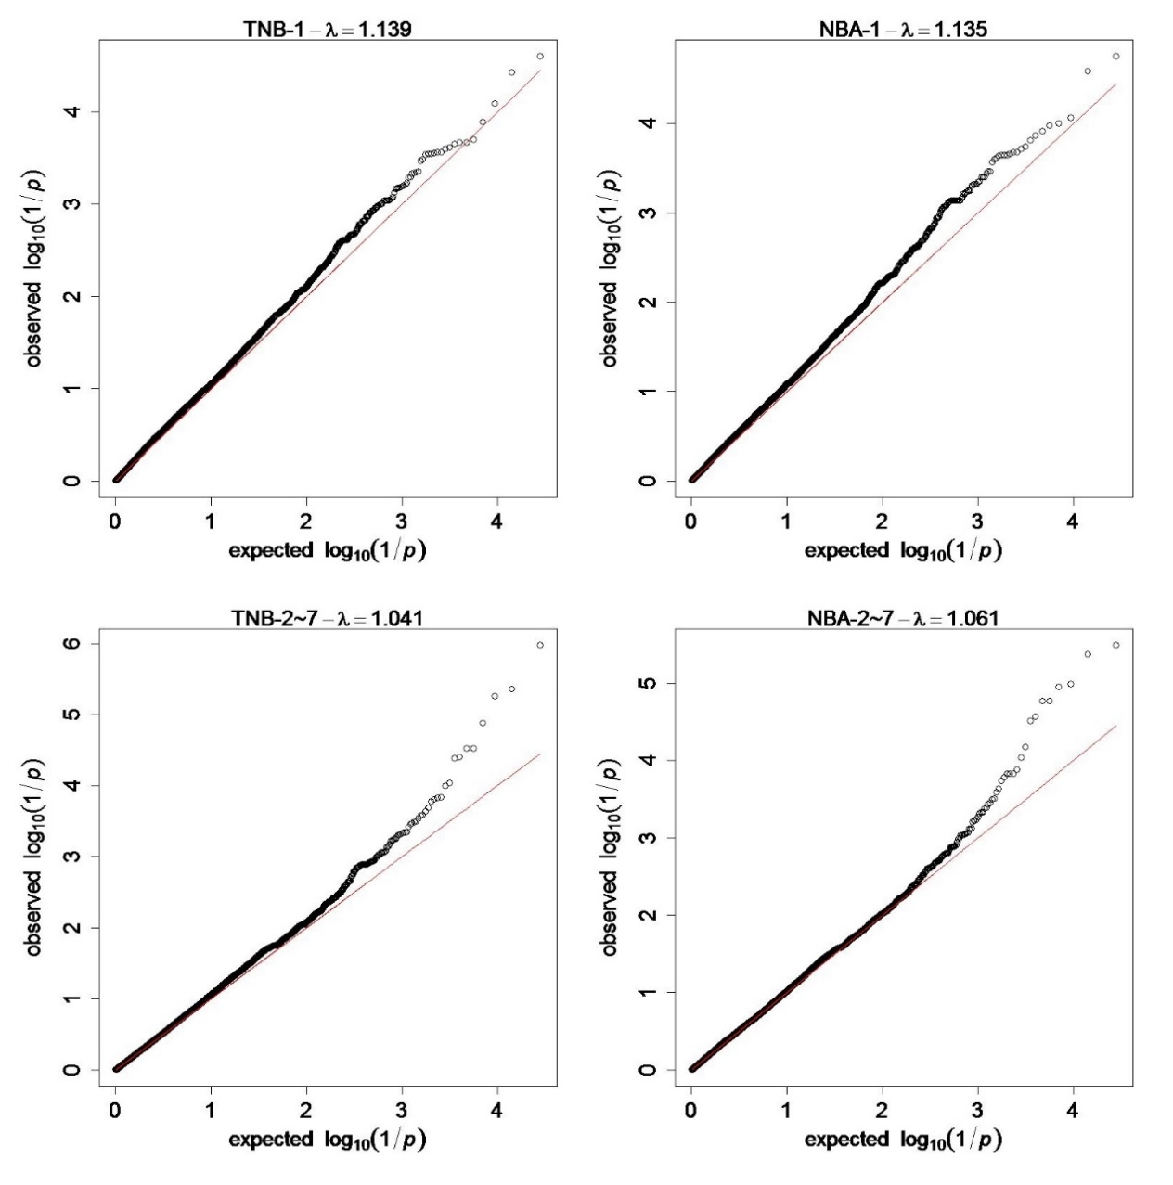
Supplementary Figure S2 Quantile-quantile (Q-Q) plots of genome-wide association study for litter size. The black circles indicate single nucleotide polymorphisms markers. The red line in the QQ plots indicates the distribution of single nucleotide polymorphisms markers under the null hypothesis and the skew at the right edge indicates that these markers are stronger associated with the traits than it would be expected by chance.

