Leucine alters immunoglobulin A secretion and inflammatory cytokine expression induced by lipopolysaccharide via the nuclear factor-κB pathway in chicken embryos

S. Q. Liu, L. Y. Wang, D. Z. Tang, X. X. Fan, G. H. Liu, J. P. Zhao, H. C. Jiao, X. J. Wang, S. H. Sun and H. Lin

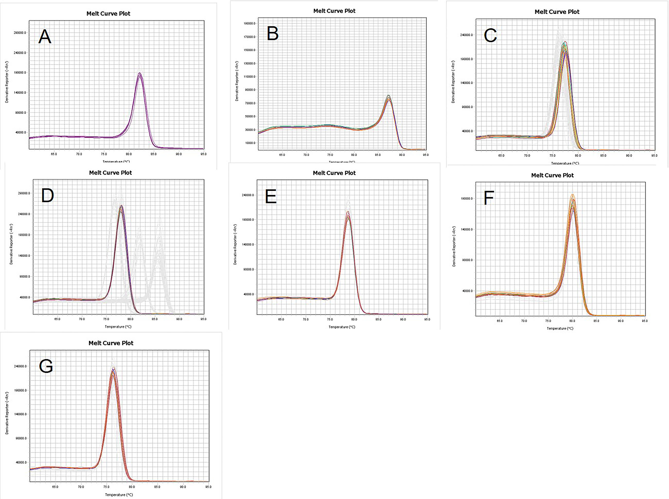
Supplementary Figure S1 The melting curves of all the primers. (A) β-actin; (B) IgA (Immunoglobulin A); (C) IL-6 (Interleukine-6); (D) IL-8 (Interleukine-8); (E) IL-10 (Interleukine-10); (F) TNF-α (Tumor necrosis factor-α); (G) TLR4 (Toll-like receptor 4).

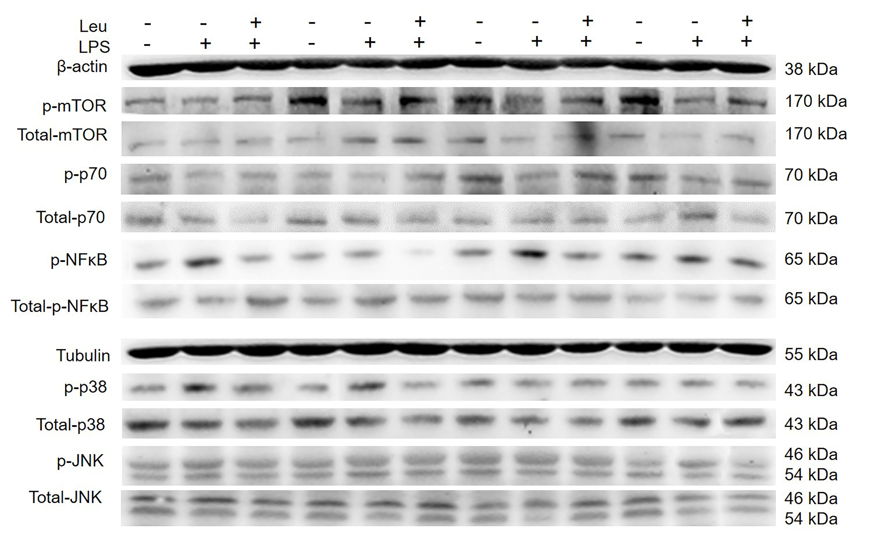
Supplementary Figure S2 Effect of leucine treatment (40 mM) on the lipopolysaccharide (LPS) (2 µg/mL) induced protein expression level of the mammalian target of rapamycin (mTOR), p70 ribosomal S6 kinase (p70S6K), Jun N-terminal kinase (JNK), p38 mitogen-activated protein kinase (MAPK), and nuclear factor-κB p65 (NF-κB p65). The intestinal tissue of chicken embryos were collected to measure the protein expression by Western blotting. Tubulin and β-actin were used as an internal control, respectively. Each treatment had 12 replicates and we chose the objective representing the results on the one membrane.

