Genome-wide association study for growth traits in Nelore cattle
Ana Paula Nascimento Terakado¹, Raphael Bermal Costa^{2*}, Gregório Miguel Ferreira de Camargo², Natália Irano¹, Tiago Bresolin¹, Luciana Takada¹, Caio Victor Damasceno Carvalho², Henrique Nunes Oliveira¹, Roberto Carvalheiro¹, Fernando Baldi¹, Lucia Galvão de Albuquerque¹

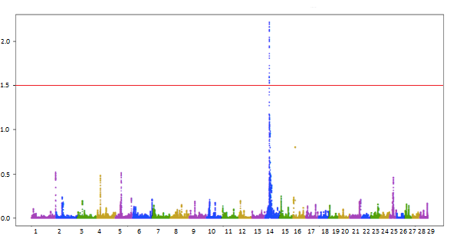
Supplementary Figure S1. Manhattan plot for birth weight. Proportion of genetic variance explained by windows of 50 adjacent SNPs (y-axis) per chromosome (x-axis).
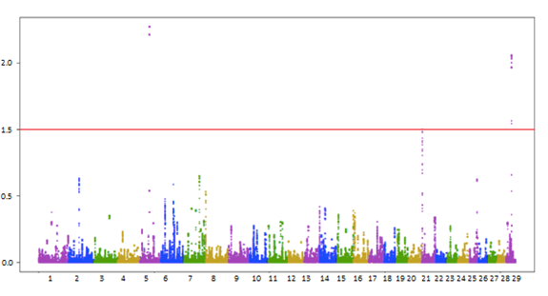
Supplementary Figure S2. Manhattan plot for weight gain from birth to weaning. Proportion of genetic variance explained by windows of 50 adjacent SNPs (y-axis) per chromosome (x-axis).
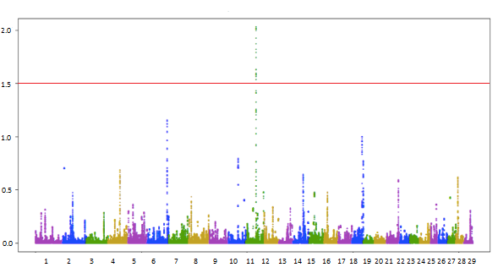
Supplementary Figure S3. Manhattan plot for weight gain from weaning to yearling. Proportion of genetic variance explained by windows of 50 adjacent SNPs (y-axis) per chromosome (x-axis).
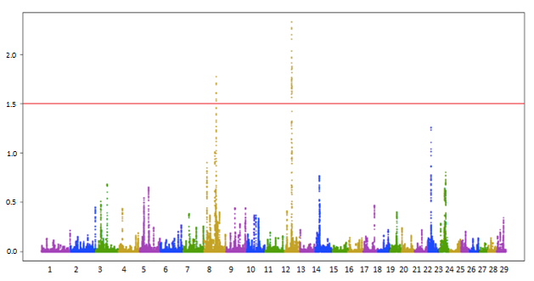
Supplementary Figure S4. Manhattan plot for yearling height. Proportion of genetic variance explained by windows of 50 adjacent SNPs (y-axis) per chromosome (x-axis).
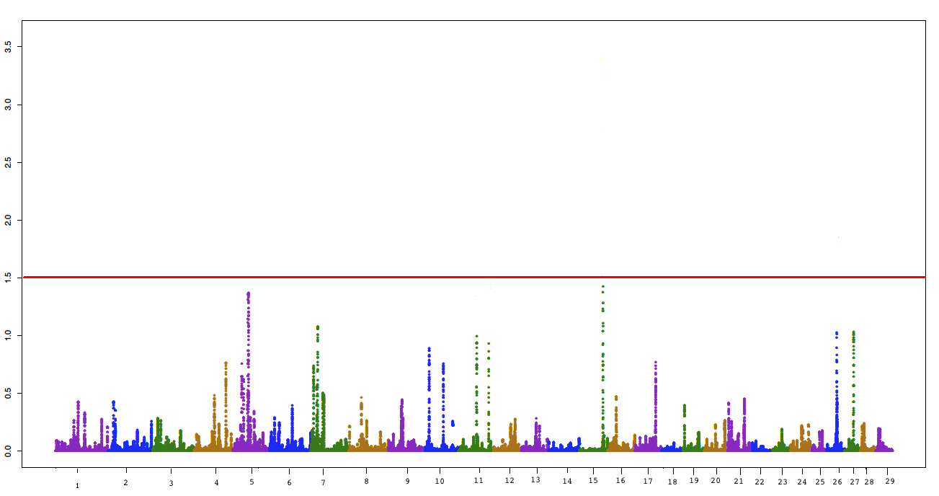
Supplementary Figure S5. Manhattan plot for cow weight. Proportion of genetic variance explained by windows of 50 adjacent SNPs (y-axis) per chromosome (x-axis).

