Evaluation of the impact of a herd health and production management program in organic dairy cattle farms – a process evaluation approach
J.E. Duval, N. Bareille, A. Madouasse, M. de Joybert, K. Sjöström, U. Emanuelson, F. Beaugrand-Bonnet and C. Fourichon
Supplementary Material S1 Concept of the tested Herd Health and Production Management Program
Meeting 1 to 3/4:
Farmer and advisor
Meeting 0:
Farmer, advisor, researcher
Outline of the Herd Health and Production Management Program
Step 0: Farmer and advisor define farm specific herd health indicators and alert thresholds to be monitored during each subsequent farm meeting
Step 1: Monitoring of the herd health situation by farmer and advisor
Detection of a herd health problem
Step 2a: Reinforce prevention protocols for the identified herd health problem
Reactive prevention
NO detection of a herd health problem
Step 2b: Discuss the implementation of preventive protocols
Pro-active prevention

Step 2. Detail of a preventive protocol: example for diarrhea in calves and risk factors related to housing conditions

To be filled in by
farmer and advisor

Evaluation of the impact of a herd health and production management program in organic dairy cattle farms – a process evaluation approach
J.E. Duval, N. Bareille, A. Madouasse, M. de Joybert, K. Sjöström, U. Emanuelson, F. Beaugrand-Bonnet and C. Fourichon

Supplementary Material S2 Framework for a written farm visit summary

Official farm number: ………………………………..

Name(s) persons involved in the farm visit:
………………………………………………..………………………………………………..………………………………………………..

Name author summary: ………………………………………………………………………………………………

Date of the visit: ……/……./……..

1- Levels herd health indicators

Health domain | Indicators used | Health level identified per indicator | Alert level crossed  Yes/No | Improvement or degradation of the situation compared to the last visit
Reproduction
Mastitis
Metabolic diseases
Lameness
Health calves

2 - Diagnosis of the health problem (if one identified) and associated risk factors

It will be necessary to resume certain elements of the diagnostic procedure to explain how the origin of the health problem was identified.

The advisor explains in this part the risk factors identified and hierarchies them in order of importance:

Risk factors identified:

3 - Objective(s) farmer with regard to the identified herd health problem

4 - Summarize practices proposed/identified and explain how these can help to attain improvement of the herd health problem

5 - Expected implementation of proposed practices

Practices | Expected month of implementation
 | M+1  (January) | M+2  (February) | M+3  (March) | M+4  (April) | M+5  (May) | in 6 months, precise
Example :  Start disinfection of the teat ends after milking |  | X
Practice n°1
Practice n°2

Practice n°3

Practice n°4

Remarks on the calendar, include also feedback on the implementation of recommended practices identified during previous visits (delayed implemenation of practices, abandonnement of practices, etc.)

Date next visit:
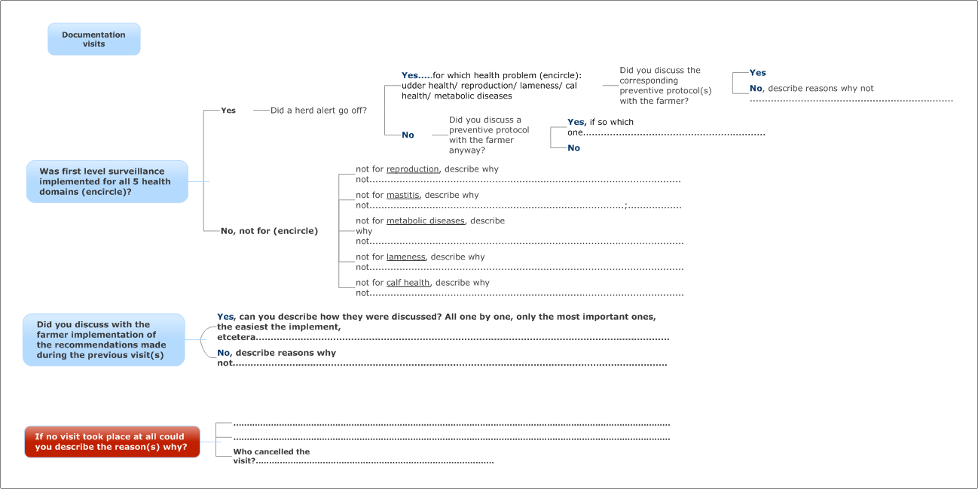
Evaluation of the impact of a herd health and production management program in organic dairy cattle farms – a process evaluation approach
J.E. Duval, N. Bareille, A. Madouasse, M. de Joybert, K. Sjöström, U. Emanuelson, F. Beaugrand-Bonnet and C. Fourichon
Supplementary Material S3 Descriptive herd figures describing the average value of herd health and herd production indicators per country, per study period and per study group.
Coun-try | Study period | Type of study groupe | Herd size (cow-years) | Milk yield per cow per day (kg) | Preva-  lence of high somatic cell count (%) | Appa-rent new udder infection risk (%) | Calving interval (geome-tric mean) (days) | Calving to first artificial insemina-tion interval (days) | Preva-  lence of fat/  protein ratios >1.5 (%) | Preva-  lence of fat/  protein ratios <1.0 (%) | On-farm mortality adult cow (death/ year at risk) (%) | Calf mortality 1-30 days after birth (death/ month at risk) (%)
FR¹ | P1³ | Control | 51,76 | 18,02 | 33,33 | 15,90 | 409,97 | 97,86 | 0,12 | 0,05 | 3,06 | 5,57
FR¹ | P1³ | Intervention | 54,92 | 19,44 | 34,27 | 15,79 | 404,36 | 173,43 | 0,12 | 0,04 | 3,11 | 5,49
FR¹ | P2⁴ | Control | 55,88 | 18,40 | 29,20 | 14,08 | 414,01 | 95,35 | 0,13 | 0,05 | 4,12 | 4,38
FR¹ | P2⁴ | Intervention | 54,65 | 19,68 | 30,44 | 15,08 | 409,36 | 87,54 | 0,12 | 0,05 | 4,64 | 4,51
SE² | P1³ | Control | 65,39 | 26,97 | 26,26 | 13,11 | 395,78 | 86,97 | 0,11 | 0,05 | 4,04 | 2,25
SE² | P1³ | Intervention | 91,92 | 28,19 | 26,40 | 12,73 | 391,76 | 90,41 | 0,11 | 0,05 | 3,61 | 1,20
SE² | P2⁴ | Control | 71,09 | 28,24 | 27,84 | 13,03 | 401,60 | 90,30 | 0,11 | 0,05 | 4,31 | 1,05
SE² | P2⁴ | Intervention | 101,16 | 29,48 | 26,26 | 12,23 | 388,58 | 81,14 | 0,10 | 0,06 | 3,17 | 1,90
¹ FR= France
² SE= Sweden
³ P1= Before the intervention with the herd health and production management program
⁴ P2 = After the intervention with the herd health and production management program

