Evaluation of the potential use of a meta-population for genomic selection in autochthonous beef cattle populations
E. F. Mouresan, J. J. Cañas-Álvarez, A. González-Rodríguez, S. Munilla, J. Altarriba, C. Díaz, J. A. Baró, A. Molina, J. Piedrafita, L. Varona

Supplementary Table S1. Accuracy from purebred genomic evaluation in testing populations (h²=0.4)
 |  |  | Training sets
 |  |  | AV | ANI | BP | Mo | Pi | Re | RG
Validation sets | AV | Gen1 | 0.580  (0.014) | 0.125  (0.032) | 0.117  (0.022) | 0.135  (0.029) | 0.146  (0.012) | 0.144  (0.015) | 0.137  (0.025)
 |  | Gen2 | 0.475  (0.026) | 0.158  (0.021) | 0.112  (0.019) | 0.111  (0.021) | 0.144  (0.018) | 0.112  (0.028) | 0.137  (0.021)
 |  | Gen3 | 0.437  (0.029) | 0.171  (0.017) | 0.130  (0.021) | 0.128  (0.019) | 0.138  (0.011) | 0.137  (0.025) | 0.167  (0.012)
 | ANI | Gen1 | 0.170  (0.037) | 0.605  (0.012) | 0.167  (0.022) | 0.166  (0.022) | 0.106  (0.016) | 0.136  (0.016) | 0.126  (0.019)
 |  | Gen2 | 0.160  (0.035) | 0.495  (0.015) | 0.168  (0.009) | 0.188  (0.013) | 0.124  (0.018) | 0.154  (0.019) | 0.155  (0.033)
 |  | Gen3 | 0.150  (0.029) | 0.454  (0.020) | 0.151  (0.011) | 0.203  (0.016) | 0.121  (0.014) | 0.192  (0.022) | 0.139  (0.015)
 | BP | Gen1 | 0.121  (0.030) | 0.155  (0.010) | 0.603  (0.013) | 0.137  (0.017) | 0.131  (0.017) | 0.128  (0.025) | 0.160  (0.022)
 |  | Gen2 | 0.152  (0.028) | 0.108  (0.012) | 0.475  (0.008) | 0.153  (0.020) | 0.142  (0.016) | 0.148  (0.026) | 0.159  (0.017)
 |  | Gen3 | 0.156  (0.026) | 0.106  (0.023) | 0.420  (0.011) | 0.140  (0.023) | 0.121  (0.012) | 0.107  (0.022) | 0.145  (0.025)
 | Mo | Gen1 | 0.132  (0.018) | 0.164  (0.015) | 0.132  (0.022) | 0.591  (0.015) | 0.104  (0.019) | 0.149  (0.025) | 0.143  (0.018)
 |  | Gen2 | 0.130  (0.014) | 0.166  (0.015) | 0.133  (0.024) | 0.486  (0.023) | 0.141  (0.010) | 0.155  (0.007) | 0.161  (0.006)
 |  | Gen3 | 0.082  (0.018) | 0.139  (0.011) | 0.143  (0.006) | 0.442  (0.017) | 0.140  (0.020) | 0.134  (0.016) | 0.142  (0.022)
 | Pi | Gen1 | 0.138  (0.017) | 0.141  (0.014) | 0.177  (0.019) | 0.127  (0.020) | 0.613  (0.017) | 0.128  (0.026) | 0.101  (0.013)
 |  | Gen2 | 0.125  (0.026) | 0.149  (0.019) | 0.198  (0.023) | 0.105  (0.012) | 0.525  (0.017) | 0.124  (0.028) | 0.125  (0.017)
 |  | Gen3 | 0.112  (0.017) | 0.122  (0.024) | 0.190  (0.011) | 0.148  (0.011) | 0.496  (0.012) | 0.124  (0.032) | 0.098  (0.022)
 | Re | Gen1 | 0.120  (0.021) | 0.124  (0.027) | 0.131  (0.013) | 0.116  (0.022) | 0.087  (0.015) | 0.608  (0.015) | 0.132  (0.018)
 |  | Gen2 | 0.124  (0.021) | 0.128  (0.018) | 0.149  (0.026) | 0.143  (0.023) | 0.101  (0.027) | 0.543  (0.027) | 0.114  (0.018)
 |  | Gen3 | 0.131  (0.014) | 0.146  (0.032) | 0.159  (0.021) | 0.137  (0.009) | 0.100  (0.023) | 0.481  (0.015) | 0.107  (0.011)
 | RG | Gen1 | 0.136  (0.033) | 0.156  (0.024) | 0.168  (0.021) | 0.136  (0.019) | 0.172  (0.032) | 0.126  (0.010) | 0.637  (0.005)
 |  | Gen2 | 0.133  (0.025) | 0.158  (0.014) | 0.184  (0.012) | 0.159  (0.022) | 0.163  (0.025) | 0.147  (0.024) | 0.545  (0.014)
 |  | Gen3 | 0.123  (0.021) | 0.131  (0.021) | 0.177  (0.018) | 0.161  (0.016) | 0.161  (0.021) | 0.149  (0.028) | 0.474  (0.024)

Supplementary Table S2. Accuracy from purebred genomic evaluation in testing populations (h²=0.1)
 |  |  | Training sets
 |  |  | AV | ANI | BP | Mo | Pi | Re | RG
Validation sets | AV | Gen1 | 0.387  (0.013) | 0.077  (0.014) | 0.091  (0.031) | 0.054  (0.018) | 0.079  (0.031) | 0.080  (0.025) | 0.063  (0.016)
 |  | Gen2 | 0.307  (0.019) | 0.096  (0.024) | 0.105  (0.037) | 0.040  (0.015) | 0.084  (0.043) | 0.087  (0.023) | 0.052  (0.026)
 |  | Gen3 | 0.270  (0.021) | 0.091  (0.054) | 0.099  (0.034) | 0.099  (0.013) | 0.073  (0.017) | 0.085  (0.022) | 0.058  (0.022)
 | ANI | Gen1 | 0.076  (0.018) | 0.419  (0.006) | 0.069  (0.011) | 0.091  (0.013) | 0.079  (0.017) | 0.071  (0.017) | 0.071  (0.017)
 |  | Gen2 | 0.064  (0.020) | 0.346  (0.013) | 0.079  (0.014) | 0.094  (0.031) | 0.067  (0.011) | 0.083  (0.023) | 0.091  (0.016)
 |  | Gen3 | 0.096  (0.006) | 0.284  (0.011) | 0.090  (0.013) | 0.122  (0.025) | 0.087  (0.014) | 0.085  (0.039) | 0.093  (0.012)
 | BP | Gen1 | 0.106  (0.033) | 0.059  (0.018) | 0.385  (0.015) | 0.087  (0.039) | 0.077  (0.018) | 0.104  (0.025) | 0.092  (0.019)
 |  | Gen2 | 0.099  (0.025) | 0.080  (0.018) | 0.292  (0.013) | 0.086  (0.022) | 0.080  (0.017) | 0.108  (0.014) | 0.082  (0.013)
 |  | Gen3 | 0.103  (0.021) | 0.084  (0.014) | 0.244  (0.018) | 0.105  (0.012) | 0.074  (0.017) | 0.059  (0.020) | 0.063  (0.019)
 | Mo | Gen1 | 0.129  (0.017) | 0.077  (0.017) | 0.054  (0.027) | 0.440  (0.025) | 0.070  (0.031) | 0.067  (0.018) | 0.090  (0.016)
 |  | Gen2 | 0.119  (0.019) | 0.063  (0.017) | 0.068  (0.011) | 0.377  (0.017) | 0.070  (0.028) | 0.052  (0.029) | 0.086  (0.033)
 |  | Gen3 | 0.066  (0.022) | 0.083  (0.021) | 0.059  (0.014) | 0.312  (0.009) | 0.073  (0.019) | 0.033  (0.017) | 0.081  (0.033)
 | Pi | Gen1 | 0.063  (0.017) | 0.033  (0.020) | 0.076  (0.016) | 0.101  (0.027) | 0.419  (0.016) | 0.059  (0.028) | 0.080  (0.021)
 |  | Gen2 | 0.039  (0.032) | 0.055  (0.022) | 0.080  (0.020) | 0.087  (0.016) | 0.362  (0.015) | 0.057  (0.028) | 0.087  (0.019)
 |  | Gen3 | 0.050  (0.016) | 0.059  (0.018) | 0.063  (0.033) | 0.095  (0.022) | 0.294  (0.017) | 0.082  (0.013) | 0.091  (0.009)
 | Re | Gen1 | 0.087  (0.023) | 0.095  (0.009) | 0.030  (0.018) | 0.120  (0.013) | 0.055  (0.017) | 0.380  (0.036) | 0.078  (0.016)
 |  | Gen2 | 0.096  (0.027) | 0.113  (0.014) | 0.063  (0.022) | 0.111  (0.009) | 0.090  (0.016) | 0.300  (0.013) | 0.077  (0.021)
 |  | Gen3 | 0.091  (0.017) | 0.085  (0.013) | 0.063  (0.033) | 0.123  (0.014) | 0.071  (0.016) | 0.285  (0.017) | 0.069  (0.011)
 | RG | Gen1 | 0.053  (0.027) | 0.057  (0.025) | 0.103  (0.029) | 0.034  (0.019) | 0.049  (0.021) | 0.045  (0.025) | 0.398  (0.025)
 |  | Gen2 | 0.045  (0.018) | 0.070  (0.018) | 0.107  (0.021) | 0.061  (0.020) | 0.068  (0.012) | 0.066  (0.020) | 0.334  (0.022)
 |  | Gen3 | 0.051  (0.022) | 0.060  (0.019) | 0.097  (0.039) | 0.073  (0.020) | 0.090  (0.028) | 0.080  (0.022) | 0.291  (0.019)

Supplementary Table S3. Accuracy from genomic evaluation in admixed ×2 populations in the generation 1 (h²=0.4).
 |  | Validation sets
 |  | AV | ANI | BP | Mo | Pi | Re | RG
Training sets | AV-ANI | 0.475  (0.013) | 0.498  (0.012) | 0.150  (0.015) | 0.180  (0.012) | 0.153  (0.018) | 0.126  (0.015) | 0.167  (0.018)
 | AV-BP | 0.481  (0.020) | 0.179  (0.032) | 0.500  (0.016) | 0.144  (0.024) | 0.169  (0.007) | 0.141  (0.010) | 0.186  (0.027)
 | AV-Mo | 0.480  (0.017) | 0.178  (0.026) | 0.160  (0.015) | 0.504  (0.018) | 0.136  (0.013) | 0.126  (0.023) | 0.163  (0.027)
 | AV-Pi | 0.477  (0.016) | 0.164  (0.028) | 0.140  (0.025) | 0.126  (0.021) | 0.525  (0.012) | 0.111  (0.009) | 0.180  (0.028)
 | AV-Re | 0.482  (0.016) | 0.174  (0.028) | 0.146  (0.019) | 0.150  (0.024) | 0.120  (0.024) | 0.518  (0.017) | 0.175  (0.021)
 | AV-RG | 0.478  (0.013) | 0.150  (0.020) | 0.150  (0.024) | 0.154  (0.014) | 0.111  (0.020) | 0.140  (0.017) | 0.545  (0.011)
 | ANI-BP | 0.121  (0.018) | 0.495  (0.013) | 0.498  (0.016) | 0.176  (0.018) | 0.185  (0.009) | 0.140  (0.015) | 0.167  (0.022)
 | ANI-Mo | 0.126  (0.023) | 0.497  (0.011) | 0.170  (0.018) | 0.506  (0.015) | 0.158  (0.007) | 0.126  (0.028) | 0.139  (0.016)
 | ANI-Pi | 0.120  (0.024) | 0.491  (0.014) | 0.149  (0.016) | 0.162  (0.020) | 0.529  (0.010) | 0.117  (0.017) | 0.164  (0.016)
 | ANI-Re | 0.124  (0.015) | 0.494  (0.013) | 0.149  (0.013) | 0.181  (0.023) | 0.151  (0.024) | 0.518  (0.015) | 0.153  (0.022)
 | ANI-RG | 0.114  (0.024) | 0.490  (0.016) | 0.162  (0.015) | 0.185  (0.011) | 0.134  (0.015) | 0.137  (0.024) | 0.543  (0.011)
 | BP-Mo | 0.138  (0.038) | 0.173  (0.012) | 0.499  (0.019) | 0.501  (0.017) | 0.172  (0.015) | 0.137  (0.014) | 0.158  (0.028)
 | BP-Pi | 0.134  (0.016) | 0.159  (0.033) | 0.498  (0.014) | 0.122  (0.022) | 0.531  (0.011) | 0.124  (0.013) | 0.181  (0.015)
 | BP-Re | 0.135  (0.020) | 0.165  (0.025) | 0.499  (0.016) | 0.144  (0.021) | 0.163  (0.017) | 0.521  (0.016) | 0.172  (0.021)
 | BP-RG | 0.133  (0.028) | 0.144  (0.023) | 0.497  (0.017) | 0.151  (0.010) | 0.152  (0.015) | 0.153  (0.019) | 0.544  (0.012)
 | Mo-Pi | 0.138  (0.023) | 0.154  (0.012) | 0.151  (0.010) | 0.499  (0.016) | 0.526  (0.012) | 0.110  (0.014) | 0.152  (0.024)
 | Mo-Re | 0.140  (0.025) | 0.165  (0.014) | 0.165  (0.019) | 0.506  (0.016) | 0.132  (0.016) | 0.517  (0.015) | 0.142  (0.016)
 | Mo-RG | 0.134  (0.031) | 0.143  (0.015) | 0.165  (0.023) | 0.505  (0.017) | 0.118  (0.017) | 0.136  (0.026) | 0.542  (0.011)
 | Pi-Re | 0.141  (0.015) | 0.150  (0.017) | 0.141  (0.019) | 0.128  (0.025) | 0.527  (0.013) | 0.514  (0.015) | 0.168  (0.020)
 | Pi-RG | 0.130  (0.020) | 0.125  (0.012) | 0.145  (0.011) | 0.131  (0.008) | 0.523  (0.011) | 0.124  (0.017) | 0.542  (0.009)
 | Re-RG | 0.134  (0.022) | 0.133  (0.016) | 0.153  (0.012) | 0.151  (0.009) | 0.103  (0.016) | 0.521  (0.015) | 0.543  (0.011)

Supplementary Table S4. Accuracy from genomic evaluation in admixed ×2 populations in the generation 1 (h²=0.1).
 |  | Validation sets
 |  | AV | ANI | BP | Mo | Pi | Re | RG
Training sets | AV-ANI | 0.303  (0.020) | 0.318  (0.011) | 0.094  (0.027) | 0.101  (0.014) | 0.045  (0.019) | 0.078  (0.016) | 0.071  (0.022)
 | AV-BP | 0.299  (0.023) | 0.056  (0.014) | 0.317  (0.023) | 0.122  (0.023) | 0.086  (0.018) | 0.064  (0.012) | 0.113  (0.028)
 | AV-Mo | 0.298  (0.020) | 0.066  (0.021) | 0.090  (0.019) | 0.334  (0.036) | 0.071  (0.015) | 0.092  (0.013) | 0.051  (0.017)
 | AV-Pi | 0.299  (0.021) | 0.079  (0.019) | 0.097  (0.021) | 0.105  (0.019) | 0.335  (0.021) | 0.051  (0.015) | 0.069  (0.033)
 | AV-Re | 0.301  (0.021) | 0.069  (0.022) | 0.108  (0.016) | 0.097  (0.026) | 0.045  (0.029) | 0.299  (0.025) | 0.058  (0.018)
 | AV-RG | 0.295  (0.020) | 0.075  (0.019) | 0.105  (0.020) | 0.116  (0.017) | 0.060  (0.025) | 0.097  (0.026) | 0.317  (0.039)
 | ANI-BP | 0.085  (0.015) | 0.315  (0.013) | 0.313  (0.025) | 0.074  (0.021) | 0.076  (0.010) | 0.058  (0.019) | 0.103  (0.026)
 | ANI-Mo | 0.065  (0.020) | 0.315  (0.010) | 0.072  (0.019) | 0.327  (0.037) | 0.061  (0.011) | 0.086  (0.018) | 0.040  (0.030)
 | ANI-Pi | 0.071  (0.020) | 0.317  (0.017) | 0.081  (0.013) | 0.060  (0.013) | 0.331  (0.020) | 0.047  (0.007) | 0.056  (0.031)
 | ANI-Re | 0.085  (0.014) | 0.318  (0.014) | 0.095  (0.014) | 0.058  (0.012) | 0.034  (0.023) | 0.298  (0.026) | 0.047  (0.015)
 | ANI-RG | 0.066  (0.016) | 0.318  (0.014) | 0.089  (0.012) | 0.070  (0.017) | 0.048  (0.032) | 0.086  (0.028) | 0.311  (0.039)
 | BP-Mo | 0.060  (0.024) | 0.054  (0.019) | 0.312  (0.028) | 0.333  (0.035) | 0.099  (0.020) | 0.073  (0.017) | 0.085  (0.018)
 | BP-Pi | 0.064  (0.029) | 0.065  (0.023) | 0.313  (0.026) | 0.077  (0.015) | 0.338  (0.018) | 0.030  (0.011) | 0.098  (0.041)
 | BP-Re | 0.076  (0.027) | 0.055  (0.020) | 0.315  (0.028) | 0.073  (0.019) | 0.073  (0.018) | 0.293  (0.025) | 0.091  (0.031)
 | BP-RG | 0.056  (0.020) | 0.064  (0.021) | 0.315  (0.026) | 0.092  (0.014) | 0.086  (0.025) | 0.075  (0.029) | 0.320  (0.043)
 | Mo-Pi | 0.047  (0.026) | 0.072  (0.025) | 0.073  (0.023) | 0.326  (0.039) | 0.336  (0.019) | 0.062  (0.016) | 0.037  (0.022)
 | Mo-Re | 0.057  (0.023) | 0.067  (0.028) | 0.086  (0.023) | 0.327  (0.039) | 0.060  (0.015) | 0.301  (0.026) | 0.029  (0.012)
 | Mo-RG | 0.040  (0.008) | 0.073  (0.023) | 0.084  (0.023) | 0.328  (0.037) | 0.072  (0.027) | 0.106  (0.021) | 0.308  (0.038)
 | Pi-Re | 0.065  (0.028) | 0.079  (0.021) | 0.091  (0.011) | 0.058  (0.022) | 0.331  (0.019) | 0.290  (0.026) | 0.044  (0.031)
 | Pi-RG | 0.047  (0.021) | 0.085  (0.038) | 0.090  (0.013) | 0.071  (0.019) | 0.333  (0.019) | 0.063  (0.021) | 0.311  (0.042)
 | Re-RG | 0.056  (0.017) | 0.077  (0.011) | 0.103  (0.012) | 0.072  (0.020) | 0.044  (0.025) | 0.301  (0.024) | 0.312  (0.042)

Supplementary Figure S1. Accuracy from single-breed genomic evaluation under different genetic architecture scenarios.
PG=Polygenic effects, 10G(20%)=Polygenic effects + 10 genes explaining 20% of the genetic variance, 4G(50%)=Polygenic effects + 4 genes explaining 50% of the genetic variance, Ex=Polygenic effects drawn from an exponential distribution, LMAF=polygenic effects with low allelic frequencies (≤0.05), 4MG=4 major genes.
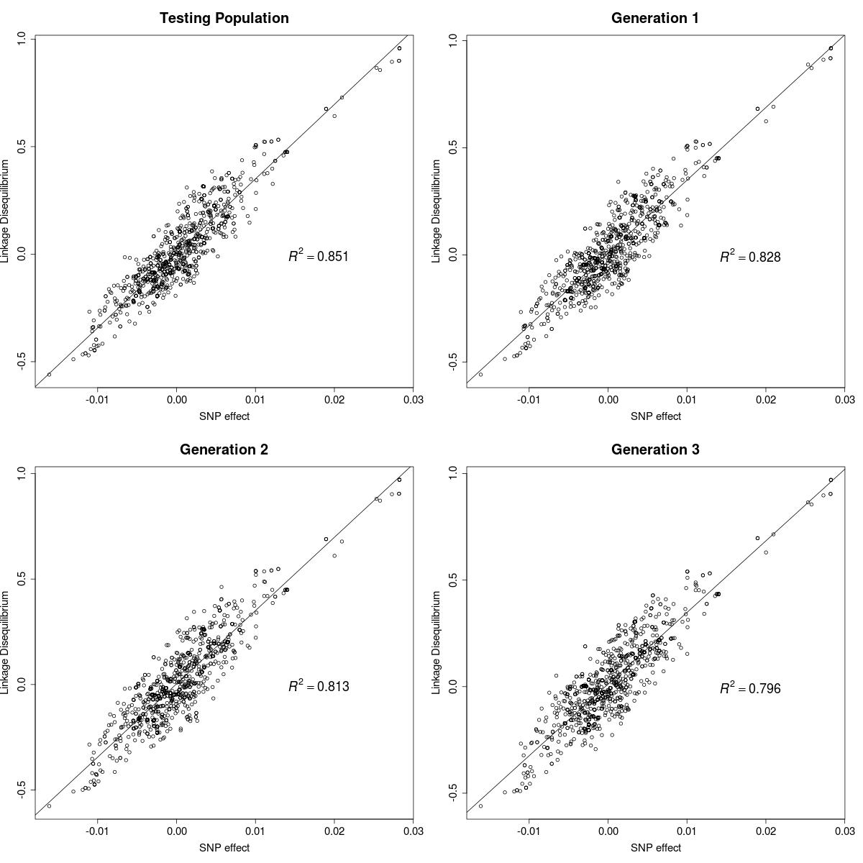
Supplementary Figure S2. Relationship between the linkage disequilibrium with a causal gene with an additive effect of 20.16 units and the estimated SNP effects for the 1000 closest markers in one case of the 4MG scenario.
.

Supplementary Figure S3. Accuracy from admixed ×2 genomic evaluation under different genetic architecture scenarios.
PG=Polygenic effects, 10G(20%)=Polygenic effects + 10 genes explaining 20% of the genetic variance, 4G(50%)=Polygenic effects + 4 genes explaining 50% of the genetic variance, Ex=Polygenic effects drawn from an exponential distribution, LMAF=polygenic effects with low allelic frequencies (≤0.05), 4MG=4 major genes.

Supplementary Figure S4. Accuracy from admixed ×7 genomic evaluation under different genetic architecture scenarios.
PG=Polygenic effects, 10G(20%)=Polygenic effects + 10 genes explaining 20% of the genetic variance, 4G(50%)=Polygenic effects + 4 genes explaining 50% of the genetic variance, Ex=Polygenic effects drawn from an exponential distribution, LMAF=polygenic effects with low allelic frequencies (≤0.05), 4MG=4 major genes.

