**Modelling homeorhetic trajectories of milk component yields, body composition and dry-matter intake in dairy cows: Influence of parity, milk production potential and breed**

J.B. Daniel1,2, N.C. Friggens1,H. Van Laar2, K.L. Ingvartsen3, and D. Sauvant1

*1UMR 0791 Modélisation Systémique Appliquée aux Ruminants, INRA, AgroParisTech, Université Paris-Saclay, 75005 Paris, France*

2*Trouw Nutrition R&D, P.O. Box 220, 5830 AE Boxmeer, the Netherlands*

3*University of Aarhus, Faculty of Agricultural Sciences, Research Center Foulum, PO Box 50, DK-8830 Tjele, Denmark*

**Supplementary Material S1…………………………………………………………………………….2**

**Supplementary Material S2…………………………………………………………………………….8**

**Supplementary Material S3…………………………………………………………………………..16**

**Supplementary Material S4………………………………………………………………………......20**

**Supplementary Material S5…………………………………………………………………………..23**

**Supplementary Material S6…………………………………………………………………………..26**

**Supplementary Material S1**

1. **Regulating sub-model**

All definitions and values of the parameters of the regulating sub-model are presented in Table 1 of the manuscript.

* 1. Regulating sub-model for fat

 (1)

with  at t=0

 (2)

with  at t=0

 (3)

with  at t=0

 (4)

with at t=0

* 1. Regulating sub-model for protein

 (5)

with  at t=0

 (6)

with  at t=0

 (7)

with  at t=0

* 1. Regulating sub-model for lactose

 (8)

with  at t=0

 (9)

with  at t=0

 (10)

with at t=0

* 1. Effect of pregnancy

 (11)

 (12)

* 1. Effect of growth

 (13)

 (14)

1. **Operating sub-model**

All definitions and values of the parameters of the operating sub-model are presented in Table 2 of the manuscript.

* 1. Milk yield and composition

 (15)

 (16)

 (17)

 (18)

 (19)

 (20)

 (21)

* 1. Body weight, body composition and gravid uterus

 (22)

 (23)

 (24)

(25)

 (26)

 (27)

 (28)

 (29)

* 1. Energy requirements and dry-matter intake

 (30)

 (31)

 (32)

 (33)

 (34)

 (35)

 (36)

 (37)

 (38)

 (39)

**Supplementary Material S2**

1. **Effect of Pregnancy** 
   1. In the regulating sub-model

The effect of pregnancy on the lactation curves was included in the regulating sub-model and assumed to influence the shift between the dynamic priorities of partitioning between milk and body reserves. Pregnancy was represented by a simple exponential function (unit-less):

 (1)

DIP and DP are the days in pregnancy and the length of the pregnancy, respectively. The conception date triggers DIP.

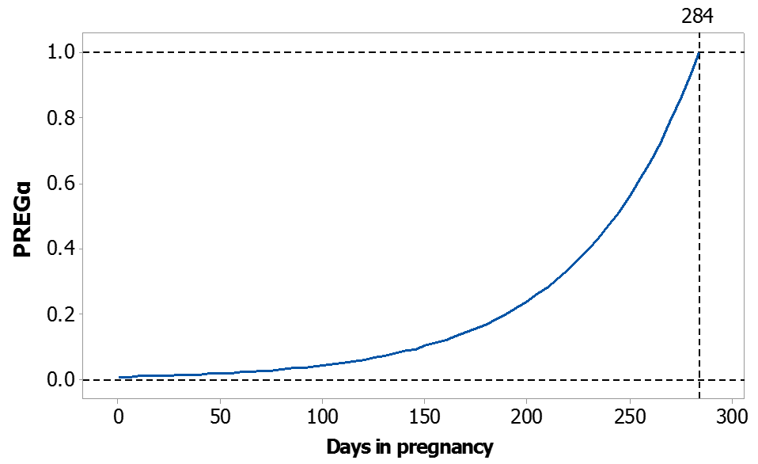

**Figure S1.** Function PREGα relative to days in pregnancy (DIP). Parameters values can be found in Table 1 of the manuscript.

As can be seen in Figure S1, the function PREGα goes from 0 when non-pregnant, to 1 at the end of pregnancy. The parameter kPREGα controls the shape of the exponential function and was calibrated on the milk yield difference between non-pregnant and pregnant cows assessed by the test-day genetic evaluation model from Leclerc (2008). The effect of PREGα on the regulating sub-model was applied through the following equation, where PREGβ is used as a multiplier of the parameter kMA (in equations 3,4,6,7,9 and 10 in Supplementary Material S1):

 (2)

where kPREGβ is the maximum size effect of function PREGα on kMA. As for the parameter kPREGα, kPREGβ was fitted with data from Leclerc (2008). When there is no pregnancy, PREGα=0, and thus PREGβ = 1, which leaves parameter kMA unaffected by the PREGβ function. However, when there is a pregnancy, PREGβ >1 and kMA is increased. This has the direct consequences to decrease lactation persistency but also to simultaneously increase body reserve gain. This means that the model implicitly ascribes different body condition score targets (or amount of lipid to store) for pregnant and non-pregnant cow. Direct experimental evidence in favour or against this effect is lacking. However, there is no doubt that pregnancy affects the persistency of milk yield and this effect has been quantified (Oltenacu *et al.*, 1980; Coulon *et al.*, 1995; Olori *et al.,* 1997).

* 1. In the operating sub-model

The function PREGα (equation 1) was also used to estimate the weight of the gravid uterus (GU) as:

 (3)

where GUcalv, the weight of the gravid uterus at the last day of pregnancy, was assumed to be fixed across animal, and equal to 87 kg (Bell, 1995). The weight of the gravid uterus was then used to estimate the empty BW (see equation 27 in Supplementary Material S1).

1. **Effect of growth**
   1. On priorities C, M and A

A fourth priority, for growth, was incorporated into the model so that it takes a priority over all other dynamic priorities. The shape of this priority was controlled by GRα:

 (4)

where kGR0 represents the degree of maturity of the cow at first calving that is, the ratio of empty BW at first calving on mature empty BW. Therefore when the animal has reached maturity, GRα=0. Parameter P is the parity number and t is the number of days in milk. With the assumption that cows reach maturity in the third lactation, the ratio between BW in first lactation and mature BW was found to be 0.85 and was not affected by breed (Friggens *et al.*, 2007). Accordingly, the slope parameter, kGRα, was fitted so that GRα is approximately 0 at the onset of the thirdlactation for an animal that started the first lactation with a degree of maturity of 0.85. Figure S2 illustrates the shape of GRα for a primiparous cows that started the first lactation with a degree of maturity of 0.85. From that figure, it can be seen that this animal would reached 95% [=(1-GRα)*100] of its mature weight at approximately 290 days in milk.

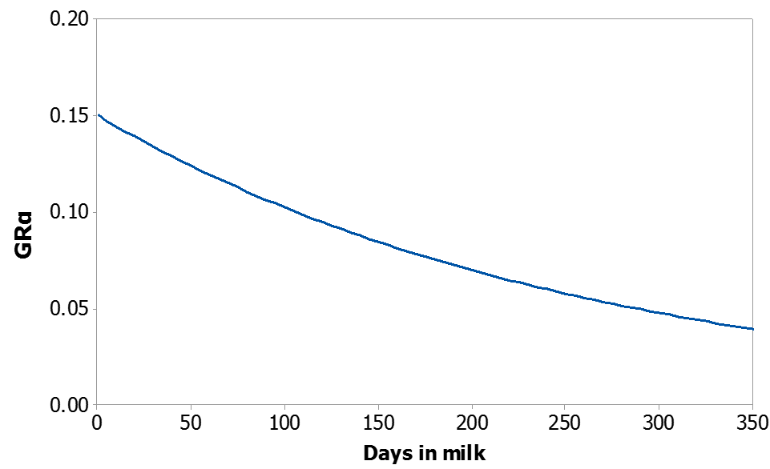

**Figure S2.** Function GRα relative to days in milk for a primiparous cow calving with a body weight equal to 85% of its mature body weight. Parameters values can be found in Table 1 of the manuscript.

This conceptual priority for growth GRα, based on the degree of maturity, was then used to affect the others priorities C, M and A through the following function, called GRβ (equation 5). GRβ multiplies priorities C, M and A each time there are used in the operating sub-model (see equations 15, 16, 17, 22 and 23 in Supplementary Material S1). In such way, when the animal is growing, the size effect of C, M and A is decreased. However, when the animal is mature, GRα = 0, and thus GRβ = 1, which leave dynamic priorities C, M and A unaffected.

 (5)

where kGRβ is a scaling factor that adjusts the effect of function GRα. The parameter kGRβ was fitted using dataset 1 so that realistic differences were simulated by the model in milk yield between primiparous and multiparous cows.

* 1. On developmental growth

The degree of maturity (= 1-GRα) multiply with the mature empty BW (MEBW) give the empty BW of the animal. This empty BW is used to obtained the size of body fat and body protein (see equation 24 and 25 in Supplementary Material S1). The rate of growth (in kg/d) for body fat (BF, equation 32 in Supplementary Material S1) and body protein (BP, equation 33 in Supplementary Material S1), needed to estimate the net energy requirement for growth, is obtained using the derivative of BF and BP (equations 24 and 25 in Supplementary Material S1, excluding changes in body fat and protein due to lactation).

1. **Specificity of the regulating sub-models of fat and lactose**

Regarding the regulating sub-models of fat and lactose, minor modifications were introduced. In the case of fat, secretion of milk fat is generally not maximal at the onset of lactation, with a very rapid increase during the first weeks. To simulate this effect, a small adaptation to the regulating sub-model structure was necessary for fat. Therefore, a fictitious dynamic priority C0F was added previous to CF with a mass action law controlling a delay of 1/ kC0CF between C0F and CF.

 with  at t=0 (6)

The resulting differential equation for CF is:

 with  at t=0 (7)

This results in a rapid increase priority for fat catabolism (CF) during the first weeks of lactation, followed by a subsequent decrease, as can be seen in Figure 2 of the manuscript.

With respect to the regulation sub-model for lactose, body glycogen storage was assumed negligible and therefore no glucose compartment was needed in this model. This assumption was justified because model outputs were generated daily. Therefore, lactose production is only driving by priority ML whose shape resembles a lactation curve, as described by the gamma function of Wood (1967) or simulated mechanistically in the mammary gland model of Neal and Thornley (1983). Consequently, priorities CL and AL were only used to generate a priority ML to acquire lactose precursor from the diet.

1. **Application of POT in the regulating sub-model**

The final equations as applied in the regulating sub-model are in Supplementary Material S1. This part describes in 3 steps the way POT was included in the model:

(1) An overriding adjustment of POT was used to scale all non-null initial values (C, M and C0F) as illustrated for C and M:

 at t=0 (8)

 at t=0 (9)

The effect of POT increases priorities C and M in the same proportion. This means that mobilization and feed intake will both increase with POT. These effects are consistent with the existing positive genetic correlations, between loss of body condition score and milk yield in early lactation (Berry *et al.*, 2002) and between DMI and milk yield (Veerkamp *et al.*, 1995).

(2) Differences in the effect of POT have been observed between milk components in a dataset of Holstein cows receiving the same ration (dataset 1). For an increase of 10 kg of milk at peak, the proportional increase of lactose secretion was larger than the increase in protein secretion, itself larger than the increase in fat secretion. In order to simulate this, the ratio POT/POTREF was adjusted for each milk component using a parameter (kM) as follows:

 (10)

Therefore the function (POT/POTREF) from equation 8 and 9 was replaced by equation 10 using kMF, kMP or kML. A value of kM = 1 indicates no adjustment effect of kM on POT, values of kM < 1 amplify the effect of POT and values > 1 reduce the effect of POT.

(3) Furthermore, increasing length of mobilization phase has been found in cows selected for maximum compared to average milk production (Coffey *et al.*, 2004). To reproduce this effect, kCMF (equations 2 and 3 in Supplementary Material S1) and kCMP (equations 5 and 6 in Supplementary Material S1), within the regulating sub-models of fat and protein, respectively, were adjusted with POT to allow varying length of mobilization:

 (11)

1. **References**

Bell AW, Slepetis R and Ehrhardt RA. 1995. Growth and accretion of energy and protein in the gravid uterus during late pregnancy in Holstein cows. Journal of Dairy Science 78, 1954–1961.

Berry DP, Buckley F, Dillon P, Evans FD, Rath M and Veerkamp RF 2002. Genetic parameters for level and change of body condition score and body weight in dairy cows. Journal of Dairy Science 85, 2030–2039.

Coffey MP, Simm G, Oldham JD, Hill WG and Brotherstone S 2004. Genotype and diet effects on energy balance in the first three lactations of dairy cows. Journal of Dairy Science 87, 4318–4326.

Coulon JB, Pérochon L and Lescourret F 1995. Modelling the effect of the stage of pregnancy on dairy cows' milk yield. Animal Science 60:401–408.

Friggens NC, Berg P, Theilgaard P, Korsgaard IR, Ingvartsen KL, Løvendahl P and Jensen J 2007. Breed and parity effects on energy balance profiles through lactation: Evidence of genetically driven body energy change. Journal of Dairy Science 90, 5291–5305.

Leclerc H 2008. Development of the French dairy cattle test-day model genetic evaluation and prospects of using results for herd management. Ph.D. Thesis. AgroParisTech, Paris, France.

Olori VE, Brotherstone S, Hill WG and McGuirk BJ 1997. Effect of gestation stage on milk yield and composition in Holstein Friesian dairy cattle. Livestock Production Science 52, 167–176.

Oltenacu PA, Rounsaville TR, Milligan RA and Hintz RL 1980. Relationship between days open and cumulative milk yield at various intervals from parturition for high and low producing cows. Journal of Dairy Science 63, 1317–1327.

Veerkamp RF, Simm G and Oldham JD 1995. Genotype by environment interaction: experience from Langhill. Pages 59–66 in Breeding and feeding the high genetic merit dairy cow. Lawrence TL, Gordon FJ and Carson A, ed.: British Society of Animal Science Occasional Publications, Midlothian, Scotland.

Wood PDP 1967. Algebraic model of the lactation curve in cattle. Nature 216, 164–165.

**Supplementary Material S3**

1. **Body protein and body fat relative to days in milk**

Available data from literature with measured body fat and protein changes relative to days in milk were selected. A total of 8 publications (72 treatments means, 13 intra-experiment comparisons) were used: Belyea *et al.* 1978; Martin and Ehle, 1986; Chilliard *et al.*, 1991; McGuffey *et al.*, 1991; Gibb *et al.*, 1992; Andrew *et al.*, 1994; Komaragiri and Erdman, 1997; Komaragiri *et al.*, 1998. In this publications, body protein and body fat were adjusted to correct for the between experiment variability by centring body protein on 85 kg and body fat on 105 kg. Unadjusted and adjusted values (body protein 85, body fat 105) are presented in Figure S3.

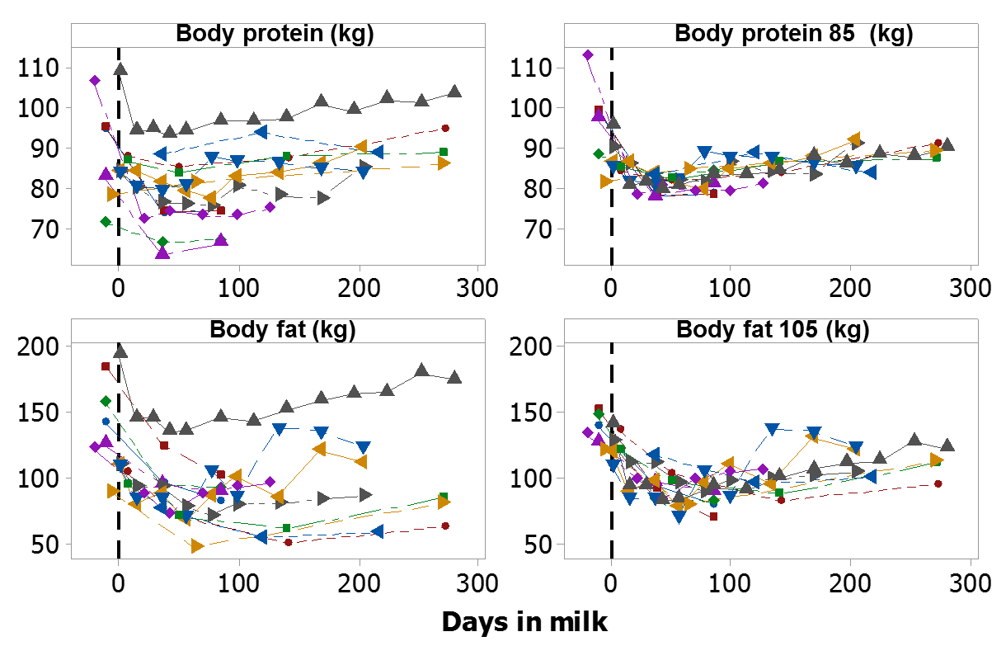

**Figure S3.** Body protein and body fat relative to days in milk, unadjusted (left panels) and adjusted (right panels) for the between-experiment variation. Each line represents one intra-experiment comparison (total of 13) including 72 treatments means.

Adjusted body protein and fat were then used to calibrate parameters kAF, kCF,kAP and kCP, that control the size of fat/protein being deposited/mobilised. These values were then adjusted by calibration against the changes in empty BW observed in dataset 1 (see manuscript). The final result of these calibration is shown on Figure S4 across 3 milk production potentials (POT=20, 35 and 50kg) for an animal with mature empty BW of 520 kg and with body condition score at calving of 3.5 (1-5 scale). For comparison, the adjusted data from Figure S3 are also presented in grey.

 

**Figure S4** Effect of potential parameter POT, at levels 20 (even stippled line), 35 (solid line) and 50 kg (uneven stippled line), on body protein and body fat (kg) relative to DIM for a third lactation Holsteins cows, together with data from literature (see text for reference). Parameters for mature empty BW (MEBW), body condition score at calving (BCSc) and conception date were 520 kg, 3.50 and 100 DIM, respectively.

1. **Relationship between body fatness and BCS**

In the model body fatness (ratio between body fat and body weight) is estimated from BCS using the relationship established in NRC (2001). This relationship was compared to the one proposed by Yan *et al.* (2005) and the within-experiment relationship between body fatness and BCS, obtained with 25 treatment means from 4 experiments (Wright and Russel, 1984; Chilliard *et al.*, 1991; Komaragiri and Erdman, 1997; Komaragiri *et al.*, 1998), which was:

 (RMSE=0.0237). (1)

The comparison between these 3 equations is shown in Figure S5. The relationship from NRC (2001) retained in the model is an intermediate between the 2 others propositions.



**Figure S5**. Comparison of 3 equations that predict body fatness (% of fat in empty BW) from BCS (1-5 scale). Equation 1: ●; NRC (2001): ○; Yan *et al.* (2005): ▲.

1. **References**

Andrew SM, Waldo DR and Erdman RA 1994. Direct analysis of body composition of dairy cows at three physiological stages. Journal of Dairy Science 77, 3022–3033.

Belyea RL, Frost GR, Martz FM, Clark JL and Forkner LG 1978. Body composition of dairy cattle by potassium-40 liquid scintillation detection. Journal of Dairy Science 61, 206–211.

Chilliard Y, Cisse M, Lefaivre R and Remond B. 1991. Body composition of dairy cows according to lactation stage, somatotropin treatment and concentrate supplementation. Journal of Dairy Science 74, 3103–3116.

Gibb MJ, Irvings WE, Dhanoa MS and Sutton JD 1992. Changes in body components of autumn-calving Holstein Friesian cows over the first 29 weeks of lactation. Animal Production 5, 339–360.

Komaragiri MVS and Erdman RA. 1997. Factors affecting body tissue mobilization in early lactation dairy cows. 1. Effects of dietary protein on mobilization of body fat and protein. Journal of Dairy Science 80, 929–937.

Komaragiri MVS, Casper DP and Erdman RA. 1998. Factors affecting body tissue mobilization in early lactation dairy cows. 2. Effect of dietary fat on mobilization of body fat and protein. Journal of Dairy Science 81, 169–175.

Martin RA and Ehle FR 1986. Body composition of lactating and dry Holstein cows estimated by deuterium dilution. Journal of Dairy Science 69, 88–98.

McGuffey RK, Basson RP and Spike TE 1991. Lactation response and body composition of cows receiving somatotropin and three ratios of forage to concentrate. Journal of Dairy Science 74, 3095–3102.

NRC 2001. Nutrient requirements of dairy cattle, 7th revised edition. National Academy Press, Washington, DC, USA.

Wright IA and Russel AJF. 1984. Partition of fat, body composition and body condition score in mature cows. Animal Production 38, 23–32.

Yan T, Agnew RE and Mayne CS. 2005. Prediction of body weight and composition in lactating dairy cows: Relationship between body condition score and body composition. In: The Proceedings of BSAS Annual Meeting, p180, York, U.K.

**Supplementary Material S4**

1. **Model calibration using dataset 1**

The model was calibrated against data of multiparous cows from dataset 1. For some parameters, others datasets were used in combination with dataset 1 (see details in Table S1). Parameters not listed in Table S1 were either fixed by the user (POT, POTREF, P, DP, Conc. date, [NEL]) or based on others sources described in the text as they are introduced: BCS_BF and BP_FFM from NRC (2001), GUcalv and kNEL_GU from Bell *et al.* (1995), EBW_BW and FFM_EBW from literature dataset detailed in Supplementary Material S3, kM, kls and kgt from Sauvant *et al.* (2015), kGU from Ferrell *et al.,* 1976. Note that BCSc for this dataset was not available and was set at 3.25 (see Table 2). Considering this assumption, MEBW was thus estimated by minimizing difference between EBW at calving from multiparous cows (average parity number = 3.4 ± 1.5) simulated by the model and estimated from the dataset. See Supplementary Material S5 for detail description of estimation of EBW from BW data.

**Table S1.** Source of data used for the calibration of model parameters

|  |  |  |
| --- | --- | --- |
| **Parameters** | **Role** | **Data used for calibration** |
| kC0CF, kCMF,kCMP, kCML, kMAF, kMAP, kMAL | Parameters controlling the shape of the dynamic priorities (C0F, CF, MF, AF, CP, MP, AP, CL, AL, ML) | Multiparous of dataset 1 |
| kC0F, MFt0, MPt0, MLt0 | Parameter controlling initial size of priority compartments | Multiparous of dataset 1 |
| kMF, kMP, kML | Parameters controlling the effect of POT on each regulating sub-model (fat, protein and lactose) | Multiparous of dataset 1 |
| kPREGα, kPREGβ | Parameters controlling the effect of pregnancy | Multiparous of dataset 1 and Leclerc (2008) |
| kGRα, kGRβ | Parameters controlling the effect of growth | Multiparous and primiparous of dataset 1 |
| kMY, kMFY, kMPY, kMLY, | First set of scaling factors for milk production | Multiparous of dataset 1 |
| kCF, kAF, kCP, kAP, MEBW, BCSc | First set of scaling factors for milk production | Multiparous of dataset 1 and literature dataset (see Supplementary Material S3) |

1. **Model calibration using dataset 2**

A subset of dataset 2 (parity 2) was used to derive the 7 breed scaling parameters, i.e. adjust the relative secretion of milk components (kMFY, kMPY, kMLY) and changes in body composition (kCF, kAF, kCP and kAP) according to breed. The set of parameters for milk composition were estimated through a least square procedure performed with the simplex algorithm of the Modelmaker 3.0 software (Cherwell Scientific Ltd, 2000) using values estimated with dataset 1 as default values and 100 convergence steps. Scaling parameters for body composition were estimated iteratively based on observed changes in BCS and empty BW relative to calving of the multiparous cows from Dataset 2 as follows. First, kAF and kCF were adjusted to achieve a minimal difference between observed and predicted BCS. Second, kCP and kAP were adjusted to achieve a minimal difference between observed and predicted empty BW. Finally, steps 1 and 2 were repeated until model fit was considered graphically satisfactorily. Before the estimation of those scaling parameters, POT was changed to match the observed peak of lactation in second parity for each breed. Additionally, MEBW and BCSc were changed so that predicted calving empty BW equal observed calving empty BW and predicted BCSc equal observed BCSc. The estimated scaling parameters are displayed in Table 2 of the manuscript (Dataset 2).

1. **Model identifiability**

The full model was tested for identifiability. For that purpose, Matlab software GenSSI (Chis *et al.* 2011), which uses the generating series approach, was used. When all 24 parameters related to identifiability testing were considered as totally unknown the analysis concluded that the model is not globally identifiable. However, assuming the initial conditions of the compartments C and M are known (i.e. kMF, kMP, kML, MFt0, MPt0, MLt0 = all parameters dealing with the effect of potential) the identifiability analysis led to the conclusion that the model is structurally locally identifiable.

1. **References**

Bell AW, Slepetis R and Ehrhardt RA. 1995. Growth and accretion of energy and protein in the gravid uterus during late pregnancy in Holstein cows. Journal of Dairy Science 78, 1954–1961.

Cherwell Scientific Ltd. 2000. Modelmaker user manual. Cherwell Scientific Ltd, Oxford, England.

Chis O, Banga JR and Balsa-Canto E 2011. GenSSI: a software toolbox for structural identifiability analysis of biological models. Bioinformatics 27, 2610–2611.

Ferrell CL, Garrett WN, Hinman N and Grichting G 1976. Energy utilization by pregnant and non-pregnant heifers. Journal of Animal Science 42, 937–950.

Leclerc H 2008. Development of the French dairy cattle test-day model genetic evaluation and prospects of using results for herd management. Ph.D. Thesis. AgroParisTech, Paris, France.

NRC 2001. Nutrient requirements of dairy cattle, 7th revised edition. National Academy Press, Washington, DC, USA.

Sauvant D, Ortigues-Marty I, Giger-Reverdin S and Nozière P 2015. Updating energy requirements and efficiency of dairy ruminant females. Rencontre Recherche Ruminants 22, 225–228.

**Supplementary Material S5**

1. **Calculated nutritional values of the rations**

Table S2 shows the calculated chemical composition of the ration fed, and the calculated nutritional values with the INRA Systali model (Sauvant and Nozière, 2016).

**Table S2.** Calculated nutritional values with INRA Systali feed unit system

|  |  |  |  |  |  |
| --- | --- | --- | --- | --- | --- |
|  | **Dataset 1**1  (Trouw Nutrition R&D) | |  | **Dataset 2**1  (Nielsen *et al.* 2003) | |
| Variables | Mean | SD |  | Mean | SD |
| CP (g/kg DM) | 164 | 13 |  | 147 | 4 |
| RDP (g/kg DM) | 112 | 9 |  | 104 | 4 |
| RUP (g/kg DM) | 52 | 7 |  | 43 | 2 |
| NDF (g/kg DM) | 385 | 26 |  | 352 | 25 |
| Forage NDF (g/kg DM) | 303 | 50 |  | 236 | 25 |
| Starch (g/kg DM) | 193 | 26 |  | 97 | 14 |
| EE (g/kg DM) | 36 | 6 |  | 34 | 0 |
| Concentrate inclusion (% DM) | 34 | 11 |  | 49 | 0 |
| NEL (MJ/kg DM) | 7.17 | 0.24 |  | 6.64 | 0.31 |
| MP (g/kg DM) | 90.0 | 6.5 |  | 83.5 | 1.4 |

1Statistics of 30 514 weekly individual data are presented for dataset 1 and 6 591 weekly individual data are presented for dataset 2.

1. **Creation of subsets within dataset 1 and 2**

In dataset 1, average lactation curves for milk yield, milk component yields and BW were calculated. The multiparous cows were divided into 4 groups based on average milk production between weeks 4 and 14 (MYpeak), thus there were: 87 cows with MYpeak<35kg/d, 142 cows with 35<MYpeak<40 kg/d, 122 cows with 40<MYpeak<45 kg/d and 69 cows with MYpeak>45 kg/d. For primiparous cows, cows were assigned into 3 groups based on average milk yield between weeks 4 and 18 as follows (MYpeak_primi): 65 cows with MYpeak_primi <28kg/d, 99 cows with 28< MYpeak_primi <32kg/d and 96 cows with MYpeak_primi >32 kg/d.

In dataset 2, 6 average lactation curves for milk yield, milk component yields, BW and BCS were obtained: Holstein parity 1 (52 cows); Holstein parity 2 (41 cows), Danish Red parity 1 (44 cows), Danish Red parity 2 (36 cows), Jersey parity 1 (40 cows) and Jersey parity 2 (34 cows).

1. **Estimation of empty BW**

As one of the ambitions of the model was to simulate the empty BW trajectory through lactation, an estimation of gut fill was necessary for both of the datasets. An equation predicting the liquid weight within reticulo-rumen (**RRLiq**, %BW) was derived from a meta-analysis database (Sauvant and Nozière, 2016) using NDF intake (NDFI, kg) and BW (kg) as predictors, the resulting equation was (517 treatment means, R2=0.94, RMSE=0.74):

 (1)

Gut fill was then calculated as (Martin and Sauvant, 2003):

 (2)

where 11.4 % is the DM content of the reticulo-rumen and 69.6% is the weight of the reticulo-rumen contents relative to the weight of the whole digestive tract contents. Finally empty BW was calculated as:



1. **References**

Martin O and Sauvant D 2003. Modeling digestive tract contents in cattle. Rencontre Recherche Ruminants 10, 167–170.

Nielsen HM, Friggens NC, Lovendahl P, Jensen J and Ingvartsen KL 2003. Influence of breed, parity, and stage of lactation on lactational performance and relationship between body fatness and live weight. Livestock Production Science 79, 119–133.

Sauvant D and Nozière P. 2016. Quantification of the main digestive processes in ruminants: the equations involved in the renewed energy and protein feed evaluation systems. Animal 10, 755-770.

**Supplementary Material S6**

**Table S3.** Summary of observed versus predicted outputs (empty BW, dry-matter intake, milk yield, milk component yields, milk component contents) for primiparous cows across milk production potential (P1 is POT1=35.0; P2 is POT=42.2; P3 is POT=49.4) of dataset 1.

|  |  |  |  |  |  |  |  |
| --- | --- | --- | --- | --- | --- | --- | --- |
|  | Observed2 | Predicted2 | RMSPE%3 | ECT%4 | ER%5 | ED%6 | CCC7 |
| Empty BW (kg) | | | | | | | |
| P1 | 451 ± 25 | 454 ± 26 | 1.5 | 15.4 | 7.0 | 77.6 | 0.97 |
| P2 | 452 ± 20 | 455 ± 25 | 2.0 | 10.6 | 49.1 | 40.4 | 0.95 |
| P3 | 454 ± 20 | 459 ± 25 | 1.8 | 26.1 | 38.8 | 35.1 | 0.96 |
| Dry-matter intake (kg/day) | | | | | | | |
| P1 | 17.6 ± 1.5 | 17.9 ± 1.4 | 2.0 | 53.7 | 8.0 | 38.2 | 0.98 |
| P2 | 18.7 ± 1.7 | 19.4 ± 1.6 | 4.3 | 85.4 | 0.1 | 14.5 | 0.89 |
| P3 | 19.7 ± 1.9 | 20.9 ± 1.8 | 6.3 | 94.1 | 0.0 | 5.9 | 0.81 |
| Milk yield (kg/day) | | | | | | | |
| P1 | 22.8 ± 2.4 | 22.6 ± 3.0 | 4.0 | 5.6 | 53.0 | 41.4 | 0.97 |
| P2 | 26.5 ± 3.1 | 27.0 ± 3.6 | 4.0 | 23.8 | 32.5 | 43.6 | 0.96 |
| P3 | 31.2 ± 3.4 | 31.5 ± 4.2 | 3.0 | 10.5 | 66.5 | 23.0 | 0.99 |
| Milk fat yield (g/day) | | | | | | | |
| P1 | 1031 ± 73 | 1013 ± 85 | 3.7 | 18.3 | 21.9 | 59.8 | 0.87 |
| P2 | 1124 ± 83 | 1133 ± 94 | 3.8 | 2.6 | 24.2 | 73.2 | 0.78 |
| P3 | 1219 ± 79 | 1254 ± 103 | 6.0 | 49.7 | 30.1 | 20.1 | 0.89 |
| Milk protein yield (g/day) | | | | | | | |
| P1 | 807 ± 59 | 817 ± 62 | 7.1 | 3.0 | 25.6 | 71.3 | 0.55 |
| P2 | 908 ± 69 | 935 ± 71 | 7.3 | 16.5 | 17.6 | 65.9 | 0.58 |
| P3 | 1019 ± 73 | 1054 ± 80 | 8.7 | 15.3 | 30.3 | 54.4 | 0.39 |
| Milk lactose yield (g/day) | | | | | | | |
| P1 | 1078 ± 129 | 1028 ± 167 | 7.2 | 40.6 | 31.8 | 27.6 | 0.90 |
| P2 | 1247 ± 160 | 1220 ± 198 | 5.5 | 15.0 | 40.8 | 44.2 | 0.95 |
| P3 | 1449 ± 175 | 1412 ± 229 | 5.2 | 24.1 | 58.2 | 17.8 | 0.97 |
| Milk fat content (g/kg) | | | | | | | |
| P1 | 45.5 ± 2.2 | 45.3 ± 2.8 | 3.6 | 1.4 | 38.1 | 60.5 | 0.80 |
| P2 | 42.6 ± 2.4 | 42.2 ± 2.5 | 2.2 | 16.3 | 9.4 | 74.3 | 0.93 |
| P3 | 39.3 ± 3.0 | 40.1 ± 2.3 | 3.8 | 25.7 | 8.3 | 66.0 | 0.88 |
| Milk protein content (g/kg) | | | | | | | |
| P1 | 35.6 ± 1.8 | 36.8 ± 5.1 | 13.9 | 5.4 | 82.5 | 12.2 | 0.29 |
| P2 | 34.4 ± 1.9 | 35.1 ± 4.8 | 12.6 | 2.1 | 83.0 | 14.9 | 0.41 |
| P3 | 32.8 ± 1.8 | 33.9 ± 4.6 | 13.2 | 6.2 | 80.1 | 13.7 | 0.37 |
| Milk lactose content (g/kg) | | | | | | | |
| P1 | 47.3 ± 0.7 | 45.4 ± 1.7 | 4.8 | 68.1 | 27.4 | 4.5 | 0.30 |
| P2 | 47.0 ± 0.7 | 44.9 ± 1.8 | 5.1 | 71.9 | 24.8 | 3.3 | 0.30 |
| P3 | 46.4 ± 0.6 | 44.6 ± 1.8 | 4.7 | 64.4 | 34.1 | 1.5 | 0.35 |
|  |  |  |  |  |  |  |  |

1POT is the parameter controlling the overall effect of milk production potential (see Table 1 in the manuscript)

2Mean ± SD

3Root mean squared prediction error expressed as a percentage of the observed mean.

4Error due to intercept bias, as a percent of total MSPE.

5Error due to slope bias, as a percent of total MSPE.

6Error due to disturbance, as a percent of total MSPE.

7Concordance correlation coefficient (scale from −1 to 1).

**Table S4.** Summary of observed versus predicted outputs (empty BW, dry-matter intake, milk yield, milk component yields, milk component contents) for multiparous cows across milk production potential (M1 is POT1=32.8; M2 is POT=39.1; M3 is POT=43.8; M4 is POT=49.4) of dataset 1.

|  |  |  |  |  |  |  |  |
| --- | --- | --- | --- | --- | --- | --- | --- |
|  | Observed2 | Predicted2 | RMSPE%3 | ECT%4 | ER%5 | ED%6 | CCC7 |
| Empty BW (kg) | | | | | | | |
| M1 | 510 ± 25 | 485 ± 16 | 5.5 | 76.9 | 3.5 | 19.6 | 0.47 |
| M2 | 504 ± 19 | 487 ± 16 | 3.8 | 64.7 | 0.8 | 34.4 | 0.52 |
| M3 | 505 ± 16 | 490 ± 17 | 3.1 | 48.3 | 13.5 | 38.2 | 0.44 |
| M4 | 508 ± 14 | 497 ± 18 | 2.7 | 30.6 | 33.5 | 35.9 | 0.35 |
| Dry-matter intake (kg/day) | | | | | | | |
| M1 | 20.4 ± 1.8 | 20.1 ± 1.6 | 2.4 | 30.2 | 8.0 | 61.8 | 0.96 |
| M2 | 21.6 ± 2.0 | 21.7 ± 1.8 | 2.0 | 3.9 | 14.3 | 81.8 | 0.98 |
| M3 | 22.5 ± 2.2 | 22.9 ± 1.9 | 3.2 | 33.1 | 8.8 | 58.1 | 0.95 |
| M4 | 24.0 ± 2.2 | 24.4 ± 2.0 | 3.1 | 34.6 | 2.7 | 62.6 | 0.95 |
| Milk yield (kg/day) | | | | | | | |
| M1 | 26.6 ± 4.4 | 26.3 ± 4.6 | 3.9 | 7.2 | 9.2 | 83.6 | 0.97 |
| M2 | 30.6 ± 5.8 | 31.1 ± 5.4 | 4.8 | 10.6 | 1.2 | 88.2 | 0.97 |
| M3 | 34.2 ± 6.4 | 34.6 ± 6.0 | 4.0 | 10.0 | 3.2 | 86.8 | 0.98 |
| M4 | 38.7 ± 7.2 | 38.9 ± 6.7 | 3.2 | 1.8 | 7.7 | 90.6 | 0.99 |
| Milk fat yield (g/day) | | | | | | | |
| M1 | 1217 ± 156 | 1224 ± 167 | 3.9 | 1.9 | 12.0 | 86.0 | 0.95 |
| M2 | 1342 ± 211 | 1355 ± 182 | 5.3 | 2.6 | 2.0 | 95.4 | 0.92 |
| M3 | 1450 ± 231 | 1454 ± 194 | 6.3 | 0.1 | 3.8 | 96.1 | 0.92 |
| M4 | 1538 ± 233 | 1572 ± 207 | 6.3 | 10.2 | 0.2 | 89.6 | 0.90 |
| Milk protein yield (g/day) | | | | | | | |
| M1 | 959 ± 116 | 982 ± 149 | 8.9 | 6.9 | 37.3 | 55.8 | 0.82 |
| M2 | 1066 ± 145 | 1112 ± 169 | 8.2 | 27.1 | 19.3 | 53.6 | 0.86 |
| M3 | 1161 ± 147 | 1209 ± 183 | 8.7 | 21.6 | 29.1 | 49.3 | 0.84 |
| M4 | 1276 ± 155 | 1325 ± 201 | 8.5 | 19.6 | 35.1 | 45.3 | 0.85 |
| Milk lactose yield (g/day) | | | | | | | |
| M1 | 1216 ± 217 | 1215 ± 242 | 5.5 | 0.0 | 24.5 | 75.5 | 0.96 |
| M2 | 1392 ± 284 | 1426 ± 284 | 6.7 | 12.7 | 2.1 | 85.2 | 0.95 |
| M3 | 1550 ± 313 | 1583 ± 316 | 5.6 | 14.9 | 2.0 | 83.1 | 0.96 |
| M4 | 1741 ± 351 | 1771 ± 353 | 5.0 | 11.4 | 1.8 | 86.8 | 0.97 |
| Milk fat content (g/kg) | | | | | | | |
| M1 | 46.1 ± 2.5 | 46.9 ± 3.0 | 3.2 | 31.7 | 22.1 | 46.2 | 0.88 |
| M2 | 44.2 ± 2.8 | 44.0 ± 2.8 | 1.9 | 6.5 | 1.2 | 92.2 | 0.95 |
| M3 | 42.7 ± 3.5 | 42.3 ± 2.6 | 3.1 | 10.0 | 23.8 | 66.2 | 0.94 |
| M4 | 40.1 ± 3.6 | 40.7 ± 2.5 | 3.9 | 16.4 | 38.8 | 44.8 | 0.94 |
| Milk protein content (g/kg) | | | | | | | |
| M1 | 36.4 ± 2.0 | 37.8 ± 5.4 | 14.2 | 7.3 | 80.1 | 12.6 | 0.34 |
| M2 | 35.2 ± 2.2 | 36.2 ± 5.2 | 13.2 | 4.5 | 78.6 | 17.0 | 0.45 |
| M3 | 34.4 ± 2.4 | 35.3 ± 5.1 | 13.1 | 4.4 | 74.4 | 21.2 | 0.46 |
| M4 | 33.4 ± 2.5 | 34.5 ± 4.9 | 12.5 | 6.5 | 69.9 | 23.6 | 0.54 |
| Milk lactose content (g/kg) | | | | | | | |
| M1 | 45.7 ± 0.7 | 46.0 ± 1.6 | 2.5 | 9.0 | 78.8 | 12.2 | 0.79 |
| M2 | 45.4 ± 0.8 | 45.7 ± 1.7 | 2.4 | 7.0 | 74.4 | 18.7 | 0.80 |
| M3 | 45.2 ± 0.9 | 45.5 ± 1.7 | 2.3 | 9.7 | 76.4 | 13.9 | 0.86 |
| M4 | 44.8 ± 0.9 | 45.3 ± 1.7 | 2.6 | 17.5 | 68.1 | 14.5 | 0.79 |
|  |  |  |  |  |  |  |  |

1POT is the parameter controlling the overall effect of milk production potential (see Table 1 in the manuscript)

2Mean ± SD

3Root mean squared prediction error expressed as a percentage of the observed mean.

4Error due to intercept bias, as a percent of total MSPE.

5Error due to slope bias, as a percent of total MSPE.

6Error due to disturbance, as a percent of total MSPE.

7Concordance correlation coefficient (scale from −1 to 1).

**Table S5.** Summary of observed versus predicted outputs (empty BW, BCS, dry-matter intake, milk yield, milk component yields, milk component contents) for primiparous cows across breeds (Danish Red (DR) with POT1=29.1, Holstein (H) with POT=35.0, Jersey (J) with POT=24.0 ) of dataset 2.

|  |  |  |  |  |  |  |  |
| --- | --- | --- | --- | --- | --- | --- | --- |
|  | Observed2 | Predicted2 | RMSPE%3 | ECT%4 | ER%5 | ED%6 | CCC7 |
| Empty BW (kg) | | | | | | | |
| DR | 458 ± 20 | 479 ± 29 | 5.0 | 83.2 | 16.4 | 0.4 | 0.72 |
| H | 462 ± 20 | 470 ± 24 | 2.0 | 66.8 | 24.9 | 8.2 | 0.94 |
| J | 311 ± 11 | 322 ± 16 | 4.5 | 58.2 | 23.0 | 18.8 | 0.64 |
| Body condition score (1-5 scale) | | | | | | | |
| DR | 3.58 ± 0.14 | 3.48 ± 0.16 | 3.2 | 69.0 | 8.1 | 22.9 | 0.76 |
| H | 3.06 ± 0.15 | 3.05 ± 0.19 | 2.3 | 3.8 | 49.3 | 46.9 | 0.94 |
| J | 3.01 ± 0.13 | 3.08 ± 0.14 | 3.1 | 41.9 | 7.6 | 50.5 | 0.78 |
| Dry-matter intake (kg/day) | | | | | | | |
| DR | 17.4 ± 1.0 | 16.7 ± 1.3 | 3.9 | 82.6 | 12.7 | 4.7 | 0.86 |
| H | 19.6 ± 1.7 | 18.5 ± 1.6 | 5.7 | 93.2 | 0.1 | 6.7 | 0.81 |
| J | 15.3 ± 1.6 | 15.3 ± 1.1 | 5.7 | 0.4 | 6.8 | 92.9 | 0.85 |
| Milk yield (kg/day) | | | | | | | |
| DR | 19.5 ± 1.6 | 19.3 ± 2.1 | 4.8 | 5.9 | 45.7 | 48.4 | 0.90 |
| H | 23.8 ± 2.0 | 23.3 ± 2.5 | 4.3 | 28.1 | 30.0 | 41.8 | 0.92 |
| J | 17.0 ± 1.6 | 16.0 ± 1.8 | 8.3 | 46.2 | 9.8 | 44.0 | 0.70 |
| Milk fat yield (g/day) | | | | | | | |
| DR | 886 ± 39 | 870 ± 54 | 4.1 | 18.1 | 38.2 | 43.7 | 0.75 |
| H | 1060 ± 59 | 1034 ± 63 | 4.6 | 26.8 | 12.9 | 60.2 | 0.70 |
| J | 1017 ± 50 | 965 ± 60 | 6.8 | 56.2 | 14.7 | 29.1 | 0.45 |
| Milk protein yield (g/day) | | | | | | | |
| DR | 721 ± 16 | 690 ± 42 | 6.6 | 41.5 | 50.8 | 7.8 | 0.29 |
| H | 838 ± 19 | 829 ± 51 | 5.3 | 3.8 | 83.3 | 12.9 | 0.48 |
| J | 690 ± 15 | 660 ± 40 | 7.3 | 35.1 | 56.3 | 8.6 | 0.07 |
| Milk lactose yield (g/day) | | | | | | | |
| DR | 956 ± 91 | 901 ± 115 | 7.8 | 54.3 | 18.7 | 27.0 | 0.79 |
| H | 1150 ± 113 | 1065 ± 136 | 8.3 | 78.0 | 8.7 | 13.3 | 0.77 |
| J | 818 ± 92 | 747 ± 95 | 11.1 | 59.9 | 5.0 | 35.1 | 0.63 |
| Milk fat content (g/kg) | | | | | | | |
| DR | 45.6 ± 2.1 | 45.4 ± 2.6 | 3.0 | 1.5 | 36.7 | 61.9 | 0.85 |
| H | 44.7 ± 2.3 | 44.7 ± 2.5 | 1.1 | 0.6 | 13.5 | 85.9 | 0.98 |
| J | 60.1 ± 4.0 | 60.5 ± 3.6 | 7.2 | 0.7 | 25.4 | 73.9 | 0.33 |
| Milk protein content (g/kg) | | | | | | | |
| DR | 37.2 ± 2.7 | 36.1 ± 3.7 | 6.7 | 18.3 | 39.9 | 41.8 | 0.75 |
| H | 35.6 ± 3.7 | 35.9 ± 3.6 | 4.8 | 5.0 | 3.4 | 91.6 | 0.89 |
| J | 40.9 ± 3.3 | 41.5 ± 4.3 | 10.0 | 2.1 | 46.0 | 51.9 | 0.43 |
| Milk lactose content (g/kg) | | | | | | | |
| DR | 48.9 ± 0.8 | 46.6 ± 1.2 | 4.9 | 94.2 | 3.4 | 2.3 | 0.23 |
| H | 48.3 ± 0.9 | 45.7 ± 1.2 | 5.4 | 97.4 | 1.7 | 0.9 | 0.25 |
| J | 48.0 ± 1.0 | 46.5 ± 1.2 | 3.5 | 84.0 | 5.1 | 11.0 | 0.40 |
|  |  |  |  |  |  |  |  |

1POT is the parameter controlling the overall effect of milk production potential (see Table 1 in the manuscript). Breed scaling parameters used for the simulation can be found in Table 2 of the manuscript.

2Mean ± SD

3Root mean squared prediction error expressed as a percentage of the observed mean.

4Error due to intercept bias, as a percent of total MSPE.

5Error due to slope bias, as a percent of total MSPE.

6Error due to disturbance, as a percent of total MSPE.

7Concordance correlation coefficient (scale from −1 to 1).