Pig cognitive bias affects the conversion of muscle into meat by antioxidant and autophagy mechanisms

Y. Potes, M. Oliván, A. Rubio-González, B. de Luxán-Delgado, F. Díaz, V. Sierra, L. Arroyo, R. Peña, A. Bassols, J. González, R. Carreras, A. Velarde, M. Muñoz-Torres, A. Coto-Montes
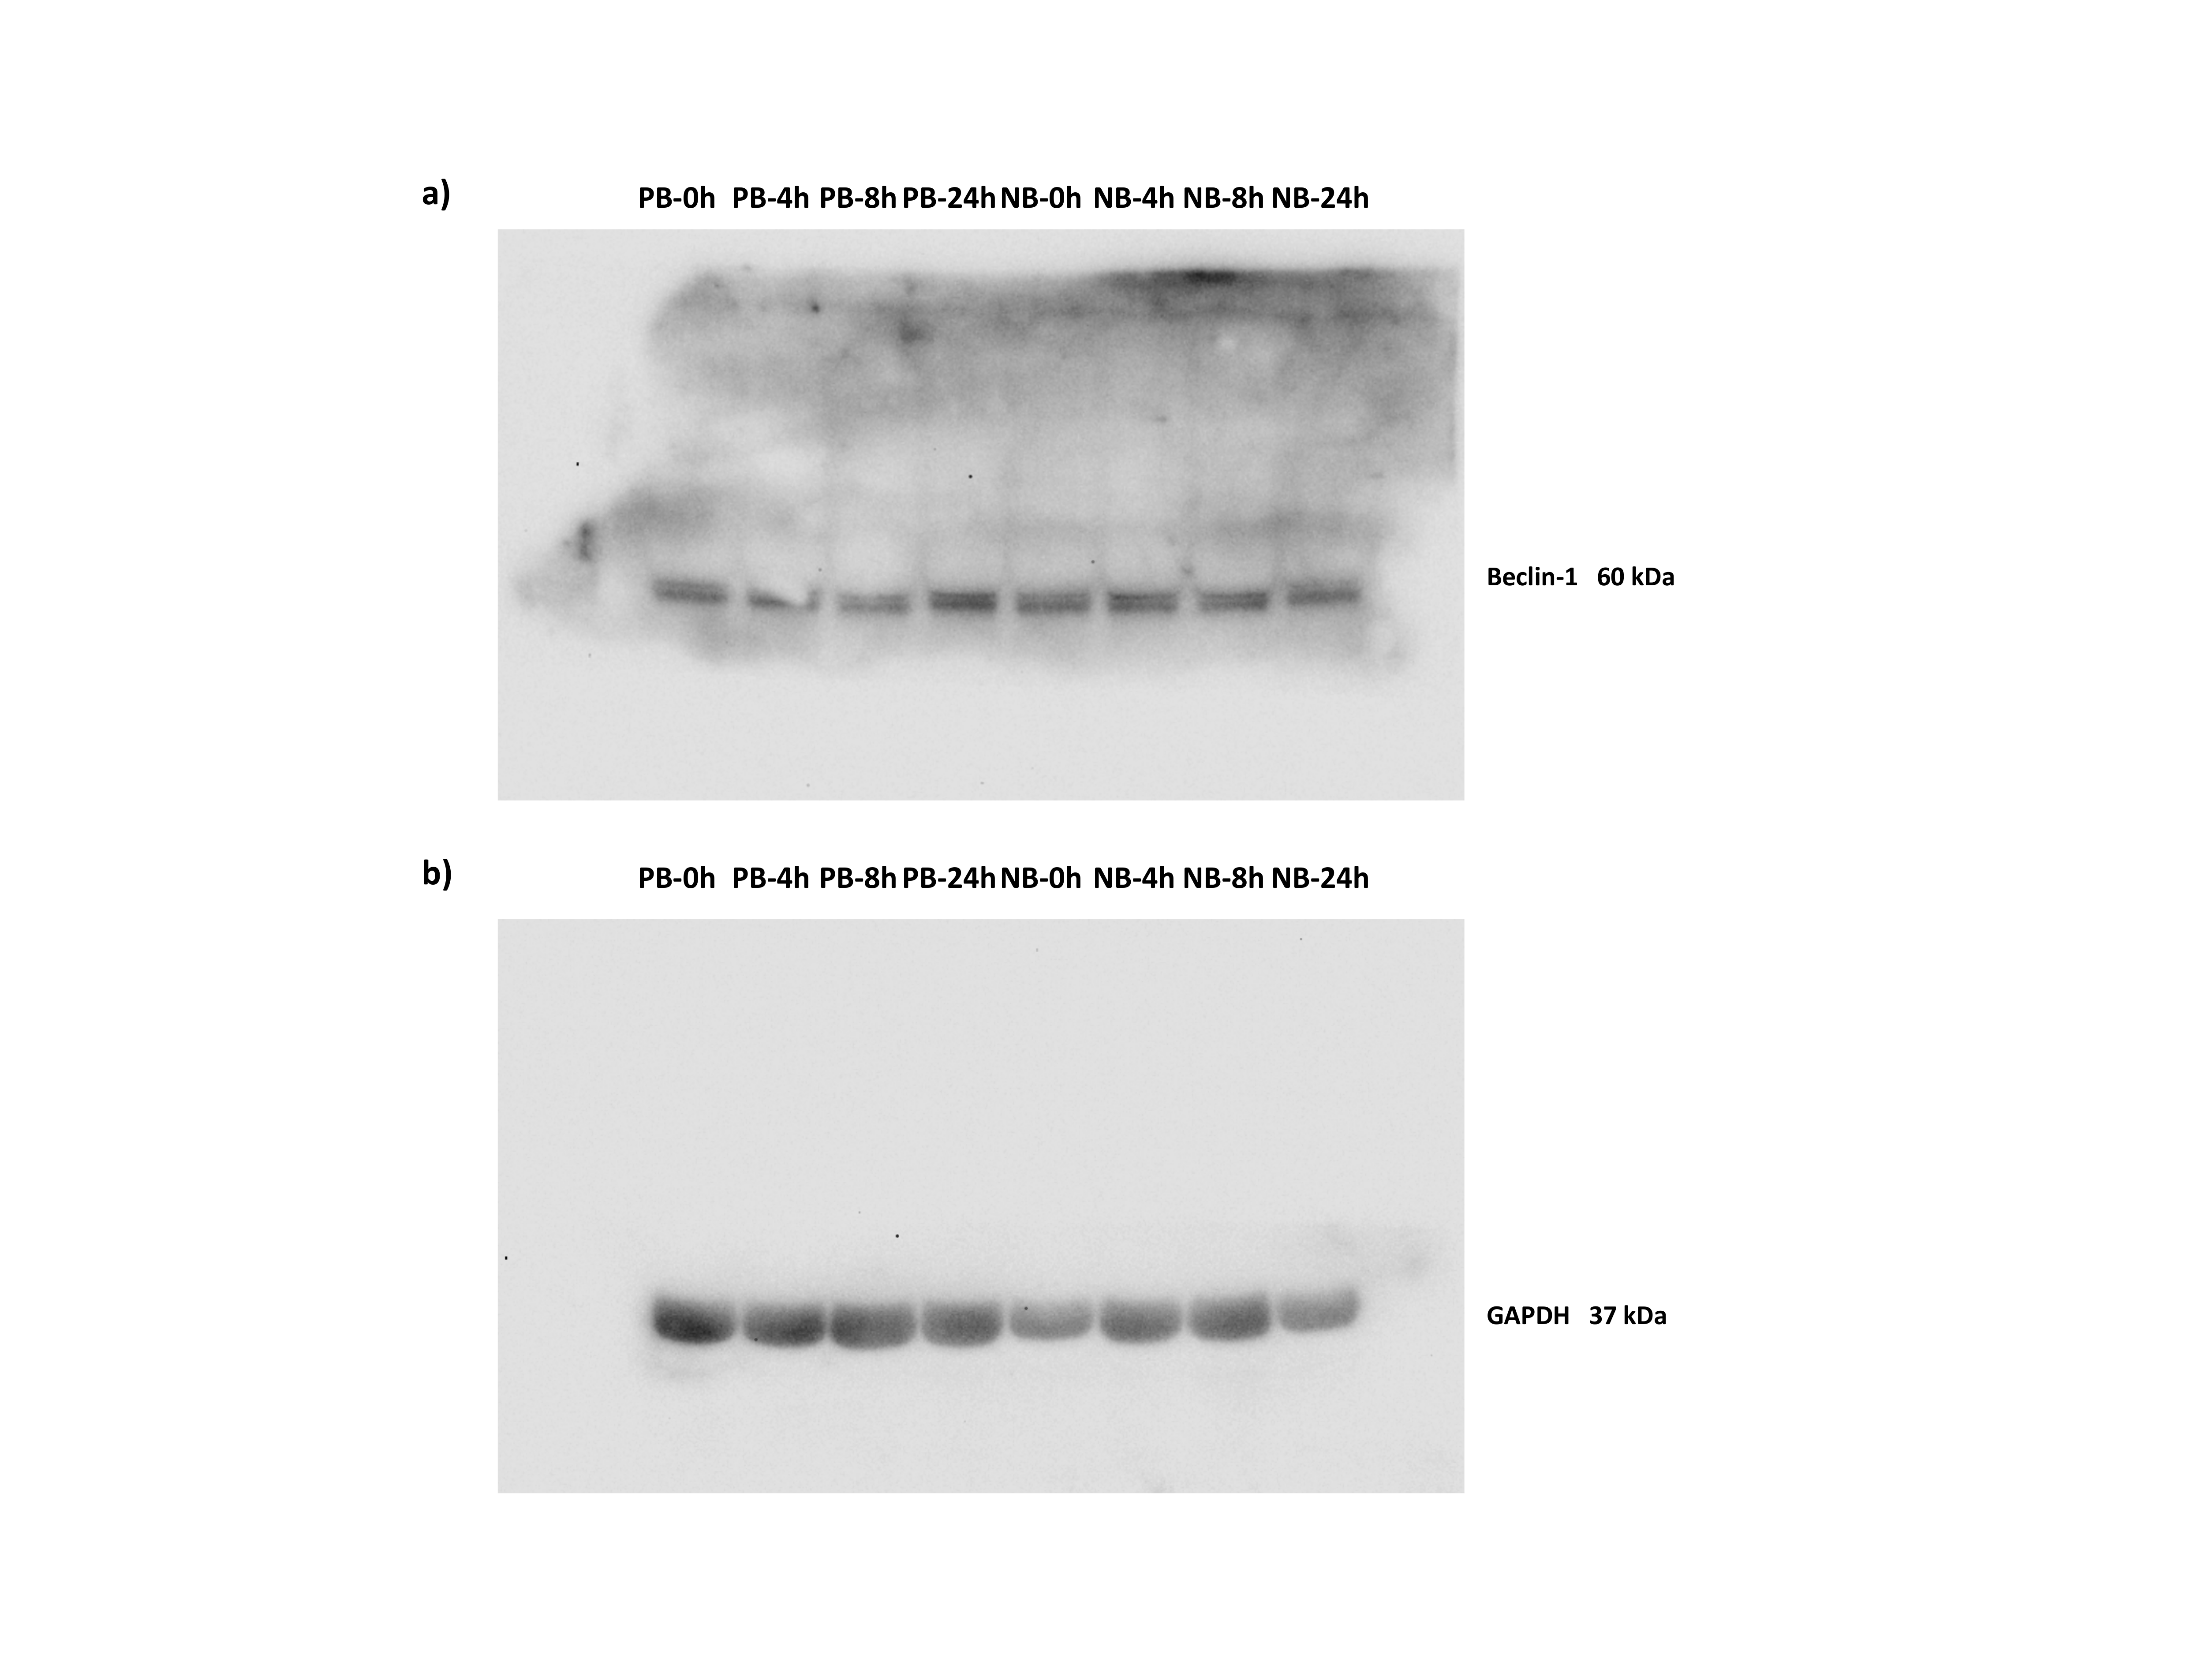

Supplementary Figure S1 Western blot analysis of Beclin-1 expression in the muscle tissue of positive (PB) and negative (NB) pigs for cognitive bias at different postmortem time (0, 4, 8 and 24 h), a) membrane incubated with primary antibody anti-Beclin-1 and the corresponding horseradish peroxidase-conjugated secondary antibody, b) the same membrane after washing and incubated with primary antibody anti-GAPDH (used for normalization) and the corresponding horseradish peroxidase-conjugated secondary antibody.

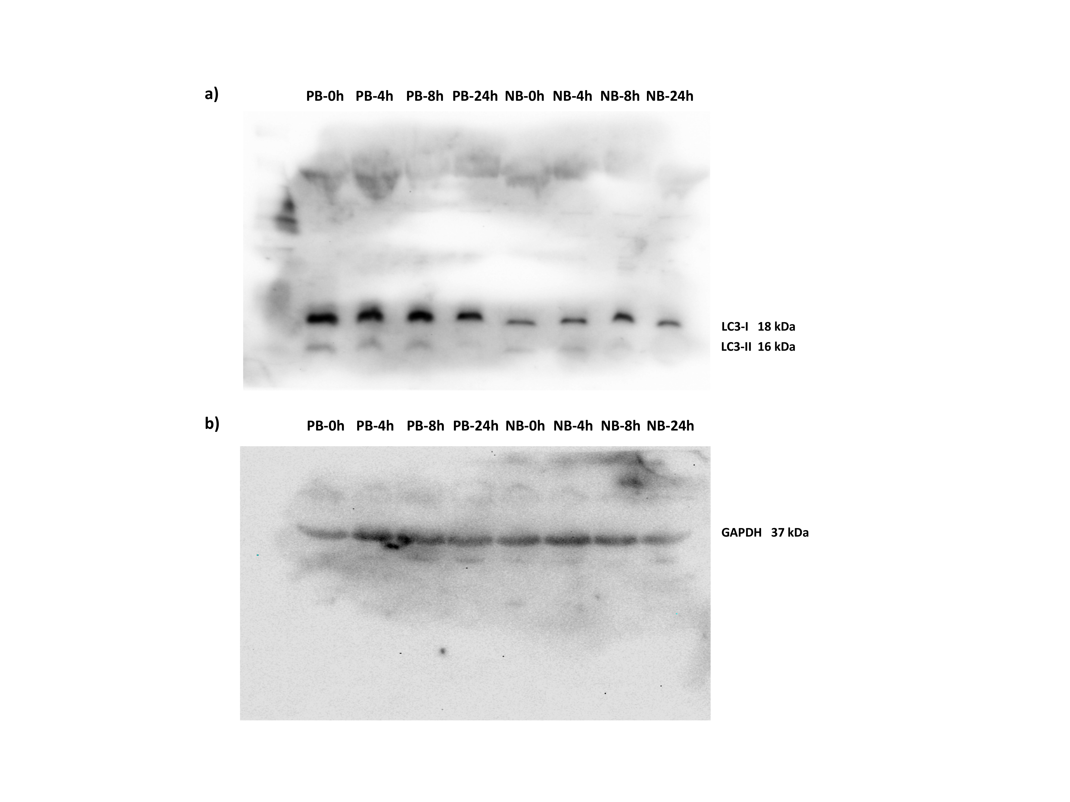
Supplementary Figure S2 Western blot analysis of LC3-I and LC3-II expression in the muscle tissue of positive (PB) and negative (NB) pigs for cognitive bias at different postmortem time (0, 4, 8 and 24 h), a) membrane incubated with primary antibody anti-LC3 and the corresponding horseradish peroxidase-conjugated secondary antibody, b) the same membrane after washing and incubated with primary antibody anti-GAPDH (used for normalization) and the corresponding horseradish peroxidase-conjugated secondary antibody.

