Genome-wide population structure and evolutionary history of the Frizarta dairy sheep
A. Kominakis¹, A.L. Hager-Theodorides¹, A. Saridaki², G. Antonakos³ and G. Tsiamis²
¹ Department of Animal Science and Aquaculture, Agricultural University of Athens, Iera Odos 75, 11855, Athens, Greece; ² Department of Environmental and Natural Resources Management, University of Patras, Seferi 2, 30100, Agrinio, Greece; ³ Agricultural and Livestock Union of Western Greece, 13rd Km N.R. Agrinio-Ioannina, 30100, Lepenou, Greece

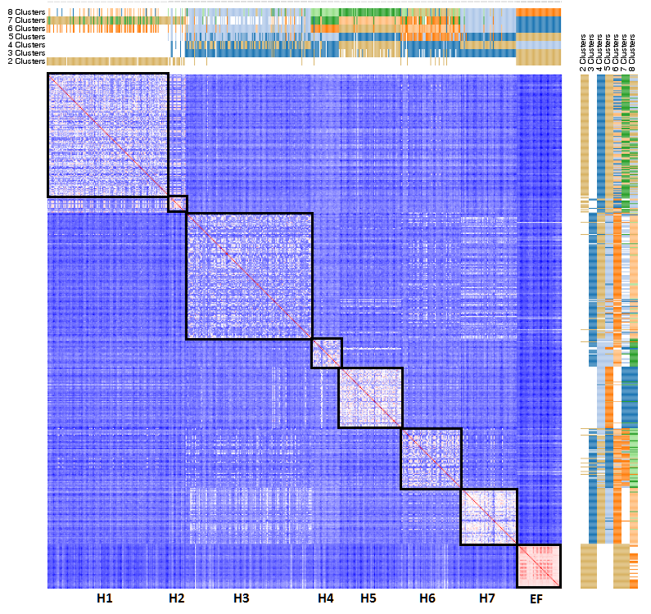
Supplementary Figure S3 Heat Map of the genomic relationship matrix along with k-means clustering (k=2-8). H1-H7 denote the 7 herds. EF denote animals of the East Friesian breed. Note that the Frizarta animals could not be assigned to herds based on the k-means clustering method, in contrast to animals of EF origin.

