Genome-wide population structure and evolutionary history of the Frizarta dairy sheep
A. Kominakis¹, A.L. Hager-Theodorides¹, A. Saridaki², G. Antonakos³ and G. Tsiamis²
¹ Department of Animal Science and Aquaculture, Agricultural University of Athens, Iera Odos 75, 11855, Athens, Greece; ² Department of Environmental and Natural Resources Management, University of Patras, Seferi 2, 30100, Agrinio, Greece; ³ Agricultural and Livestock Union of Western Greece, 13rd Km N.R. Agrinio-Ioannina, 30100, Lepenou, Greece

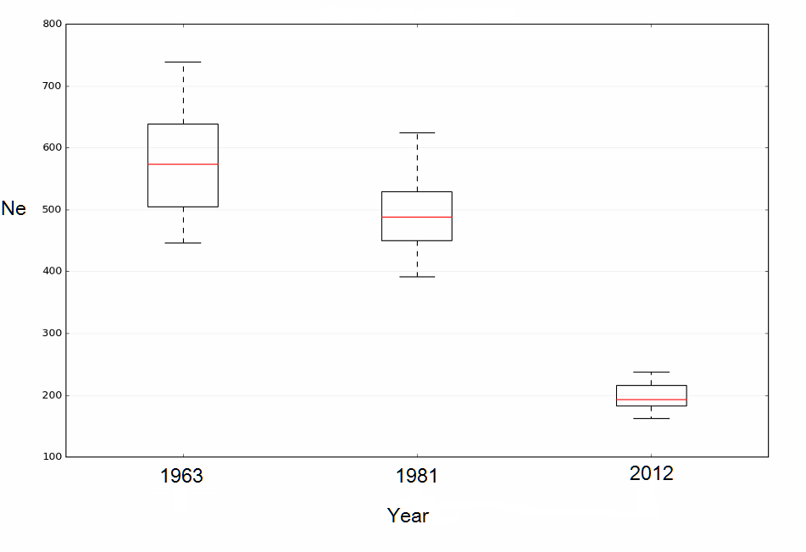

Supplementary Figure S1 Box-plot of effective population size (N_{e}) of the Frizarta sheep breed at three past time points (mean and 95% confidence interval of N_{e} were calculated from N_{e} of the 26 ovine autosomal chromosomes).

