Validation of a mathematical model of the bovine estrous cycle for cows with different estrous cycle characteristics

H. M. T. Boer, S.T. Butler, C. Stötzel, M.F.W. te Pas, R. F. Veerkamp, H. Woelders

Supplementary Figure S3

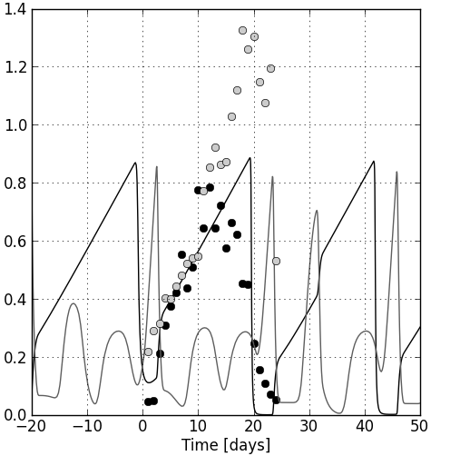
Example of model predictions and data points for CL (black line, black bullets) and follicle (grey line, grey bullets) for an individual cow with a 3-wave cycle after estimating the eleven parameters mentioned in Table 2. The model was simulated for three to four cycles and the empirical data were overlaid over the second simulated cycle. The second follicular wave of this simulated cycle does not completely regress. No dimension is given at the y-axis because the equations are expressed on a relative scale.

