Calcineurin role in porcine oocyte activation
L. Tůmová, E. Chmelíková, T. Žalmanová, V. Kučerová-Chrpová, R. Romar, M. Dvořáková, K. Hošková and J. Petr

Supplementary material

Supplementary Table S1 Degree of cortical granule exocytosis in in vitro matured porcine oocytes after treatment with cyclosporin A and calcium ionophore
 | Group
CGE level (%) | CsA + Ca-Io | CsA | Ca-Io | Control - MII | P-value
Complete exocytosis | 2.6ª | 0.0ª | 83.9^{b} | 0.0ª | 0.00
Medium exocytosis | 10.3 | 6.9 | 16.1 | 0.0 | 0.40
Low exocytosis | 48.6ª | 10.3^{ab} | 0.0^{b} | 35.0ª | 0.04
No exocytosis | 38.5ª | 82.8^{b} | 0.0^{c} | 65.0^{ab} | 0.01
n | 39 | 29 | 31 | 20
CsA = cyclosporin A; Ca-Io = calcium ionophore A23187; MII = oocyte at metaphase II stage; n = number of oocyte assessed.
a,b,c Values within a rows with different superscripts differ significantly at P<0.05.

Supplementary Figure S1 Calcineurin subunit determination by Western blotting
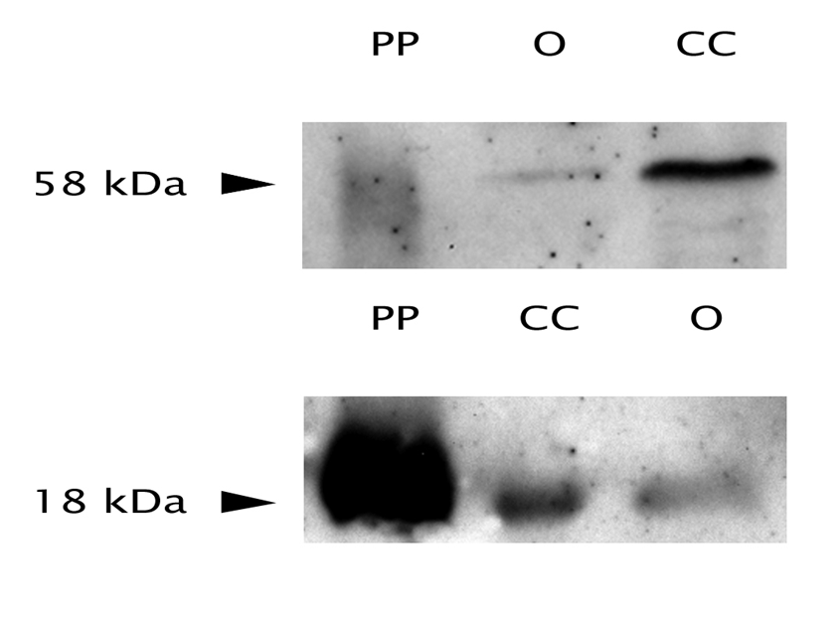
Western blotting calcineurin A (58 kDa) and B (18 kDa) detection.
PP = calcineurin pure protein from porcine brain 5 ng
O = 250 oocytes at second meiotic metaphase stage
CC = cumulus cells from 250 oocytes at second meiotic metaphase stage

Supplementary Figure S2 Calcineurin subunit localization by immunocytochemical detection

Supplementary Figure S3 Co-localization of cortical granules (CG) with calcineurin subunits

Supplementary Figure S4 Cortical granules exocytosis after calcineurin inhibition

a = CsA and Ca-Io group
b = CsA group
c = Ca-Io group
d = control group with oocytes at the stage of second meiotic metaphase

