Additional files
Supplementary Table S1 Primers for isolation of cDNA of the porcine ZFAT gene
Primers | Forward primer sequence(5’-3’) | Reverse primer sequence (5’-3’) | Tm (ºC) | Amplicon (bp)
F1/R1 | TGTTGTAACCTCTTCTCACCG | TAGGGCGTCTGCTGGATAG | 68(-0.5/cycle for 26 cycles and 55 for 18cycles | 718
F2/R2 | ACACCAACGAGAAGCCCTACA | TGACCCCCTGGAACACAAACT | Same as above | 707
F4/R4 | GCCCGTATTGCGATTTCTAT | ACATCGTCGGAGGACACCA | Same as above | 960
F5/R5 | TGCCTCAAGAAGTTCGTCAGC | AAGTTTGCCGCAGTATTCACAC | Same as above | 557
F6/R6 | CAGTCTCAGGTCAAACCCAGC | GTTGGGGTGCTTCCTGTTG | Same as above | 1038
F7/R7 | GGACGATGACCGAGAAAAGG | GCAGATGTGGCAGTCGTAGAG | Same as above | 744

Supplementary Table S2 Primers for SNPShot genotyping of the ZFAT coding variants
SNP | Primers | Primer Sequence (5' - 3')ª | Tm (ºC) |  | Amplicon (bp)
c.60T>C | F8/R8 | F:TGTTGTAACCTCTTCTCACCG  R: TATTACCCGAGGGCAAACC  S:TTTTTTTTTTTTTTTCCCTTCCTCGGCGTGCTTCTC |  | 57 |  | 257
c.630C>A | F9/R9 | F: GAAAATGGACCTCGGAAGAAG  R: GACTTCATAGGCTGCTCGTAGG  S:TTTTTTTTTTTTTTTTTTTTTTCAAGATCGTTCCAGTGGAGGC |  | 57 |  | 363
c.660T>C | F10/R10 | F: CACACAACCACACGACATACA  R: ACACAGAACAGACGCTTTACC  S:TTTTTTTTTTTTTTTTTTTTTTTTTTTTTGGAAACCGGAGCTGCAGACCC |  | 57 |  | 316
c.1077C>T | F11/R11 | F: GCGACTGCTGCTCCTTCACCT  R: CGCAGATGTGGCAGTCGTAGAG  S:TTTTTTTTTTTTTTTGTGCGCGTCCCGGATGTGCCT |  | 65 |  | 245
c.1416C>T, | F12/R12 | F: TGCCTCAAGAAGTTCGTCAGC  R: GACCCCCTGGAACACAAACTC  S:TTTTTTTTTTTTTTTTTTTTTTGAAGACCGAGCTCTCCTGGGC |  | 57 |  | 197
c.2337T>C | F13/R13 | F: CTGAAAGGGCTGATTGGAAAG  R: TGACAGCCCAGCACAATCGT  S:TTTTTTTTTTTTTTTTTTTTTGTGCCGCTGCAGGTCTGAGCC |  | 65 |  | 342
c.2935G>C | F14/R14 | F: TATCCTGGGACTTCGGGTAGCG  R: TCATTCAGCGTGTCCACCAGG  S:TTTTTTTTTTTTTTTTTTTTTTTTTTTTTTCTTCAGCTTCCGTGATGTGCA |  | 65 |  | 256
ª F:forward primer, R: reverse primer, S: primer used to genotype the SNPs.

Supplementary Table S3 The 52SNPs significantly associated with F41 adhesion phenotypes in the White Duroc ×Erhualian F₂ population ª.
Chromosome | SNP | Positions | Log(1/p)
4 | ALGA0021980 | 425398 | 6.51
4 | ASGA0016987 | 1810630 | 7.46
4 | ASGA0017024 | 2131332 | 7.69
4 | MARC0062117 | 2197200 | 7.70
4 | ASGA0017047 | 2272554 | 7.70
4 | H3GA0011218 | 2437013 | 7.70
4 | ASGA0017090 | 2495035 | 7.70
4 | ASGA0017093 | 2574823 | 7.60
4 | M1GA0005199 | 2722839 | 7.60
4 | MARC0060304 | 2768758 | 7.74
4 | H3GA0011431 | 4325365 | 6.65
4 | MARC0022513 | 4638347 | 6.92
4 | DRGA0004374 | 4693557 | 8.87
4 | DRGA0004397 | 5253532 | 6.67
4 | H3GA0011516 | 5348536 | 6.79
4 | ASGA0017546 | 5423307 | 8.36
4 | H3GA0011525 | 5437467 | 8.51
4 | H3GA0011528 | 5477446 | 10.43
4 | MARC0084509 | 5585112 | 10.37
4 | ASGA0017554 | 5796491 | 8.85
4 | DRGA0004416 | 5931042 | 8.66
4 | ALGA0022520 | 5952141 | 11.12
4 | ALGA0022556 | 6137527 | 9.17
4 | M1GA0005479 | 6149802 | 11.29
4 | MARC0031758 | 6197683 | 11.37
4 | ALGA0022580 | 6333072 | 11.29
4 | H3GA0011590 | 6399437 | 5.99
4 | ALGA0022599 | 6479429 | 11.71
4 | ALGA0022604 | 6525136 | 12.01
4 | ALGA0022612 | 6550657 | 12.06
4 | H3GA0011604 | 6572544 | 7.77
4 | INRA0012316 | 6695155 | 12.13
4 | ASGA0017733 | 6837082 | 12.22
4 | H3GA0011659 | 6845012 | 12.22
4 | ALGA0022658 | 6951188 | 12.25
4 | ASGA0017746 | 6977891 | 12.22
4 | ALGA0022682 | 7067626 | 12.10
4 | ALGA0022690 | 7135769 | 11.82
4 | ASGA0017783 | 7156581 | 11.23
4 | H3GA0011673 | 7201622 | 11.82
4 | ALGA0022705 | 7233107 | 9.61
4 | ASGA0017943 | 8537988 | 7.02
4 | MARC0111165 | 8626767 | 9.89
4 | ALGA0022893 | 8963064 | 8.14
4 | ASGA0018040 | 9005118 | 11.18
4 | ALGA0022944 | 9309658 | 7.49
4 | ALGA0022970 | 9900957 | 6.15
4 | ALGA0023067 | 10645620 | 6.58
4 | ASGA0018632 | 16237949 | 6.14
4 | ASGA0018644 | 16515101 | 6.50
4 | MARC0090245 | 16648839 | 6.50
4 | DIAS0000430 | 16666892 | 6.51
ª The most significant SNP were highlighted by orange color

Supplementary Table S4 Association of SNP ALGA0022658 with ETEC F41 adhesion phenotypes in White Duroc × Erhualian F₂ animals
 | non-adhesive | adhesive
GG | 7 | 42
AG | 62 | 192
AA | 277 | 85

A B
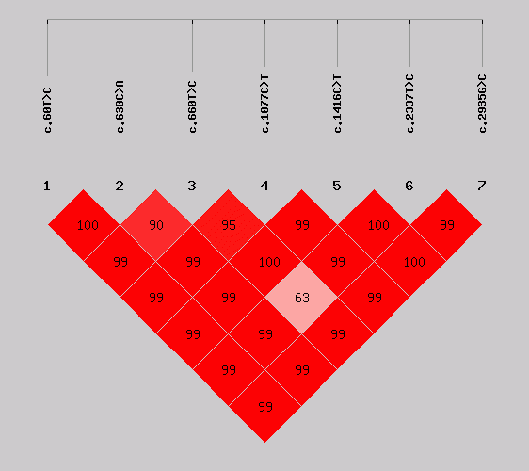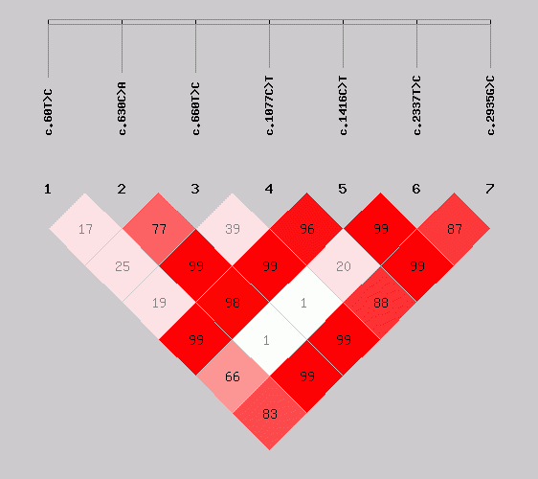
Supplementary Figure S1 Linkage disequilibrium measures (D’ values) between pairs of the seven ZFAT polymorphic loci in Western commercial pigs (A) and Chinese indigenous pigs (B).

