SUPPLEMENTARY MATERIAL – for Online Publication Only

Effects of feed and water access and inclusion of fish oil and medium chain fatty acids in a starter diet on broiler chickens growth performance and humoral immunity

D. M. Lamot 1,2, S. A. S. van der Klein 2, I. B. van de Linde ¹, P. J. A. Wijtten 1, B. Kemp 2, H. van den Brand 2 and A. Lammers 2

1 Cargill Animal Nutrition Innovation Center Velddriel, Veilingweg 23, 5534LD Velddriel, the Netherlands
2 Adaptation Physiology Group, Wageningen University, PO Box 338, 6700AH Wageningen, the Netherlands

Corresponding author: David Lamot. Email: david_lamot@cargill.com.
Supplementary Material S1 - General immune development (0 to 28 days)

Results
Regardless of treatments, expression of natural antibodies (NAb) titers against Keyhole Limpet Hemocyanin (KLH) IgM increased as the chicken aged from 7 to 28 days (P<0.001; Supplementary Table S2, S3, and Supplementary Figure S1a). NAb anti-KLH IgY was also age dependent from 7 to 28 days (P<0.001; Supplementary Table S2, S3, and Supplementary Figure S1b), but its expression initially declined from 7 days onwards, reached a lowest point at 21 days, increasing again at 25 days and then remaining stable until 28 days. Interferon gamma (IFN-γ) concentrations declined from 21 days onwards (P<0.001; Supplementary Table S3 and Supplementary Figure S1c). The agglutination titer increased from 21 to 28 days of age as a result of sheep red blood cell (SRBC) immunization at 21 days of age (P<0.001; Supplementary Table S4 and Supplementary Figure S1d). The classical (CPW) and alternative (APW) complement pathway were found to be age dependent until 21 days of age, whereas only the CPW remained age dependent until 28 days of age (P<0.001; Supplementary Figures S1e and S1f).

Discussion
Considering age dependent immune development in the chicken, the NAb anti-KLH IgM titers increased over time, while for NAb anti-KLH IgY the level decreased directly after hatch and remained low thereafter. These findings correspond with earlier research (Simon et al., 2014). Maternal transfer of NAb IgM from broiler breeders into the egg was found to be very limited (Hamal et al., 2006). Therefore, the measured NAb anti-KLH IgM levels in the current experiment are supposed to be of endogenous origin. However, there is major transfer of maternal NAb IgY to the yolk (Hamal et al., 2006), which is directly absorbed from the residual yolk by the chicken at the moment of hatch (Tesar et al., 2008).
While current results suggest that IFN-γ is already available at a very young age (from 2 days of age onwards), this does not match earlier research where IFN-γ mRNA expression was only marginal in similar aged chickens with a similar period of feed withdrawal (Simon et al., 2014). The observed differences might be explained by the fact that in earlier research IFN-γ mRNA expression was determined in intestinal tissue (mucosal response), whilst in the current study IFN-γ concentrations at the protein level in blood samples were analyzed (systemic response). Because IFN-γ was determined in healthy chicken a strong systemic response is not likely, whereas direct exposure of intestinal immune cells to bacteria may induce stronger pro-inflammatory responses. Moreover, the lack of endogenous sIgA production at 21 days could be the reason for enhanced pro-inflammatory cytokine induction, because sIgA prevents bacterial translocation and has anti-inflammatory properties (Lammers et al., 2010).
In the current experiment the higher CPW complement activity at 7 days compared to 14 days of age (Supplementary Figure 1) may be the result of the presence of maternal antibodies, because the CPW is antibody dependent (Janeway et al., 2001). At 14 days of age maternal antibodies are no longer present, whereas endogenous immunoglobulin production is still suboptimal. However, CPW activity between 7 and 21 days of age may also be influenced by endogenous produced IgM, because production of this isotype precedes IgY production. APW related complement activity only increased from 21 days of age onwards (Supplementary Figure 1), but is antibody independent.
The age dependent increase in agglutination titer is most likely a consequence of SRBC immunization. Until now, to our knowledge no literature is available demonstrating age related dynamics in complement activity of broiler chickens.
Concluding, the humoral immune status by means of NAb anti-KLH IgM and IgY, IFN- γ, and complement activity (CPW and APW) is strongly age dependent, while the agglutination titer is strongly challenge dependent.

References
Hamal KR, Burgess SC, Pevzner IY and Erf GF 2006. Maternal antibody transfer from dams to their egg yolks, egg whites, and chicks in meat lines of chickens. Poultry Science 85, 1364-1372. doi:10.1093/ps/85.8.1364.
Janeway CA, Travers P, Walport M and Shlomchik MJ 2001. Chapter 2: The complement system and innate immunity. In Immunobiology: The immune system in health and disease (fifth edition), pp. 43-64. Garland Science, New York, NY, USA.
Lammers A, Wieland WH, Kruijt L, Jansma A, Straetemans T, Schots A, den Hartog G and Parmentier HK 2010. Successive immunoglobulin and cytokine expression in the small intestine of juvenile chicken. Developmental & Comparative Immunology 34, 1254-1262. doi:10.1016/j.dci.2010.07.001.
Simon K, de Vries Reilingh G, Kemp B and Lammers A 2014. Development of ileal cytokine and immunoglobulin expression levels in response to early feeding in broilers and layers. Poultry Science 93, 3017-3027. doi:10.3382/ps.2014-04225.
Tesar DB, Cheung EJ and Bjorkman PJ 2008. The chicken yolk sac igy receptor, a mammalian mannose receptor family member, transcytoses igy across polarized epithelial cells. Molecular Biology of the Cell 19, 1587-1593. doi:10.1091/mbc.E07-09-0972.

Summary Table S1 Effects of moment of feed and water access after placement in the grow-out facility and pre-starter composition on natural antibody (NAb) Keyhole Limpet Hemocyanin (KLH) IgM and IgY and interferon gamma (IFN-γ) in broiler chickens at 2 days of age (LSmeans)¹
 | DIET |  |  | SEM | P values
 | CONT | FISH | MCFA
n | 32 | 32 | 32
IgM (NAb anti-KLH titer) | 1.6 | 1.5 | 1.5 | 0.1 | 0.762
IgY (NAb anti-KLH titer) | 7.8 | 7.8 | 7.7 | 0.5 | 0.971
IFN-γ (pg/ml) | 100 | 99.6 | 90.8 | 10.9 | 0.766
DIET = Starter diet; CONT = Control; FISH = Fish Oil; MCFA = Medium chain fatty acids.
¹ One broiler chicken sampled per cage. For analysis of data collected from 0 to 2 days of age, effects of feed and
water access and the interaction with starter diet composition were excluded from the model.
Supplementary Table S2 Effects of moment of feed and water access after placement in the grow-out facility and pre-starter composition on natural antibody (NAb) keyhole Limpet Hemocyanin (KLH) IgM and IgY, interferon gamma (IFN-γ), and complement activity based on the classical (CPW) and alternative (APW) complement pathway in broiler chickens 7 to 21 days (LSmeans)¹
Z |  | IgM  (NAb anti-KLH titer) |  |  | IgY  (NAb anti-KLH titer) |  |  | IFN-γ  (pg/ml) |  |  | Complement CPW²  (%) |  |  | Complement APW²  (%)
 |  | 7 d | 14 d | 21 d | 7 d | 14 d | 21 d | 7 d | 14 d | 21 d | 7 d | 14 d | 21 d | 7 d | 14 d | 21 d
DIR | CONT | 2.9 | 4.5 | 3.9 | 5.0 | 3.5 | 2.7 | 110.3 | 106.7 | 153.4 | - | - | - | - | - | -
 | FISH | 2.8 | 4.1 | 4.1 | 4.6 | 2.5 | 2.2 | 139.3 | 104.1 | 112.9 | - | - | - | - | - | -
 | MCFA² | 2.9 | 4.5 | 4.2 | 4.8 | 3.5 | 3.0 | 102.0 | 97.1 | 155.7 | - | - | - | - | - | -
DEL | CONT | 2.8 | 4.2 | 3.7 | 4.7 | 2.8 | 2.8 | 112.9 | 96.7 | 86.9 | - | - | - | - | - | -
 | FISH | 2.3 | 4.2 | 5.1 | 6.0 | 3.7 | 2.9 | 129.4 | 96.6 | 117.4 | - | - | - | - | - | -
 | MCFA | 2.2 | 4.7 | 4.2 | 4.9 | 3.7 | 3.1 | 126.8 | 96.9 | 110.4 | - | - | - | - | - | -
 | SEM (n=16) | 0.5 |  |  | 0.6 |  |  | 19.7 |  |  | - |  |  | -
FA | DIR | 2.9 | 4.4 | 4.1 | 4.8 | 3.2 | 2.6 | 117.2 | 102.6 | 140.7 | 47.6 | 19.0 | 60.1 | 12.5 | 25.6 | 80.7
 | DEL | 2.4 | 4.4 | 4.3 | 5.2 | 3.4 | 2.9 | 123.0 | 96.7 | 104.9 | 56.9 | 14.7 | 52.5 | 9.2 | 9.8 | 89.6
 | SEM (n=48) | 0.3 |  |  | 0.3 |  |  | 11.3 |  |  | 7.7 |  |  | 7.3
DIET | CONT | 2.8 | 4.4 | 3.8 | 4.9 | 3.2 | 2.7 | 111.6 | 101.7 | 120.2 | 53.1 | 28.2 | 62.9 | 15.5 | 19.1 | 96.5
 | FISH | 2.6 | 4.2 | 4.6 | 5.3 | 3.1 | 2.6 | 134.4 | 100.3 | 115.2 | 59.6 | 22.7 | 45.1 | 10.0 | 15.9 | 75.0
 | MCFA | 2.5 | 4.6 | 4.2 | 4.8 | 3.6 | 3.0 | 114.4 | 97.0 | 133.0 | 43.9 | 6.6 | 60.7 | 8.0 | 13.9 | 72.6
 | SEM (n=32) | 0.4 |  |  | 0.4 |  |  | 13.7 |  |  | 9.5 |  |  | 8.7
DAY |  | 2.6^{A} | 4.4^{B} | 4.2^{B} | 5.0^{A} | 3.3^{B} | 2.8^{C} | 120.1 | 99.7 | 122.8 | 52.2^{A} | 16.8^{B} | 56.3^{A} | 10.8^{A} | 16.2^{A} | 85.7^{B}
 | SEM | 0.2 |  |  | 0.2 |  |  | 7.9 |  |  | 5.3 |  |  | 5.1
P values
FA |  | 0.850 |  |  | 0.296 |  |  | 0.279 |  |  | 0.807 |  |  | 0.482
DIET |  | 0.905 |  |  | 0.816 |  |  | 0.882 |  |  | 0.275 |  |  | 0.093
DAY |  | <0.001 |  |  | <0.001 |  |  | 0.510 |  |  | <0.001 |  |  | <0.001
FA x DIET |  | 0.824 |  |  | 0.134 |  |  | 0.439 |  |  | 0.746 |  |  | 0.187
FA x DAY |  | 0.414 |  |  | 0.941 |  |  | 0.307 |  |  | 0.394 |  |  | 0.127
DIET x DAY |  | 0.337 |  |  | 0.621 |  |  | 0.907 |  |  | 0.153 |  |  | 0.636
FA x DIET x DAY |  | 0.634 |  |  | 0.875 |  |  | 0.669 |  |  | - |  |  | -
FA = Feed and water access; DIR = Direct access; DEL = Delayed access (48h); DIET = Starter diet; CONT = Control; FISH = Fish Oil; MCFA = Medium chain fatty acids.
¹ One broiler chicken sampled per cage.
² The three-way interaction between day, moment of feed and water access and starter diet composition was excluded from the model, as it did not solve for that term and therefore had to be omitted. Results expressed as the chance (percentage) for a response at that age.
A,B,C Values within a column with different superscripts differ significantly at P < 0.05.
Supplementary Table S3 Effects of moment of feed and water access after placement in the grow-out facility and pre-starter composition on natural antibody (NAb) keyhole Limpet Hemocyanin (KLH) IgM and IgY, and interferon gamma (IFN-γ) in broiler chickens 21 to 28 days (LSmeans)¹
 |  | IgM  (NAb anti-KLH titer) |  |  | IgY  (NAb anti-KLH titer) |  |  | IFN-γ  (pg/ml)
 |  | 21 d | 25 d | 28 d | 21 d | 25 d | 28 d | 21 d | 25 d | 28 d
DIR | CONT | 3.8 | 5.9 | 6.3 | 2.7 | 3.9 | 3.9 | 153.4 | 79.3 | 58.8
 | FISH | 4.1 | 5.9 | 6.3 | 2.3 | 3.7 | 4.3 | 113.3 | 78.8 | 55.4
 | MCFA | 4.2 | 5.5 | 6.6 | 2.9 | 3.2 | 3.8 | 155.8 | 105.5 | 71.9
DEL | CONT | 3.7 | 5.2 | 6.2 | 2.7 | 3.5 | 3.8 | 86.8 | 73.2 | 52.5
 | FISH | 5.2 | 5.3 | 6.0 | 3.0 | 3.8 | 3.7 | 117.0 | 79.7 | 57.3
 | MCFA | 4.3 | 5.5 | 6.1 | 3.1 | 3.5 | 3.8 | 110.4 | 84.1 | 63.2
 | SEM (n=16) | 0.4 |  |  | 0.4 |  |  | 17.0
FA | DIR | 4.0 | 5.8 | 6.4 | 2.6 | 3.6 | 4.0 | 140.8 | 87.9 | 62.0
 | DEL (48 h) | 4.4 | 5.3 | 6.1 | 2.9 | 3.6 | 3.8 | 104.7 | 79.0 | 57.7
 | SEM (n=48) | 0.2 |  |  | 0.2 |  |  | 9.7
DIET | CONT | 3.8 | 5.5 | 6.3 | 2.7 | 3.7 | 3.8 | 120.1 | 76.2 | 55.6
 | FISH | 4.6 | 5.6 | 6.2 | 2.6 | 3.8 | 4.0 | 115.1 | 79.2 | 56.3
 | MCFA | 4.2 | 5.5 | 6.3 | 3.0 | 3.3 | 3.8 | 133.1 | 94.8 | 67.6
 | SEM (n=16) | 0.3 |  |  | 0.3 |  |  | 11.8
DAY |  | 4.2^{A} | 5.5^{B} | 6.3^{C} | 2.8^{A} | 3.6^{B} | 3.9^{B} | 122.8^{A} | 83.4^{B} | 59.8^{C}
 | SEM | 0.2 |  |  | 0.2 |  |  | 6.8
P values
FA |  | 0.490 |  |  | 0.886 |  |  | 0.017
DIET |  | 0.586 |  |  | 0.957 |  |  | 0.074
DAY |  | <0.001 |  |  | <0.001 |  |  | <0.001
FA x DIET |  | 0.704 |  |  | 0.845 |  |  | 0.260
FA x DAY |  | 0.127 |  |  | 0.389 |  |  | 0.357
DIET x DAY |  | 0.365 |  |  | 0.250 |  |  | 0.961
FA x DIET x DAY |  | 0.359 |  |  | 0.615 |  |  | 0.654
FA = Feed and water access; DIR = Direct access; DEL = Delayed access (48h); DIET = Starter diet; CONT = Control; FISH = Fish Oil; MCFA = Medium chain fatty acids.
¹ One broiler chicken sampled per cage.
A,B,C Values within a column with different superscripts differ significantly at P < 0.01.
Supplementary Table S4 Effects of moment of feed and water access after placement in the grow-out facility and pre-starter composition on complement activity based on the classical (CPW) and alternative (APW) complement pathway, and agglutination titer in broiler chickens 21 to 28 days (LSmeans)¹
 |  | Agglutination titer |  |  |  | Complement CPW² (%) |  |  | Complement APW² (%)
 |  | 21 d | 25 d | 28 d |  | 21 d | 25 d | 28 d | 21 d | 25 d | 28 d
DIR | CONT | 0.0 | 4.4 | 6.9 |  | - | - | - | - | - | -
 | FISH | 0.0 | 3.0 | 5.7 |  | - | - | - | - | - | -
 | MCFA | 0.0 | 2.8 | 7.2 |  | - | - | - | - | - | -
DEL | CONT | 0.0 | 2.9 | 6.2 |  | - | - | - | - | - | -
 | FISH | 0.0 | 2.5 | 6.4 |  | - | - | - | - | - | -
 | MCFA | 0.0 | 2.3 | 5.9 |  | - | - | - | - | - | -
 | SEM (n=16) | 0.5 |  |  |  | - |  |  | -
FA | DIR | 0.0 | 3.4 | 6.6 |  | 60.0 | 54.2 | 77.7 | 82.6 | 91.7 | 99.7
 | DEL (48 h) | 0.0 | 2.6 | 6.2 |  | 52.3 | 30.0 | 83.5 | 86.9 | 92.6 | 99.9
 | SEM (n=48) | 0.3 |  |  | 9.3 |  |  |  | 15.3
DIET | CONT | 0.0 | 3.7 | 6.6 |  | 63.4 | 63.4 | 81.3 | 95.6 | 95.4 | 100.0
 | FISH | 0.0 | 2.7 | 6.0 |  | 44.7 | 44.7 | 74.7 | 75.3 | 91.0 | 97.6
 | MCFA | 0.0 | 2.5 | 6.6 |  | 60.1 | 60.1 | 85.2 | 72.5 | 88.6 | 90.7
 | SEM (n=16) | 0.3 |  |  |  | 11.9 |  |  | 8.2
DAY |  | 0.0^{A} | 3.0^{B} | 6.4^{C} |  | 56.2^{A} | 41.6^{A} | 80.7^{B} | 84.9 | 92.2 | 99.9
 | SEM | 0.2 |  |  |  | 6.3 |  |  | 7.0
P values
FA |  | 0.549 |  |  |  | 0.311 |  |  | 0.297
DIET |  | 0.114 |  |  |  | 0.356 |  |  | 0.542
DAY |  | <0.001 |  |  |  | <0.001 |  |  | 0.444
FA x DIET |  | 0.604 |  |  |  | 0.380 |  |  | 0.368
FA x DAY |  | 0.144 |  |  |  | 0.241 |  |  | 0.596
DIET x DAY |  | 0.593 |  |  |  | 0.865 |  |  | 0.808
FA x DIET x DAY |  | 0.180 |  |  |  | - |  |  | -
FA = Feed and water access; DIR = Direct access; DEL = Delayed access (48h); DIET = Starter diet; CONT = Control; FISH = Fish Oil; MCFA = Medium chain fatty acids.
¹ One broiler chicken sampled per cage.
² The three-way interaction between day, moment of feed and water access and starter diet composition was excluded from the model, as it did not solve for that term and therefore had to be omitted. Results expressed as the chance (percentage) for a response at that age.
A,B,C Values within a column with different superscripts differ significantly at P < 0.01.

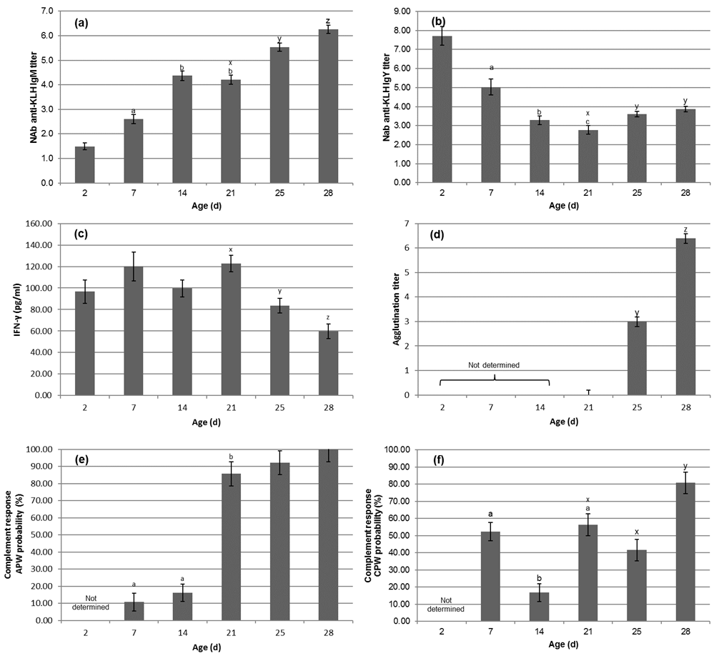Supplementary Figure S1 Natural antibody (NAb) anti-Keyhole Limpet Hemocyanin (KLH) IgM (a) and IgY titers (b), interferon gamma (IFN-γ) concentrations (c), agglutination titers (d), and complement activity (the chance for a response at that age, expressed as percentage) based on the alternative (APW) (e) and classic (CPW) (f) complement pathway in broiler chickens from 2 to 28 days in direct fed broiler chickens. Chickens received a control, fish oil or medium chain fatty acids (MCFA) containing starter diet from 0 to 7 days. Chickens were sensitized with sheep red blood cells at 21 days. Levels that differ within the period from 7 to 21 days (grow-out period) are indicated by superscripts labelled a-c, differences within the period from 21 to 28 days (immunization period) are indicated by superscripts labelled x-z. Columns with different superscripts differ significantly at P < 0.05.

