Developing a multi-Kinect-system for monitoring in dairy cows: object recognition and surface analysis using wavelets –
Supplementary Material S2
J. Salau^{1,3}, J.H. Haas¹, G.Thaller¹, M. Leisen², W. Junge¹
¹ Institute of Animal Breeding and Husbandry, Kiel University, Olshausenstraße 40, 24098 Kiel, Germany
² Rinderzucht Schleswig Holstein eG, Rendsburger Str. 178. 24537 Neumünster, Germany
³ TiDa Tier und Daten GmbH, Bosseer Str. 4c, 24259 Westensee/Brux, Germany
Corresponding author: Jennifer Salau, e-mail: jsalau@tierzucht.uni-kiel.de

Wavelet analysis
Two-dimensional wavelet transforms served as method of analysis in the study “Developing a multi-Kinect-system for monitoring in dairy cows: object recognition and surface analysis using wavelets”. As the principles coincide, wavelet analysis will be explained for the one-dimensional case to keep the notation simple. Afterwards the necessary transfer to two dimensions will be provided.
Similar to Fourier transform, the wavelet transform analyses data regarding frequency components. In Fourier transform the data is presented as linear combination of sines and cosines, which are defined on the unbounded real numbers. In wavelet analysis basis functions called mother wavelets are used instead. They have compact support, i.e. the functions are equal to zero outside a bounded area. There exist various types of mother wavelets which come in pairs with additional functions called scaling functions. The wavelets allow a more individual analysis of non-stationary data than the Fourier transform, because a representation using functions with compact support can more easily adapt to locally different behavior of non-stationary data than a representation using functions with unbounded domain (see Daubechies, 1990 for a discussion of windowed Fourier transform and wavelet transform). On the first level of wavelet decomposition, the scaling function – usually denoted as ϕ – is used to approximate the data. Hereby it is shifted along the original signal and for every location coefficients are calculated to fit the scaling function to this part of the data. In this way, the low frequency part of the signal can be described. The mother wavelet – usually denoted as ψ – is used similarly to present the high frequency parts, called details of level 1. For every following decomposition level, both ϕ and ψ are scaled (see Equation S1.1) and used on the approximation of the previous level. The procedure is illustrated in Figure S1.1.
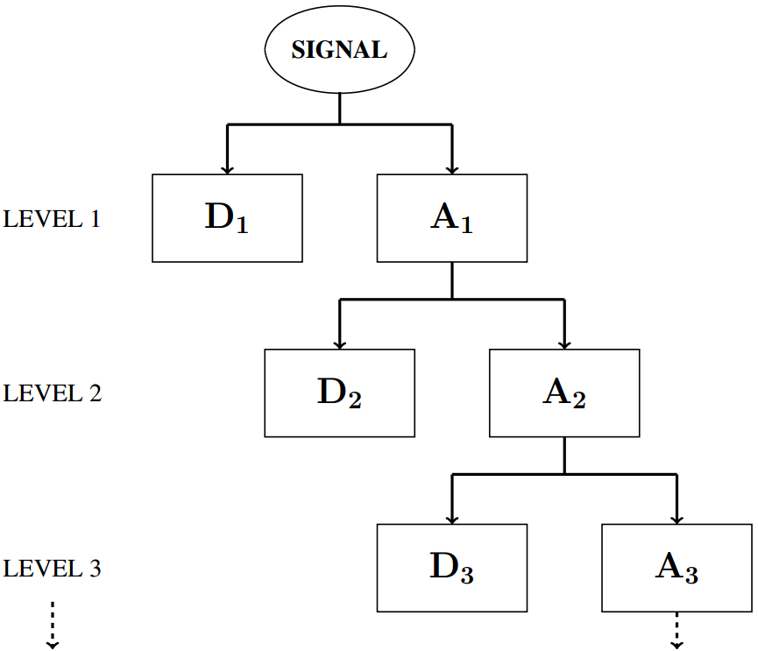
Figure S1.1 The process of wavelet decomposition. Starting with the original signal in the top row, the first three levels of decomposition are illustrated in this diagram. At first, the signal is decomposed into a high frequency part -- the details D₁ -- and a low frequency part -- a signal approximation A₁. Every further decomposition level uses the latest approximation A_{i} and splits it up in next levels details D_{i+1} and approximation A_{i+1}. In this way, the approximations of the original signal get smoother with rising number of decomposition levels.
The scaled and shifted versions of scaling function and mother wavelet are for tϵ[0, 2^{(j-1)}] defined as follows
ϕ_{j,k}(t) := 2^{(j-1)/2} ϕ (2^{(j-1)}t-k) , ψ_{j,k}(t) := 2^{(j-1)/2} ψ(2^{(j-1)} t-k), (S1.1)
whereby j denotes the decomposition level, and k the shift applied to move along the signal. For every decomposition level j we thus get a series of coefficients (w_{j, k})_{k} for the scaled and shifted wavelet ψ_{j, k} and a series of coefficients (s_{j, k})_{k} for the scaled and shifted scaling function ϕ_{j, k}. The original signal f can be approximated after J levels of decomposition by
$f(t)≈\sum_{j=1}^{J}{\sum_{k}{w_{j,k}}}ψ_{j,k}$(t) + $\sum_{j=1}^{J}{\sum_{k}{s_{j,k}}}ϕ_{j,k}\left(t\right)=D_{J}+A_{J}$ (S1.2)
where D_{J} and A_{J} (compare Figure S1.1) denote the reconstructed signal's details and approximation belonging to decomposition level J, respectively.
Two-dimensional wavelet transform
On way of transferring wavelet analysis in higher dimensions is to construct so called separable two-dimensional wavelets out of the one dimensional wavelets (Bergh et. al., 2007). The main difference is that details have to be considered in three instead of only one direction: horizontal, vertical, and diagonal. The two-dimensional scaling function Φ and the direction related mother wavelets Ψ^{h}, Ψ^{v}, and Ψ^{d} for the description of horizontal, vertical, and diagonal details, respectively, are constructed according to Equations S1.3 and S1.4:
Φ(x,y) = ϕ(x)ϕ(y) , Ψ^{h}(x,y) = ϕ(x)ψ(y), (S1.3)
Ψ^{v}(x,y) = ψ(x)ϕ(y) , Ψ^{d}(x,y) = ψ(x)ψ(y). (S1.4)
Equation S1.5 gives the definition of scaled and shifted versions, exemplarily for the two-dimensional scaling function:
Φ_{j,k=(kx,ky)}(x,y) = 2^{j} Φ(2^{j} x-k_{x},2^{j} y-k_{y}). (S1.5)
For decomposition level j the two-dimensional discrete wavelet transform calculates series of coefficients (s_{j,k})_{k=(kx,ky)}, (w^{h}_{j,k})_{k=(kx,ky)}, (w^{v}_{j,k})_{k=(kx,ky)}, and (w^{d}_{j,k})_{k=(kx,ky)} belonging to Φ_{j,k}, Ψ^{h} _{j,k}, Ψ^{v} _{j,k}, and Ψ^{d} _{j,k}, respectively.
Wavelet transform applied to Kinect recordings
With every use of the wavelet transform, the appropriate wavelet and decomposition level for the given purpose has to be specified. The Kinect recordings’ image size of 480x640 pixel determines a maximal number of 8 decomposition levels, because the domains of Φ_{j,k}, Ψ^{h} _{j,k}, Ψ^{v} _{j,k}, and Ψ^{d} _{j,k} get larger with every decomposition level and must not exceed the signal size. The match between original image and full reconstruction of the image serves as measure, how well the wavelet fitted the given type of data. Therefore, the maximum and the sum of squared pixelwise differences between full reconstruction and original are meaningful comparison criteria between wavelets.
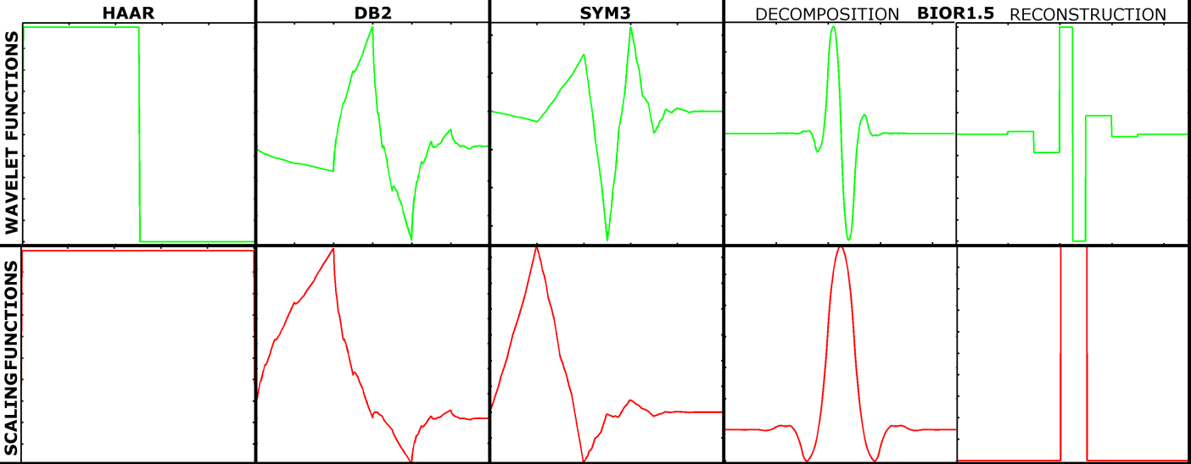
Figure S1.2 Overview of mother wavelets (first row of illustrations) and scaling functions (second row of illustrations) used for this study. Wavelets of different shapes were chosen and compared according to their ability to match depth images recorded with the Microsoft Kinect camera. The used wavelets were the haar wavelet (first column), the Daubechies No.2 wavelet (db2, second column), the Symlet wavelet No.3 (sym3, third column), the biorthogonal 1.5 wavelet (bior1.5, fourth and fifth column), and their corresponding scaling functions. The bior1.5 wavelet uses differently shaped functions for decomposition (fourth column) and reconstruction (fifth column). All illustrations were generated using the option 'Wavelet Display' of the GUI tool from the Wavelet Toolbox.
A set of differently shaped mother wavelets was chosen (Figure S1.2) to perform 8 levels of wavelet decomposition and full image reconstruction (Equation S1.2) using the functions wavedec2.m and wrcoef2.m (MATLAB R2007a, Wavelet Toolbox). The chosen wavelets were the haar wavelet (also Daubechies No.1), Daubechies No.2 (db2), the Symlet wavelet No.3 (sym3) and the biorthogonal 1.5 wavelet (bior1.5). As illustrated in Figure S1.2, the latter uses different mother wavelets and scaling functions for decomposition and reconstruction (for more information on biorthogonal wavelets see Bergh et. al., 2007 or Louis et. al., 1998).
For decomposition levels J = 1,...,8 the wavelet coefficients (w^{h}_{j,k})_{j≤J},_{k=(kx,ky)}, (w^{v}_{j,k})_{j≤J,k=(kx, ky)}, and (w^{d}_{j,k})_{j≤J,k=(kx,ky)} were used to determine three matrices D^{h}_{J}, D^{v}_{J}, and D^{d}_{J} of the same size as the original image containing the image's pixelwise details. Equation S1.6 gives the calculation of D^{h}_{J} for decomposition level J
D^{h}_{J} = $\sum_{j=1}^{J}{\sum_{k=(k_{x}, k_{y})}{w}}$^{h}_{j,k} Ψ^{h} _{j,k} (x,y). (S1.6)
D^{v}_{J} and D^{d}_{J} were determined in the same way. Additionally, all absolute details were summed up: D^{All}_{J}:=|D^{h}_{J}|+|D^{v}_{J}|+|D^{d}_{J}|. In total four matrices per image, wavelet, and decomposition level were calculated. For a better understanding of these abstract concepts, Figure S1.3 gives an example for the summed details D^{All}₁ reconstructed after a transformation with the haar wavelet (mid and right illustration) for a depth map recorded from sideview position (left illustration). The details' range is too wide, to properly display all values in the same illustration. The values greater or equal an upper boundary and the values smaller or equal a lower boundary are displayed in the mid and the right illustration, respectively. In this way, variation of the details in foreground and background are made visible.
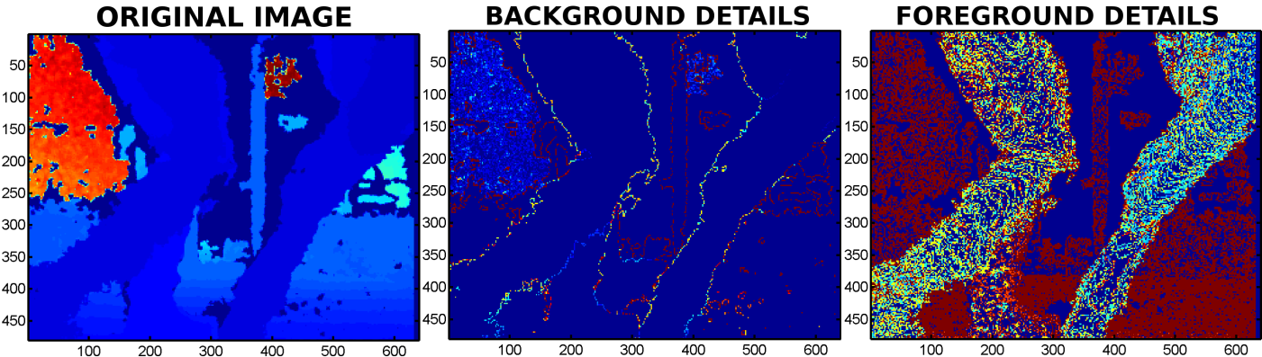
Figure S1.3 An example of an original depth map (left) and its reconstructed summed details D^{All}₁ (mid, right) after one level of decomposition using the haar wavelet. The summed details are determined by adding up the absolute reconstructed details calculated for horizontal (D^{h}₁), vertical (D^{v}₁), and diagonal (D^{d}₁) direction: D^{All}₁=|D^{h}₁|+|D^{v}₁|+|D^{d}₁|. Considering the whole image, the detail values show a very wide range. To display the variation within the details in the image background, the detail values were, at first, cut at a lower boundary (mid). At second, the values were cut at an upper boundary (right). This makes the details' variation in the foreground visible.

References
Bergh J, Ekstedt F and Lindberg M 2007. Wavelets mit Anwendungen in Signal- und Bildverarbeitung. Springer, Berlin/Heidelberg, Germany.
Daubechies I 1990. The wavelet transform, time-frequency localization and signal analysis. IEEE Transactions on Information Theory 36, 961-1005.
Louis AK, Maaß P and Rieder A 1998. Wavelets: Theorie und Anwendung (2nd ed.). B.G.Teubner, Stuttgart, Germany.
Misiti M, Misiti Y, Oppenheim G and Poggi JM 2014. Wavelet Toolbox User‘s Guide, MATLAB. The MathWorks, Inc.

