Supplementary Figures S1 and S2
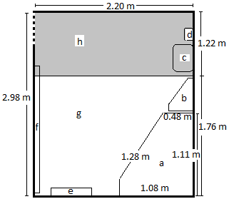 | 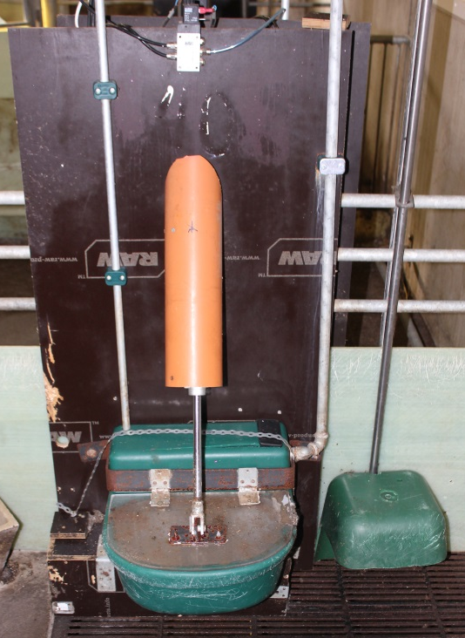
Supplementary Figure S1. Diagram illustrating the farrowing pen. Letters show the position of a) Covered creep area, b) Feed trough, c) Water trough, d) Shielded drinking nipple for piglets, e) Straw rack, f) Sloping wall, g) Solid floor, h) Slatted floor (slat width 0.09 m). | Supplementary Figure S2. A photograph of the self-build water trough when the lid to the trough is closed (centre of picture). To the right of the water trough the shielded drinking nipple for the piglets can be seen. The distance from the floor to the shielding was 24 cm.

