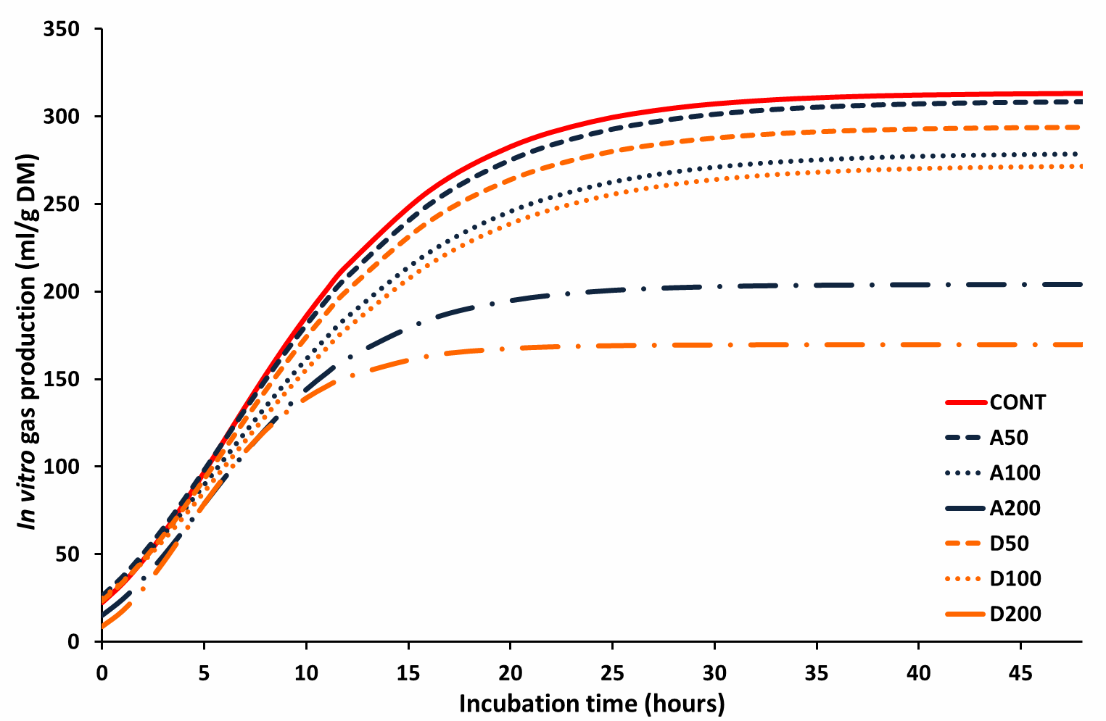
Supplementary Figure S1: Cumulative in vitro gas production curves derived from the incubation of CONT and CONT supplemented with hop cones in buffered rumen fluid

CONT, A50, A100, A200, D50, D100 and D200 denote substrate (CONT) prepared for in vitro studies as a total mixed ration, incubated in the presence of hop varieties Aurora (A) and Dana (D), whose concentrations in the buffered rumen fluid represented a cow’s daily intake of 0, 50, 100 and 200 g of hop cones, respectively.

