Supplementary Material S1. Drivers for livestock production development
Demand for livestock products
The demand for livestock products is increasing. This is attributed to an increasing global population, most of which will occur in tropical, developing countries. A second important reason is the predicted dietary change as a consequence of rising incomes and urbanisation (FAO, 2009; McDermott et al., 2010; Nonhebel and Kastner, 2011). Pica-Ciamarra and Otte (2011) discussed that such changing dietary patterns could only be observed in a few countries: China, India, Indonesia and Brasil. Figure S1 gives the relationships between the gross domestic product (GDP) and animal protein consumption with data for 1981 and 2009 in one graph. The figure shows the rising animal protein consumption with increasing income, the income effect that is higher at low consumption levels than at high and it confirms the report of Pica-Ciamarra and Otte (2011) that income effects on dietary composition in the poorer countries have been relatively marginal.
Nevertheless, the combined effect of population growth and changing dietary patterns resulted in an increased production in developing countries from 1990 till 2003 (meat +207%, milk +114% and eggs +34%; Pica-Ciamarra and Otte, 2011).
Poverty reduction
Many individuals and organisations in research and development stressed the positive contribution of livestock to poverty elevation and food security of the poor. Udo et al. (2011) discussed that the poultry is the species to start with, followed by small ruminants, while cattle are too expensive and require too much care to be successful in development programs for the poor: “smallholder dairying.....proved to be a good means to increase household incomes. A paradox is that poultry, pigs or small ruminants better fit the farming conditions of the poor, but their contribution to household incomes is small......The social, cultural and capital assets function of livestock will remain important for these [very poor] households”.
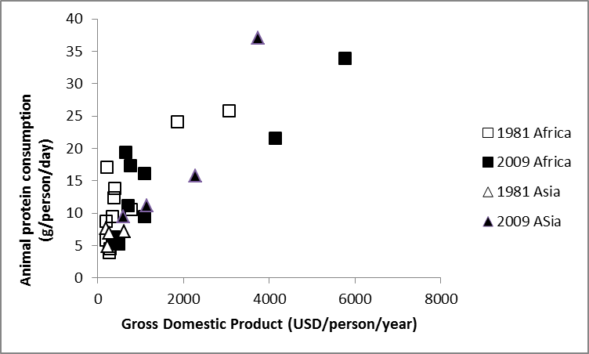
Figure S1. Relationship between per capita income (represented by GDP (uncorrected for value inflation between 1981 and 2009)) and per capita animal protein consumption. Countries included are: Benin, Nigeria, Mali, Ghana, Ethiopia, Kenya, South-Africa, Namibia, Rwanda, Malawi, Mozambique, China, India, Bangladesh and Indonesia.(Source FAO, 2013).
Environmental issues
Mining of soils is a problem in many tropical farming systems, most specifically smallholder systems. Doumbia et al. (2012) showed that rice farmers in Mali with livestock could benefit from animal manure not only with regard to amount of fertiliser application, but more importantly that they had manure available in times of untimely mineral fertiliser supply. In crop production science the benefit from livestock manure for soil fertility and crop production in the tropics is widely acknowledged (Rufino, 2008; Tittonell et al., 2010). Zingore et al. (2011) estimated that up to 10 tons (equivalent of the manure production of 5 to 10 cows) of animal manure should be applied yearly for a period of 10 years to restore soil productivity to the original level in Zimbabwe. Crop production, however, can benefit from small quantities already (Tittonell et al., 2010; Doumbia et al., 2012).
The contribution of livestock to greenhouse gas emissions is to a major extent attributable to the enteric methane production by ruminants (see Hristov et al. (2013)). Gerber et al. (2011) published the relationship of estimated methane emissions per kg milk produced and the output of milk per cow and concluded that low production cows often found at low production systems are detrimental for the world’s climate. They conclude that “[t]he possible combination of economic and environmental benefits stemming from productivity gains in dairy production suggests the presence of low cost mitigation options...”. Since production increment is often associated with reduced number of animals and consequently with reduced non-production functions (of which manure production is one), farmers might consider such low cost mitigation options as costly (Udo et al., 2011).

References
Doumbia D, van Paassen A, Oosting SJ and van der Zijpp AJ 2012. Livestock in the rice-based economy of Office du Niger: The development potential for increased crop-livestock integration through multi-actor processes. NJAS Wageningen Journal of Life Sciences 60-63, 101-115.
FAO 2009. The state of food and agriculture – Livestock in the balance. Food and Agriculture Organization, Rome, Italy.
FAO 2013. FAOSTAT. Food and Agriculture Organization, Rome, Italy. http://faostat3.fao.org/faostat-gateway/go/to/home/E. (Retrieved between June and September 2013).
Gerber P, Vellinga T, Opio C and Steinfeld H 2011. Productivity gains and greenhouse gas emissions intensity in dairy systems. Livestock Science 139, 100-109.
Hristov AN, Oh J, Lee C, Meinen R, Montes F, Ott T, Firkins J, Rotz A, Dell C, Adesogan A, Yang W, Tricarico J, Kebreab E, Waghorn G, Dijkstra J and Oosting SJ 2013. Mitigation of greenhouse gas emissions in livestock production – A review of technical options for non-CO2 emissions. Edited by Gerber PJ, Henderson B and Makkar HPS. FAO Animal Production and Health Paper No. 177. FAO, Rome, Italy.
McDermott JJ, Staal SJ, Freeman HA, Herrero M and van der Steeg JA 2010. Sustaining intensification of smallholder livestock systems in the tropics. Livestock Science 130, 95-109.
Nonhebel S and Kastner T 2011. Changing demands for food, livestock feed and biofuels in the past and in the near future. Livestock Science 139, 3-11.
Pica-Ciamarra U and Otte J 2011. The ‘livestock revolution’: rhetoric and reality. Outlook on Agriculture 40, 7-19.
Rufino MC 2008. Quantifying the contribution of crop-livestock integration to African farming. PhD-thesis Wageningen University, Wageningen, The Netherlands.
Tittonell P, Muriuki A, Shepherd KD, Mugendi D, Kaizzi KC, Okeyo J, Verchot L, Coe R and Vanlauwe B 2010. The diversity of rural livelihoods and their influence on soil fertility in agricultural systems of East Africa – A typology of smallholder farms. Agricultural Systems 103, 83-97.
Udo HMJ, Aklilu HA, Phong LT, Bosma RH, Budisatria IGS, Patil BR, Samdup T and Bebe BO 2011. Impact of intensification of different types of livestock production in smallholder crop-livestock systems. Livestock Science 139, 22-30.
Zingore S, Tittonell P, Corbeels M, van Wijk MT and Giller KE 2011. Managing soil fertility diversity to enhance resource use efficiencies in smallholder farming systems: a case from Murewa District, Zimbabwe. Nutrient Cycling in Agroecosystems 90, 87-103.

