Supplementary Figure S1a and S1b: Example of thermogram from the side (S1a) and from the back (S1b). The black line shows the manual marking of the pig’s surface, and thus the area in which the software searches to find the minimum, maximum and average surface temperature. The blue line marks the area in which the software searches to find the coldest spot on the ear, and the blue X identifies the coldest spot on the ear.

1a
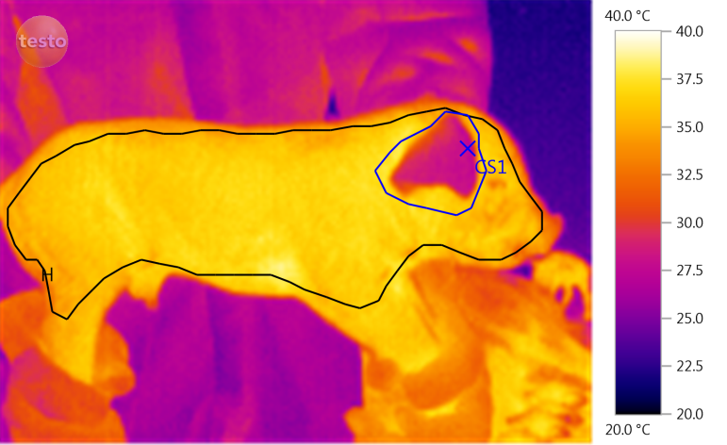

1b
