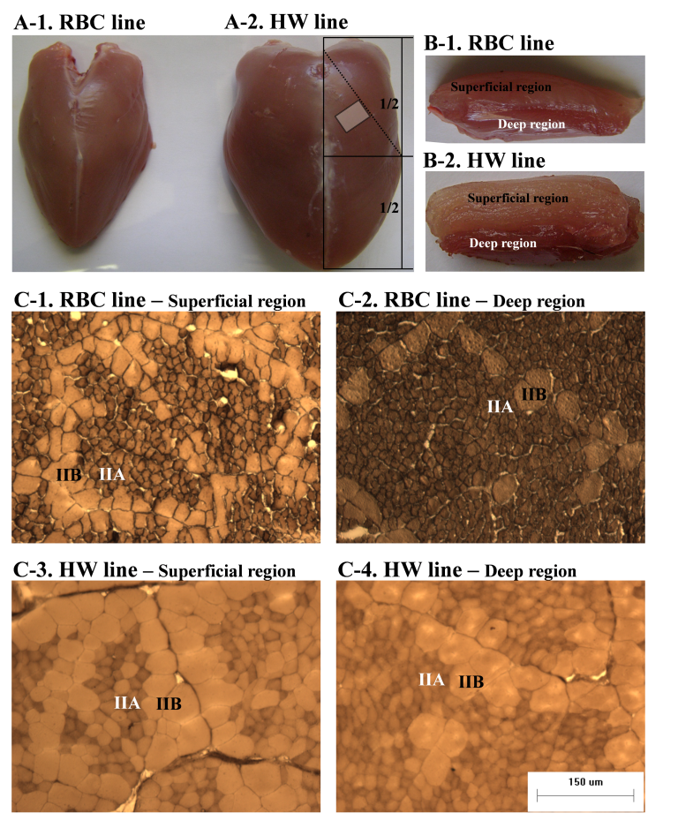
Supplementary Figure S1. Pectoralis major muscle (A) and cross-sectional area of pectoralis major muscle (B) of the different quail lines at 42 d of age. The area of the pectoralis major muscle was measured at the diagonal line of a point 1/2 in the pectoralis major muscle as reported by Scheuermann et al. (2004). Muscle samples were taken from the mid-point on the diagonal line (A-2). Muscle fiber cross-sections (C) of the different quail lines and different muscle regions (superficial and deep regions) in the pectoralis major muscle that were stained for myosin ATPase activity after acidic preincubation (pH 4.6). Bar indicates 150 μm. Abbreviations: RBC, random bred control; HW, heavy weight; IIA, fiber type IIA (fast-twitch and oxido-glycolytic); IIB, fiber type IIB (fast-twitch and glycolytic).

