Appendices

Section 1: Description of Interviews

Interviews were conducted in July and august 2015 with staff and program directors at the Open Society Foundation, the Global Fund for Women and the Ford Foundation, which differ in crucial dimensions but share a commitment to funding women’s programs around the world. Unfortunately, we were not able to arrange an interview with the Gates Foundation, which limits our interview data, a limit we hope to remedy with our work moving forward.
Ford represents one of the oldest and largest US foundations, with an extensive portfolio of programs focused on women and gender equality beginning in the 1960s. For many years, Ford has been a top funder for programs targeting women and girls both inside and outside the United States. In 2012, for example, it provided almost $42 million in grants to women and girls outside the United States. The Open Society Foundation (OSF) was established in 1979 and while women’s equality and empowerment were always an aspect of its programming, they were generally often approached as part of a larger strategy of support for civil society, human rights and democratic transitions. Although it only provided about $4.5 million to women and girls outside the United States in 2012, it is the world’s leader in funding for human rights, providing the most money and largest number of grants of any foundation. In 2011, the OSF funded more than 2,500 grants and spent more than $260 million (http://data.foundationcenter.org/#/fc1000/population_group:women_girls/international/top:foundations/bar:amount/2012, accessed July 31, 2015). The Global Fund for Women was established by three women in 1987 for the sole purpose of funding women-led organizations globally and with a primary focus on conflict areas. In 2012, it provided almost $8 million in grants for women and girls. (“Advancing Human Rights. Update on Global Foundation Grantmaking,” The Foundation Center 2014, 4-5. http://www.give.org/charity-reviews/national/global-fund-for-women-in-san-francisco-ca-3283, accessed August 23, 2015).
All three foundations have provided grants to women through a variety of programs and issue areas. This suggests a commitment to funding women as a comprehensive strategy in the social, economic and political realms, although the three foundations have historically had different areas of emphases. While the Ford Foundation has funded more heavily in the social sector, with the majority of its grants falling in the education and health sectors, the Open Society Foundations has focused their funding on civic and political participation and women’s leadership, with a strong secondary focus on gender based violence. The Global Fund for Women has concentrated its grants “on supporting women’s groups working in hard to access places and working with marginalized populations and on underrepresented issues”(Jill Irvine, correspondence with Jane Sloan, 28 August, 2015). It has funded a broad array of issues including sexual and reproductive health and rights; ending gender based violence, economic rights and environmental justice, peacebuilding and conflict transformation; women’s political participation and rights, access to education, and fostering social change philanthropy (primarily via supporting women’s funds.
All three foundations where we conducted interviews are currently in the process of restructuring their women’s rights programs and refocusing their funding priorities. The Ford Foundation, under the leadership of program director Margaret Hempel, recently reorganized its women’s rights and empowerment programs, which were scattered across a number of units. (For more on the Ford Foundation’s Program on Gender, Sexuality and Reproductive Justice, see http://www.fordfoundation.org/issues/sexuality-and-reproductive-health-and-rights/protecting-womens-rights.) In 2014, the Program on Gender, Sexuality and Reproductive Justice was formed with the mandate to fund in six priority areas: protecting women’s rights; reducing HIV/AIDS discrimination and exclusion; supporting sexuality research; promoting reproductive rights and the right to sexual health; youth sexuality, reproductive health and rights; and advancing LGBT rights.
In contrast to the Ford Foundation, where the restructuring appears to have been propelled primarily by organizational concerns, recent developments at the OSF’s Women’s Rights Program were part of broader restructuring inspired by the Foundation’s new President, Christopher Stone in 2012. In 2013, a fundamental review of the International Women’s Rights Program was launched, which resulted in a streamlining of its six previous areas of funding (political participation; violence against women; economic empowerment; women’s rights movements; and sexual and reproductive rights) to three areas of emphasis: strengthening women’s rights organizations and movements; promoting sexual and reproductive rights; and economic justice. The renamed, Women’s Rights Program, shifted from a definite regional focus, working in conflict and post-conflict countries to a less defined regional focus based on “opportunity” and need. Recently appointed program director, Cynthia Eyakuze, has spearheaded this reorganization in conversation with women’s rights activists in a variety of communities and staff within the OSF.
The Global Fund for Women has faced a different set of challenges, which has prompted this public foundation to change its strategies and practices. For more than two decades, The Global Fund for Women used strategy of “let a hundred flowers bloom,” with no particular thematic focus. Rather, the sole funding criteria was to give to projects led by women that were focused on social change. In contrast to many other foundations or donors, The Global Fund often provided funds for general operating costs. The Global Fund’s 25 anniversary, and new leadership under President and CEO Musimbi Kanyoro, provided the impetus for “deep reflection” about its achievements and its vision moving forward. Drawing upon a variety of sources, including a study produced by researchers at Stanford University, internal data provided by program directors, and consulting with its extensive Board of Advisors and others, the Global Fund produced a new strategic plan. The new plan identifies three areas of thematic focus moving forward: sexual and reproductive rights; economic and social rights; and gender based violence. The Global Fund continues to provide “core funding,” that covers general operating costs, as part of its continuing commitment to building and strengthening women’s movements. Nevertheless, it is shifting toward a strategy of funding fewer organizations at a greater level over a longer period of time, even as it continues to give a relatively large number of small grants to women’s organizations. Recognizing the need to report to their many individual, small donors the impact of their work, Global Fund hired staff to develop more rigorous methods of evaluation and assessment.
In our semi-structured interviews, we asked questions to identify how women’s empowerment programs are envisioned and structured. How are women’s needs defined and gender constructed through the funding process? How has this changed over time? In what ways is it reflected in the organizational structures and culture of the foundation? We were particularly interested in understanding foundations’ “theory of change” and the different ways in which foundations have considered or responded to the criticisms that aid can undermine rather than strengthen women’s organizing and organizations. Thus, we asked about foundations’ strategies for assisting and empowering women’s movements and political activism. To what extent are these foundations concerned with movement building for sustained change, including “intersectional” alliances and engagement with other social movements and issues? How do they understand the processes of creating capacity, framing issues, and forming coalitions? How do they direct funds to these ends? What are the challenges they face in attempting to support women’s movements and women’s rights activism?
List of interviews:

- Cynthia Eyakuze, Director, Women’s Rights Program, Open Society Foundations, July 30, 2015
- Margaret Hempel, Director, Program on Gender, Sexuality and Reproductive Justice, Ford Foundation, August 14, 2015,
- Musimbi Kanyoro, President and CEO, Global Fund for Women, August 27, 2015
- Jane Sloan, Director of Programs, Global Fund for Women, August 27, 2015
- Pei-Yao Chen, Director of Learning, Evaluation and Impact, Global Fund for Women, August 3, 2015

Section 2: Description of Primary Dataset

Empirical work was done on two datasets acquired from The Foundation Center. The first ranges 1992-2001, the second ranges 2002-2013. The two data sets vary only in the internal coding used for issue areas, strategies, and similar details, but use identical inclusion criteria and data-gathering methodology. Both datasets contain all grants of at least 10,000 Nominal USD made during the year by any of the 1,000 largest U.S. based foundations. Data was collected by direct reporting from foundations, foundation websites, public reporting, and annual IRS information returns. More information on the overall dataset is available at http://data.foundationcenter.org/about.html.

Because the dataset contains information only on foundation funding, we cannot rule out the impact of other sources of funding for women’s empowerment programs. As such the conclusions in this study apply to the ways in which Foundation funding does or does not provide for effective political action. Organizations may compensate for foundation funding through alternate income sources, but due to the massive scale of foundation funding, and the stated goals of foundations to be effective funders of women’s empowerment, identified shortfalls in patterns of foundation funding have serious implications for women’s empowerment.

Within our study, we create a custom data set composed of only those grants pertaining to women’s empowerment. Grants were selected if
- At least one of the grant population codes was women or girls or
- No grant population codes were specified and at least one of the recipient organization population codes was women or girls

This subsection of the data included 59,558 grants in the 1992-2001 data and 111,438 grants in the 2002-2013 data. Because of the switch in coding methods, we calculate trends in issue areas, strategy, and related areas only within the 2002-2013 data. However, we calculate trends in gross spending and spending by foundation across both data sets as methodology for these variables is consistent between the two sets.

Unlike AWID’s data, the Foundation Center dataset contains organizations that are not explicit women’s organizations, but which receive grant funding for and contain programs directed at women and girls. Our primary concern is not to attempt a total tally of funding to women’s organizations, but rather a comprehensive dataset of foundation giving to women’s empowerment programs. As such there is imperfect overlap between the funding recipients in the Foundation Center data and the organizations interviewed by AWID. We draw primarily on AWID data for analyzing the goals and needs of women’s organizations, but use the Foundation Center data to examine the extent to which foundation funding patterns match stated goals. As noted in the text, the overlap between the datasets is much more significant when examining funding for political purposes (see appendix 3), and as such our analysis on specific types of funding is limited to these recipient organizations.

Within the 2002-2013 data, grants are assigned up to 10 issue areas, up to 10 populations, up to 10 strategy codes, and one primary activity override code that denotes the primary subject of the grant. Recipient organizations are assigned an organization type, up to 10 issue areas, up to 10 populations, and up to 10 strategy codes. The indicators detailed in sections 2-6 below use a combination of all of these, while Figure 8 referencing the top funded issues uses the activity override code to indicate primary issue focus.

Section 3: Political Binary Indicator

In order to better capture funding to traditional women’s empowerment organizations, we construct a subset of the Foudnation Center data containing only political funding. This subsection is used for all subsequent analysis of trends in specific forms of funding. Due to the differences in coding methodology discussed above, the political binary indicator was only constructed for 2002-2013 data, and all sections concerning political spending only examine this data. Any grant that met any of the criteria below was included as political. Due to a lack of granularity in the data, multi-part grants with at least one political dimension were counted as entirely political, potentially inflating totals for political giving.

We consider grant as political if it contained at least one of the following:
- A political grant subject issue
- A political grant strategy
- A political grant target population
- A political recipient organization subject issue area
- A political recipient organization strategy
- A political recipient organization target population
- A political recipient organization type

Because any of the above is enough to qualify a grant as political, activities that are not themselves coded as political but which are performed by political organizations are included, as are political actions performed by organizations which are not themselves coded as political.

The same lists of issues, strategies, and populations were used both for grants and for recipient organizations.

The following Subject Issues were considered political: Environmental Justice, Media Justice, Narcotics, Community policing, Courts, Leadership Development, Democracy, Civic participation, Election Regulation, Campaign finance reform, Political organizations, Voter education and registration, Public Integrity, Government Regulation, Food Sovereignty, Community organizing, Neighborhood associations, Anti-predatory lending, Human Rights, Individual liberties, Right to life, Right to die, Freedom from violence and torture, Freedom to slavery, Right to privacy, Freedom of religion, Right to free movement and asylum, Reproductive rights, Social rights, Traditional marriage, Marriage equality, Freedom of information, Voter rights, Labor rights, Environmental and resource rights, Cultural rights, Economic justice, Justice rights, Due process, Capital punishment, Antidiscrimination, Immigrants’ rights, Minority rights, Disabled persons’ rights, Women’s rights, Rights of the ages, LGBTQ rights, Children’s rights, Prisoners’ rights, Diversity and intergroup relations, Democracy and civil society development, Foreign Policy, Goodwill promotion, Multilateral cooperation, International peace and security, Arms control, Arms trafficking, Disarmament, Landmines, Nuclear non-proliferation, Conflict resolution

The following Strategies were considered political: Policy, Advocacy and systems reform, Advocacy, Systems reform, Litigation, Grassroots organizing, Coalition Building, Equal access

Section 4: General Operating Support

We coded grants as General Operating Support if the Grant Strategy Code contained at least one of the following: General operating support, Capacity building and technical assistance, Seed Money, Capital and infrastructure, Equipment, Information Technology, Building and renovations, Rent, Land acquisitions, Building acquisitions, Facilities maintenance, Financial Sustainability, Earned Income, Endowments, Financial Services, Annual campaigns, Fundraising, Debt reduction, Internships.

As with all the indicators, any grant flagged was counted in its entirety. Due to a lack of granularity in the data, multi-part grants only partially earmarked for General Operating Support would have been counted here in full as General Operating Support, potentially inflating the totals.

The breakdown for each sub-variable of General Operating Support is represented here below. Because grants have multiple strategy codes, the sum of all of the sub-variables is greater than the aggregate figures.

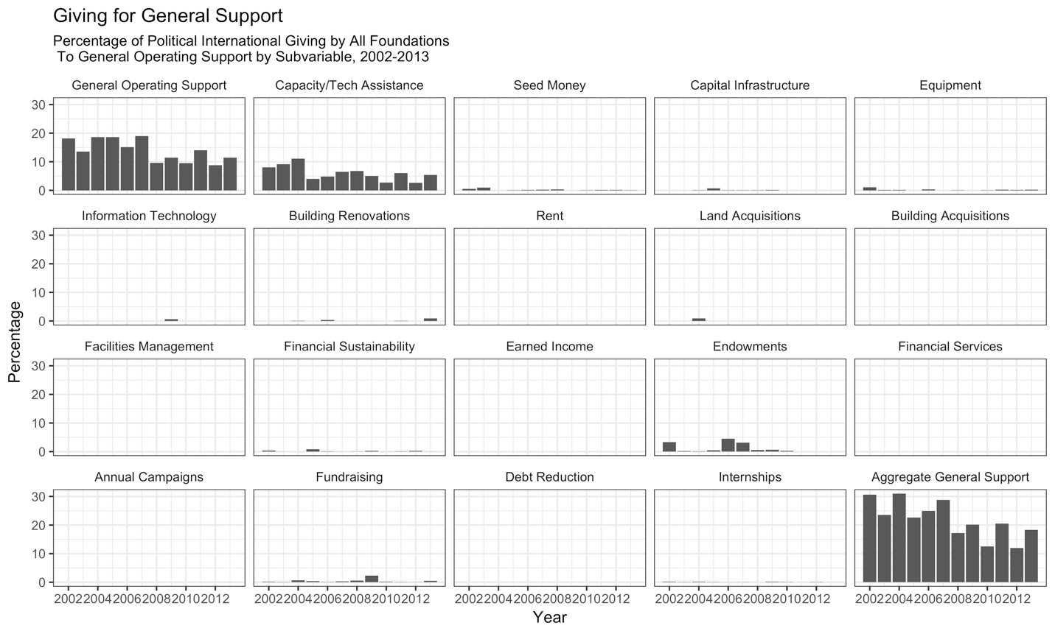

Section 5: Leadership Development

We coded grants as Leadership Development if the Grant Strategy Code contained any of the following: Leadership and professional development, Faculty or staff development, Board development, Management and leadership development.

As with all indicators, any grant flagged was counted in its entirety. Due to a lack of granularity in the data multi-part grants only partially earmarked for Leadership Development would have been counted here in full as Leadership Development, potentially inflating the totals.

The breakdown for each sub-variable of Leadership Development is represented here below. Because grants have multiple strategy codes, the sum of all of the sub-variables is greater than the aggregate figures.
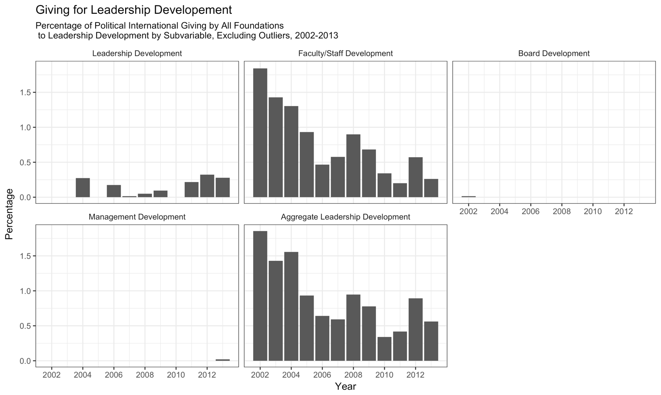
In the leadership development dimension, there are two significant outliers in a 2012 and a 2003 grant from the Gates Foundation. These grants were for 13,996,740 Nominal USD and 40,000,000 Nominal USD respectively. We excluded these grants from the calculation of trends in funding for leadership development. We have chosen to do this for several reasons. Firstly, these two grants are the only two grants ever given for leadership development by the Gates Foundation, and thus do not represent a reliable or predictable source of funding for leadership development. Furthermore, these two grants together are significantly larger than all other leadership development grants in the time period put together, making them highly influential outliers. Because we are attempting to identify the general trends in funding, we have thus excluded these two grants as not indicative of general trends in funding. The figures in the text exclude the Gates grants. Below are the graph and table for funding by year including these two grants.
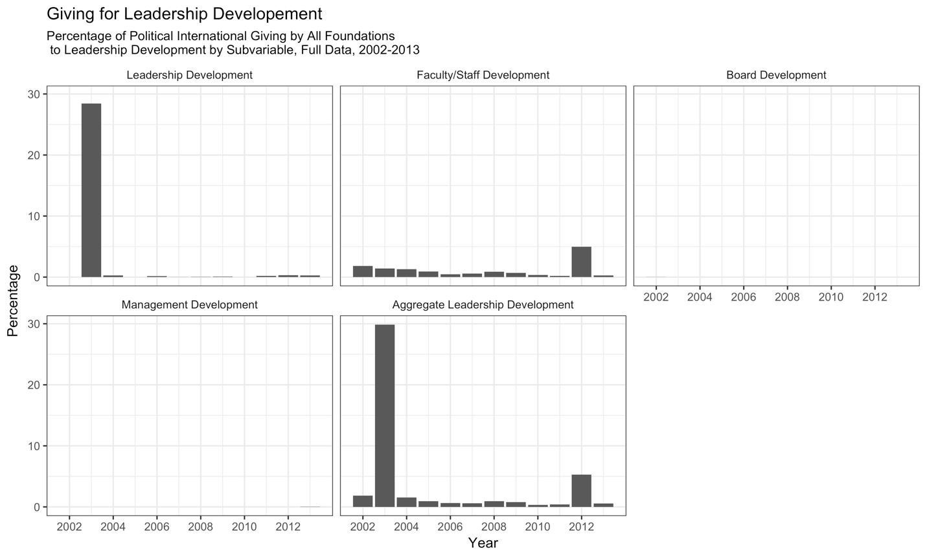

Section 6: Finding Voice

We coded grants as Finding Voice if the grant strategy contained at least one of the following: Outreach, Public engagement and education, Audience development, Marketing, Cause-related marketing, Convening, Online engagement, Grassroots and organizing, Publications, Online media, Research.

We include marketing here because these codings apply only to grants that are already flagged as political in nature. While marketing may not normally be considered related to traditional outreach or voice-finding, specifically within a political context it captures important activities such as campaigning and program promotion.

Like all the indicators, any grant flagged was counted in its entirety. Due to a lack of granularity in the data multi-part grants only partially earmarked for Finding Voice may have been counted here in full, potentially inflating the totals.

Below is the complete breakdown of funding for Finding Voice by sub variable. An aggregate figure excluding research is included for reasons discussed in the text.
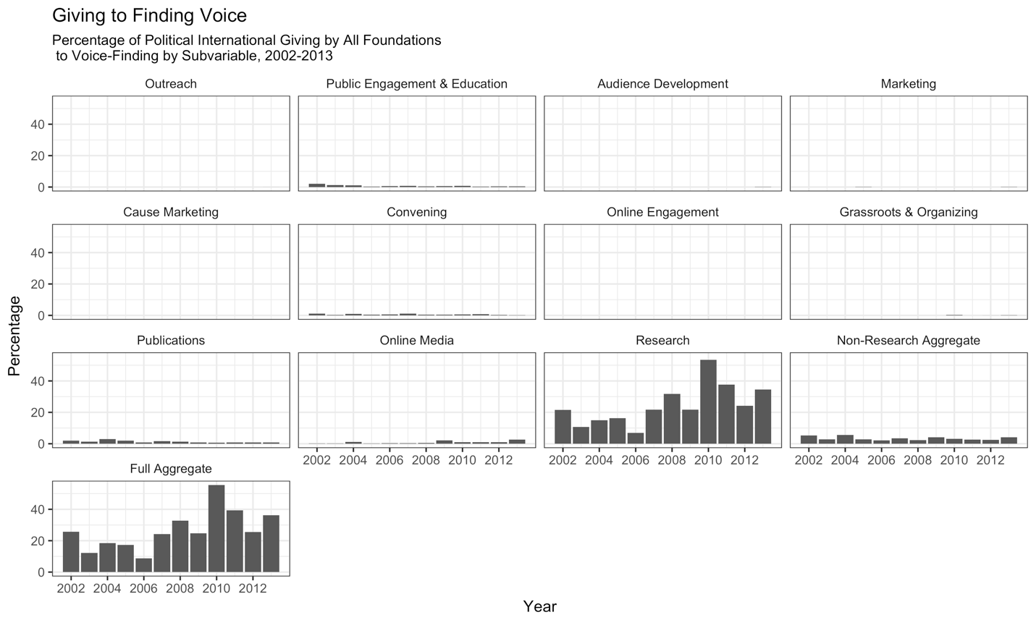

Section 7: Alliance Building

We coded grants as Alliance Building if the grant strategy contained at least one of the following: Mergers, Network Building and Collaboration, Conferences, Conference Hosting, Conference Presenting, Conference Attending, Exchange Programs, Non-profit Collaboration, Coalition Building, Travel Grants

Like all the indicators, any grant flagged was counted in its entirety. Due to a lack of granularity in the data multi-part grants only partially earmarked for Alliance Building may have been counted here in full, potentially inflating the totals.

In the text we refer to conferencing as a general activity. Grants were considered as funding conferencing if the grant strategy contained at least one of the following: Conferences, Conference Hosting, Conference Presenting, Conference Attending.

The breakdown for each sub-variable of Alliance Building is represented here below. Because grants have multiple strategy codes, the sum of all of the sub-variables is greater than the aggregate figure.
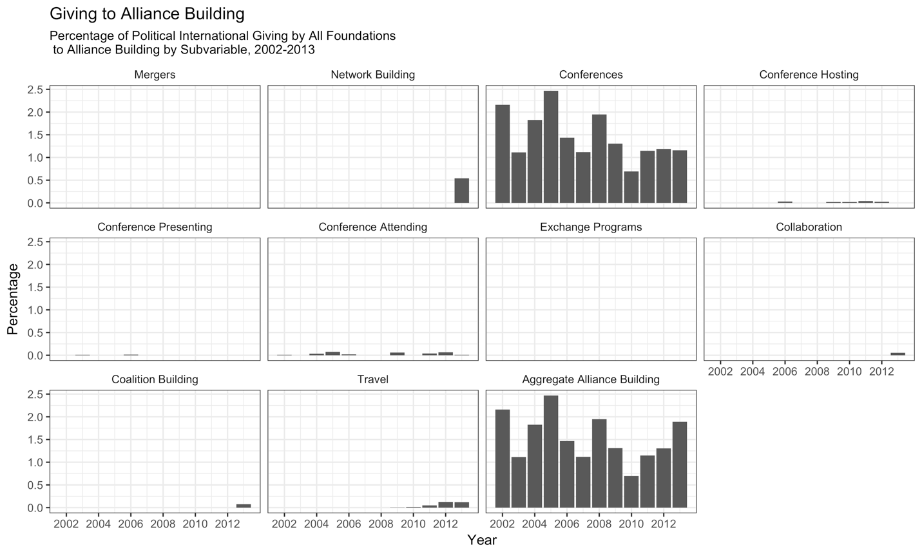

The average level of funding for organizations tagged as alliances or coalitions is referenced in the text. Grants were considered if the Recipient Organization Type was Coalitions and Alliances. Below is the annual breakdown for funding for alliances and coalitions

