Appendix

How narratives and evidence influence rumor belief in conflict zones: Evidence from Syria

# Technical details of the fieldwork that informs this manuscript

As I state in the main text, this manuscript is informed by 35 interviews with Syrian refugees in Jordan and 179 interviews with Syrian refugees in Turkey. These interviews were completed with a questionnaire that includes open-ended and closed-ended questions. In this appendix, I describe how I conducted my interviews and the questions from my questionnaire that inform this paper.

## How I conducted interviews

As I explain in the main text, I conducted interviews a bit differently in Jordan and Turkey. In Jordan, I was more exploratory. In Turkey, I had narrowed down exactly where I wanted to focus conversations. In both countries, I made sure that interviews had an average duration between 60 and 90 minutes. If an interview was stretching long, then I reassured the respondent that we did not have to go longer if they did not want to. Nevertheless, there were some respondents who wanted to speak at length. One interview lasted four hours.

In Jordan, I used several means to identify respondents. In Irbid, Amman, and Zaatari village, respondents were identified through the social network of the interpreter and then snowball sampling. In Zaatari refugee camp, respondents were identified by walking to several camp districts and then snowball sampling. I intentionally used several entry points into communities, in order to obtain a diverse sample (Bloch 2007, Schon 2019). This diversity can be observed through the variety of origin locations, destination locations, and migration timing of my respondents in Jordan.

Figure 1: Respondent origins for Jordan sample

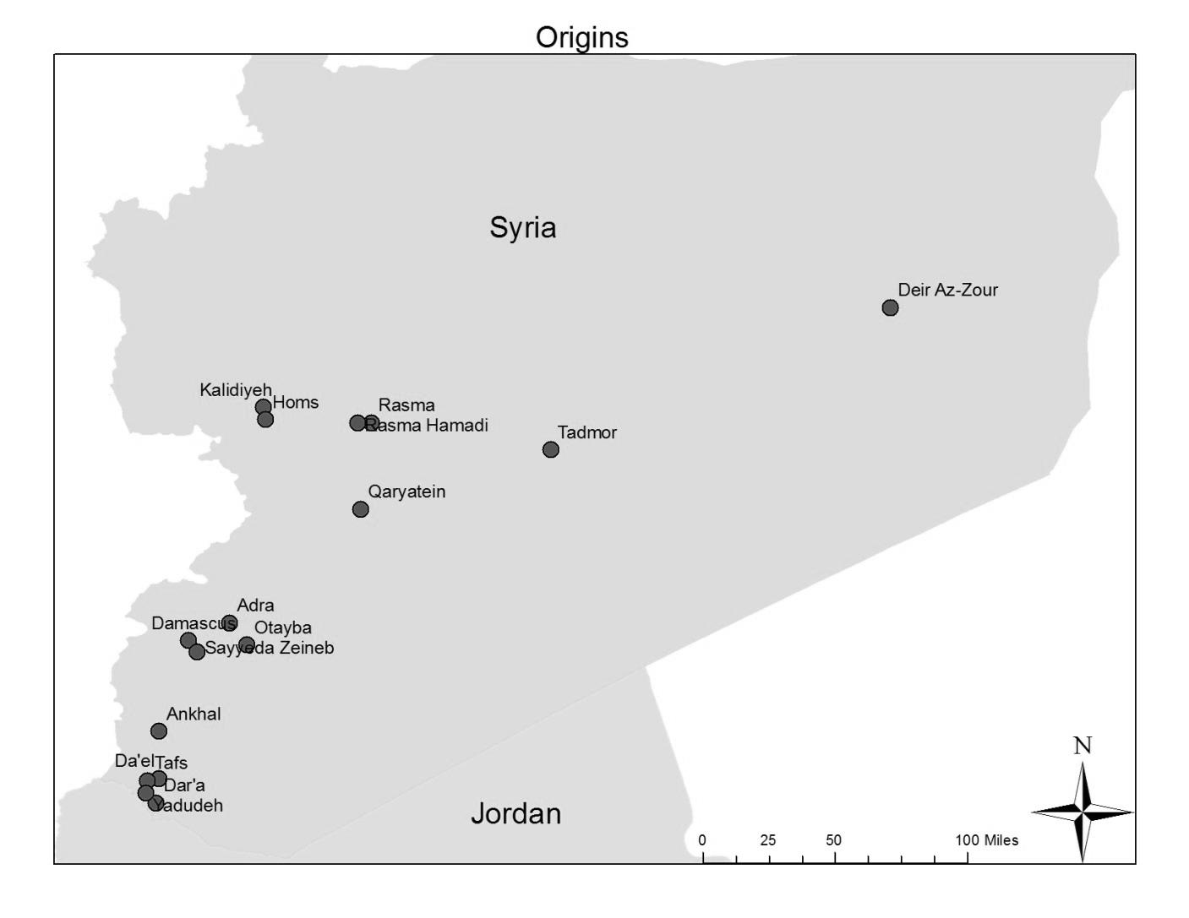

Figure 2: Respondent destinations for Jordan sample

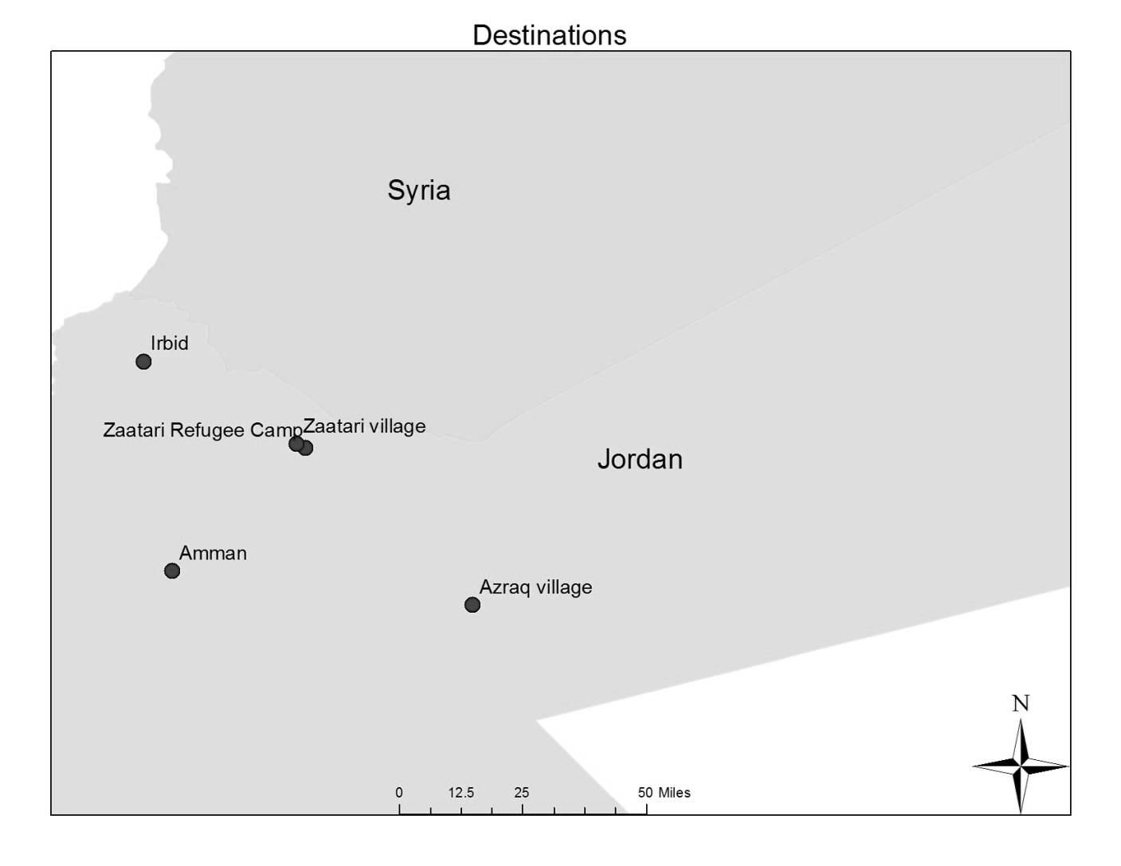

Figure 3: Migration timing for Jordan sample

Caption: Here, the vertical axis refers to the number of respondents who left their homes in Syria during each time period. Each time period covers 6 months. For example, 2012-1 is the first 6 months of 2012 and 2012-2 is the second 6 months of 2012.

The language of the interview depended upon the language skills of the respondent. If the respondent was comfortably fluent in English, then I interviewed the respondent alone. If the respondent spoke English but was not fully comfortable, then we conducted the interview in English with an interpreter to help translate any words that were unclear. If the respondent was not fluent in English, then we conducted the interview in Arabic with an interpreter.

For respondent safety, I kept their identities confidential and obtained verbal consent. I only refer to them through their code numbers in my writing. While I was arranging interviews, I did not write down the names of respondents. If I did obtain their names, then I maintained the information on hard copy paper that I shredded and discarded after interviews were complete.

In Turkey, I kept interviews structured. I wanted to ask all respondents the same sets of questions. I conducted interviews in Istanbul and Izmir. This site selection was influenced by security concerns at the Turkey-Syria border. In addition, Istanbul had become host to the largest number of Syrian refugees out of any city in Turkey. Izmir was host to over 100,000 Syrian refugees, and it hosted a different demographic profile of Syrians. Language choices for interviews were done in the same manner as for the interviews in Jordan. Also, I again had several entry points into communities, including Syrian schools and the social network of my interpreter, and obtained a diverse sample.

Figure 4: Respondent origins for Turkey and Jordan samples

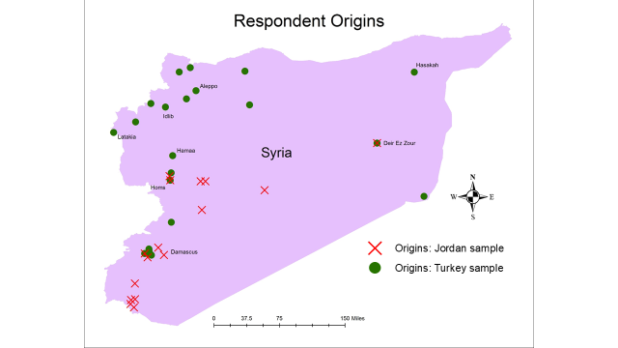

Figure 5: Interview locations in Istanbul

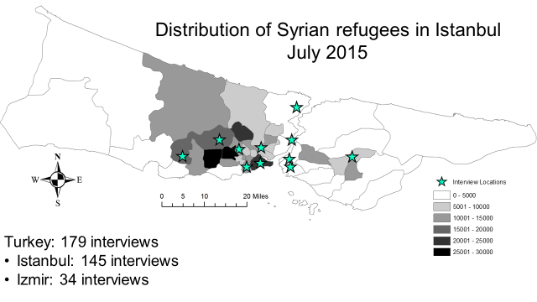

Figure 6: Migration timing for Turkey sample



## Questions that inform this paper

The primary focus of interviews was civil war in Syria and migration-related decisions that civilians were making. I was not originally expecting to spend any time thinking about rumors. This changed due to one pivotal moment that occurred during one of my conversations in Zaatari refugee camp. After discussing conflict and migration at length, a man stopped and told me that we had not yet discussed the biggest problem. He told me that many Syrians had been trying to exit Syria, but they had been taking the wrong routes. They did not have the information that they needed to exit quickly and safely. This stuck with me. It made me realize that I needed to explore this issue further.

This led me to incorporate a few questions into my interviews in Turkey that I would ask all respondents there. After asking my respondents about their migration and how they made decisions related to migration, I wanted to probe how they chose whether to believe particular pieces of information that they had heard. Below, I share the key section of my questionnaire that informed this paper.

# Things You Heard

**I am now going to ask you about specific things that you heard while you were inside Syria since March 2011.**

## Do you specifically remember any of these things that you heard? If yes, please share some examples of things that you heard that you did believe, as well as some examples of things that you did not believe:

|  |  |
| --- | --- |
| Things you believed | Things you did not believe |
|  |  |

## Do you think that you were able to tell the difference between rumors, or false information, and accurate information while you were in Syria? (If NO, skip to 63.)

### 1. YES 0. NO 98. DON’T KNOW 99. REFUSED

## How did you determine whether a piece of information was true or false? Did you discuss it with other people? Did you ask the source who provided the information?

In these questions, there are several important considerations. First, I started this section of the interview with a brief preface. After reading the preface, I would intentionally pause to ensure that my respondent had a moment to think about this topic. It was also intentional to refer to “things you heard” and not “rumor.” The word “rumor” is often interpreted as indicating that a piece of information is false. Since rumor really refers to unverified information in scholarship, I did not want to restrict the thoughts of my respondent to false information.

Another important component of this question is the distinction between “things you believed” and “things you did not believe.” This broad question would sometimes be met with confusion initially. When there was confusion, I would suggest an absurdly obvious true piece of information and an absurdly obvious false piece of information as examples. I did not want to influence what respondents did and did not believe, so I suggested absurd examples that were consistent with views they had already expressed. Since these questions were typically about 45 minutes into the interview, I generally had a good working understanding of respondent views by this point. If the respondent had already expressed opposition to Bashar Assad and frustration that it felt like the war would never end, I would suggest that “Bashar Assad announced the war would end tomorrow” as an example of a thing they might have heard that they did not believe. This kind of intentional absurdity made many respondents laugh, and it helped encourage frank answers.

Furthermore, specifying “things you did not believe” provides an opportunity to discuss pieces of information that failed to spread. This is far from perfect in its ability to capture information regardless of whether it spreads, but it does make progress in this direction beyond previous research (Bhavnani, Findley et al. 2009, Greenhill and Oppenheim 2017).

After that, I asked: “Do you think that you were able to tell the difference between rumors, or false information, and accurate information while you were in Syria?” The variable in this paper on whether people believe they can distinguish fact from fiction comes from this question. This question uses the word “rumors” because it allowed me to use vocabulary that respondents would use. The way I use the word in this question, however, is different than how I define the word in my academic writing. In academic writing, I conform to existing definitions of rumors as unverified information. This is a crucial point for researchers to consider. There are many concepts like rumors that have different technical definitions than what regular people would use.

To follow up on that question, I asked for elaboration on how respondents evaluated new information: “How did you determine whether a piece of information was true or false? Did you discuss it with other people? Did you ask the source who provided the information?” Here, the first question is the real question, with the subsequent two questions being suggestions for how they could answer the question. Discussing new information with other people denotes that a “collective sense-making” process is taking place (Shibutani 1966). Asking about the source is the relationship mechanism that I discuss in the paper. Surprisingly to me, a large amount of respondents used the expression “I depended on my experience.” I view this as an interesting way to say that they were evaluating new information on their own. I do not engage with this manner of expressing this answer in the paper, but it might be worthwhile for future work to engage with this answer further.

Finally, I use three other variables to examine which respondents were using which mechanism of evaluating information. First, I recorded the gender of respondents. Second, I recorded their level of education. Third, I asked whether respondents had wasta when they were in Syria. This is the same variable as is used in Schon (2019).

# Suggestive correlates of information evaluation mechanisms

In the main text, I elaborated on exactly how Categories (1), (2), and (3) of rumor evaluation work. This discussion was really intended to show how each process works, as opposed to quantifying the frequency of each process, but it is also important to share some numbers and identify some factors that could be influencing how people choose methods of evaluating new information. My discussion in this Appendix is intended to spark ideas for future research, so it should be taken as suggestive.

There are three factors in particular that had suggestive correlations with the selection of evaluation methods: education, gender, and social status. Categories (1) and (2) were used the most, with 37 respondents reporting using them. Category (3) was not insignificant though, as 16 respondents reported using this type of tactic. Based on chi-squared tests, college-educated respondents were more likely to believe that they could evaluate new information on their own (Category 1). At the same time, college-educated respondents were less likely to evaluate the source of new information (Category 2). Women and respondents with advantaged social status were more likely to use collective sense-making (Category 3). This suggests that there is important variation in rumor evaluation to consider across gender, education, and social status lines. Furthermore, chi-squared tests indicate that gender, college education, and advantaged social status did not influence the likelihood of whether a respondent felt that they could distinguish between fact and fiction. Tables showing the corresponding two by two tables are included below. These correlations suggest several exciting avenues for further research.

Table A1: Category 1 by gender

|  |  |  |
| --- | --- | --- |
|  | Men | Women |
| Self-evaluation | 31 | 6 |
| No self-evaluation | 23 | 7 |

Table A2: Category 2 by gender

|  |  |  |
| --- | --- | --- |
|  | Men | Women |
| Evaluate the source | 30 | 7 |
| Don’t evaluate the source | 24 | 6 |

Table A3: Category 3 by gender

|  |  |  |
| --- | --- | --- |
|  | Men | Women |
| Collective sense-making | 9 | 6 |
| No collective sense-making | 45 | 7 |

Table A4: Category 1 by college education

|  |  |  |
| --- | --- | --- |
|  | College Educated | Not College Educated |
| Self-evaluation | 20 | 17 |
| No self-evaluation | 7 | 23 |

Table A5: Category 2 by college education

|  |  |  |
| --- | --- | --- |
|  | College Educated | Not College Educated |
| Evaluate the source | 11 | 26 |
| Don’t evaluate the source | 16 | 14 |

Table A6: Category 3 by college education

|  |  |  |
| --- | --- | --- |
|  | College Educated | Not College Educated |
| Collective sense-making | 7 | 9 |
| No collective sense-making | 20 | 31 |

Table A7: Category 1 by social status

|  |  |  |
| --- | --- | --- |
|  | Advantaged status | Not advantaged status |
| Self-evaluation | 14 | 21 |
| No self-evaluation | 10 | 17 |

Table A8: Category 2 by social status

|  |  |  |
| --- | --- | --- |
|  | Advantaged status | Not advantaged status |
| Evaluate the source | 11 | 23 |
| Don’t evaluate the source | 13 | 15 |

Table A9: Category 3 by social status

|  |  |  |
| --- | --- | --- |
|  | Advantaged status | Not advantaged status |
| Collective sense-making | 11 | 4 |
| No collective sense-making | 13 | 34 |

While these responses make Categories (1) and (2) appear more common, it is important to note that the sample includes about half as many women as men. This suggests that people may select all three categories of information at similar rates. This sample just over-samples from a set of people that is less likely to use Category (3). Other researchers with greater access to female respondents may therefore expect to find more people using collective sense-making to evaluate new information.

# Works cited

Bhavnani, R., M. Findley and J. Kuklinski (2009). "Rumor Dynamics in Ethnic Violence." Journal of Politics **71**(3): 876-892.

Bloch, A. (2007). "Methodological Challenges for National and Multi-Sited Comparative Survey Research." Journal of Refugee Studies **20**(2): 230-247.

Greenhill, K. M. and B. Oppenheim (2017). "Rumor has it: The adoption of unverified information in conflict zones." International Studies Quarterly: sqx015.

Schon, J. (2019). "Motivation and opportunity for conflict-induced migration: An analysis of Syrian migration timing." Journal of Peace Research **56**(1): 12-27.

Shibutani, T. (1966). Improvised News: A Sociological Study of Rumor. New York, The Bobbs-Merrill Company, Inc.