Jami Nelson-Nuñez and Kate Cartwright, Getting Along or Going Alone: Understanding Collaboration Between Local Governments and NGOs in Bolivia. Latin American Politics and Society vol. 60, no. 1 (Spring 2018)

Appendix

Graph 1. Moran’s I Test of Autocorrelation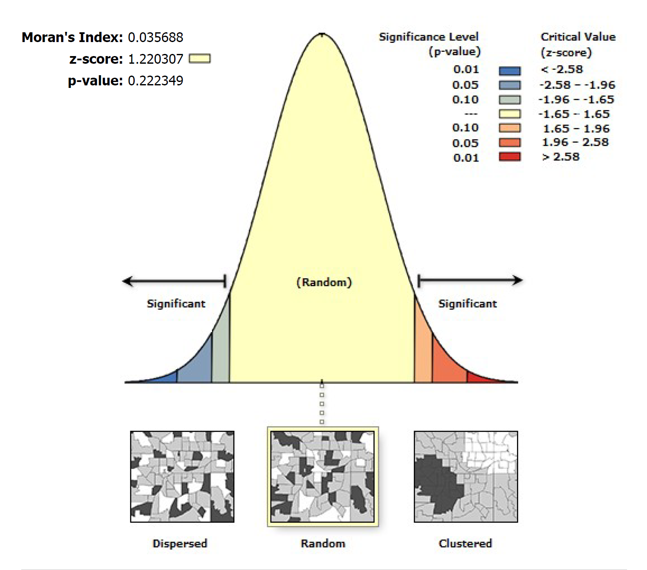

Table 1. Balance Tests
Characteristic | Full Population | Sample Mean | T-value (p-value)
Population | 33,611 | 22,390 | -2.16 (0.03)
HDI | 0.549 | 0.557 | 1.01 (0.32)
Revenue per capita | 1089.04 | 1064.66 | -0.28 (0.77)
Political competition | 0.147 | 0.144 | -0.19 (0.85)
Percent MAS 2004 turnout* | 0.186 | 0.184 | -0.10 (0.90)
Number of NGOs registered | 6.223 | 4.691 | -3.60 (0.000)
Rural (logged) | 4.184 | 4.236 | 0.82 (0.41)
* As our measure of MAS is based on the mayor’s response in the survey, we draw on voter turnout for the MAS as a percentage of the population in the 2004 mayoral election to compare to the full population.

Table 2. NGO-Government Collaboration
Factors | Model 1 | Model 2 | Model 3 | Model 4
Education | -0.11  (0.07) | -0.10  (0.07) | -0.08  (0.07) | -0.08  (0.07)
MAS mayor | -0.40  (0.59) | -0.24  (0.61) | -0.38  (0.59) | -0.06  (0.58)
Mayoral instability | -0.51**  (0.20) | -0.47**  (0.20) | -0.48**  (0.20) | -0.41**  (0.20)
Political competition | -2.35  (1.71) | -2.29  (1.70) | -2.92  (1.78) | -2.33  (1.70)
CBO engagement | -1.18**  (0.48) | -1.19**  (0.49) | -1.29***  (0.49) | -1.17**  (0.48)
NGOs | 0.04  (0.06) | 0.07  (0.06) | 0.07  (0.06) | 0.09  (0.06)
HDI | 4.17  (4.17) | 6.10  (4.54) | 7.36*  (4.25) | 5.43  (4.07)
Rural (logged) | 0.33  (0.48) | -0.05  (0.43) | -0.01  (0.42) | -0.05  (0.43)
Revenue per capita | 0.00*  (0.00) | 0.00*  (0.00) | 0.00**  (0.00) | 0.000*  (0.000)
Population | 0.00  (0.00)
Percent indigenous |  | 0.18  (1.16)
Percent Quechua |  |  | 1.34  (1.06)
Size of municipality |  |  |  | 0.00  (0.00)
N | 89 | 89 | 89 | 89
Pseudo R2 | 0.136 | 0.121 | 0.130 | 0.130
* p<0.10, **p<0.05, ***p<0.01

