Appendix Document 1. Ovid MEDLINE Search

Ovid MEDLINE
1. rush exam*.mp.
2. (Pump adj2 tank adj2 pipes).mp.
3. (rapid ultrasound in shock or rapid ultrasound for shock).mp.
4. emergency ultrasound protocol.mp.
5. (undifferentiated shock or undifferentiated hypotensi*).mp.
6. (Resuscitative adj3 ultraso*).mp.
7. shock.mp. or exp Shock/
8. hypotensi*.mp. or exp hypotension/
9. 7 or 8
10. rush protocol.mp.
11. 7 and 10
12. pocus.mp.
13. 9 and 12
14. exp Ultrasonography/
15. ultraso*.mp.
16. echocardiograph*.mp. or exp Echocardiography/
17. us.fs.
18. 14 or 15 or 16 or 17
19. point of care.mp.
20. 9 and 18 and 19
21. (bedside or bed side).mp.
22. 9 and 18 and 21
23. goal directed.mp.
24. 9 and 18 and 23
25. multiorgan ultraso*.mp.
26. 1 or 2 or 3 or 4 or 5 or 6 or 11 or 20 or 22 or 24 or 25
27. (critical care ultrasono* or (critical care adj2 echocardiograph*)).mp.
28. critical care.mp. or Critical Care/
29. 9 and 14 and 28
30. (critical* adj ill*).mp.
31. 9 and 14 and 30
32. 29 or 31
33. emergency department*.mp.
34. emergency.jw.
35. Emergency Service, Hospital/
36. emergency room*.mp.
37. (emergency adj2 physician*).mp.
38. or/33-37
39. 9 and 18 and 38
40. emergency ultraso*.mp.
41. (hemodynamic* or haemodynamic*).mp. or hemodynamics/
42. 9 or 41
43. 40 and 42
44. (intensive care or icu).mp.
45. exp Intensive Care Units/
46. Intensive Care/
47. 44 or 45 or 46
48. 9 and 18 and 47
49. 35 or 45 or 46
50. exp *ultrasonography/
51. 35 or 45 or 46
52. 50 and 51
53. 52 and 41
54. exp shock/us
55. exp hypotension/us
56. 27 or 29 or 31 or 39 or 43 or 48 or 53 or 54 or 55
57. exp *Shock/
58. exp *hypotension/
59. 57 or 58
60. exp *Ultrasonography/
61. 59 and 60
62. 26 or 56 or 61
63. 28 or 30 or 38 or 47
64. 19 or 21 or 23
65. 18 and 42 and 64 and 63
66. 62 or 65
67. remove duplicates from 66

Appendix Document 2. 3x2 Data Tables and Test Characteristics Calculations for Ghane et al.

The results from the Ghane et al article <1> were unique with respect to the other included studies in that there were 8 cases (10%) where no final clinical diagnosis was reported and 5 cases where the ultrasound diagnosis was indeterminate. The 8 cases without a resulted gold standard were removed from our analysis. We then created a 3x2 cell matrix to evaluate for potential effect of the indeterminate cases, creating best-case and worst-case test characteristics, along with calculations based on removing indeterminate cases as well. This method has previously been proposed as a method of more optimally handling non-positive, non-negative results for diagnostic tests.<2> Per our analysis, the RUSH exam performed best in the diagnosis of hypovolemic, cardiogenic, and obstructive shock. It demonstrated its relative lowest effectiveness for the mixed and distributive categories. However, even using the worst-case scenario data, the RUSH demonstrated test characteristics with specificities no lower than 91.2% (obstructive), positive likelihood ratios no lower than 7.4 (mixed) and negative likelihood ratios no higher than 0.4 (mixed).

3x2 data tables produced from the article

Ghane et al* |  |  | US+ | US- |  |  | US+ | US+/- | US- |  |  | US+ | US+/- | US- |  |  | US+ | US+/- | US- |  |  | US+ | US+/- | US-
 |  | Dx+ | 16 | 0 |  | Dx+ | 18 | 2 | 0 |  | Dx+ | 10 | 1 | 1 |  | Dx+ | 8 | 1 | 2 |  | Dx+ | 7 | 1 | 3
 |  | Dx- | 2 | 51 |  | Dx- | 1 | 3 | 45 |  | Dx- | 1 | 4 | 52 |  | Dx- | 0 | 4 | 54 |  | Dx- | 1 | 4 | 53

For reference, generic table used for calculations (adapted from Simel et al, Med Decis Making, 7:107-114, 1987):

 |  | Disease
 |  | + | -
Test | + | A | B
 | Indeterminate | E | F
 | - | C | D

Calculations used (prime [‘] calculations refer to those excluding indeterminate data):
Sensitivity’ (Sn’) = A/(A+C)
Specificity’ (Sp’) = D/(B+D)
Positive Likelihood Ratio’ (LR+’) = sensitivity’/1-Specificity’
Negative Likelihood Ratio’ (LR-‘) = 1-sensitivity’/specificity’
Worst case sensitivity (WCSn) = A/(A+C+E)
Best case sensitivity (BCSn) = (A+E)/(A+C+E)
Worst case specificity (WCSp)= B/(B+D+F)
Best case specificity (BCSp)= B+F/(B+D+F)
Worst case LR+ =WCSn/1-WCSp
Best case LR+ = BCSn/1-BCSp
Worst case LR- = 1-WCSn/WCSp
Best case LR- = 1-BCSn/BCSp

Results:

 | Sn’ | BCSn | WCSn | Sp’ | WCSp | BCSp | LR+’ | BCLR+ | WCLR+ | LR-‘ | BCLR- | WCLR-
Hypovolemic | 100 |  |  | 96.2 |  |  | 26.5 |  |  | 0
Cardiogenic | 100 | 100 | 90 | 97.8 | 91.8 | 98 | 45.5 | 50 | 11 | 0 | 0 | 0.11
Obstructive | 90.9 | 91.7 | 83.3 | 98.1 | 91.2 | 98.2 | 47.8 | 50.9 | 9.5 | 0.09 | 0.08 | 0.18
Distributive | 80 | 81.8 | 72.7 | 100 | 93.1 | 100 | Inf/UTC | Inf/UTC | 10.5 | 0.2 | 0.18 | 0.29
Mixed | 70 | 72.7 | 63.6 | 98.1 | 91.4 | 98.3 | 36.8 | 42.8 | 7.4 | 0.3 | 0.28 | 0.4
Inf/UTC, Infinity/unable to calculate

1. Ghane MR, Gharib MH, Ebrahimi A, et al. Accuracy of rapid ultrasound in shock (RUSH) exam for diagnosis of shock in critically ill patients. Trauma Monthly. 2015;20(1):e20095.
2. Simel D, Feussner J, Delong E, et al. Intermediate, indeterminate and uninterpretable diagnostic test results. Med Decis Making. 1987;7:107-14.

Appendix Figure 1. RUSH for hypovolemic shock forest plot
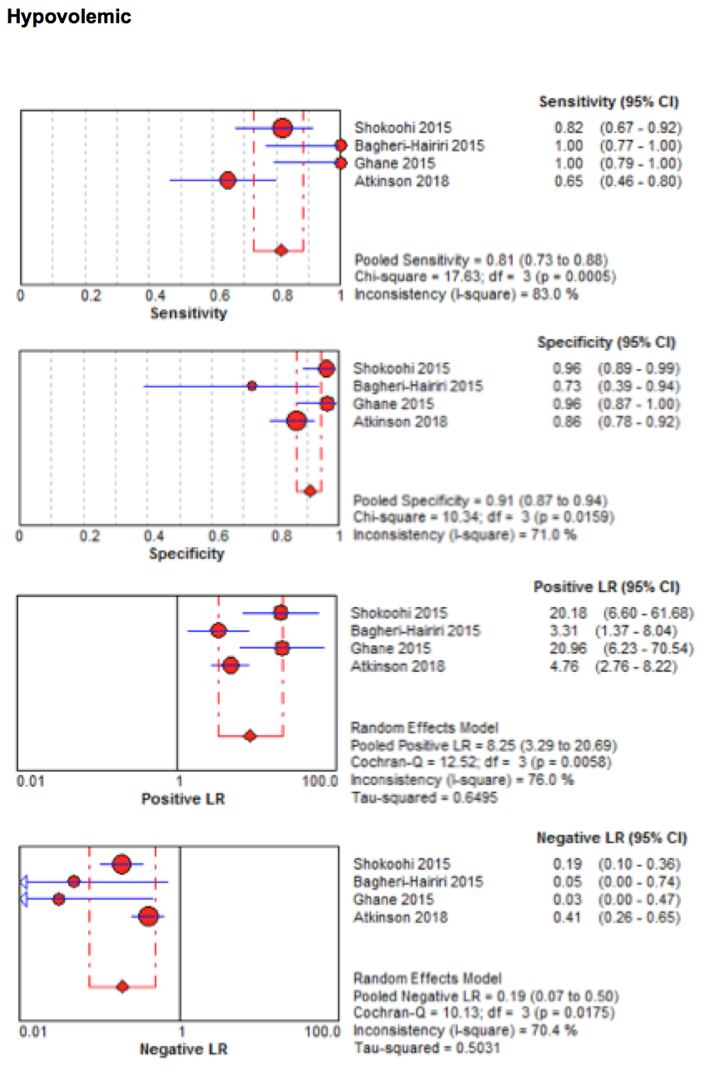

Appendix Figure 2. RUSH for cardiogenic shock forest plot
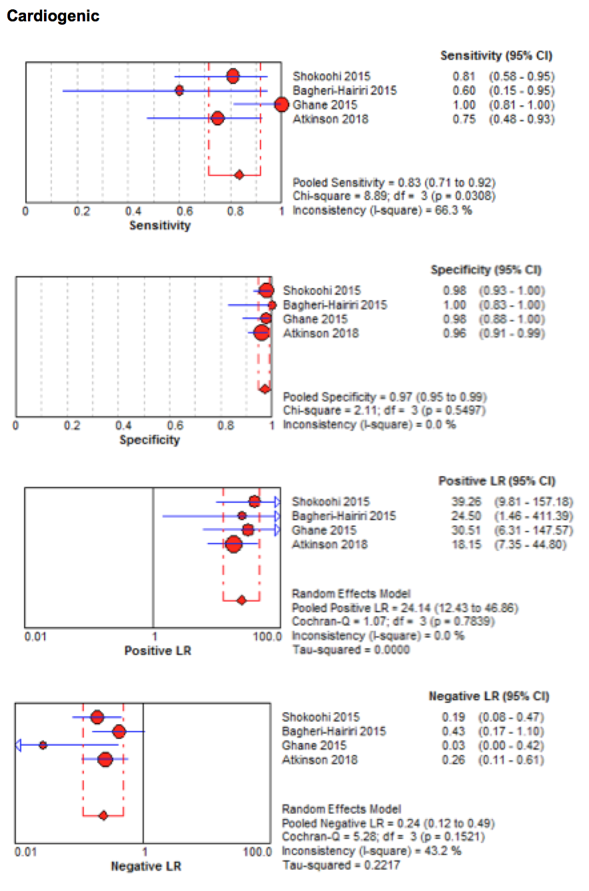

Appendix Figure 3. RUSH for obstructive shock forest plot
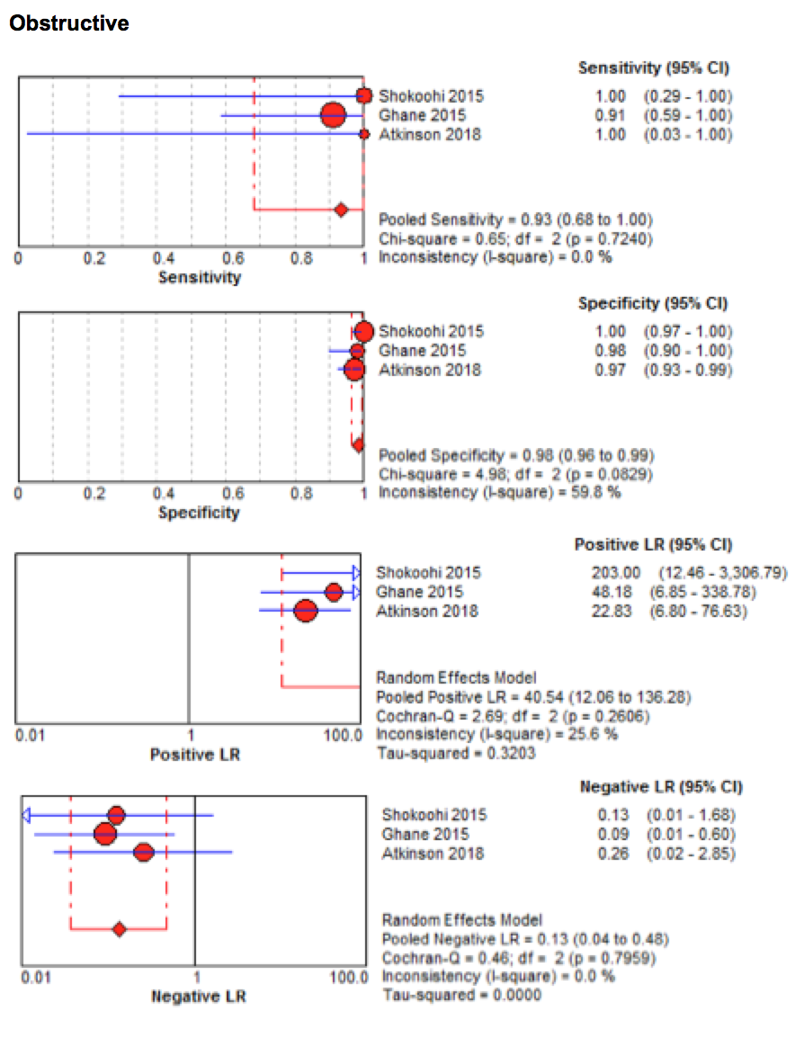

Appendix Figure 4. RUSH for distributive shock forest plot
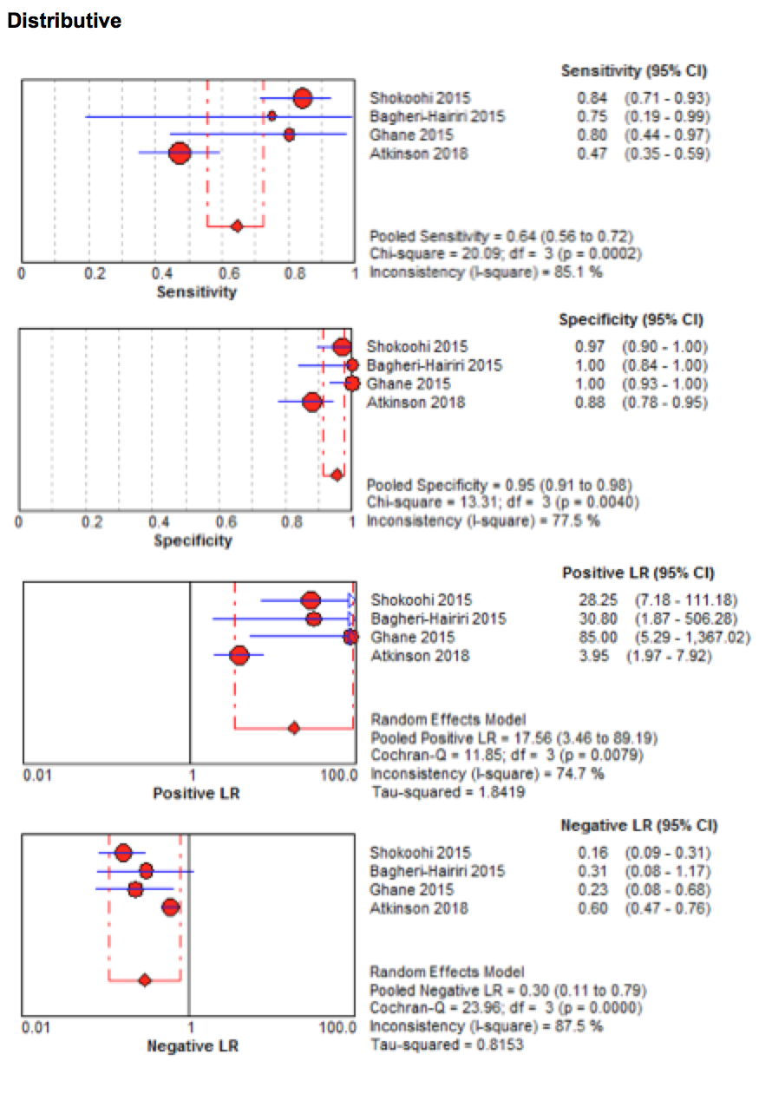

Appendix Figure 5. RUSH for mixed-etiology shock forest plot
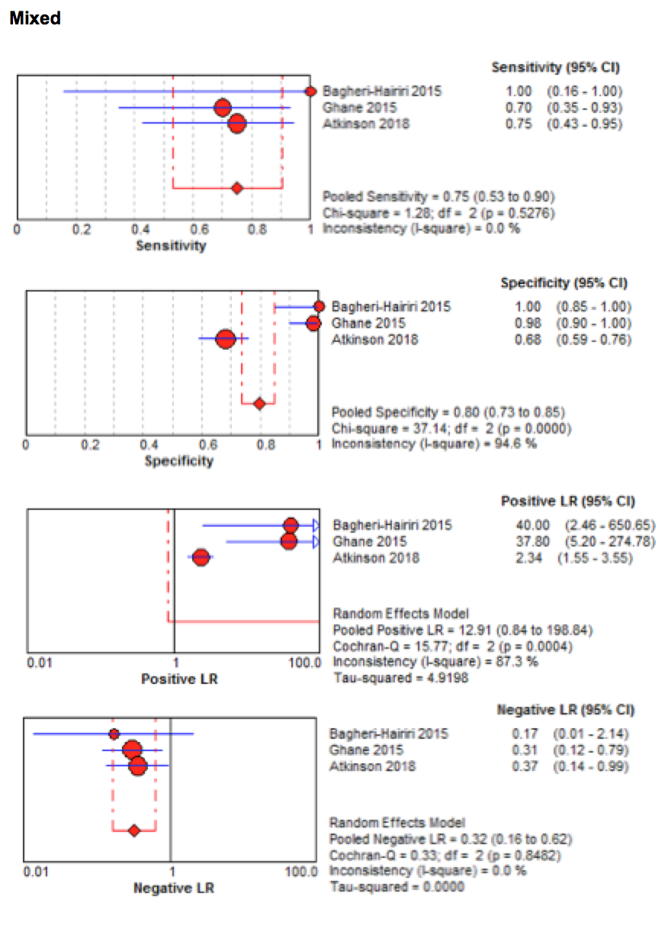

Appendix Table 1. Multi-organ ultrasound protocols compared by views/organ systems assessed

 | Cardiac | Aorta | FAST | IVC | Lung | DVT | Uterus/ectopic
UHP | X | X | X
Trinity | X | X | X
FATE | X |  |  | X | X
ACES | X | X | X | X | X
RUSH | X | X | X | X | X | X (+/-)
EGLS | X |  | X | X | X
F+R | X | X | X | X | X | X | X

Table 6. Ultrasound protocols for shock and hypotension compared by organ system/areas evaluated.

FAST, Focused Assessment with Sonography for Trauma; IVC, Inferior vena cava; DVT, deep vein thrombosis; UHP, Undifferentiated Hypotensive Patient protocol; FATE, Focus Assessed Transthoracic Echocardiography; ACES, Abdominal and Cardiac Evaluation with Sonography; RUSH, Rapid Ultrasound in Shock; EGLS, Echo-Guided Life Support; F+R, FAST and RELIABLE (RELIABLE, Right ventricular strain, pericardial Effusion, Left ventricular function, IVC, Aorta, venous Blood clots, Lung pneumothorax, Ectopic)

