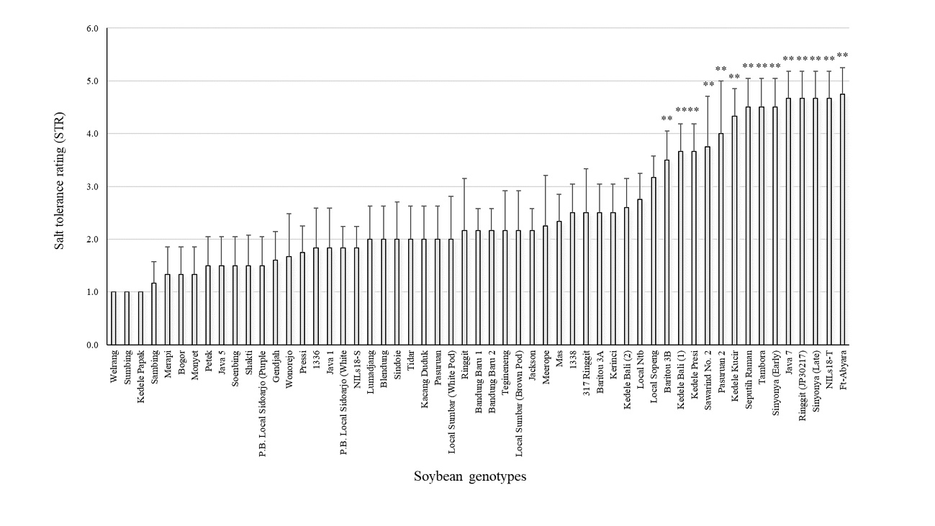
Fig. S1 Salt tolerance rating (STR) values of the 51 Indonesian soybean germplasm and the control genotypes after salt treatment with 100 mM NaCl for about three weeks under hydroponic conditions. Data are shown with mean ± SD (n = 6). ** indicates a significant difference (P < 0.01) from the salt sensitive control variety Jackson.

