**Table S1. List of all HSL accessions and commercial varieties** and genetic diversity measures Proportion of Polymorphic Loci (PLP) and Expected Heterozygosity (Hj) calculated using AFLP SURV method 4 (a Bayesian method with non-uniform prior distribution of allele frequencies) and FIS=1. Commercial varieties denoted by ‘cv’.

| Crop | Accession name | Number | Sample size | PLP | Expected heterozygosity (Hj) | S.E. (Hj) |
| --- | --- | --- | --- | --- | --- | --- |
| *Vicia faba* | Bacardi | 1 | 5 | 65.8 | 0.29 | 0.03 |
| *Vicia faba* | Beryl | 2 | 5 | 10.5 | 0.07 | 0.01 |
| *Vicia faba* | Bossingham Long Pod | 4 | 4 | 61.8 | 0.28 | 0.03 |
| *Vicia faba* | Bowland's Beauty | 5 | 5 | 56.6 | 0.24 | 0.03 |
| *Vicia faba* | Brown | 6 | 5 | 73.7 | 0.36 | 0.03 |
| *Vicia faba* | Chak'rusga | 8 | 4 | 65.8 | 0.32 | 0.03 |
| *Vicia faba* | Cretian | 9 | 5 | 73.7 | 0.33 | 0.02 |
| *Vicia faba* | Crimson Flowered | 10 | 5 | 50.0 | 0.14 | 0.02 |
| *Vicia faba* | Estonian | 11 | 5 | 57.9 | 0.22 | 0.03 |
| *Vicia faba* | Gloucester Champion | 12 | 5 | 63.2 | 0.27 | 0.03 |
| *Vicia faba* | Jack Gedes | 13 | 5 | 59.2 | 0.27 | 0.03 |
| *Vicia faba* | Jonah's | 14 | 5 | 50.0 | 0.21 | 0.03 |
| *Vicia faba* | Londonderry | 15 | 4 | 56.6 | 0.23 | 0.03 |
| *Vicia faba* | Martock | 16 | 5 | 51.3 | 0.20 | 0.03 |
| *Vicia faba* | Mr Townend's | 19 | 5 | 50.0 | 0.18 | 0.03 |
| *Vicia faba* | Painswick Wonder | 20 | 5 | 44.7 | 0.14 | 0.02 |
| *Vicia faba* | Perovka | 21 | 3 | 57.9 | 0.28 | 0.03 |
| *Vicia faba* | Red Bristow's | 22 | 5 | 76.3 | 0.34 | 0.02 |
| *Vicia faba* | Rent Payer | 23 | 5 | 64.5 | 0.24 | 0.03 |
| *Vicia faba* | Seville | 24 | 3 | 64.5 | 0.25 | 0.03 |
| *Vicia faba* | Somerset | 25 | 4 | 51.3 | 0.24 | 0.03 |
| *Vicia faba* | Stafford | 26 | 5 | 61.8 | 0.28 | 0.03 |
| *Vicia faba* | The Sutton (cv) | 28 | 3 | 52.6 | 0.21 | 0.03 |
| *Vicia faba* | Sweet Lorraine | 29 | 4 | 47.4 | 0.23 | 0.03 |
| *Vicia faba* | White Continental | 31 | 5 | 63.2 | 0.27 | 0.03 |
| *Vicia faba* | Canadian Purple | 32 | 4 | 61.8 | 0.30 | 0.03 |
| *Vicia faba* | Gloucester Bounty | 33 | 5 | 61.8 | 0.24 | 0.03 |
| *Pisum sativum* | Alex | 1 | 5 | 3.3 | 0.06 | 0.01 |
| *Pisum sativum* | Bijou | 2 | 5 | 10 | 0.08 | 0.01 |
| *Pisum sativum* | Carlin | 3 | 5 | 10 | 0.09 | 0.02 |
| *Pisum sativum* | Carruther's Purple Podded | 4 | 4 | 0.8 | 0.05 | 0.01 |
| *Pisum sativum* | Champion of England | 5 | 5 | 1.7 | 0.05 | 0.01 |
| *Pisum sativum* | Clarke's Beltony Blue | 6 | 5 | 3.3 | 0.05 | 0.01 |
| *Pisum sativum* | Commander | 7 | 5 | 5 | 0.06 | 0.01 |
| *Pisum sativum* | Cooper's Bean Pea | 8 | 5 | 2.5 | 0.05 | 0.01 |
| *Pisum sativum* | Doug Bray of Grimsby | 9 | 5 | 1.7 | 0.04 | 0.01 |
| *Pisum sativum* | Duke of Albany | 10 | 5 | 2.5 | 0.05 | 0.01 |
| *Pisum sativum* | Dun | 11 | 4 | 1.7 | 0.06 | 0.01 |
| *Pisum sativum* | Dwarf Defiance/John Lee | 12 | 5 | 0.8 | 0.04 | 0.01 |
| *Pisum sativum* | Early Capucijner | 13 | 4 | 0.8 | 0.04 | 0.01 |
| *Pisum sativum* | Eat All | 14 | 5 | 3.3 | 0.05 | 0.01 |
| *Pisum sativum* | Epicure | 15 | 5 | 3.3 | 0.05 | 0.01 |
| *Pisum sativum* | Espoir De Gemboux | 16 | 5 | 3.3 | 0.05 | 0.01 |
| *Pisum sativum* | Forty First | 17 | 5 | 0.8 | 0.04 | 0.01 |
| *Pisum sativum* | Frueher Heinrich | 18 | 5 | 5.0 | 0.06 | 0.01 |
| *Pisum sativum* | Giant Stride | 19 | 5 | 1.7 | 0.05 | 0.01 |
| *Pisum sativum* | Gladstone | 20 | 5 | 1.7 | 0.04 | 0.01 |
| *Pisum sativum* | Glory of Devon | 21 | 5 | 13.3 | 0.09 | 0.01 |
| *Pisum sativum* | Golden Sweet (India) | 22 | 5 | 0.8 | 0.04 | 0.01 |
| *Pisum sativum* | Gravedigger | 23 | 5 | 1.7 | 0.04 | 0.01 |
| *Pisum sativum* | Harold Idle | 24 | 5 | 0.0 | 0.03 | 0.00 |
| *Pisum sativum* | Holland Capucijners | 25 | 5 | 0.0 | 0.02 | 0.00 |
| *Pisum sativum* | Hugh's Huge | 26 | 5 | 2.5 | 0.05 | 0.01 |
| *Pisum sativum* | Irish Preans | 27 | 5 | 0.8 | 0.04 | 0.01 |
| *Pisum sativum* | Jeyes | 28 | 5 | 1.7 | 0.04 | 0.01 |
| *Pisum sativum* | Kent Blue | 29 | 5 | 0.8 | 0.04 | 0.01 |
| *Pisum sativum* | Lancashire Lad | 30 | 5 | 0.0 | 0.02 | 0.00 |
| *Pisum sativum* | Large Grey | 31 | 5 | 11.7 | 0.09 | 0.02 |
| *Pisum sativum* | Latvian | 32 | 5 | 55.8 | 0.14 | 0.02 |
| *Pisum sativum* | Latvian Grey Pea | 33 | 5 | 57.5 | 0.18 | 0.02 |
| *Pisum sativum* | Latvian Large Grey | 34 | 5 | 3.3 | 0.05 | 0.01 |
| *Pisum sativum* | Laxton's Exquisite | 35 | 4 | 45 | 0.07 | 0.01 |
| *Pisum sativum* | Magnum Bonum | 36 | 5 | 3.3 | 0.05 | 0.01 |
| *Pisum sativum* | McPartlin | 37 | 4 | 50 | 0.15 | 0.02 |
| *Pisum sativum* | Moldova | 38 | 5 | 2.5 | 0.05 | 0.01 |
| *Pisum sativum* | Mr Bethall's Purple Podded | 39 | 5 | 3.3 | 0.05 | 0.01 |
| *Pisum sativum* | Mr Bound's Bean Pea | 40 | 5 | 1.7 | 0.04 | 0.01 |
| *Pisum sativum* | Mummy's | 41 | 5 | 2.5 | 0.05 | 0.01 |
| *Pisum sativum* | Ne Plus Ultra | 42 | 4 | 0.8 | 0.04 | 0.01 |
| *Pisum sativum* | Newick | 43 | 5 | 0.0 | 0.02 | 0.00 |
| *Pisum sativum* | Ostgotaart | 44 | 4 | 40.8 | 0.06 | 0.01 |
| *Pisum sativum* | Panthers | 45 | 5 | 5.8 | 0.07 | 0.01 |
| *Pisum sativum* | Parsley | 46 | 5 | 18.3 | 0.11 | 0.01 |
| *Pisum sativum* | Pilot | 47 |  | 11.7 | 0.09 | 0.01 |
| *Pisum sativum* | Poppet | 48 | 5 | 8.3 | 0.08 | 0.01 |
| *Pisum sativum* | Prean | 49 | 4 | 40.8 | 0.06 | 0.01 |
| *Pisum sativum* | Prew's Special | 50 | 5 | 3.3 | 0.05 | 0.01 |
| *Pisum sativum* | Prince of Prussia | 51 | 5 | 0.8 | 0.04 | 0.01 |
| *Pisum sativum* | Purple Flowered Russian | 52 | 3 | 40.8 | 0.07 | 0.01 |
| *Pisum sativum* | Purple Mangetout | 53 | 3 | 40.8 | 0.07 | 0.01 |
| *Pisum sativum* | Purple Pod | 54 | 3 | 40.0 | 0.06 | 0.01 |
| *Pisum sativum* | Purple Podded | 55 | 4 | 41.7 | 0.06 | 0.01 |
| *Pisum sativum* | Raisin Cupucijners | 56 | 4 | 1.7 | 0.05 | 0.01 |
| *Pisum sativum* | Robinson | 57 | 5 | 4.2 | 0.06 | 0.01 |
| *Pisum sativum* | Salmon Flowered | 58 | 5 | 0.8 | 0.04 | 0.01 |
| *Pisum sativum* | Simpson's Special | 59 | 5 | 5.0 | 0.06 | 0.01 |
| *Pisum sativum* | Early Onward (cv) | 60 | 5 | 16.7 | 0.10 | 0.01 |
| *Pisum sativum* | Kelvedon Wonder (cv) | 61 | 5 | 2.5 | 0.05 | 0.01 |
| *Pisum sativum* | Stenu | 62 | 4 | 40.8 | 0.07 | 0.01 |
| *Pisum sativum* | Stephens | 63 | 5 | 49.2 | 0.12 | 0.02 |
| *Pisum sativum* | Stokesley | 64 | 5 | 0.0 | 0.03 | 0.00 |
| *Pisum sativum* | Suttons Achievement | 65 | 5 | 2.5 | 0.04 | 0.01 |
| *Pisum sativum* | Suttons Harbinger | 66 | 5 | 0.0 | 0.03 | 0.00 |
| *Pisum sativum* | Suttons Purple Podded | 67 | 5 | 1.7 | 0.04 | 0.01 |
| *Pisum sativum* | Table Talk | 68 | 5 | 0.0 | 0.03 | 0.00 |
| *Pisum sativum* | Telephone | 69 | 5 | 12.5 | 0.09 | 0.01 |
| *Pisum sativum* | Time Out of Mind | 70 | 5 | 1.7 | 0.05 | 0.01 |
| *Pisum sativum* | Turner's Spring | 71 | 5 | 11.7 | 0.10 | 0.01 |
| *Pisum sativum* | Tutankhamun | 72 | 5 | 3.3 | 0.05 | 0.01 |
| *Pisum sativum* | Ultra U | 73 | 5 | 1.7 | 0.05 | 0.01 |
| *Pisum sativum* | Veitch's Western Express | 74 | 5 | 7.5 | 0.07 | 0.01 |
| *Pisum sativum* | Victorian Purple Podded | 75 | 5 | 2.5 | 0.04 | 0.01 |
| *Pisum sativum* | Wieringen White | 76 | 4 | 42.5 | 0.06 | 0.01 |
| *Pisum sativum* | Winfreda | 77 | 4 | 40.0 | 0.05 | 0.01 |
| *Lactuca sativa* | Asparagus | 1 | 5 | 11.7 | 0.09 | 0.01 |
| *Lactuca sativa* | Bath Cos | 2 | 5 | 5.8 | 0.07 | 0.01 |
| *Lactuca sativa* | Black Seeded Samara | 3 | 5 | 2.9 | 0.05 | 0.01 |
| *Lactuca sativa* | Bronze Arrow | 4 | 5 | 16.5 | 0.12 | 0.01 |
| *Lactuca sativa* | Brown Bath Ccos | 5 | 5 | 4.9 | 0.06 | 0.01 |
| *Lactuca sativa* | Brown Goldring | 6 | 5 | 6.8 | 0.07 | 0.01 |
| *Lactuca sativa* | Bunyard's Matchless | 7 | 4 | 61.2 | 0.15 | 0.02 |
| *Lactuca sativa* | Burpees Iceberg | 8 | 5 | 5.8 | 0.06 | 0.01 |
| *Lactuca sativa* | George Richardson | 9 | 4 | 61.2 | 0.13 | 0.02 |
| *Lactuca sativa* | Lacitue Cracoviensis | 11 | 5 | 9.7 | 0.08 | 0.01 |
| *Lactuca sativa* | Liller | 10 | 4 | 60.2 | 0.14 | 0.02 |
| *Lactuca sativa* | Loos Tennis Ball | 12 | 5 | 9.7 | 0.09 | 0.01 |
| *Lactuca sativa* | Maroulli Cos | 13 | 5 | 62.1 | 0.14 | 0.02 |
| *Lactuca sativa* | Mescher | 14 | 5 | 9.7 | 0.08 | 0.01 |
| *Lactuca sativa* | Northern Queen | 15 | 5 | 11.7 | 0.10 | 0.01 |
| *Lactuca sativa* | Rouge D'Hiver | 16 | 5 | 68.9 | 0.16 | 0.02 |
| *Lactuca sativa* | Soulie | 17 | 5 | 69.9 | 0.18 | 0.02 |
| *Lactuca sativa* | Iceberg (cv) | 18 | 5 | 9.7 | 0.08 | 0.01 |
| *Lactuca sativa* | Corsair (cv) | 19 | 5 | 11.7 | 0.09 | 0.01 |
| *Lactuca sativa* | Stoke | 20 | 5 | 7.8 | 0.07 | 0.01 |
| *Lactuca sativa* | White Samara | 21 | 5 | 10.7 | 0.09 | 0.01 |
| *Lactuca sativa* | Windermere | 22 | 5 | 23.3 | 0.16 | 0.02 |
| *Daucus carota* | Afghan Purple | 1 | 5 | 58.4 | 0.19 | 0.02 |
| *Daucus carota* | Altringham | 2 | 4 | 56.7 | 0.21 | 0.02 |
| *Daucus carota* | Beta III | 3 | 4 | 56.2 | 0.20 | 0.02 |
| *Daucus carota* | Egmont Gold | 4 | 3 | 53.9 | 0.21 | 0.02 |
| *Daucus carota* | Giant Improved Flak | 5 | 2 | 59.0 | 0.28 | 0.02 |
| *Daucus carota* | John's Purple | 6 | 5 | 52.8 | 0.18 | 0.02 |
| *Daucus carota* | Manchester Table | 7 | 4 | 59.0 | 0.22 | 0.02 |
| *Daucus carota* | Red Elephant | 8 | 4 | 57.9 | 0.23 | 0.02 |
| *Daucus carota* | Scarlet Horn | 9 | 5 | 57.3 | 0.20 | 0.02 |
| *Daucus carota* | F1 Nelson (cv) | 10 | 5 | 50.6 | 0.15 | 0.01 |
| *Daucus carota* | F1 Maestro (cv) | 11 | 5 | 56.7 | 0.16 | 0.01 |
| *Daucus carota* | White Belgium | 12 | 5 | 55.6 | 0.18 | 0.02 |
| *Cucumis sativus* | 741 Peking China | 1 | 5 | 40.3 | 0.15 | 0.02 |
| *Cucumis sativus* | Jordanian | 2 | 5 | 52.5 | 0.21 | 0.02 |
| *Cucumis sativus* | Butcher's Disease Resisting | 3 | 5 | 58.3 | 0.21 | 0.02 |
| *Cucumis sativus* | Dekah | 4 | 4 | 69.8 | 0.27 | 0.02 |
| *Cucumis sativus* | Izjastsnõi | 5 | 4 | 77.7 | 0.37 | 0.02 |
| *Cucumis sativus* | Boothby's Blond | 6 | 5 | 64.7 | 0.22 | 0.02 |
| *Cucumis sativus* | King of the Ridge | 7 | 5 | 56.1 | 0.16 | 0.02 |
| *Cucumis sativus* | Sigmadew | 9 | 5 | 71.9 | 0.22 | 0.02 |
| *Cucumis sativus* | Telegraph Improved (cv) | 10 | 3 | 68.3 | 0.24 | 0.02 |
| *Cucumis sativus* | Burpless Tasty Green (cv) | 11 | 5 | 18.0 | 0.12 | 0.01 |
| *Brassica napus var. pabularia* | Asparagus Marshall Curtis Mill | 2 | 5 | 1.7 | 0.05 | 0.01 |
| *Brassica napus var. pabularia* | Canadian Ragged Jack | 3 | 5 | 5.1 | 0.06 | 0.01 |
| *B. oleracea var. acephala* | Georgia Southern Collared | 4 | 5 | 45.8 | 0.14 | 0.02 |
| *Brassica napus var. pabularia* | Madeley | 5 | 5 | 5.9 | 0.06 | 0.01 |
| *Brassica napus var. pabularia* | Marrowfat Greens | 6 | 5 | 4.2 | 0.05 | 0.01 |
| *Brassica napus var. pabularia* | Ragged Jack | 7 | 5 | 2.5 | 0.05 | 0.01 |
| *Brassica napus var. pabularia* | Red Russian | 8 | 5 | 8.5 | 0.07 | 0.01 |
| *Brassica napus var. pabularia* | Russian/Hungry Gap | 9 | 4 | 52.5 | 0.11 | 0.01 |
| *Brassica oleracea var. acephala* | Spis Bladene | 11 | 5 | 58.5 | 0.20 | 0.02 |
| *Brassica oleracea var. acephala* | Redbore (cv) | 12 | 5 | 55.1 | 0.14 | 0.02 |
| *Brassica oleracea var. acephala* | Dwarf Green Curled (cv) | 13 | 5 | 49.2 | 0.15 | 0.02 |
| *Brassica oleracea var. acephala* | Tall Kale | 14 | 5 | 19.5 | 0.12 | 0.02 |

**Table S2. Potential duplicates revealed by AFLP marker analysis.**

| **Crop** | **Accession 1** | **Accession 2** |
| --- | --- | --- |
| *Brassica napus* var. *pabularia* | Ragged Jack | Red Russian |
| *Lactuca sativa* | Brown bath cos | Brown Goldring |
| *Lactuca sativa* | Bunyard’s Matchless | George Richardson |
| *Pisum sativum* | Lancashire Lad | Stephen’s |

**Figures S1-S6**.UPGMA dendrograms of Nei’s genetic distance.

**Figure S1: UPGMA dendrogram of 26 HSL *Vicia faba* accessions** and one commercial variety (cv) analysed using primer pair; 76 polymorphic loci, 3 - 5 individuals sampled per accession.



Beryl

Sweet Lorraine

Martock

Jonah's

Somerset

Gloucester Champion

Gloucester Bounty

Londonderry

White Continental

Bowland's Beauty

Bacardi

Jack Gedes

Brown

Perovka

Stafford

Canadian Purple

Bossingham Long Pod

Chak'rusga

Cretian

Mr Townend's

Rent Payer

Estonian

Red Bristow's

Seville

The Sutton (cv)

Crimson Flowered

Painswick Wonder

70.0

100.0

**Figure S2:** **UPGMA dendrogram of 20 HSL *Lactuca sativa* accessions** and two commercial varieties (cv) analysed using two primer pairs; 103 polymorphic loci, 4 – 5 individuals sampled per accession.



98.2

100.0

100.0

100.0

53.9

78.2

Asparagus

Laitue Cracoviensis

Corsair (cv)

Bath Cos

Maroulli Cos

Brown Bath Cos

Brown Goldring

Bunyard’s Matchless

George Richardson

Burpee’s Iceberg

Iceberg (cv)

Bronze Arrow

Rouge D’Hiver

Black Seeded Samara

Loos Tennis Ball

Mescher

Stoke

White Seeded Samara

Liller

Northern Queen

Soulie

Windermere

**Figure S3: UPGMA dendrogram of 8 HSL *Cucumis sativus* accessions** and two commercial varieties (cv) analysed using two primer pairs; 139 polymorphic loci, 4 – 5 individuals sampled per accession.

Figure **S4:** **UPGMA dendrogram of 10 HSL *Brassica napus* var. *pabularia* (*i*) *and Brassica oleracea* var. *acephala* (*ii*) accessions** and two commercial varieties (cv) analysed using two primer pairs; 118 polymorphic loci, 2 - 5 individuals per accession.



81.5

67.9

84.1

89.0

741 Peking China

Butcher's Disease Resisting

Jordanian

Izjastnoi

Boothby's Blond

Dekah

Sigmadew

Telegraph Improved (cv)

King of the Ridge

Burpless Tasty Green (cv)



100.0

92.0

100.0

77.5

76.9

*ii*

Marrowfat Greens

Asparagus Marshall

Curtis Mill

Madeley

Ragged Jack

Red Russian

Canadian Ragged Jack

Russian/Hungry Gap

Tall Kale

Georgia Southern

Collared

Spis Bladene

Redbore (cv)

Dwarf Green (cv)

*i*

99.9

**Figure S5:** **UPGMA dendrogram of 10 HSL *Daucus carota*** accessions and two commercial varieties (cv) analysed using two primer pairs; 178 polymorphic loci, 2 – 5 individuals sampled per accession**.**

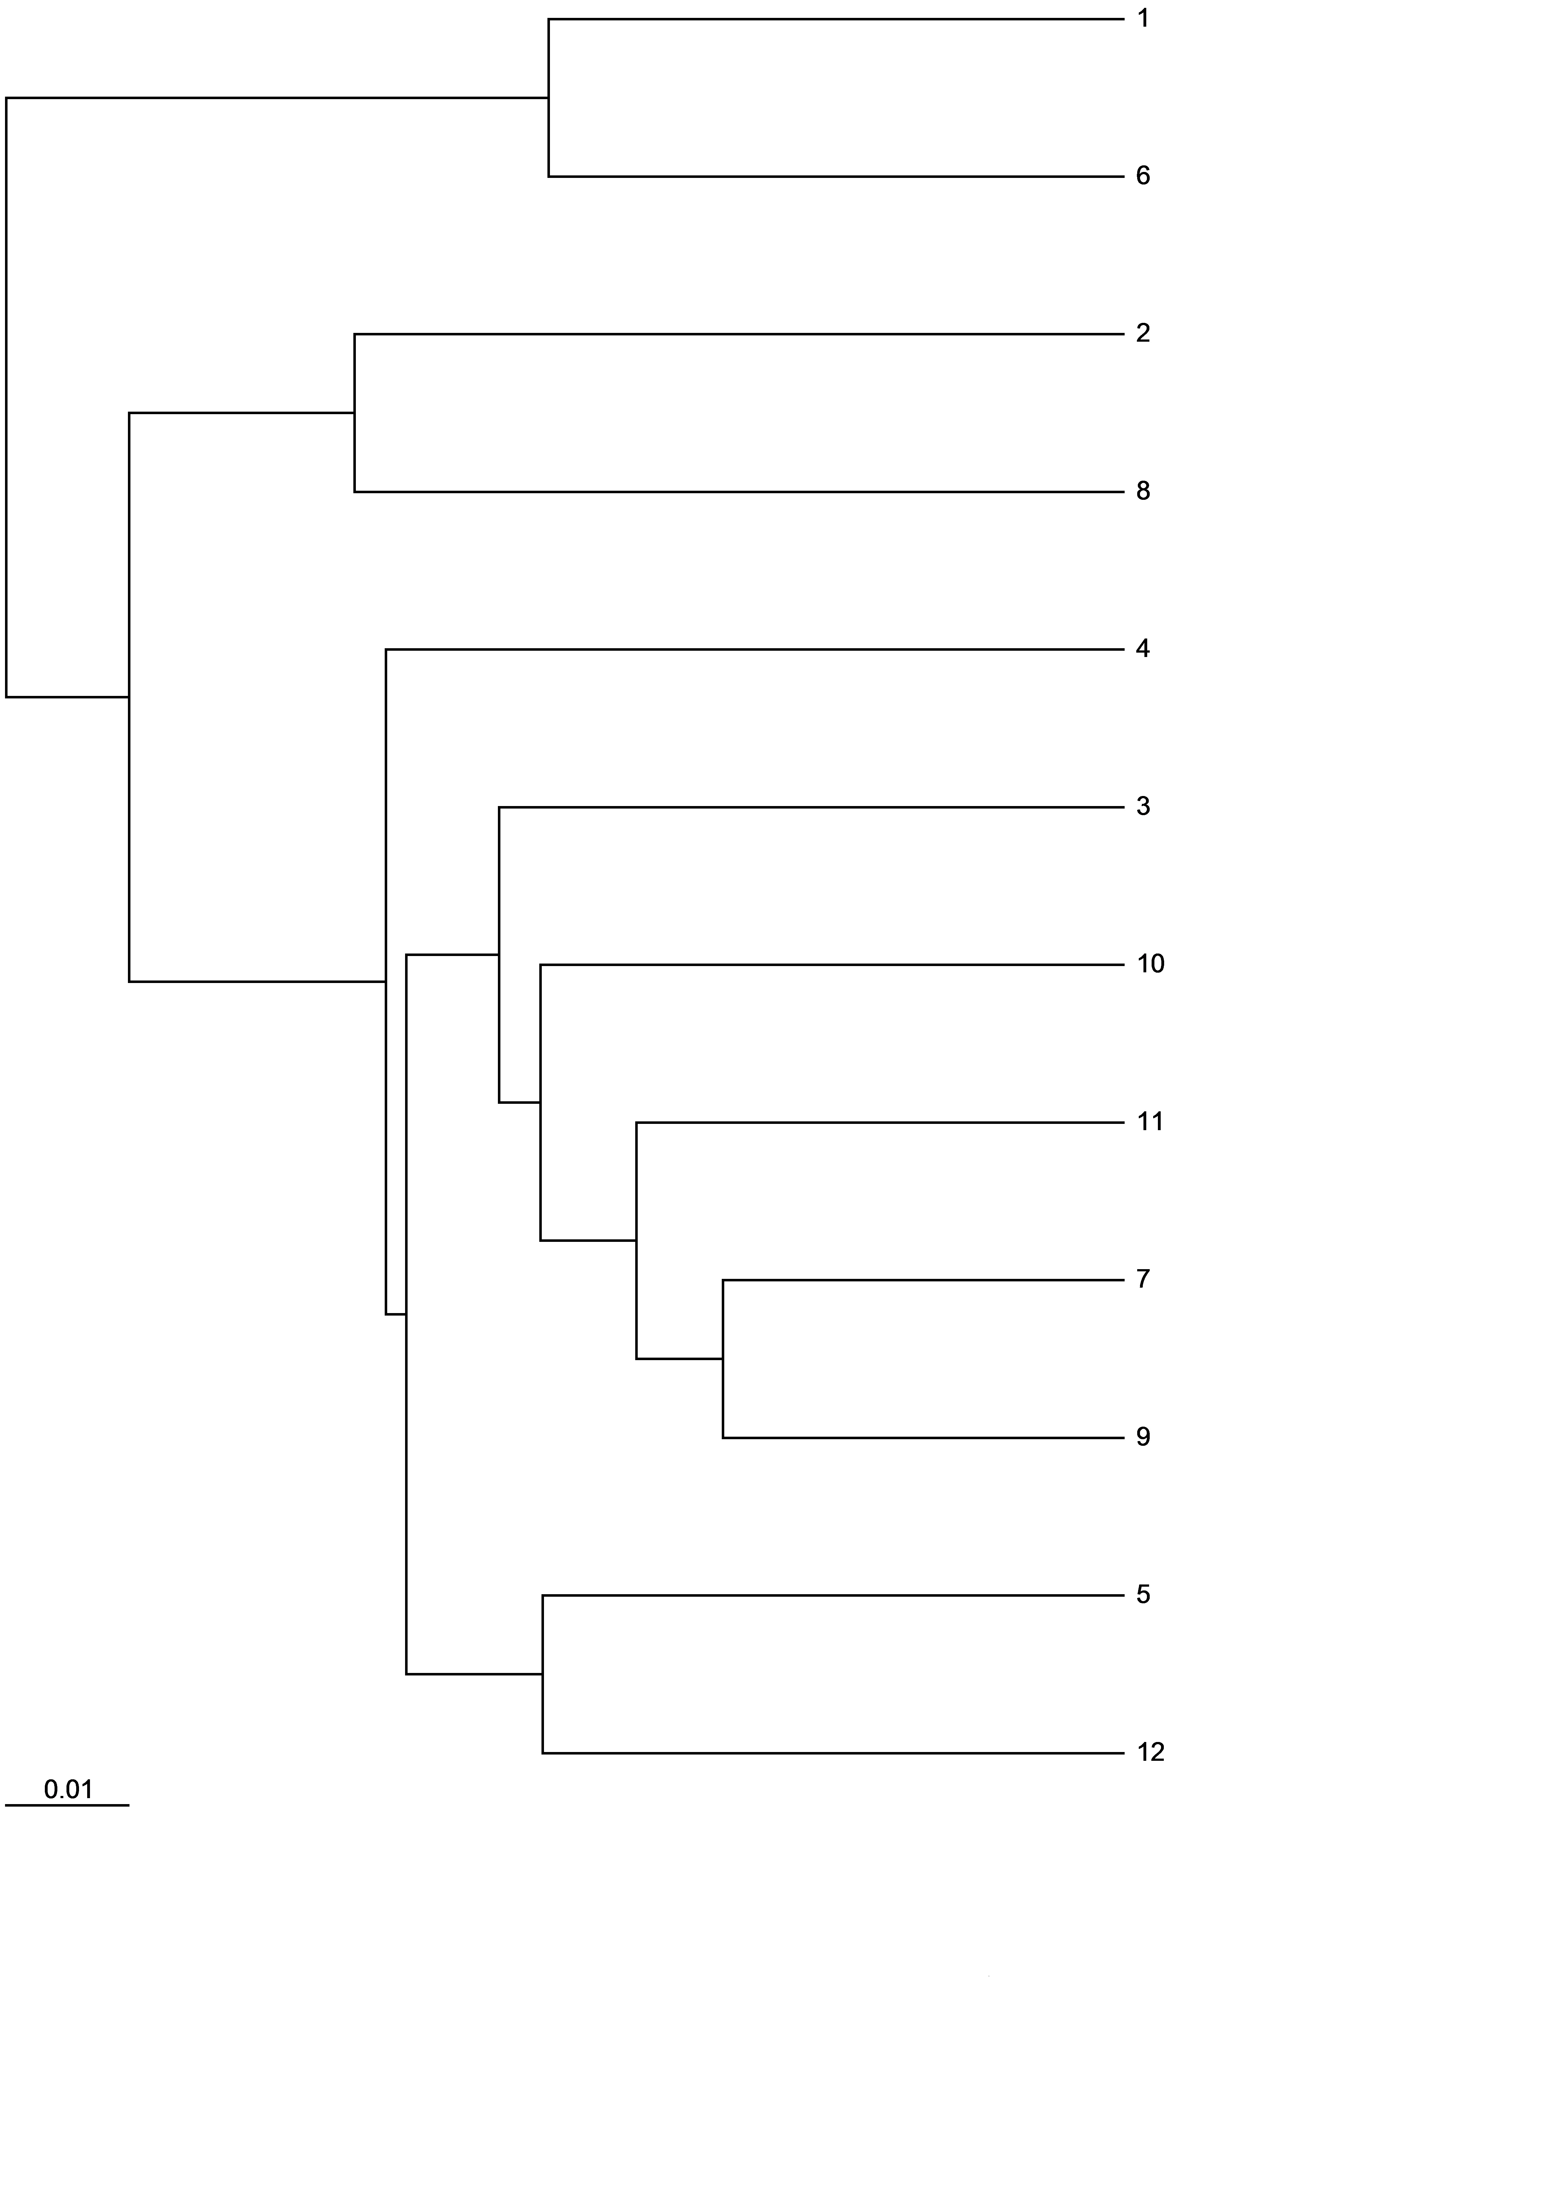

Afghan purple

John's Purple

Altringham

Red Elephant

Egmont Gold

Beta III

Nelson (cv.)

Maestro (cv.)

Manchester Table

Scarlet Horn

Giant Improved Flak

White Belgium

96.2

58.0

**Figure S6: UPGMA dendrogram of 75 HSL *Pisum sativum*** accessions and two commercial varieties (cv) analysed using two primer pairs; 120 polymorphic loci; 3 – 5 individuals sampled per accession.

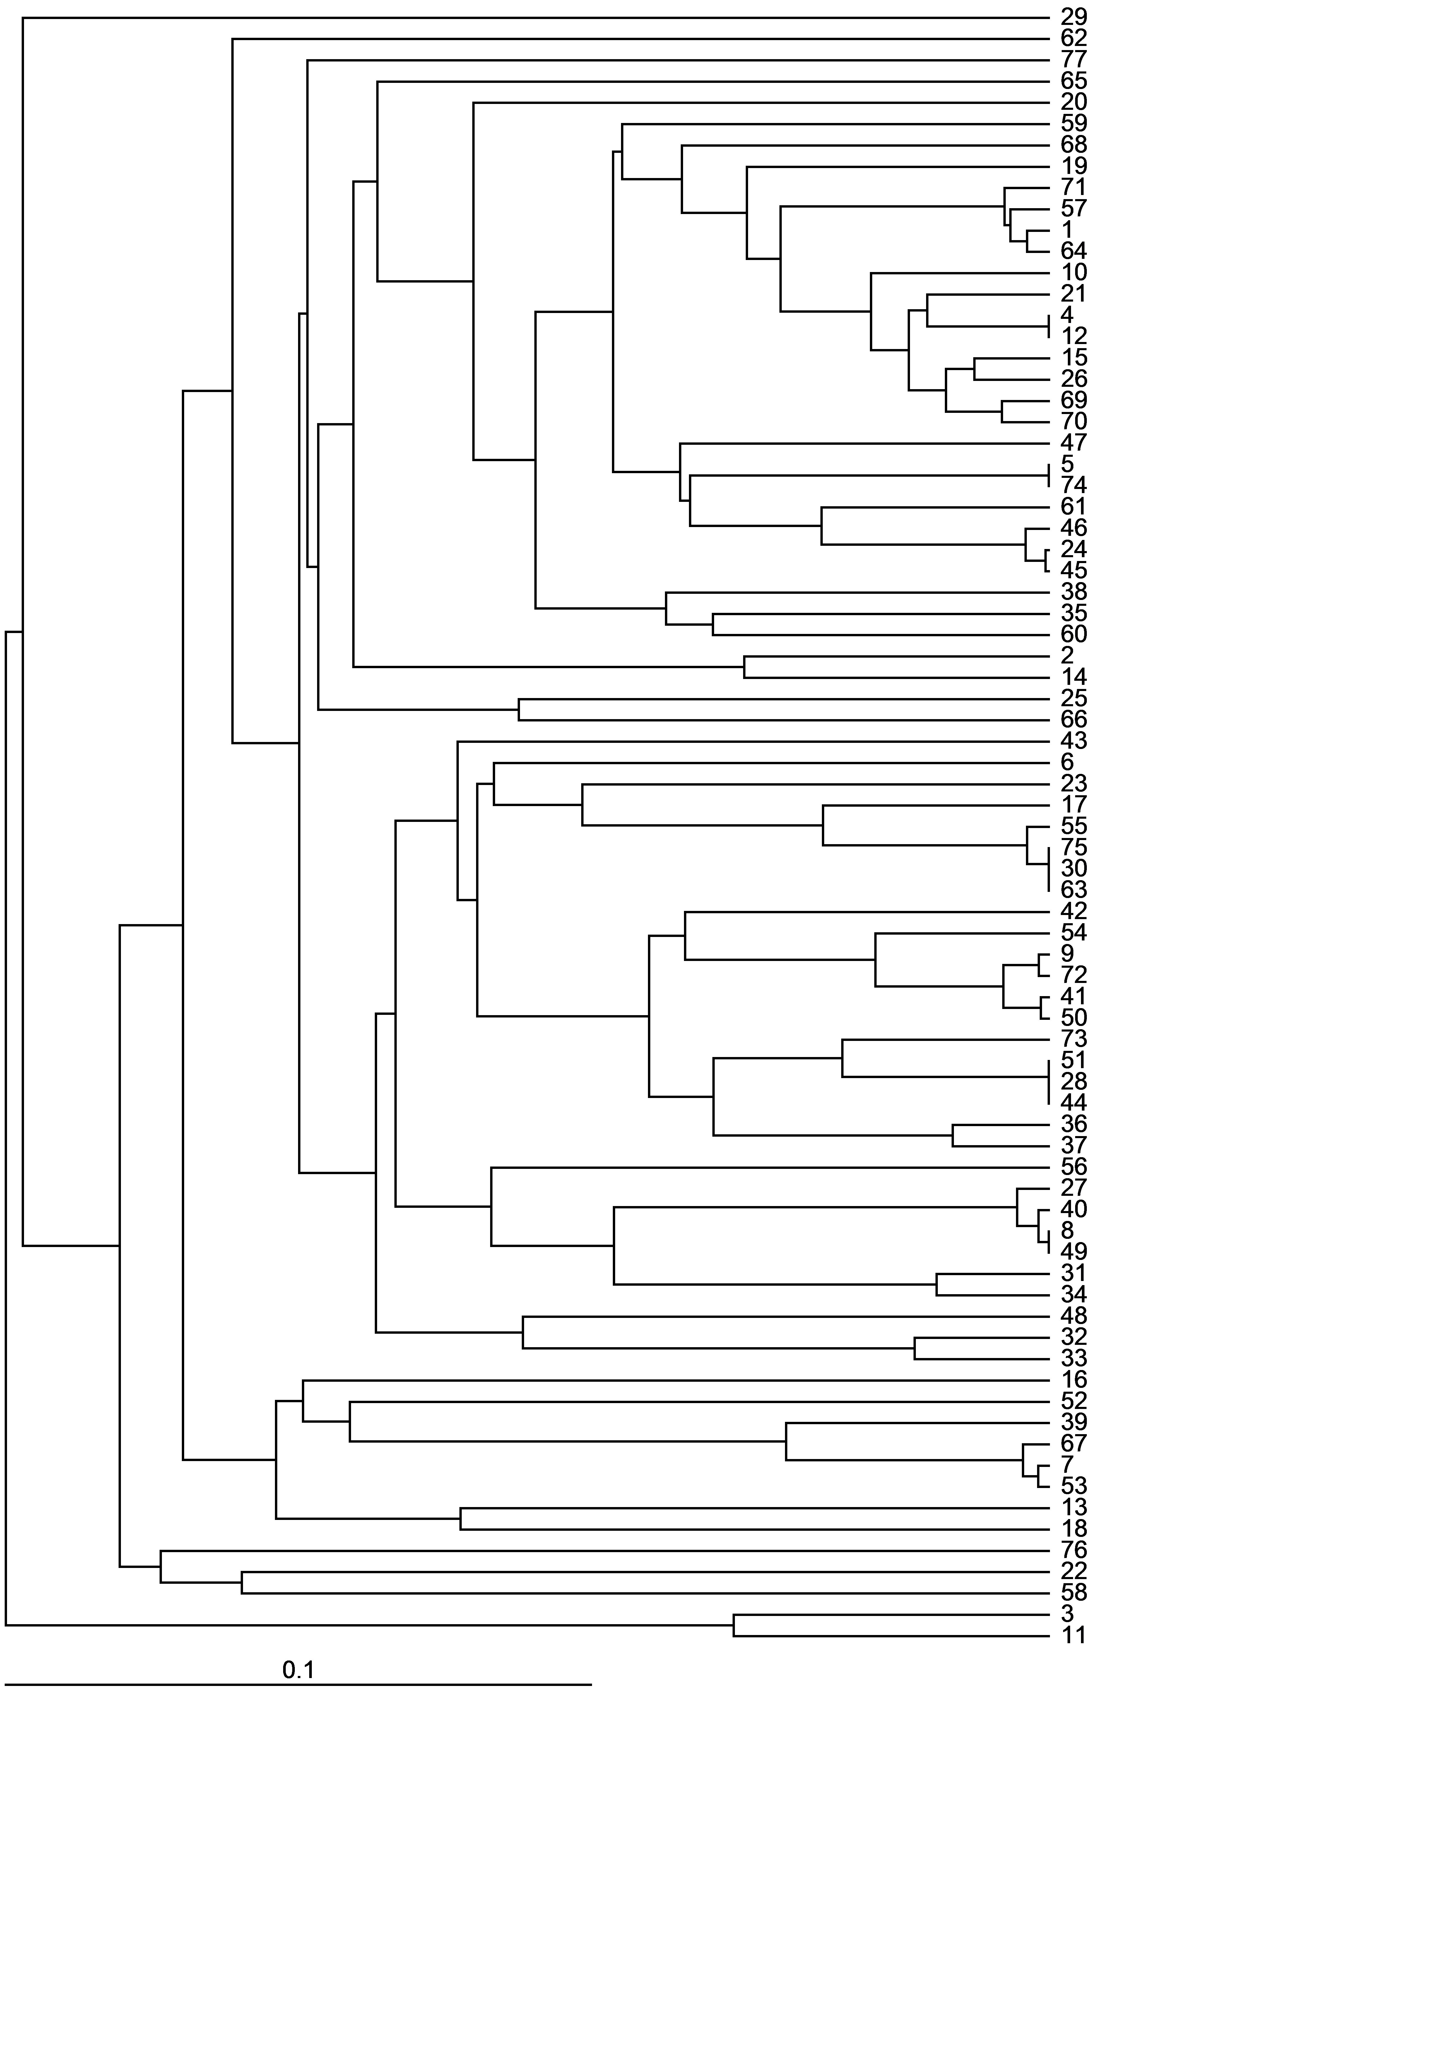

97.4

99.9

96.9

99.8

100.0

100.0

88.8

96.3

75.2

74.0

89.9

99.9

94.6

100.0

100.0

83.5

99.9

98.6

89.7

Kent Blue

Stenu

Winfreda

Suttons Achievement

Gladstone

Simpson's Special

Table Talk

Giant Stride

Turner's Spring

Robinson

Alex

Stokesley

Duke of Albany

Glory of Devon

Carruther's Purple Podded

Dwarf Defiance/John Lee

Epicure

Hugh's Huge

Telephone

Time Out of Mind

Pilot

Champion of England

Veitch's Western Wxpress

Kelvedon Wonder (cv.)

Parsley

Harold Idle

Panthers

Moldova

Laxton's Exquisite

Early Onward (cv.)

Bijou

Eat All

Holland Capucijners

Suttons Harbinger

Newick

Clarke's Beltony Blue

Gravedigger

Forty First

Purple Podded

Victorian purple Podded

Lancashire Lad

Stephens

Ne Plus Ultra

Purple Pod

Doug Bray of Grimsby

Tutankhamun

Mummy's

Prew's Special

Ultra U

Prince of Prussia

Jeyes

Ostgotaart

Magnum Bonum

McPartlin

Raisin Cupucijners

Irish Preans

Mr Bound's Bean Pea

Cooper's Bean Pea

Prean

Large Grey

Latvian Large Grey

Poppet

Latvian

Latvian Grey Pea

Espoir de Gemboux

Purple Flowered Russian

Mr Bethall's Purple Podded

Suttons Purple Podded

Commander

Purple Mangetout

Early Capucijner

Frueher Heinrich

Wieringen White

Golden Sweet (India)

Salmon Flowered

Carlin

Dun

79.4