List of Supplemental figures and Tables in the Manuscript

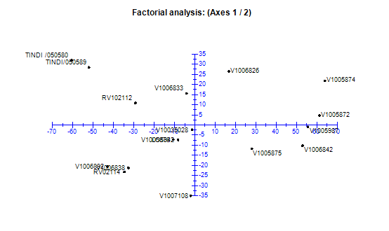
Supplemental Fig. S1. Fraction analysis presentation of the African tomato landraces
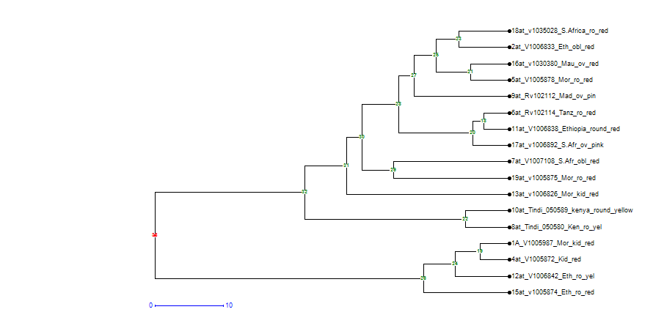
Fig S2. Dendogram showing how the 17 African tomato clustered when subjected to the Darwin’s 6 software (p < 0.05)
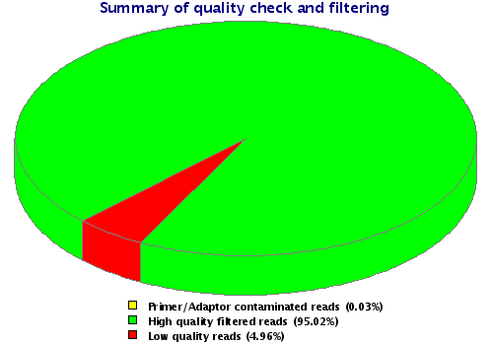
Fig. S3 Pie chart representation of the quality of the raw reads before filtering

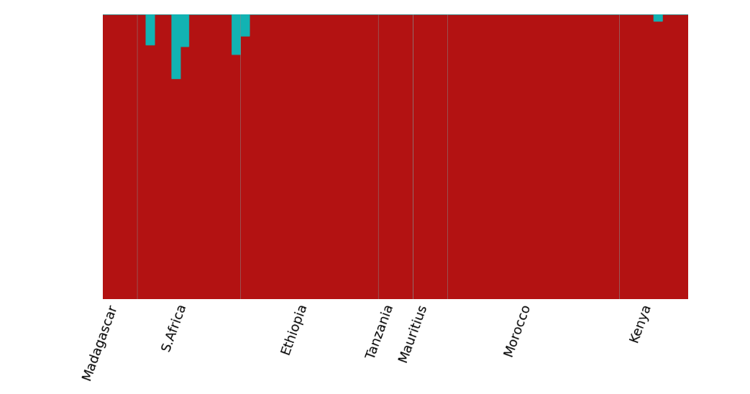
Fig.S4. Population admixture among the 17 African tomato landraces

Table S1. Principal component analysis of the quantitative traits ( p < 0.05)
Quantitative parameters | PC1 | PC2 | PC3 | PC4 | PC5 | PC6 | PC7
Flower heads | 0.07258 | -0.40814 | 0.09085 | 0.11223 | 0.0303 | 0.04267 | 0.14039
Fruit length | 0.41411 | 0.23125 | 0.11139 | -0.10733 | 0.05275 | 0.02169 | 0.03877
Fruit mass | -0.38372 | 0.24584 | 0.19038 | -0.18398 | 0.08386 | -0.06275 | 0.04988
Fruit texture | -0.29795 | 0.12817 | -0.03516 | 0.05423 | 0.19827 | 0.11512 | 0.07797
Fruit width | 0.41417 | -0.21053 | 0.17539 | -0.14587 | 0.06099 | 0.02006 | -0.02095
Internode height | 0.21518 | -0.03836 | -0.0615 | 0.05328 | -0.0867 | -0.17874 | -0.59779
Leaf length | 0.71981 | 0.11673 | -0.44241 | 0.15117 | 0.18627 | -0.27005 | 0.21874
Leaf width | 0.12114 | 0.12054 | -0.45903 | 0.14075 | -0.0819 | -0.39829 | 0.23909
Plant height | 0.10945 | -0.40855 | 0.0698 | 0.20491 | -0.0913 | -0.01389 | 0.22363
Plant width | 0.18552 | -0.24753 | 0.04562 | 0.08003 | -0.2033 | 0.33455 | 0.22363
% Variation | 20.89 | 11.63 | 9.54 | 7.92 | 6.75 | 6.16 | 5.52
Cumulative % variation | 20.89 | 32.62 | 42.16 | 50.08 | 56.83 | 62.99 | 68.51

Table S2. Simple matrix correlation of the phenotypic traits (p < 0.01)
 |  | SC | LBL | LW | LL | LVC | LBC | PC | PH | PW | PN | IH | FH | FC | SHC | FSH | FL | FW | FT | FY
SC |  | 1
LBL |  | -0.27 | 1
LW |  | -0.1 | 0.72 | 1
LL |  | 0.055 | 0.224 | 0.199 | 1
LVC |  | 0.259 | -0.1 | 0.079 | -0.05 | 1
LBC |  | -0.11 | 0.11 | 0.075 | 0.065 | 0.22 | 1
PC |  | 0.104 | -0.23 | -0.16 | 0.112 | 0.39 | 0.48 | 1
PH |  | -0.03 | -0.14 | -0.14 | -0.2 | -0 | -0.05 | -0.14 | 1
PW |  | -0.09 | 0.01 | 0.147 | -0.27 | -0 | -0.06 | -0.14 | 0.446 | 1
PN |  | -0.15 | -0.08 | -0.16 | -0.11 | -0.1 | 0.02 | 0.215 | 0.187 | 0.2619 | 1
IH |  | -0.34 | 0.226 | 0.105 | 0.005 | -0.2 | 0.25 | 0.174 | 0.117 | 0.1445 | 0.158 | 1
FH |  | -0.01 | -0.2 | -0.16 | -0.32 | 0.08 | -0.25 | -0.1 | 0.377 | 0.1867 | 0.161 | -0.12 | 1
FC |  | 0.192 | -0.18 | -0.23 | 0.055 | 0.16 | -0.06 | 0.056 | -0.241 | -0.299 | -0.13 | -0.29 | -0.21 | 1
SHC |  | 0.106 | -0.26 | -0.24 | -0.01 | 0.14 | -0.07 | 0.153 | -0.172 | -0.169 | -0.02 | -0.1 | -0.16 | 0.761 | 1
FSH |  | -0.02 | 0.061 | -0.06 | -0.05 | -0.1 | 0.03 | 0.107 | -0.064 | 0.2694 | 0.157 | 0.351 | -0.04 | -0.08 | -0.11 | 1
FL |  | -0.19 | 0.258 | 0.182 | -0.04 | 0.07 | 0.17 | 0.044 | -0.02 | 0.2209 | 0.104 | 0.175 | -0.01 | -0.39 | -0.3 | 0.1928 | 1
FW |  | -0.31 | 0.252 | 0.091 | -0.2 | -0.1 | 0.2 | -0.07 | 0.112 | 0.2302 | 0.342 | 0.361 | 0.05 | -0.32 | -0.22 | 0.3533 | 0.64 | 1
FT |  | 0.109 | -0.06 | -0.06 | 0.219 | 0.1 | 0.04 | 0.159 | -0.217 | -0.293 | -0.16 | -0.29 | -0.2 | 0.352 | 0.21 | -0.2724 | -0.23 | -0.39 | 1
FY |  | -0.28 | 0.175 | 0.446 | -0.17 | -0.1 | 0.1 | -0.09 | -0.003 | 0.229 | 0.264 | 0.271 | 0.044 | -0.23 | -0.04 | 0.3539 | 0.65 | 0.93 | -0.37 | 1
Key: SC- stem colour, LBL- leaf blade length, LW- leaf width, LL- leaf length, LVC- leaf vein colour, LBC- leaf blade colour, PC- petiole colour, PH – plant height , PW – plant width at flowering, PN – petal umbers , IH- internode height , FH- number of flower heads, FC- Flower colour, SHC- fruit shoulder colour, FSH – fruit shape, FL- fruit length, FW- fruit width, FT- fruit texture, FY- fruit yield.

Table S3. Diversity index (H´) values explaining the genetic diversity of the landraces based on qualitative traits.
Qualitative traits | Genetic index (h’)
Fruit colour | 0.99
Fruit shape | 0.99
Fruit texture | 0.99
Leaf base shape | 0.99
Leaf blade colour | 0.99
Petiole colour | 0.99
Stem colour | 0.98
Vein colour | 0.97
Total diversity | 7.89
Average genetic index (h’) | 0.99

Table S4. Differential expressed genes at specific fruit development stage
Accession | Differentially expressed genes | Before fruiting | Mature green | Mature breaker | Mature red
V1005987 | 4,000 | 102 | 5 | 2 | 3
V1006833 | 4,640 | 329 | 1 | 0 | 0
V1005872 | 2,787 | 55 | 1 | 0 | 0
V1005878 | 7,065 | 330 | 71 | 1 | 4
RV102114 | 3,586 | 299 | 3 | 1 | 1
V1007108 | 10,161 | 357 | 82 | 8 | 17
TINDI 050580 | 9,269 | 245 | 12 | 1 | 43
RV102112 | 7,125 | 570 | 0 | 0 | 29
TINDI 050589 | 7,374 | 179 | 36 | 0 | 21
V1006838 | 13,028 | 554 | 27 | 8 | 6
V1006842 | 11,854 | 483 | 35 | 1 | 10
V1006826 | 11,515 | 409 | 36 | 0 | 5
V1005874 | 11,033 | 336 | 49 | 1 | 39
V1030380 | 8,275 | 471 | 3 | 6 | 20
V1006892 | 9,538 | 338 | 5 | 0 | 3
V1035028 | 8,513 | 108 | 4 | 7 | 4
V1005875 | 11,146 | 501 | 19 | 3 | 2

