SUPPLEMENTARY MATERIALS

Table S1. Results of permutational multivariate analysis of variance (perMANOVA) implemented on all varieties.
 | DF | SumsOfSqs | MeanSqs | F.Model | R² | Pr(>F) | .
Ethnic Grps | 2 | 0.234 | 0.1172 | 4.6816 | 0.016 | 0.001 | ***
Variety | 6 | 7.034 | 1.1723 | 46.8377 | 0.492 | 0.001 | ***
Ethnic Grps:Variety | 8 | 0.585 | 0.0731 | 2.9216 | 0.041 | 0.001 | ***
Residuals | 258 | 6.458 | 0.025 |  | 0.451
Total | 274 | 14.311 |  |  | 1.000

Table S2. Differences of dispersion (left side) and morphological differentiation (right side) for each named variety among the three ethnolinguistic groups.
Variety | F.Model | DF | P-value | . | F.Model | P-value | R²
Gadam | 0.05 | 2 | 0.956 | | | 1.60 | 0.169 | NS
Kaguru | 5.09 | 2 | 0.009 | | | 1.10 | 0.406 | NS
Mbura imwe | 0.56 | 2 | 0.459 | | | 3.60 | 0.022 | 10.8 %
Mugeta | 0.38 | 2 | 0.544 | | | 6.50 | < 0.001 | 17.3 %
Muruge mbura ciiri | 7.46 | 2 | 0.015 | | | 2.02 | 0.123 | NS
Muruge mbura imwe | 4.53 | 2 | 0.043 | | | 0.34 | 0.827 | NS
Ngirigacha | 1.47 | 2 | 0.238 | | | 2.46 | 0.044 | 8.7 %
All Varieties | 1.10 | 2 | 0.330 | | | 4.70 | < 0.001 | 2 %

Figure S1. Evolution of the BIC as a function of the number of categories ranging from 1 to 100. The optimal number of categories selected is indicated by a red line.
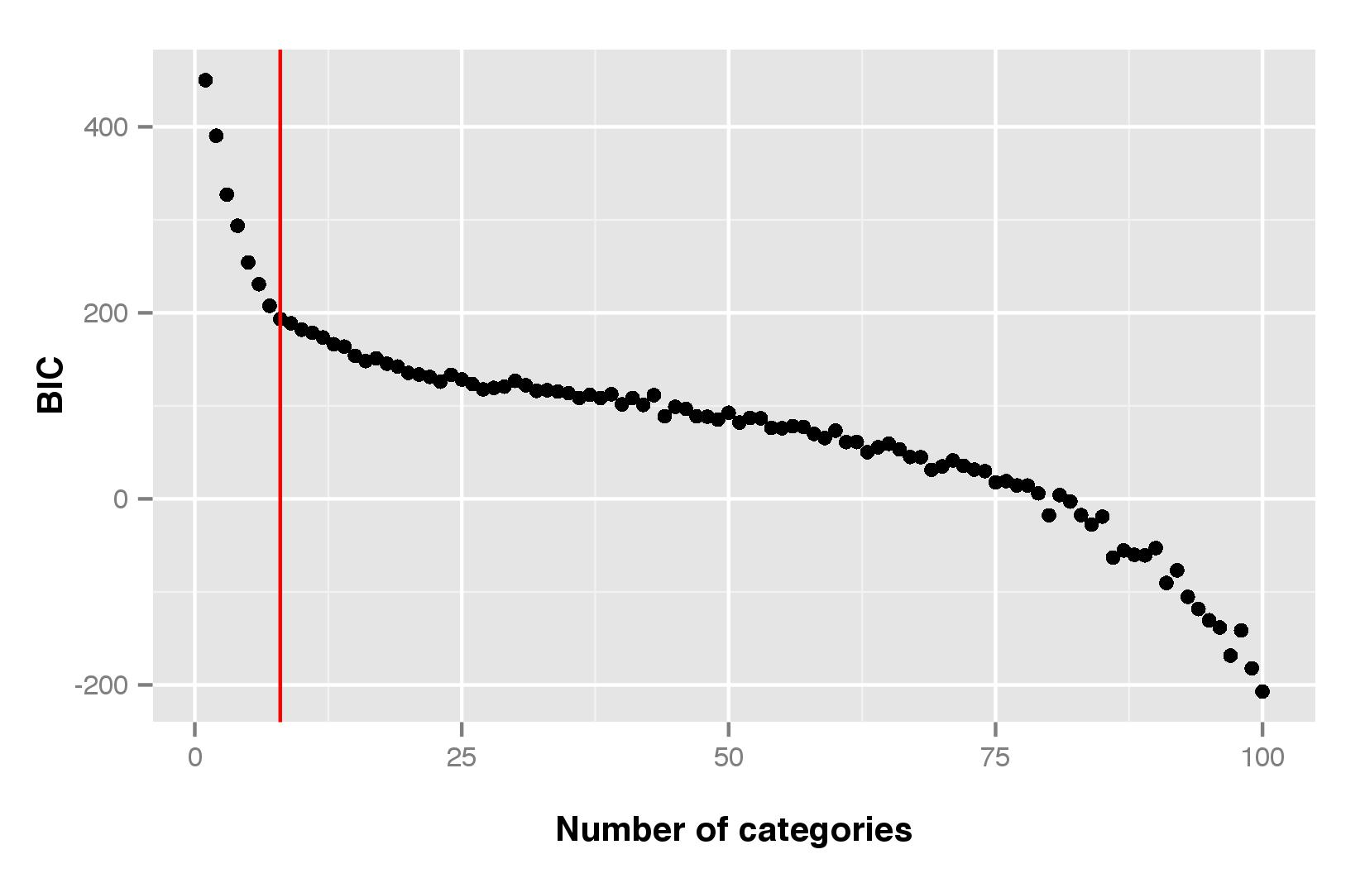

Figure S2. Contribution of morphological traits to the four DAPC axis
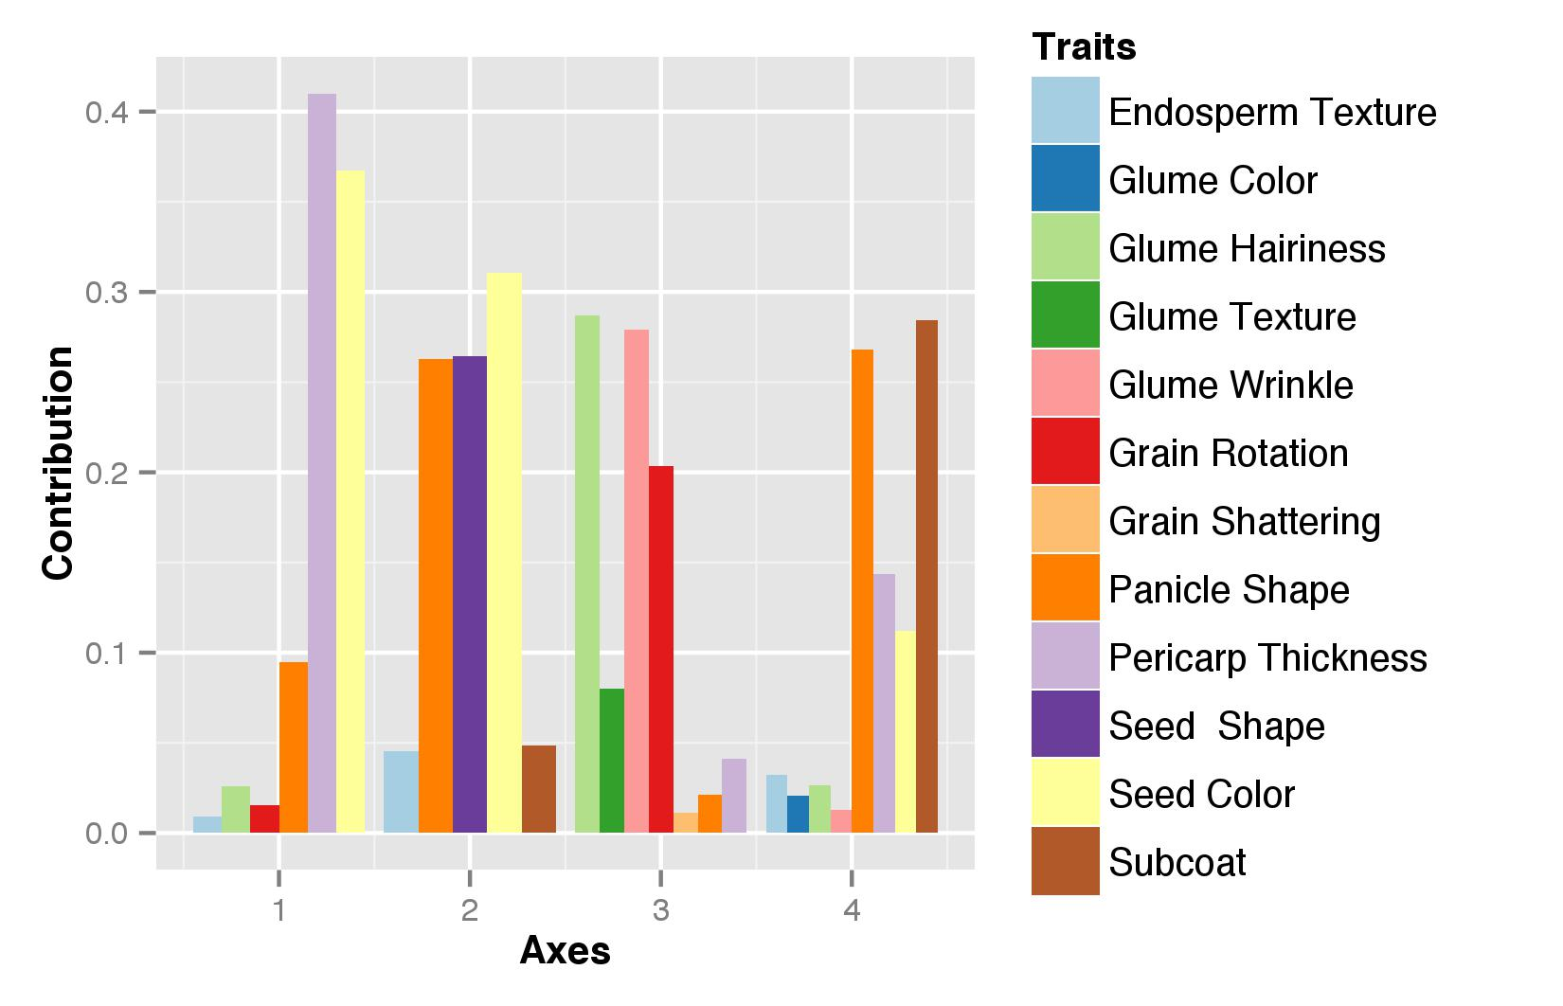

Figure S3. Distribution of the modalities of seed colors across morphological categories.
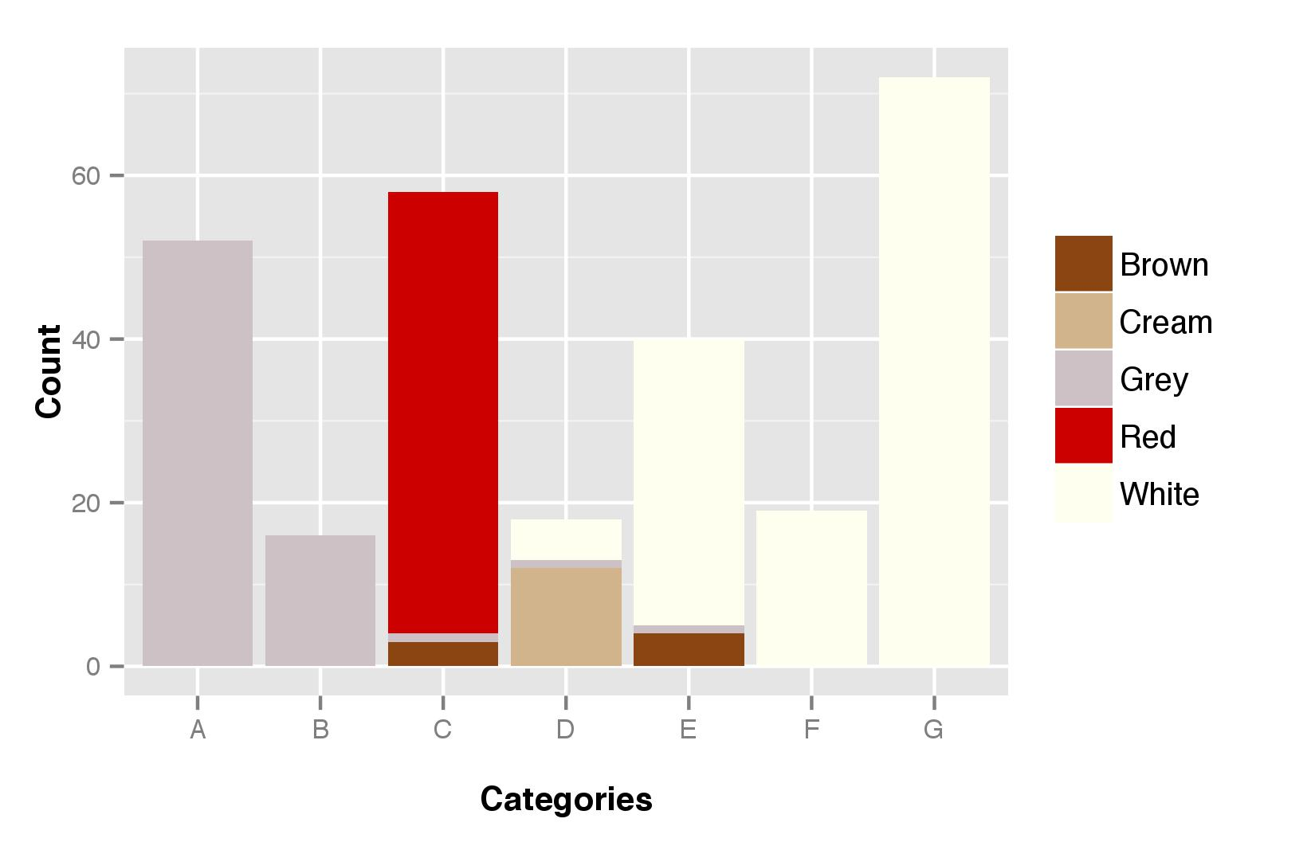

Figure S4. Distribution of the modalities of glume colors across morphological categories.
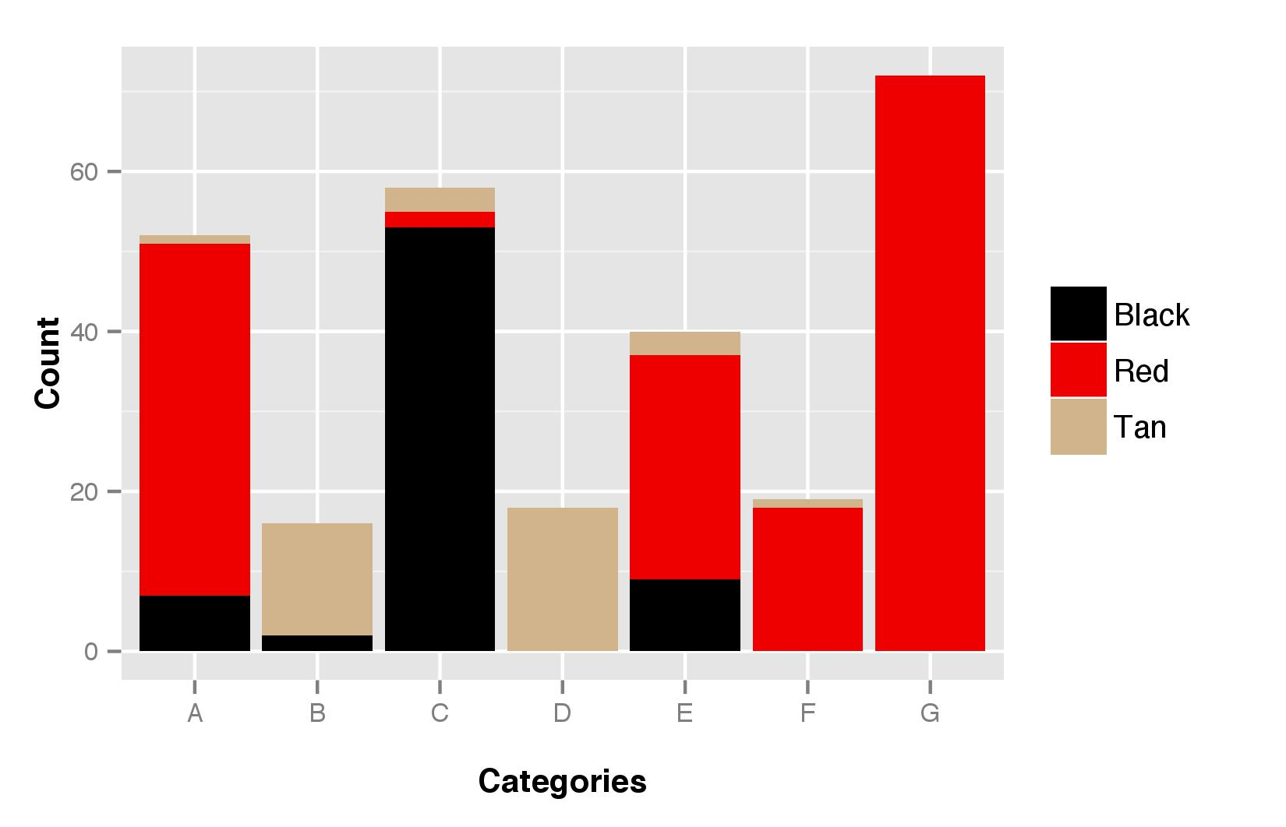

Figure S5. Distribution of the modalities of panicle shapes across morphological categories.
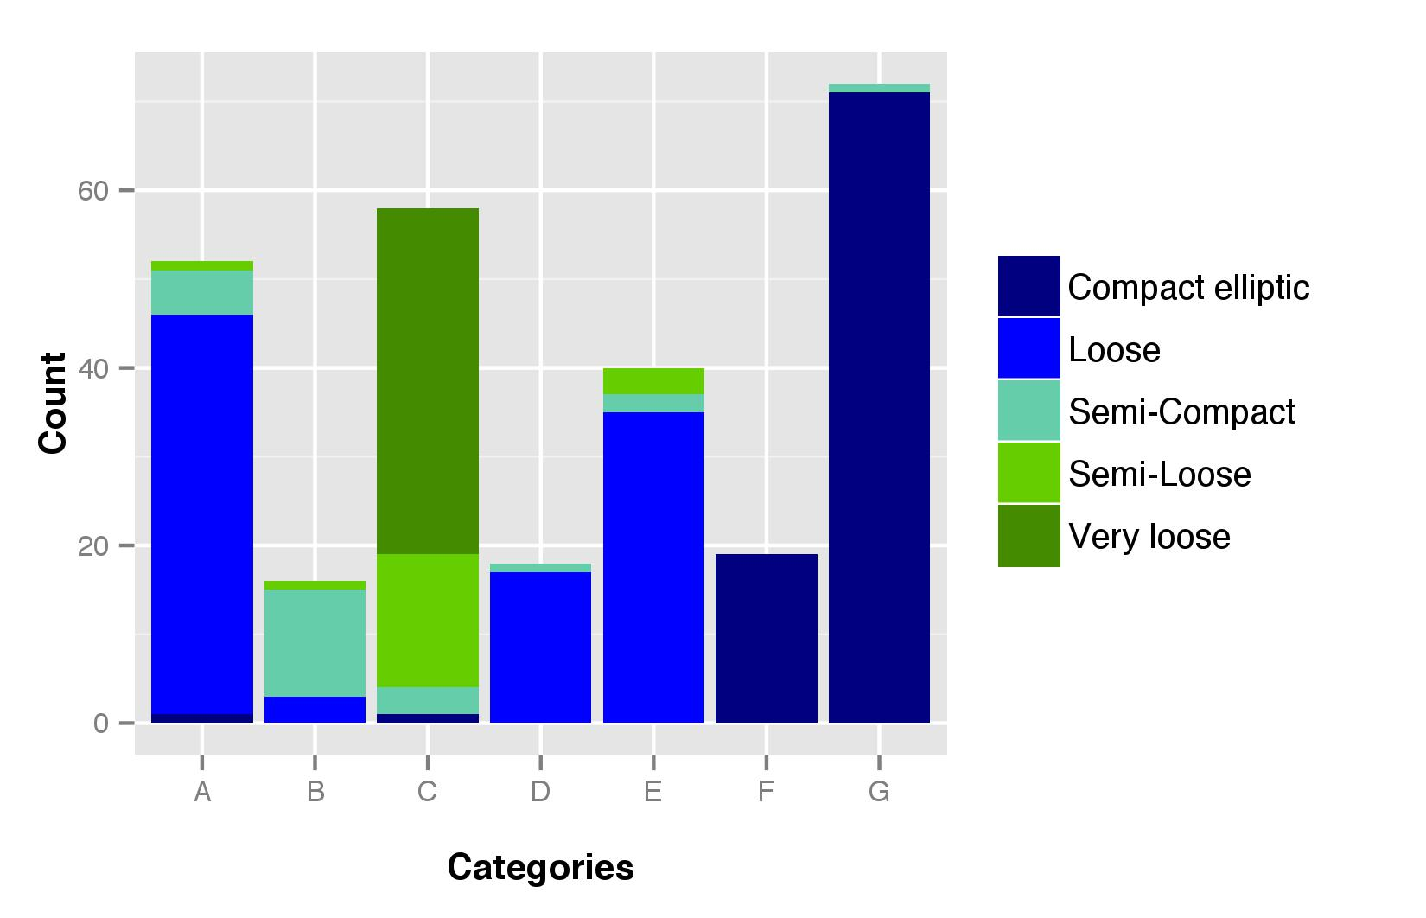

Figure S6. Distribution of farmers’ variety names across the seven morphological categories.
