Table S1. Number of SNP and their distribution per chromosome and position on cassava genome V5.0.

Chromosome. | №. of SNPs | Position range
1 | 759 | 149352-20374379
2 | 1,335 | 76-19845601
3 | 772 | 1077625-17481260
4 | 898 | 71647-17398735
5 | 794 | 91543-19761206
6 | 1,060 | 29814-19227608
7 | 1,070 | 20840-24022314
8 | 1,071 | 57151-21586336
9 | 781 | 100413-25111505
10 | 979 | 23203-23450698
11 | 1,021 | 25792-21709615
12 | 920 | 112108-20662796
13 | 877 | 76-20892663
14 | 1,315 | 205-23387655
15 | 803 | 13280-21968792
16 | 1,253 | 511-19155653
17 | 927 | 216620-16276634
18 | 734 | 146624-17276135
Total | 17,369

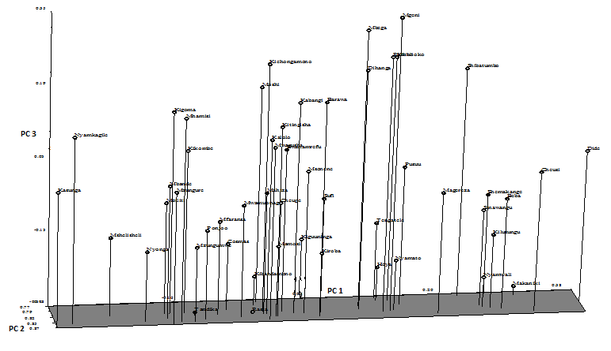
Fig S1. Principal component analysis (PCA) plot showing clustering of 52 cassava landraces using morphological descriptors.

Fig.S2. Principle component analysis (PCA) analysis plot showing differentiation among 52 cassava landraces using SNPs markers

