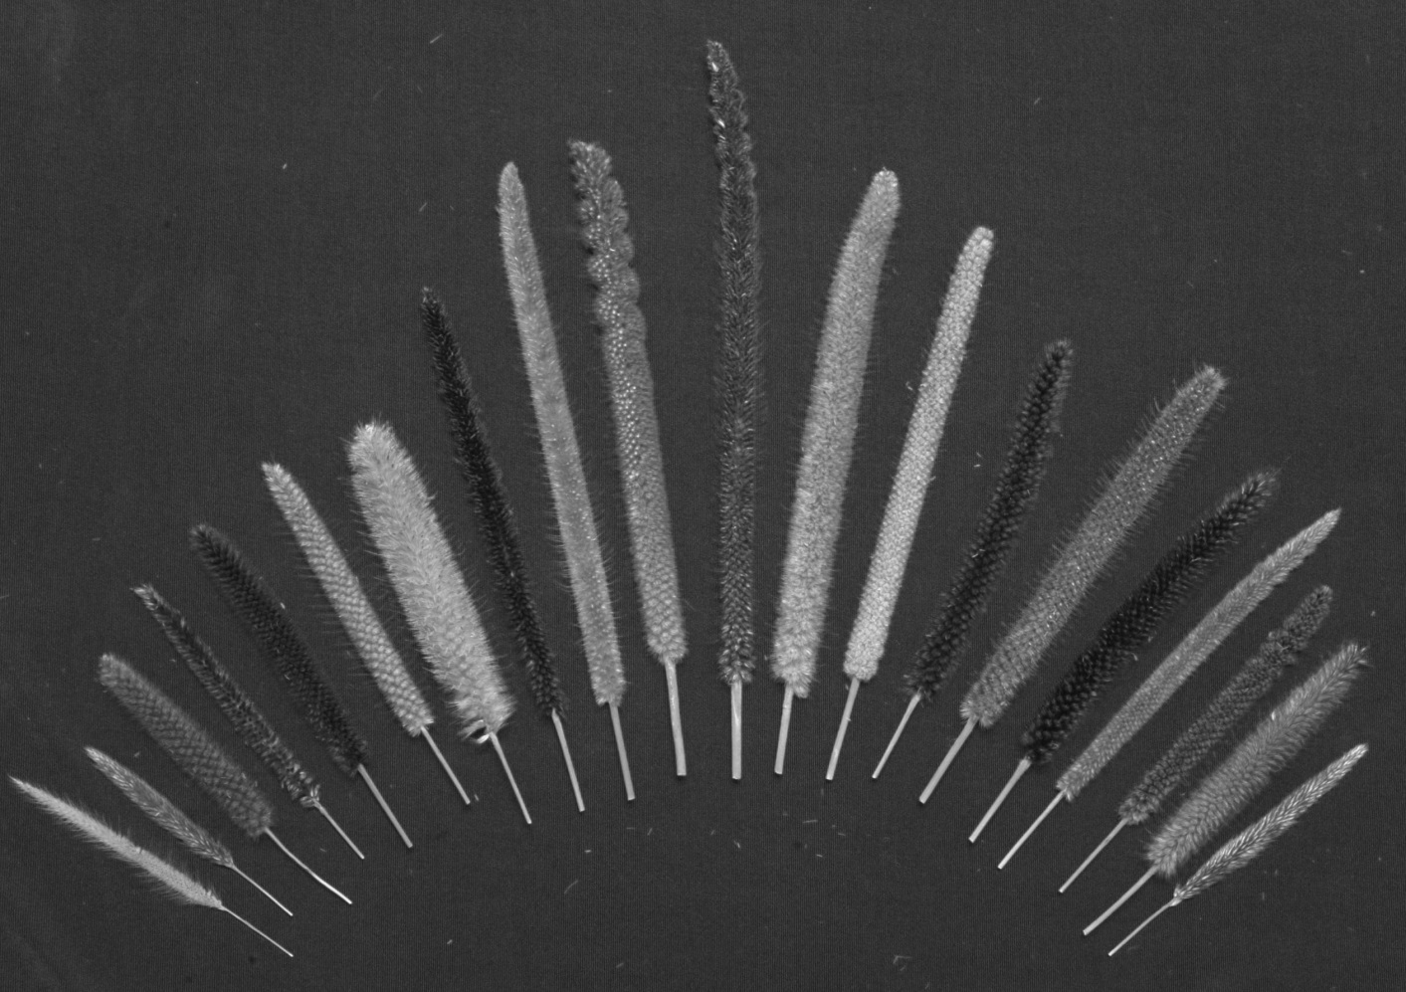
Figure S1

Table S1. Geographical gaps identified in P. glaucum subsp. monodii germplasm
conserved at ICRISAT genebank, Patancheru, India
Country | Province | District
Burkina Faso | Bam | Bourzanga, Rollo, Tikare
 | Gnagna | Bogande, Koalla, Liptougou, Liptougou, Manni, Thion
 | Gourma | Gayeri
 | Kossi | Barani, Djibasso, Kombori, Madouba
 | Namentenga | Bouroum, Tougouri
 | Oudalan | Deou, Markoye, Yalgo
 | Passore | Gomponsom, Kirsi, La-Todin, Samba, Yako
 | Sanguie | Didyr, Godyr
 | Sanmatenga | Barsalogho, Dablo, Pensa
 | Seno | Bani, Dori, Gorgadji, Sampelga, Sebba, Seytenga
 | Soum | Aribinda, Baraboule, Diguel, Djibo, Falagountou, Koutougou, Nassamfou, Pobe-Mengao, Tongomayel
 | Sourou | Gomboro, Kiembara, Lankoue, Toeni
 | Tapoa | Botou, Kantchari
 | Yatenga | Banh, Bassi, Boussou, Kain, Kalsaka, Koumbri, Namissiguima, Ouahigouya, Ouindigui, Oula, Seguenega, Solle, Tangaye, Thiou, Titao, Tougo, Zogore
Chad | Borkou-Ennedi-Tibesti | Tibesti
 | Kanem | Nokou
 | Lake | Bol
 | Guera | Mangalme
 | Salamat | Abou Deia
Mali | Ansongo | Ansongo-Central, Ouatagouna, Talataye, Tessit
 | Bafoulabe | Diakon, Oussoubidiagna
 | Banamba | Boron, Sebete, Toukouroba
 | Bandiagara | Bandiagara-Central, Dourou, Goundaka, Kani-Gogouna, Kendie, Ningari, Ouo, Sangha
 | Bankass | Bankass-Central, Baye, Diallassagou, Kami-Bonzon, Ouenkoro, Segue, Sokoura
 | Baraoueli | Baroueli-Central, Konobougou, Sanando, Tamani
 | Bla | Bla-Central, Diaramana, Falo, Touna, Yangasso
 | Bourem | Bamba, Bourem-Central, Temera
 | Diema | Bema, Diangounte-Camara
 | Dioila | Beleko
 | Dire | Danga, Dire-Central, Haibongo, Sareyamou
 | Djenne | Djenne-Central, Konio, Kouakourou, Mougna, Sofara, Taga
 | Douentza | Boni, Bore, Douentzan-Central, Hombori, Mondoro, Ngouma
 | Gao | Djebock, Gao-Central, Haoussa-Foulane
 | Goundam | Douekire, Farach, Gargando, Goundam-Central, Raz-El-Ma, Tilemsi (Lenere), Tonka
 | Gourma-Rharous | Bambara-Maoude, Gourma-Rharous, Haribomo, Inadiatafane, Modiakoye
 | Kayes | Ambidedi, Aourou, Diadioumbera, Diamou, Kayes-Central, Koussane, Lontou, Sadiola, Same, Segala
 | Kita | Sebekoro
 | Kolokani | Djidieni
 | Koro | Diankabou, Dinangourou, Koporokeniena, Koro-Central, Madougou, Toroli
 | Koulikoro | Niamina
 | Macina | Kolongotomo, Macina-Central, Monimpe, Sarro, Saye
 | Mopti | Dialloube, Fatoma, Konna, Korientze, Mopti-Central, Ouromodi, Sendegue, Soufouroulaye, Soye
 | Nara | Guire
 | Niafunke | Banikane, Koumaira, Lere, Ngorkou, Nianfuke-Central, Sarafere, Soumpi
 | Niono | Nampala, Niono-Central, Pogo, Sokolo
 | Nioro | Gogui, Nioro-Central, Simbi, Trongoumbe
 | San | Dieli, Kassorola, Kassorola, Kimparana, San-Central, Sourountouna, Sy, Tene
 | Segou | Cinzana, Dioro, Doura, Farako, Katiena, Markala, Sansading, Segou-Central
 | Tenenkou | Diafarabe, Dioura, Sossobe, Tenenkou-Central, Toguerecoumbe
 | Tombouctou | Aglal, Ber, Bourem-Inaly
 | Tominian | Fangasso, Koula, Mandiakuy, Timissa, Tominiam-Central
 | Yelimane | Kirane, Marena, Tambacara, Yelimane-Central
 | Yorosso | Boura
 | Youvarou | Ambiri, Gathi-Loumo, Guidio, Sah, Youwarou-Central
Mauritania | Assaba | Aftout (Barkewol), Boumdeid
 | Brakna | Bababe, Boghe, M Bagne, Magta-Lahjar
 | Gorgol | M Bout, Maghama, Monguel
 | Hodh ech Chargui | Amourj, Bassikounou, Djigueni, Nema, Oualata, Timbedra
 | Hodh el Gharbi | Aioun al Atrous, Kobenni, Tamchekket, Tintane
 | Tagant | Moudjeria, Tichit, Tidjikja
 | Trarza | Boutilimit, R Kiz
Niger | Diffa | Nguigmi
 | Dosso | Boboye, Dosso Canton, Loga
 | Maradi | Guidan-Roumji, Madarounfa
 | Tahoua | Illela, Tahoua
 | Tillabery | Kollo, Say, Tera
 | Zinder | Goure
Nigeria | Bauchi | Gamawa, Itas/Gad, Jama'are, Katagum, Nafada/B, Shira, Zaki
 | Borno | Bama, Damboa, Dikwa, Gwoza, Kaga, Konduga, Maidugur, Mobbar, Ngala
 | Jigawa | Babura, Biriniwa, BirninKu, Garki, Gumel, Hadejia, Jahun, KafinHau, KiriKasa, Kiyawa, Kiyawa, MalamMad, Ringim, Ringim, Sule-Tan
 | Katsina | Zango
 | Kebbi | Arewa, Argungu
 | Sokoto | Binji, Bodinga, Dange-Sh, Gada, Goronyo, Gwadabaw, Illela, Kware, Rabah, SabonBir, Silame, Sokoto, Tangazar, Wamakko, Wurno, Yabo
 | Yobe | Bade, Damaturu, Fika, Fune, Geidam, Nangere, Nguru, Yunusari, Yusufari
Senegal | Bakel | Diawara, Goudiri, Kidira
 | Linguere | Barkedji, Dahra, Dodji, Yang-Yang
 | Matam | Kanel, Ourossogui, Semme, Thilogne
 | Podor | Cas-Cas, Ndioum, Salde, Thille Boubacar
Sudan | Bahr el Ghazal | Bahr el Ghazal
 | Central | Blue Nile
 |  | El Gazira
 |  | White Nile
 | Darfur | Northern Darfur
 |  | Southern Darfur
 | Eastern | Kassala
 | Khartoum | Khartoum
 | Kordufan | North Kordufan
 |  | South Kordufan
 | Northern | Nile
 |  | Northern
 | Upper Nile | Junglei
 |  | Upper Nile (Sobat)

