SOM (Supplemental Online Material)

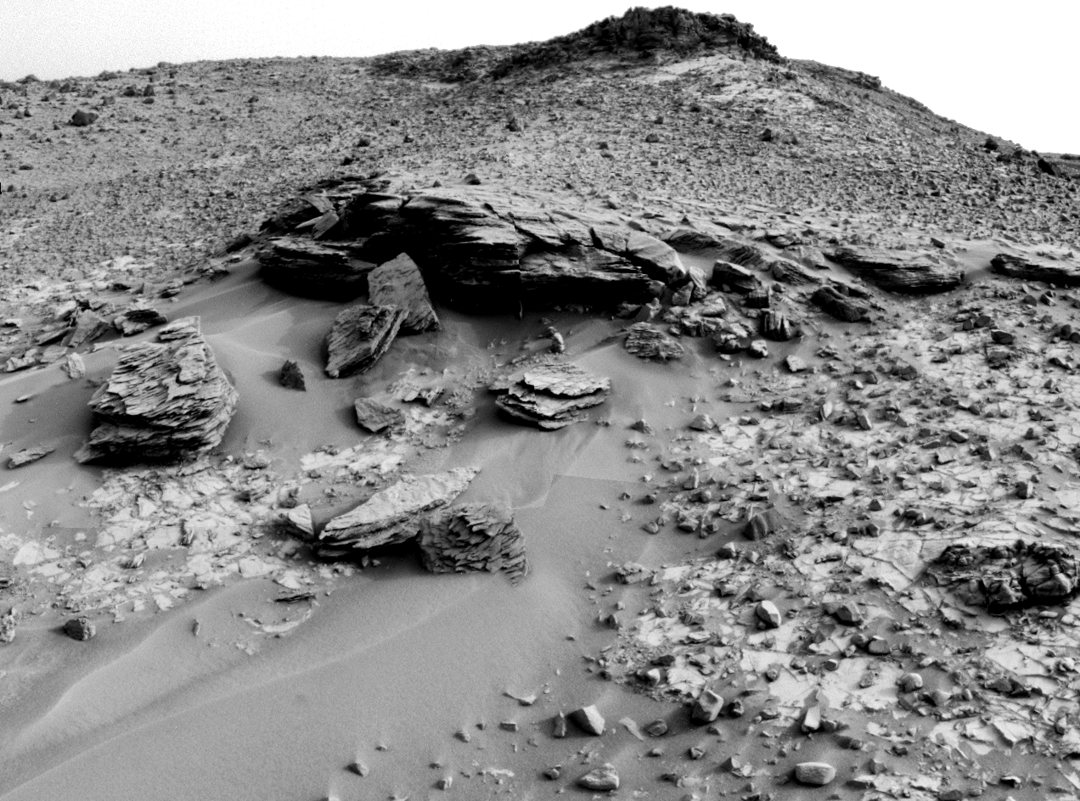
SOM-Fig. 1 Context image for Figure 1e (yellow frame). Image: Navcam, sol 794. Credit: NASA/JPL.

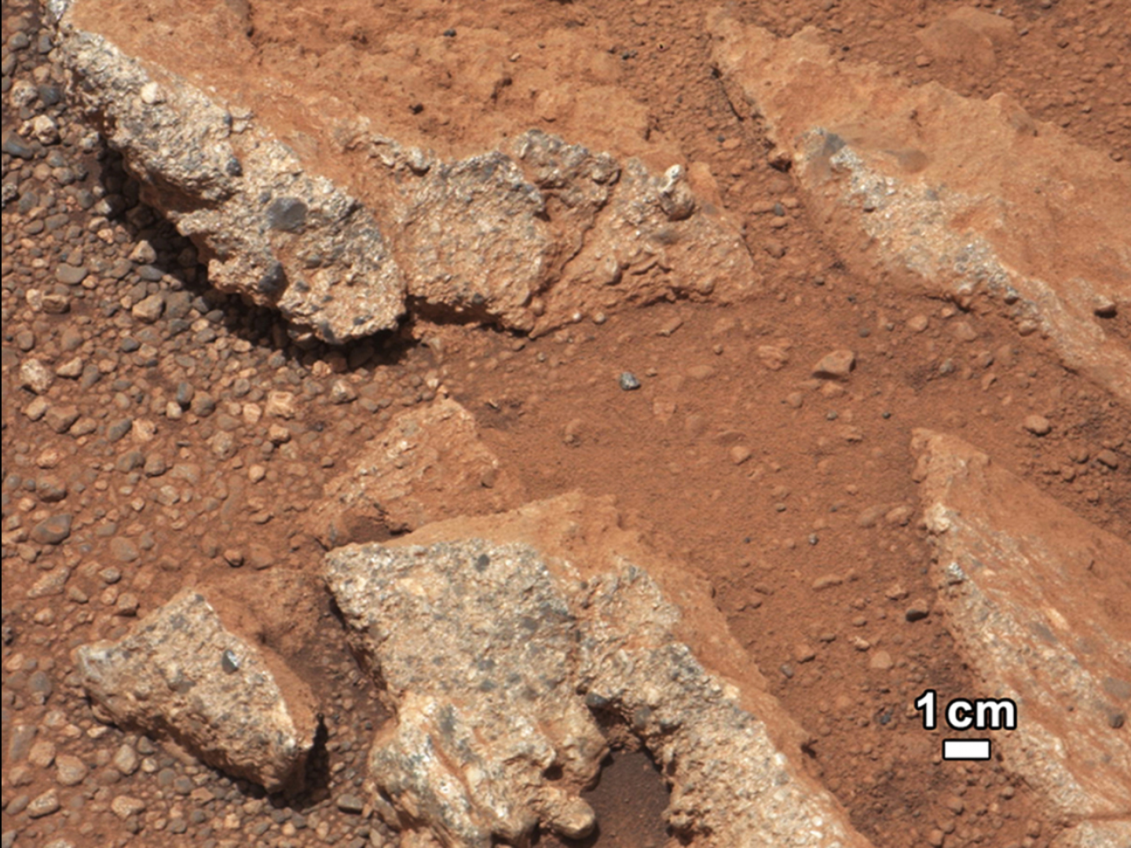
SOM-Fig. 2 Context image for Figure 1f (yellow frame). Image: Right Mastcam, sol 27. Credit: NASA/JPL. PIA16188.

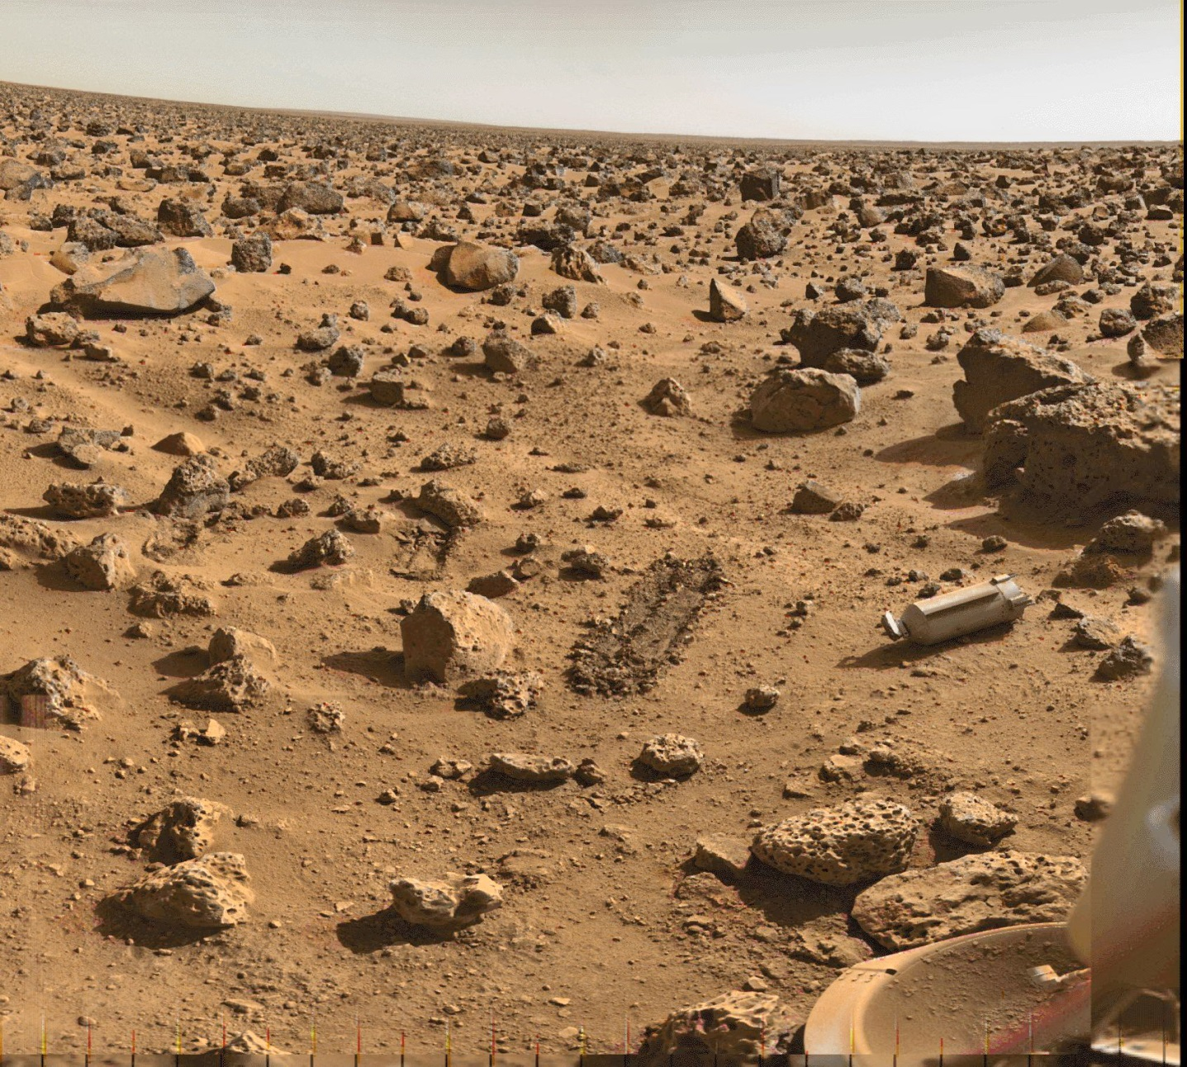
SOM-Fig. 3 Image of the Viking Lander 2 Panoramic Camera. The high density of boulders is interpreted as a lag deposit after substantial denudation. The boulders might be ejecta of small impact craters that have been erased over time (Thompson and Schultz, 2007). Note also several trenches by the scoop (located at the end of the robotic arm). Most important for the purpose of this paper is the ‘biobarrier’ in the right part of the image, an Al shroud (~30 cm x 11 cm) that covered part of the robotic arm and the scoop.

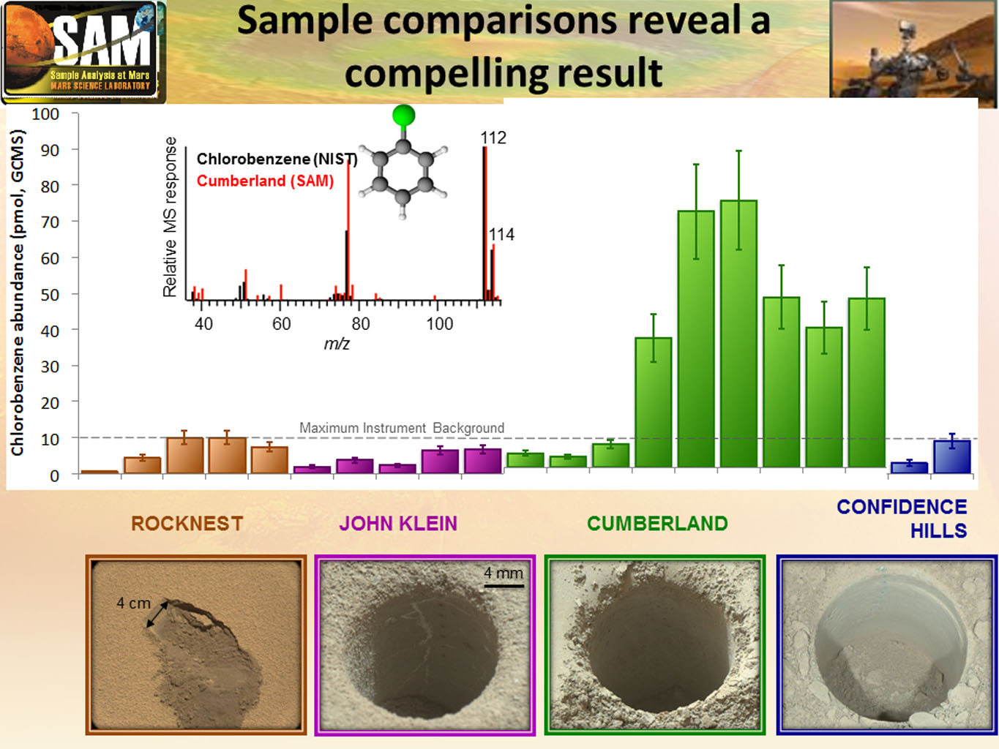
SOM-Fig. 4 Detection of chlorobenzene in four drill samples analyzed by SAM onboard the Curiosity rover. The lack of chlorohydrocarbons released from ‘John Klein’ (as opposed to ‘Cumberland’ that is only a few meters away from ‘John Klein’) has been explained by differences in the SAM analysis protocol which was not optimized for the identification of chlorohydrocarbons in the John Klein experiments (Freissinet et al. 2015). Note sub-surface veins at ‘John Klein’ (SOM-Fig. 5). Credit: NASA/JPL/GSFC. PIA19090.

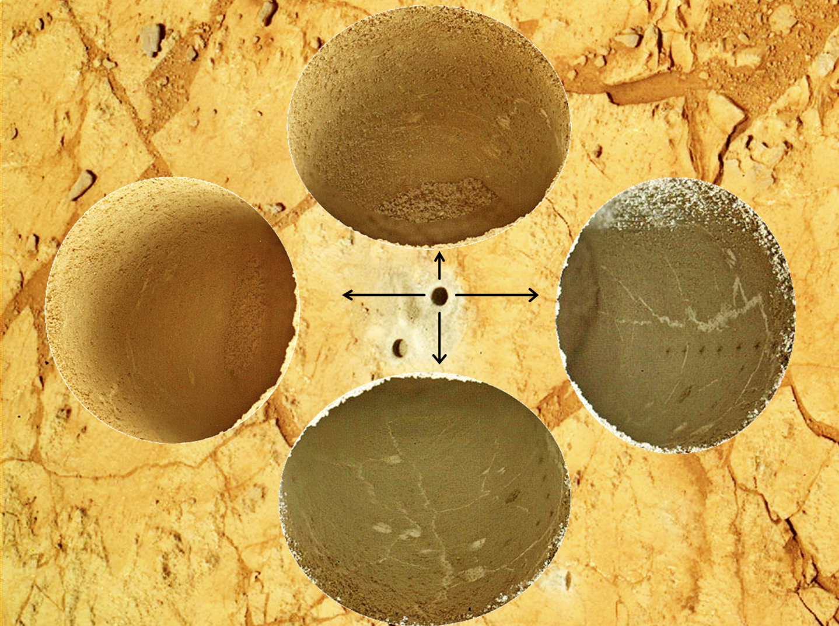
SOM-Fig. 5 Main drill hole at ‘John Klein’, Gale Crater, as imaged from four different directions by MAHLI on sol 270 (four circular insets [MAHLI] on top of a context image [Left Mastcam]). The background context image shows both the main and the mini drill hole that are ~16 mm in diameter and, respectively, ~60 mm and ~20 mm deep. Their diameter matches the field of view of the APXS instrument (chemical composition by x-ray fluorescence) mounted to the robotic arm of the Curiosity rover. John-Klein’s drill hole walls (as opposed to Cumberland’s, SOM-Fig. 4) are cross-cut by numerous veins that are (most likely) filled by a CaSO₄ phase. Also note a vertical series of ChemCam laser pits in the MAHLI inset to the right in order to determine compositional variations in the near subsurface. Credit: NASA/JPL/MSSS.

