Supplemental Information
SI-I – Table summarizing laser conditions for all the figures listed in the manuscript.
Figure Number | Power | Pulse Width | Pulse # / CW time | Image | Comments
2e | 22.2mW | 200μs | 1 | TEM
2f | 22.2mW | 200μs | 1.5k | TEM
2g | 22.2mW | 200μs | 15k | TEM
2h | 22.2mW | 200μs | 100k | TEM
2i | 22.2mW | 200μs | 1-500 | N/A
2j | 22.2mW | 200μs | 1.5k-100k | N/A
3b | 22.2mW | 200μs | 1 | HAADF
3c | 22.2mW | 200μs | 100k | HAADF
3d | 22.2mW | 200μs | +1k | HAADF
3e | 22.2mW | 200μs | +6k | HAADF
3f | 22.2mW | 200μs | +10k | HAADF
3g | 22.2mW | 200μs | +20k | HAADF
3h | 22.2mW | 200μs | +50k | HAADF
3l | 22.2mW | 200μs | 1-100k+50k | N/A
4c-h | 36.5mW | 200μs | 12k | HAADF | radial series
4j-n | 36.5mW | 200μs | 2.5M | HAADF | radial series
5a | 22.2mW | CW | 3s | HAADF | See full movie in SI
5b | 19.9mW | CW | 7s | HAADF | See full movie in SI
5c | 16.6mW | CW | 31s | HAADF | See full movie in SI
5d | 12.8mW | CW | 1005s | HAADF | See full movie in SI
6b | 16.6mW | 200μs | 1 | TEM
6c | 16.6mW | 200μs | 100 | TEM
6d | 16.6mW | 200μs | 10k | TEM
6e | 16.6mW | 200μs | 35k | TEM
6f | 16.6mW | 200μs | 1-35k | TEM
SI-3a | 22.2mW | 200μs | 1 | TEM | cf. figures 2 e-h
SI-3b | 22.2mW | 200μs | 5 | TEM | cf. figures 2 e-h
SI-3c | 22.2mW | 200μs | 15 | TEM | cf. figures 2 e-h
SI-3d | 22.2mW | 200μs | 50 | TEM | cf. figures 2 e-h
SI-3e | 22.2mW | 200μs | 100 | TEM | cf. figures 2 e-h
SI-3f | 22.2mW | 200μs | 1.5k | TEM | cf. figures 2 e-h
SI-3g | 22.2mW | 200μs | 3.5k | TEM | cf. figures 2 e-h
SI-3h | 22.2mW | 200μs | 8.5k | TEM | cf. figures 2 e-h
SI-3i | 22.2mW | 200μs | 15k | TEM | cf. figures 2 e-h
SI-3j | 22.2mW | 200μs | 20k | TEM | cf. figures 2 e-h
SI-3k | 22.2mW | 200μs | 30k | TEM | cf. figures 2 e-h
SI-3l | 22.2mW | 200μs | 40k | TEM | cf. figures 2 e-h
SI-3m | 22.2mW | 200μs | 50k | TEM | cf. figures 2 e-h
SI-3n | 22.2mW | 200μs | 70k | TEM | cf. figures 2 e-h
SI-3o | 22.2mW | 200μs | 100k | TEM | cf. figures 2 e-h
SI-3p | 22.2mW | 200μs | 1-500 | N/A | SAED of SI-3
SI-3q | 22.2mW | 200μs | 30k-100k | N/A | SAED of SI-3
SI-3r | 22.2mW | 200μs | 1.5k-20k | N/A | SAED of SI-3
SI-4 | 12.2-22.2mW | CW | N/A | HAADF | cf. figure 5
SI-5a | 16.6mW | 200μs | 1 | TEM | cf. figures 6 b-e
SI-5b | 16.6mW | 200μs | 5 | TEM | cf. figures 6 b-e
SI-5c | 16.6mW | 200μs | 20 | TEM | cf. figures 6 b-e
SI-5d | 16.6mW | 200μs | 50 | TEM | cf. figures 6 b-e
SI-5e | 16.6mW | 200μs | 52 | TEM | cf. figures 6 b-e
SI-5f | 16.6mW | 200μs | 60 | TEM | cf. figures 6 b-e
SI-5g | 16.6mW | 200μs | 80 | TEM | cf. figures 6 b-e
SI-5h | 16.6mW | 200μs | 90 | TEM | cf. figures 6 b-e
SI-5i | 16.6mW | 200μs | 100 | TEM | cf. figures 6 b-e
SI-5j | 16.6mW | 200μs | 120 | TEM | cf. figures 6 b-e
SI-5k | 16.6mW | 200μs | 200 | TEM | cf. figures 6 b-e
SI-5l | 16.6mW | 200μs | 1k | TEM | cf. figures 6 b-e
SI-5m | 16.6mW | 200μs | 3k | TEM | cf. figures 6 b-e
SI-5n | 16.6mW | 200μs | 15k | TEM | cf. figures 6 b-e
SI-5o | 16.6mW | 200μs | 35k | TEM | cf. figures 6 b-e

SI-2 – HAADF STEM image and silver and nickel as-deposited core loss EEL maps illustrating that the image contrast in the as-deposited TEM and HAADF STEM images is due to thickness variation in the film.
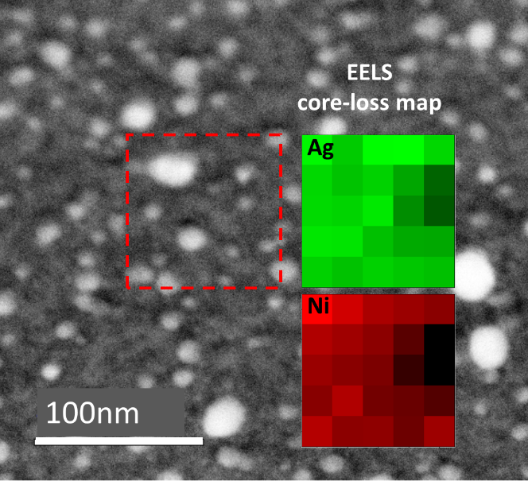
SI-3 – Exhaustive TEM image set and radially averaged and normalized SAED pattern as a function of laser pulses for 22.2mW and 200 μs pulse width exposures (complete set for figure 2 e)-h) in the manuscript).
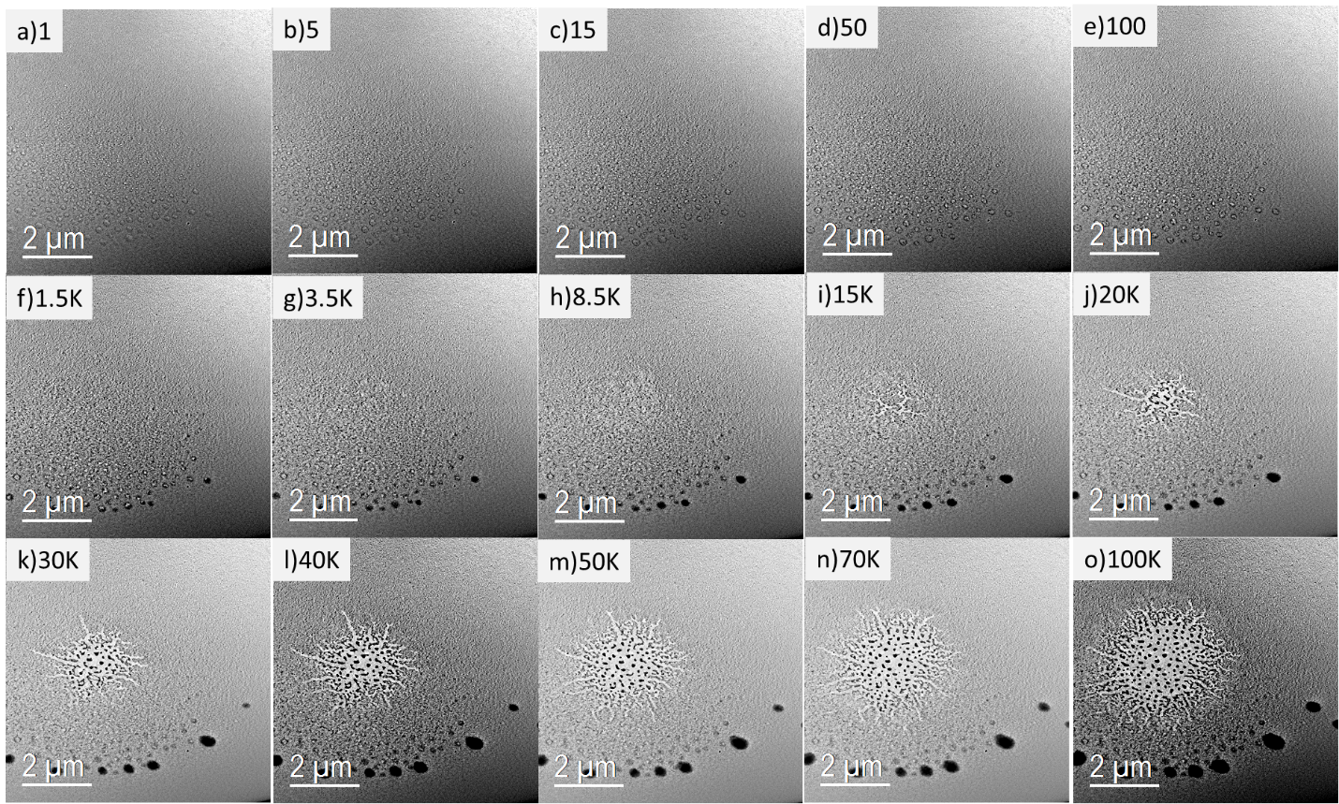
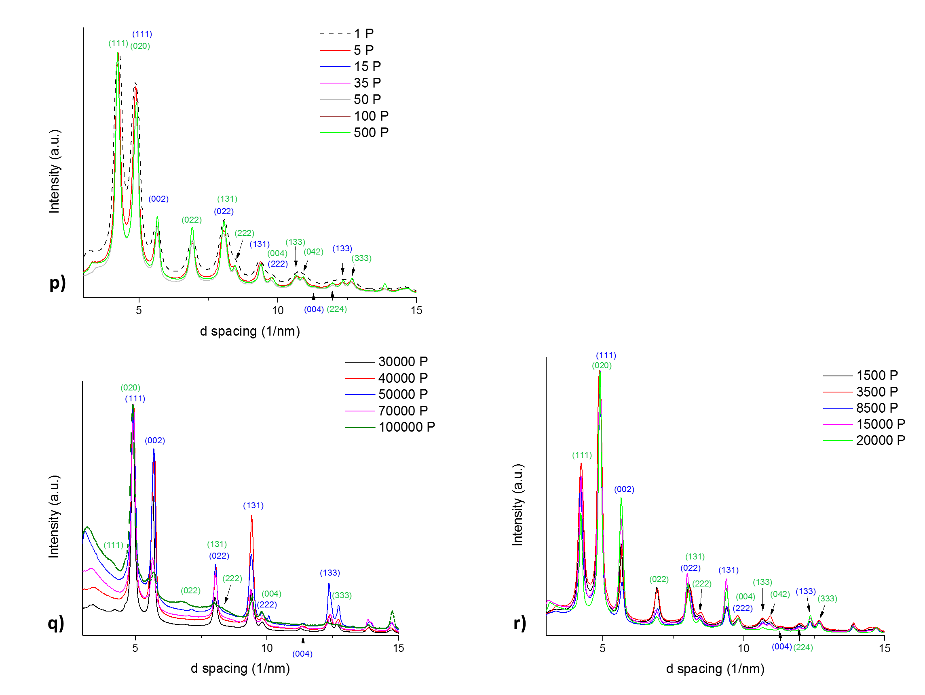
SI-4 –HAADF STEM videos of 22.2, 18.9, and 16.6 mW in situ continuous wave laser exposure experiments (still images from videos are shown in figure 5)

SI-5 – Exhaustive TEM image set as a function of laser pulses for 16.6 mW and 200 ⎧s pulse width exposures (complete set of figure 6 in the manuscript).
