S.I.

**Projection Lens Current and Corresponding ADF Detector Collection Angle**

The inner and outer semi-collection angle of the ADF detector at 1.125 mA projection lens current was provided by the manufacturer. Based on this value, we calibrated the camera length, inner and outer semi-collection angle at different projection lens currents (**Table 1**) using diffraction pattern of gold nano-spheres.

**Table 1** Camera length, inner and outer semi-collection angle at different projection lens current

|  |  |  |  |
| --- | --- | --- | --- |
| Projection Lens Current (mA) | Camera Length  (Arbitrary Unit.) | Inner Semi-Collection Angle (mrad) | Outer Semi-Collection Angle (mrad) |
| 1.065 | 85.7±1.50 | 72.3 | 380.2 |
| 1.067 | 86.9±1.29 | 71.4 | 375.6 |
| 1.070 | 87.2±1.12 | 71.1 | 374.3 |
| 1.075 | 89.2±1.34 | 69.4 | 366.3 |
| 1.086 | 90.4±2.04 | 68.5 | 361.8 |
| 1.091 | 91.4±0.83 | 67.8 | 358.4 |
| 1.095 | 92.7±0.74 | 66.9 | 353.9 |
| 1.100 | 93.2±1.25 | 66.5 | 352.0 |
| 1.125 | 100.0±1.05 | 62.0 | 330.0 |

**Linearity of HAADF Image Signal and Projected Mass of Polystyrene Beads**

In order to determine the optimal collection angle, several images of polystyrene beads were taken under different projection length at a fixed brightness/contrast condition. Projected mass of each pixel, , was calculated as in **Fig 1** using the following equation.

****, **(1)**

where . For pixels with identical projected mass (identical radial distance to the center of the bead), we averaged the intensities of these pixels to eliminate the influence of noise. Averaged intensity over mass was linearly fitted, and linear coefficients were plotted over the projection lens current. We chose the projection lens current (1.065 mA) which provides a linear coefficient over 0.95 and a good signal-to-noise-ratio for all following experiments.

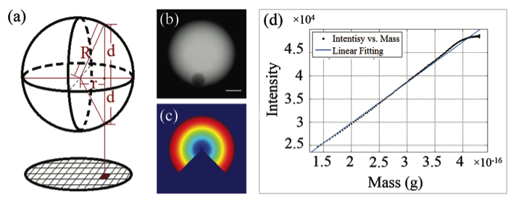

**Fig 1** Calculation of projected mass in a specific pixel area. (a) R is the radius of the bead, which can be measured as the diameter of the projected circle. r is the distance of the pixel to the center of the circle. d is the thickness of the beads projected to the pixel, . (b) A HAADF image of a polystyrene bead taken under low projection lens current. Scale bar: 1 µm. (c) Radial distance of different pixels to the center of the polystyrene bead. Intensity of pixels in the same band is averaged. The region with non-polystyrene material was not considered and results in a “wedge”. (d) The intensity over mass plot and linear fitting of the bead shown in (b).

**Topography Mapping Using AFM**

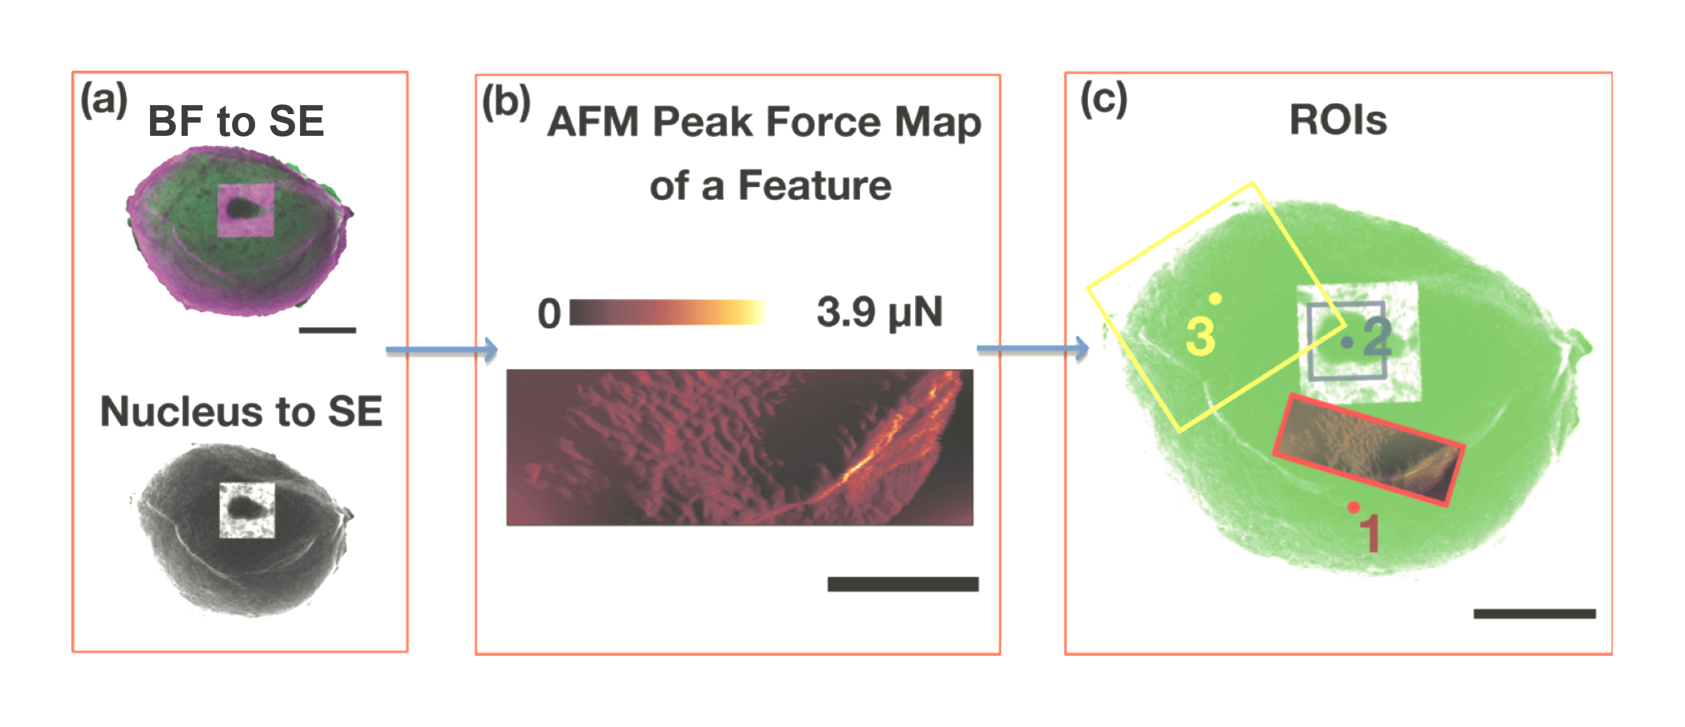

**Fig 2** AFM experiment flow-chart. (a) We first registered BF image to SE image by cross correlation, then we registered nucleus to SE image. (b) A small area of features was scanned with low resolution and registered to SE image. (c) Position of the AFM probe (red dot position 1) while scanning (b), (b) was overlaid on SE image. Position of the probe while scanning the nucleus (blue dot position 2), and position of the probe while scanning the reference (yellow dot position 3).

Steps for nucleus co-localization in STEM and AFM:

1. Locating the center of high magnification nucleus image in low magnification SE image (**Fig 2** (a)). The reason to use SE image is that both SE and AFM provide topographic information and thus the image contrasts are similar. However, from the SE image alone, it is impossible to identify the exact location of the nucleus. In the experiment, we overlapped the high-resolution nucleus image with the low magnification BF (bright field) image, and the low magnification BF image with the SE image by cross correlation. Using the translation with the highest cross-correlation, we located the exact region where the high magnification nucleus was taken in the SE image.

2. Locating the AFM probe on the sample. We manually engaged the tip to a region with an identifiable feature (a ridge on the cell membrane) and scanned a small portion of the feature with a pixel size of 5 nm (**Fig 2** (b)). While the scanning was still ongoing, we exported the AFM image and aligned it with the SE image using affine transform in the MATLAB Image Processing Toolbox. As the probe position is known in the AFM image, and thus known in the SE image (**Fig 2** (c) red dot).

3. High resolution AFM thickness mapping over a region with the nucleus (**Fig 2** (c)). We selected roughly the center of the nucleus on the SE image (blue dot) and calculated the offsets between the red and blue dot. Then we moved the AFM probe to the red dot using the control software without withdrawal. A 6 µm-by-6 µm square was scanned with lateral resolution of 12 nm to cover the entire nucleus. After one full scan, the probe was moved again to another region (yellow dot), a large area with the background and partially overlapped with the nucleus thickness map (background map) was measured. The new offsets and scanning angle were recorded for later registration. Aligning the nucleus thickness map and the background map, we were able to calculate the absolute thickness over the region enclosed the nucleus.