Supplementary Information

Analytical Multimode Scanning and Transmission Electron Imaging and Tomography of Multiscale Structural Architectures of Sulfur Copolymer-Based Composite Cathodes for Next Generation High-Energy Density Li-S Batteries

Vladimir P. Oleshko¹, Andrew A. Herzing², Christopher L. Soles¹, Jared J. Griebel³, Woo J. Chung³, Adam G. Simmonds³, and Jeffrey Pyun³

¹Materials Science and Engineering Division and ²Materials Measurement Science Division, Material Measurement Laboratory, National Institute of Standards and Technology, Gaithersburg, MD 20899
³ Department of Chemistry & Biochemistry, University of Arizona, Tucson, AZ 85721

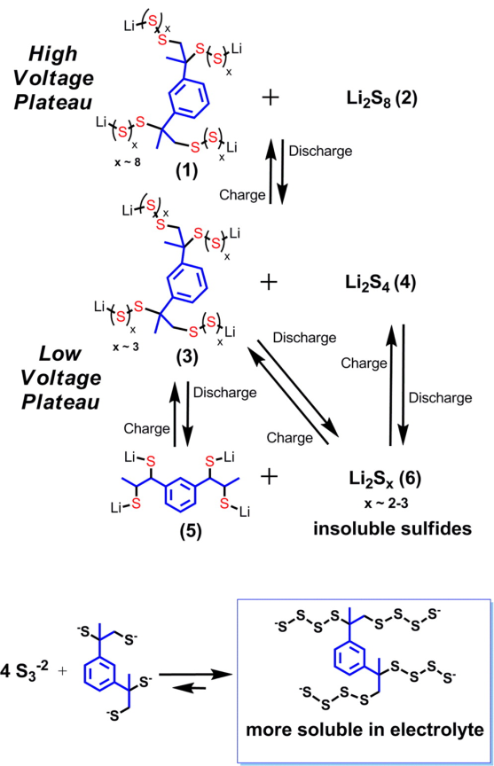

(a)

(b)

Figure 1S. (a) Proposed electrochemical reactions of poly(S-r-DIB) copolymers in Li–S batteries. (b) Proposed equilibrium between lower polysulfides and organosulfide discharge products, which at higher DIB compositions favors formation of soluble higher order polysulfides, see detailed explanations in the section below. Li⁺ cations omitted for clarity due to the presence of excess cations in the electrolyte (Simmonds et al, 2014).

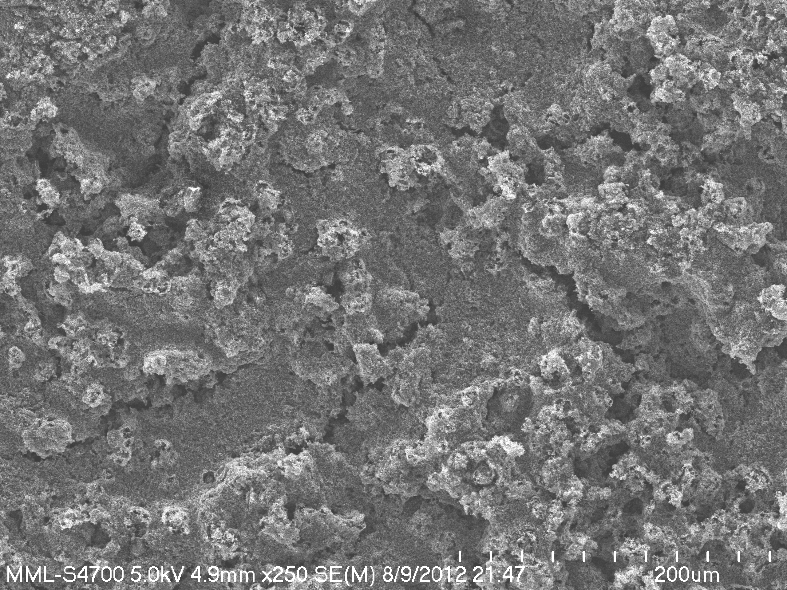
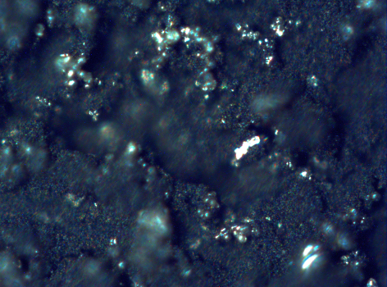
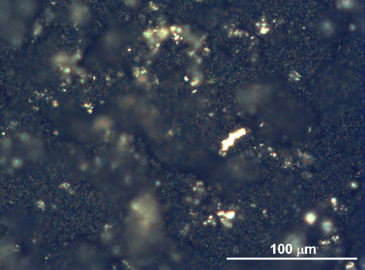
cracks
(a2)
(a3)
(a1)
cracks

100 μm
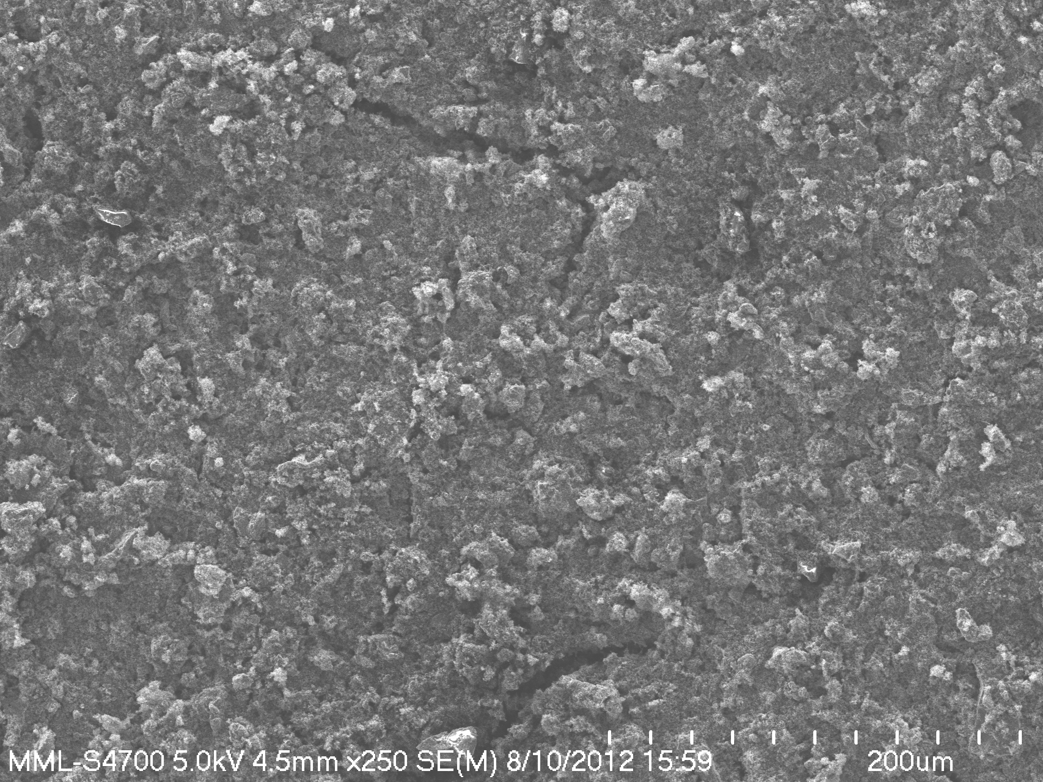
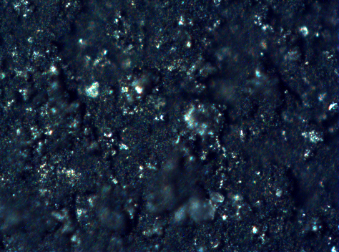
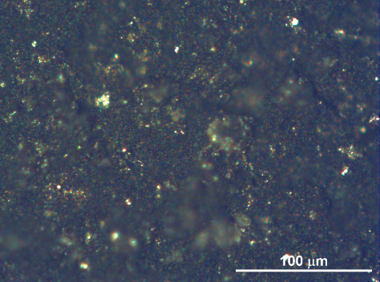
(b3)
(b2)
crack
(b1)
crack

100 μm
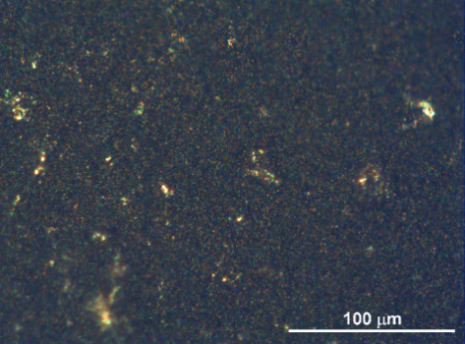
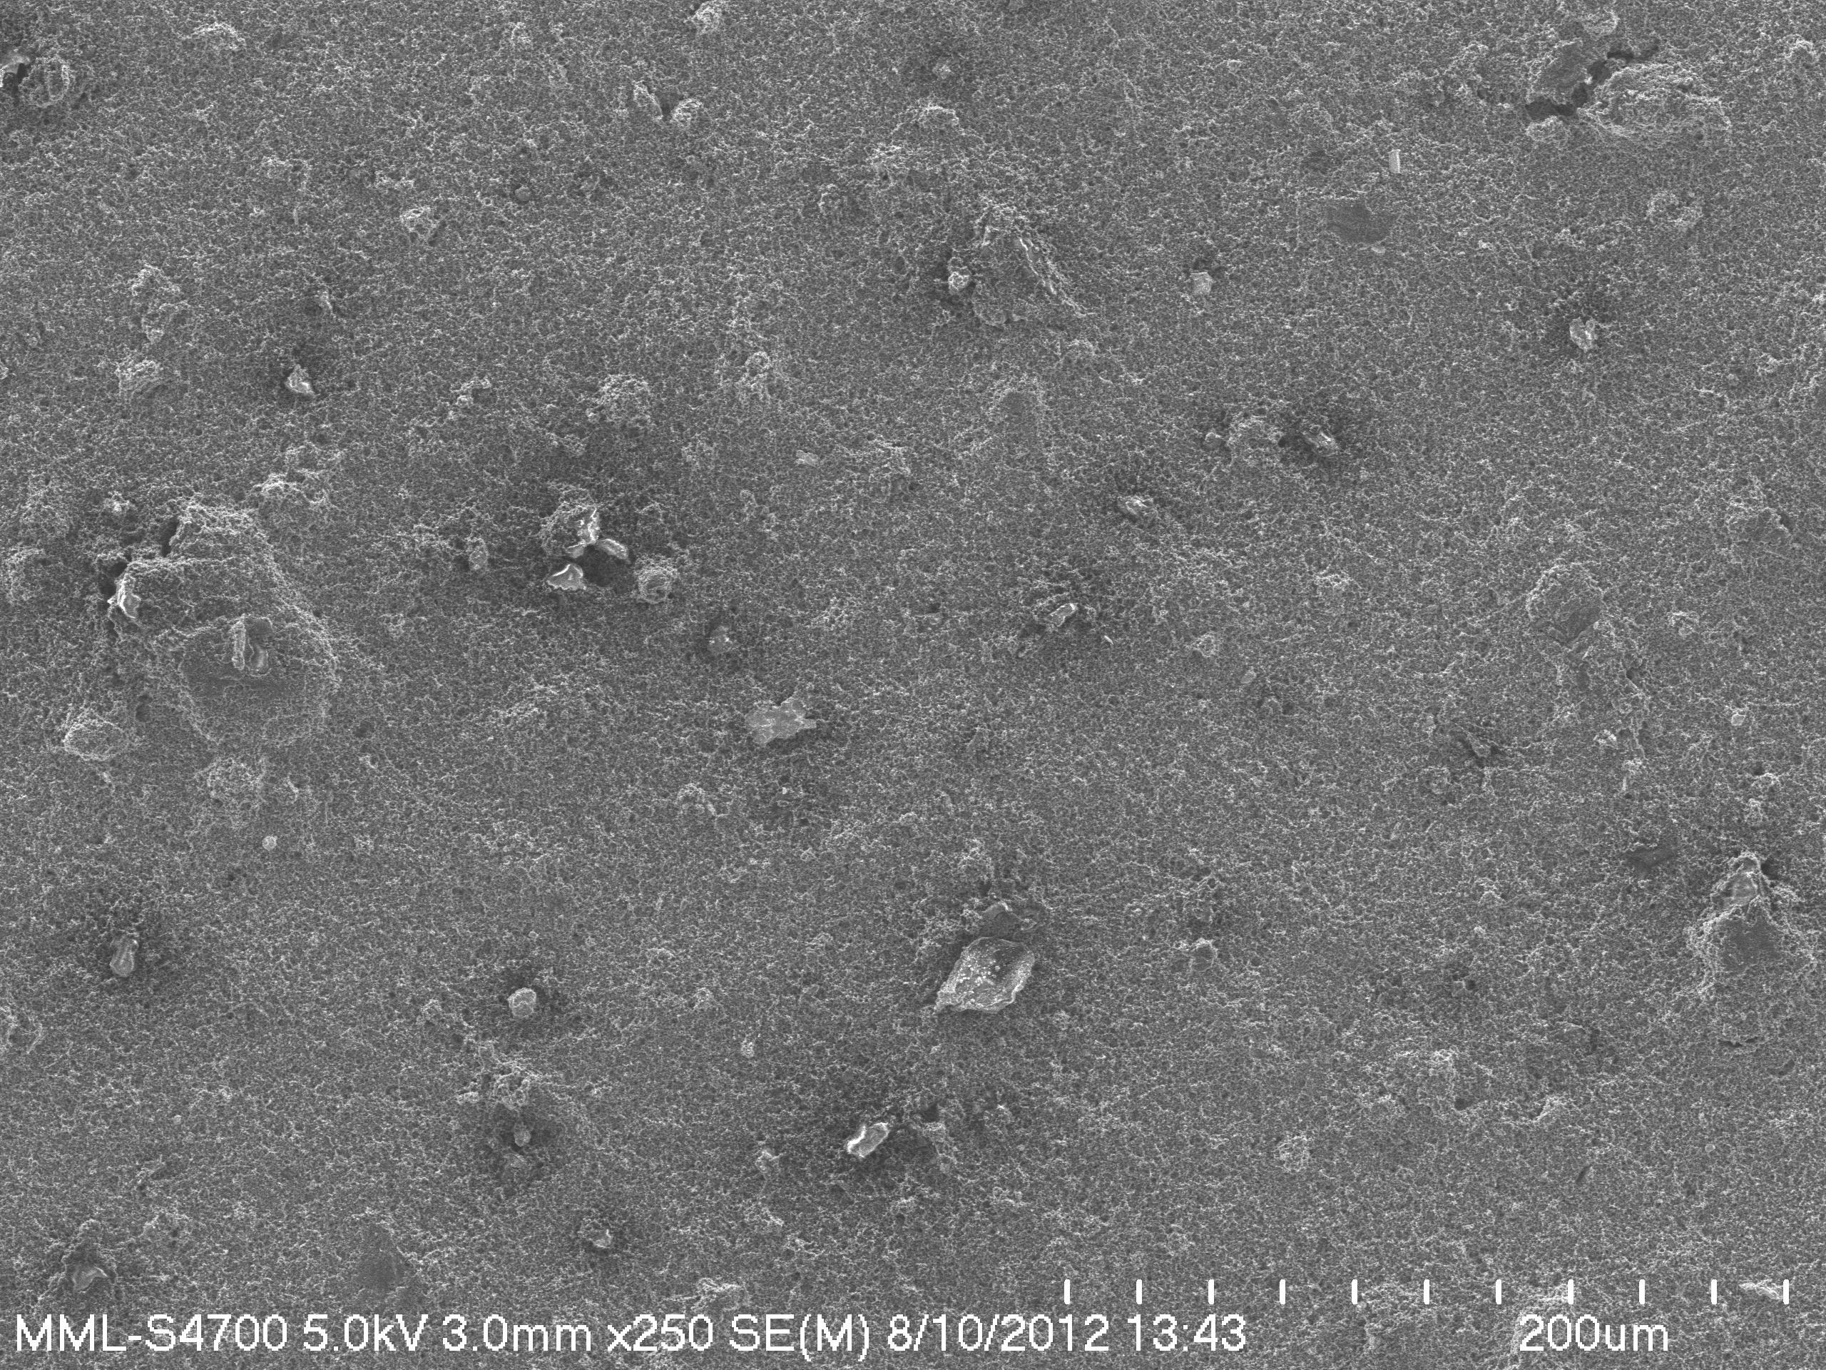
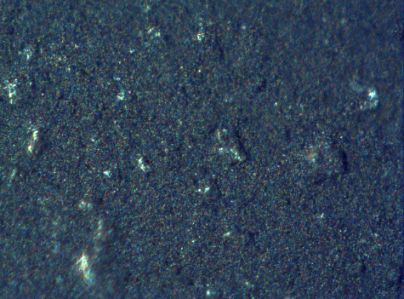
(c3)
(c2)
(c1)

100 μm
Figure 2S. Plane view color light microscopy (LM) images and low-magnification FESEM images (right column) of surfaces of the pristine composite cathodes. LM images obtained in reflection mode at working magnification of x200 under bright field illumination (left column) and under dark field illumination (middle column) from the same areas: (a1-a3) the conventional S₈ - carbon cathode; (b1-b3) the poly(S-r-DIB_{10 %}) copolymer-based cathode, and (c1-c3) the poly(S-r-DIB_{50 %} copolymer-based cathode, respectively. The poly(S-r-DIB) copolymer particles are red-orange, sulfur microparticles are yellow, and C65 carbons are black (see also Chung et al, 2013 and Simmonds et al, 2014 for further details). Note that some rough surface regions in images a1-a2, b1-b2 and c1-c2 are out of focus because of the limited focus depth of a light microscope.

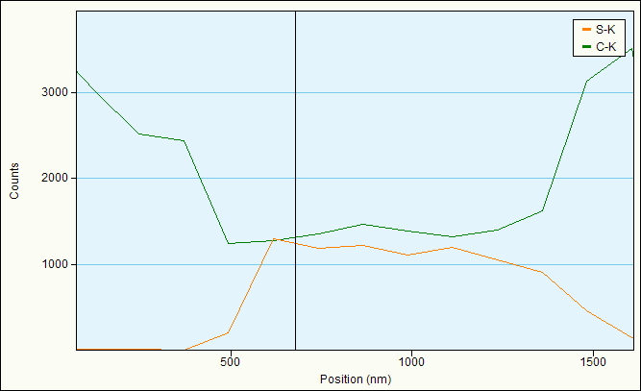
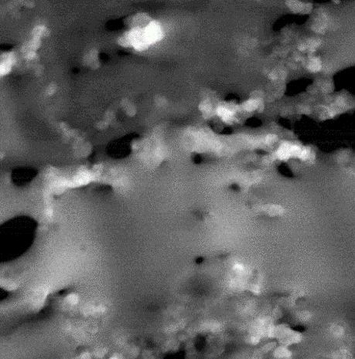
C65
(a)
(b)

1

Poly(S-r-DIB_{10-wt.%})

200 nm

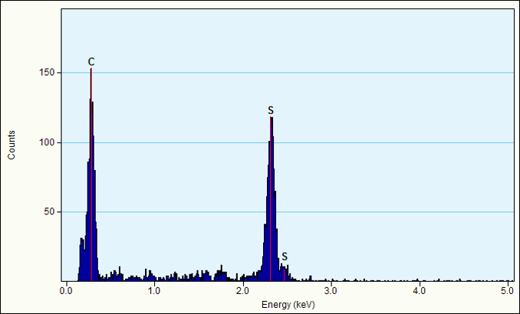
(c)

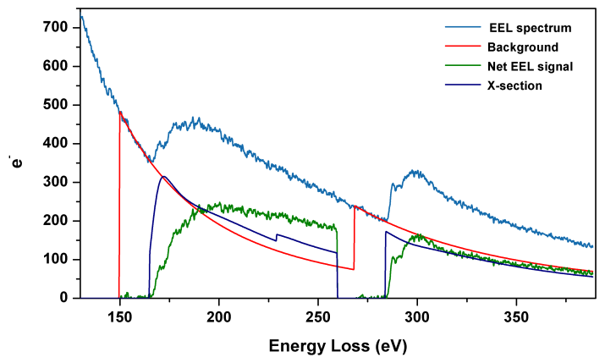

(d)

Figure 3S. (a) HAADF STEM and (b-d) drift-corrected STEM/EDX SI of an ultrathin section of the poly(S-r-DIB_{10 %}) copolymer-based cathode. Red rectangular box in (a) marks the area where spatially-correlated EDX and EELS analyses (Fig. 7a-c) were performed; (b) EDX spectral line profile along orange line shown in (a), the point 1 marked by red cross in (a) corresponds to black line in (b). (c) X-ray spectrum acquired in the point marked by red cross in (a). (d) EEL spectrum exhibiting the S L_{2,3}-edge at 165 eV and the C K-edge at 284 eV from the same point. The net SL_{2,3}- and CK-edges obtained by subtracting a power-law fitted background (red lines) are shown in green. Navy lines denote Hartree-Slater ionization cross-sections calculated for both edges (Egerton, 2011).
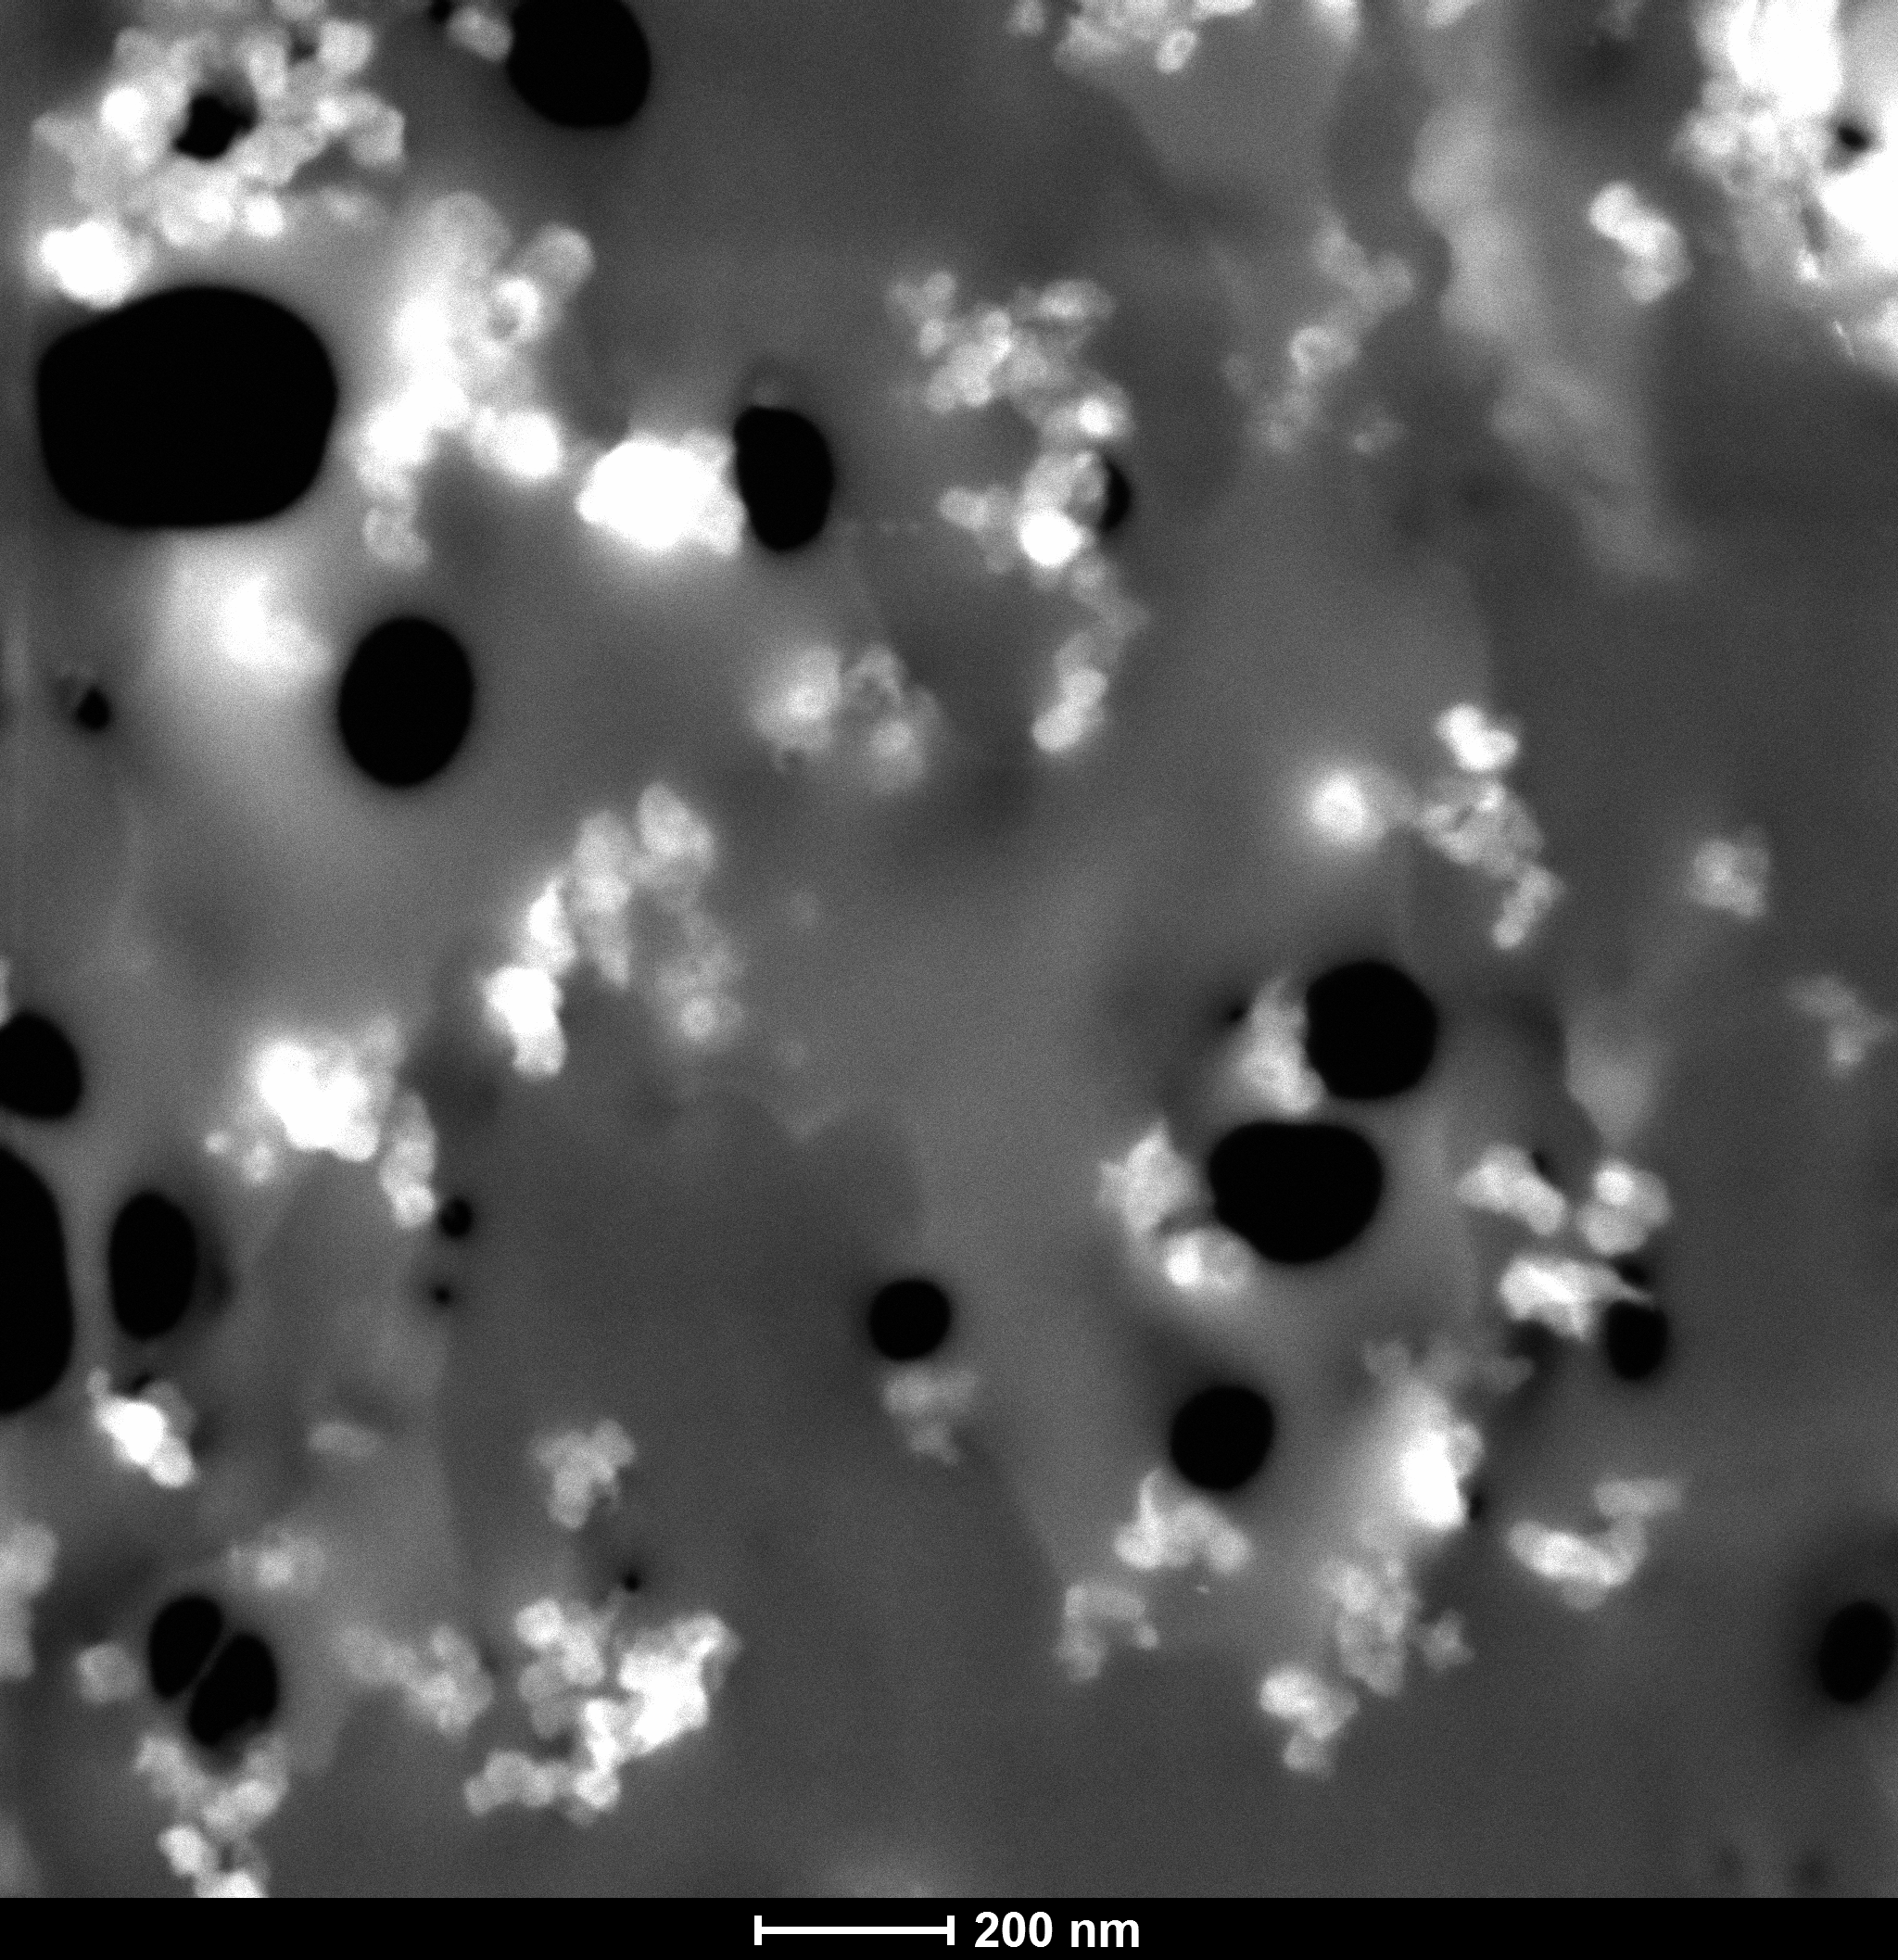
(a)
Poly(S-r-DIB_{50-wt.%})
C65
200 nm

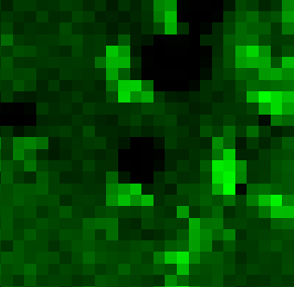
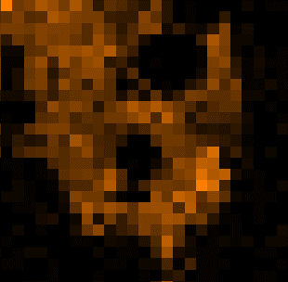
(c)
C-Kα
(b)
S-Kα
200 nm
1
1

(d)

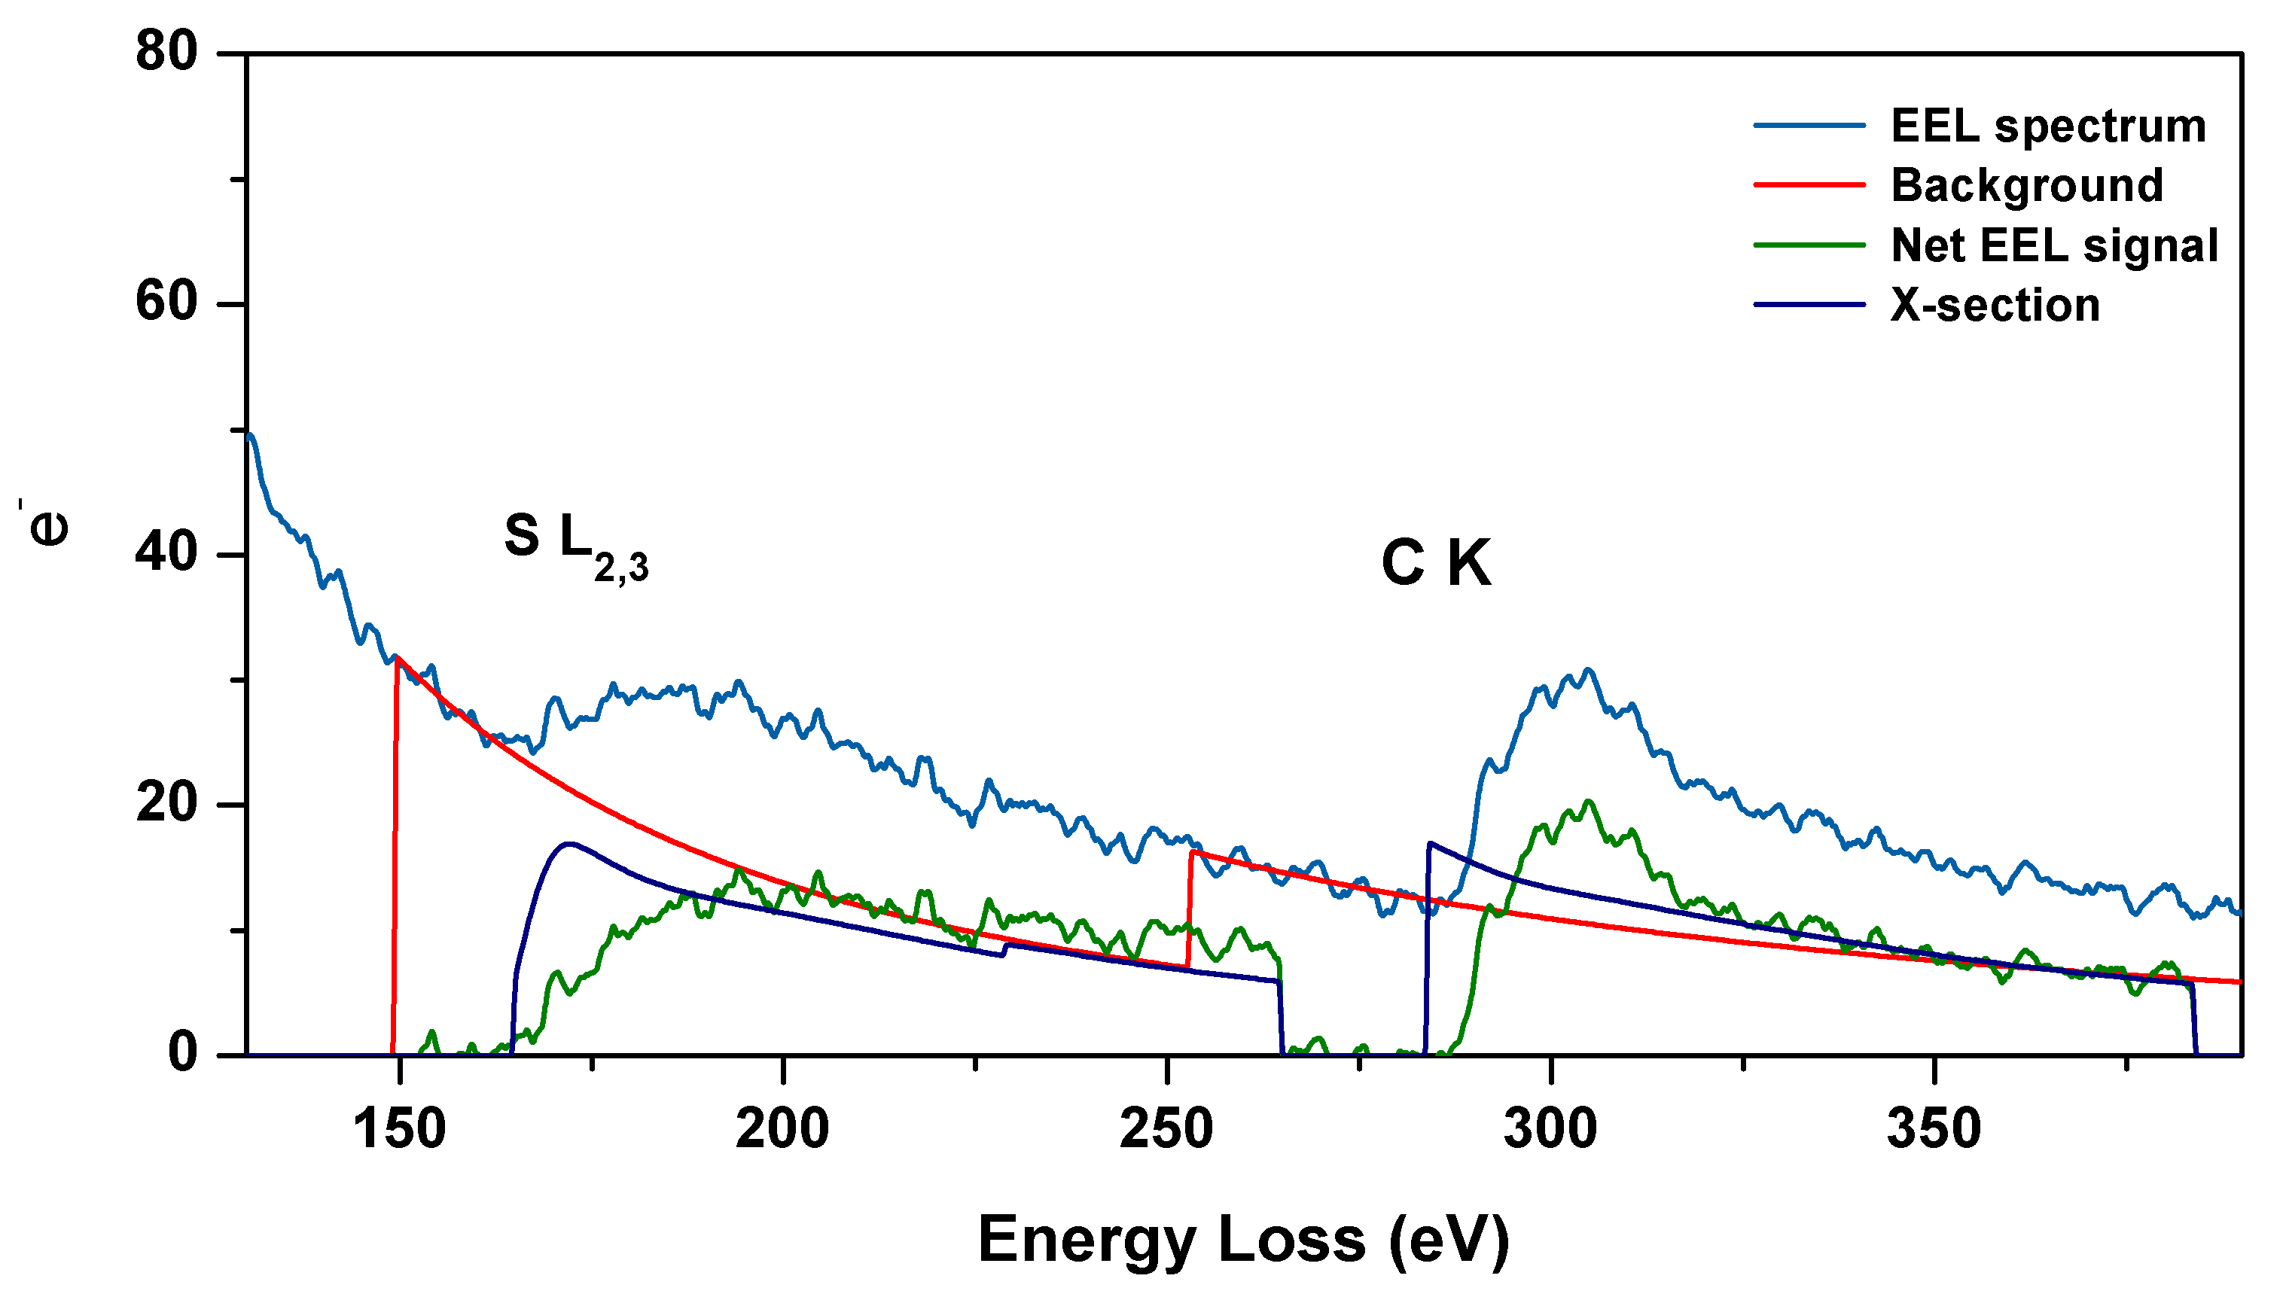
(e)

Figure 4S. (a) HAADF STEM and (b) drift-corrected STEM/EDX SI of an ultrathin section of the poly(S-r-DIB_{50 %}) copolymer-based cathode. Red rectangular box in (a) marks the area where spatially-correlated EDX and EELS analyses (Fig. 7d-f) were performed. (b) Sulfur S Kα X-ray map and (c) carbon C Kα X-ray map acquired over the same area. (d) X-ray spectrum acquired in the point marked by red cross in (b) and (c). (e) EEL spectrum exhibiting the S L_{2,3}-edge at 165 eV and the C K-edge at 284 eV from the same point. The net S L_{2,3}- and C K-edges obtained by subtracting a power-law fitted background (red lines) are shown in green. Navy lines denote Hartree-Slater ionization cross-sections calculated for both edges (Egerton, 2011).

Movies 5S. (a) ET isosurface rotation, 10 % DIB composite cathode.mp4. (b) ET through plane view, 10% DIB composite cathode.mp4.

References

Chung, W.-J., Griebel, J.J., Kim, E.-T., Yoon, H.-S., Simmonds, A.G., Ji, H.-J., Dirlam, P.T., Glass, R.S., Wie, J. J., Nguyen, N.A., Guralnick, B.W., Park, J., Somogyi, A., Theato, P., Mackay, M.E., Sung, Y.-E., Char, K.-C. & Pyun, J. (2013) The use of elemental sulfur as an alternative feedstock for polymeric materials. Nature Chem. 5, 518 - 524.
Egerton, R.F. Electron Energy-Loss Spectroscopy in the Electron Microscope, 3rd ed. (Springer, N.Y., 2011), pp. 197 - 202.
Simmonds, A.G., Griebel, J.J., Park, J., Kim, K.R., Chung, W.J., Oleshko, V.P., Kim, J., Kim, E.T., Glass, R.S., Soles, C.L., Sung, Y.-E., Char, K. & Pyun, J. (2014) Inverse vulcanization of elemental sulfur to prepare polymeric electrode materials for Li−S batteries. ACS Macro Lett. 3, 229 - 232.

