Supplementary material

Public Health Nutrition

Healthful grain foods consumption by São Paulo residents: a 12-year analysis and future trends
Mariane de M. Fontanelli, Cristiane H. Sales, Michelle A. de Castro, Regina M. Fisberg
Supplementary tables and figure
Supplementary Table 1. Demographic and socioeconomic characteristics of the population of São Paulo aged 12 years or more based on the Health Survey of São Paulo, 2003, 2008 and 2015. 2
Supplementary Table 2. Prevalence of population consuming total grain foods and grain foods meeting the ≤10:1-ratio* by Health Survey of São Paulo edition 2003, 2008 and 2015 3
Supplementary Table 3. Features associated with the intake of grain foods meeting the ≤10:1-ratio in the population of São Paulo aged 12 years or more, Health Survey of São Paulo 2003, 2008 and 2015. 4
Supplementary Table 4. Features associated with the intake of grain foods meeting the ≤10:1-ratio in the population of São Paulo aged 12 years or more by Health Survey of São Paulo edition 2003, 2008, and 2015. 5
Supplementary Figure 1. Flow diagram of the study participants. 6

Supplementary Table 1. Demographic and socioeconomic characteristics of the population of São Paulo aged 12 years or more based on the Health Survey of São Paulo, 2003, 2008 and 2015.
Characteristics | 2003 (n=2398) |  |  | 2008 (n=1662) |  |  | 2015 (n=1741)
 | n | %‡ | 95% CI | n | % | 95% CI | n | % | 95% CI
Age group, years
12-19 | 811 | 18.9 | 17.0-21.1 | 560 | 25.0 | 21.9-28.5 | 553 | 23.2 | 20.9-25.7
20-59 | 756 | 68.2 | 66.0-70.3 | 585 | 61.7 | 58.1-65.2 | 643 | 54.1 | 51.5-56.8
≥ 60 | 831 | 12.9 | 11.3-14.7 | 517 | 13.3 | 11.1-15.8 | 545 | 22.7 | 19.9-25.7
Sex
Male | 1186 | 46.1 | 43.4-48.8 | 718 | 45.2 | 42.8-47.7 | 837 | 50.0 | 47.2-52.9
Female | 1212 | 53.9 | 51.2-56.6 | 944 | 54.8 | 52.3-57.2 | 904 | 50.0 | 47.1-52.8
Education level *
< High school graduate | 1594 | 55.7 | 52.1-59.2 | 1431 | 78.7 | 72.7-83.7 | 980 | 50.8 | 47.0-54.7
High school graduate | 366 | 19.2 | 17.1-21.5 | 82 | 8.2 | 6.0-11.1 | 366 | 22.4 | 20.1-24.9
College or some college | 411 | 25.1 | 21.7-28.9 | 138 | 13.1 | 9.2-18.3 | 358 | 26.8 | 23.1-30.8
Family income per capita * ‡
≤ 1 minimum wage | 977 | 37.2 | 33.2-41.3 | 731 | 36.9 | 31.6-42.5 | 757 | 42.1 | 37.2-47.1
> 1 and ≤ 3 minimum wages | 844 | 35.3 | 31.5-39.4 | 647 | 41.0 | 36.5-45.7 | 528 | 33.3 | 29.4-37.5
> 3 minimum wages | 442 | 23.6 | 18.4-29.7 | 161 | 13.9 | 10.0-19.0 | 124 | 9.7 | 7.0-13.2
Do not know | 99 | 3.9 | 2.8-5.6 | 119 | 8.2 | 5.7-11.6 | 257 | 14.9 | 10.6-20.6
Ethnicity *
White and yellow | 1559 | 67.0 | 63.2-71.0 | 986 | 60.9 | 54.7-66.8 | 865 | 51.1 | 47.4-54.8
Black, brown and indigenous | 828 | 33.0 | 29.3-36.8 | 674 | 39.1 | 33.2-45.3 | 863 | 48.9 | 45.2-52.7
CI, confidence interval
* Numbers may not sum to the total number of participants due to missing data
† Minimum wage was BRL 480.77 (USD 119.28) in 2003, BRL 640.81 (USD 158.98) in 2008, and BRL 839.03 (USD 208.16) in 2015
‡Percentages and 95% confidence intervals were survey weighted

Supplementary Table 2. Prevalence of population consuming total grain foods and grain foods meeting the ≤10:1-ratio* by Health Survey of São Paulo edition 2003, 2008 and 2015
Consumers | 2003 |  |  | 2008 |  |  | 2015
 | n | % † | 95% CI | n | % | 95% CI | n | % | 95% CI
Total grain foods
Yes | 2380 | 99.1 | 98.5-99.5 | 1657 | 99.7 | 99.2-99.9 | 1734 | 99.6 | 98.8-99.8
No | 18 | 0.9 | 0.5-1.5 | 5 | 0.3 | 0.1-0.8 | 7 | 0.4 | 0.2-1.2
Grain foods meeting the ≤10:1-ratio
Yes | 184 | 8.7 | 6.6-11.4 | 191 | 11.8 | 9.7-14.4 | 255 | 15.8 | 13.5-18.4
No | 2214 | 91.3 | 88.6-93.4 | 1471 | 88.2 | 85.7-90.3 | 1486 | 84.2 | 81.7-86.5
CI, confidence interval
* Participants that reported the intake of at least one grain food meeting the ≤10:1 carbohydrate to fiber ratio in the 24-h dietary recall
† Percentages and 95% confidence intervals were survey weighted

Supplementary Table 3. Features associated with the intake of grain foods meeting the ≤10:1-ratio in the population of São Paulo aged 12 years or more, Health Survey of São Paulo 2003, 2008 and 2015.
Characteristics | Multivariable model† |  | Multivariable model + energy ‡
 | OR | 95% CI | OR | 95% CI
Age group, years
12-19 | 1.00 | - | 1.00 | -
20-59 | 1.08 | 0.82-1.41 | 1.18 | 0.90-1.55
≥ 60 | 1.79 | 1.39-2.30 | 2.12 | 1.63-2.75
Sex
Male | 1.00 | - | 1.00 | -
Female | 1.28 | 1.02-1.59 | 1.46 | 1.15-1.86
Education level
< High school graduate | 1.00 | - | 1.00 | -
High school graduate | 1.59 | 1.18-2.14 | 1.56 | 1.15-2.12
College or some college | 2.38 | 1.74-3.26 | 2.36 | 1.72-3.24
Family income per capita *
≤ 1 minimum wage | 1.00 | - | 1.00 | -
> 1 and ≤ 3 minimum wages | 1.12 | 0.84-1.48 | 1.09 | 0.82-1.44
> 3 minimum wages | 2.35 | 1.55-3.56 | 2.30 | 1.51-3.50
Do not know | 1.64 | 1.11-2.43 | 1.69 | 1.14-2.52
Ethnicity
White and yellow | 1.00 | - | 1.00 | -
Black, brown and indigenous | 0.70 | 0.56-0.87 | 0.70 | 0.56-0.87
Year
2003 | 1.00 | - | 1.00 | -
2008 | 1.89 | 1.37-2.59 | 1.86 | 1.35-2.56
2015 | 2.18 | 1.61-2.95 | 2.16 | 1.60-2.91
OR, odds ratio; CI, confidence interval
* Minimum wage was BRL 480.77 (USD 119.28) in 2003, BRL 640.81 (USD 158.98) in 2008, and BRL 839.03 (USD 208.16) in 2015.
† Values obtained from multivariable logistic regression models including the consumption of grain foods meeting the ≤10:1-ratio as dependent variable, and age group, sex, education level, family income per capita, ethnicity, and year as independent variables. Models included 5617 participants with complete data.
‡ Multivariable logistic regression model further adjusted for total energy intake (kcal/day).

Supplementary Table 4. Features associated with the intake of grain foods meeting the ≤10:1-ratio in the population of São Paulo aged 12 years or more by Health Survey of São Paulo edition 2003, 2008, and 2015.
Characteristics | 2003 (n=2327) † |  | 2008 (n=1645) |  | 2015 (n=1645)
 | OR ‡ | 95% CI | OR | 95% CI | OR | 95% CI
Age group, years
12-19 | 1.00 | - | 1.00 | - | 1.00 | -
20-59 | 0.80 | 0.52-1.24 | 1.18 | 0.69-2.02 | 1.37 | 0.92-2.06
≥ 60 | 1.51 | 1.03-2.19 | 2.16 | 1.33-3.52 | 1.98 | 1.25-3.12
Sex
Male | 1.00 | - | 1.00 | - | 1.00 | -
Female | 1.31 | 0.88-1.96 | 1.14 | 0.74-1.75 | 1.44 | 1.07-1.93
Education level
< High school graduate | 1.00 | - | 1.00 | - | 1.00 | -
High school graduate | 2.23 | 1.35-3.67 | 1.05 | 0.52-2.13 | 1.48 | 0.95-2.32
College or some college | 4.06 | 2.42-6.81 | 1.90 | 0.85-4.25 | 1.69 | 1.14-2.51
Family income per capita *
≤ 1 minimum wage | 1.00 | - | 1.00 | - | 1.00 | -
> 1 and ≤ 3 minimum wages | 1.16 | 0.61-2.21 | 1.08 | 0.68-1.72 | 1.10 | 0.75-1.62
> 3 minimum wages | 1.83 | 0.86-3.90 | 2.46 | 1.13-5.39 | 2.74 | 1.45-5.19
Do not know | 0.82 | 0.21-3.19 | 2.38 | 1.09-5.19 | 1.55 | 0.99-2.43
Ethnicity
White and yellow | 1.00 | - | 1.00 | - | 1.00 | -
Black, brown and indigenous | 0.59 | 0.37-0.96 | 0.56 | 0.36-0.87 | 0.91 | 0.67-1.24
OR, odds ratio; CI, confidence interval
* Minimum wage was BRL 480.77 (USD 119.28) in 2003, BRL 640.81 (USD 158.98) in 2008, and BRL 839.03 (USD 208.16) in 2015.
† Models included participants with complete data.
‡ Values obtained from multivariable logistic regression models including consumption of grain foods meeting the ≤10:1-ratio as dependent variable, and age group, sex, education level, family income per capita, and ethnicity as independent variables.

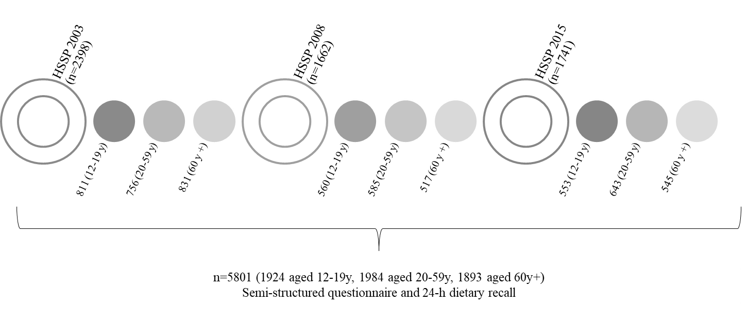

Supplementary Figure 1. Flow diagram of the study participants.
HSSP, Health Survey of São Paulo; y, years

