Table S1: Multivariable linear regression analysis of the determinants of plasma homocysteine, with plasma homocysteine as a continuous dependant variable, examining the effect of MTHFR C677T genotype (n=4006)
Variable | Effect (95% CI) |  | p-value †
Demographic characteristics
Age (rcs, three knots) |  |  | 0.0024
34 versus 27 years | -0.034 | (-0.095, 0.026)
Race |  |  | <0.0001
Caucasian | Reference
African | -0.087 | (-0.336, 0.163)
Middle eastern | -0.397 | (-0.594, -0.200)
Asian | -0.421 | (-0.574, -0.267)
Other | -0.407 | (-0.707, -0.107)
Education |  |  | 0.5001
College/University completed versus less than completed | 0.036 | (-0.068, 0.140)
Health indicators
BMI (rcs, three knots) |  |  | 0.0078
27.3 versus 21.1 kg/m² | -0.098 | (-0.167, -0.028)
Diabetes |  |  | 0.3769
Yes versus no | -0.142 | (-0.456, 0.173)
Chronic hypertension |  |  | 0.0029
Yes versus no | 0.524 | (0.180, 0.869)
Pregnancy characteristics
Nulliparous |  |  | 0.0468
Yes versus no | 0.099 | (0.001, 0.196)
Smoking |  |  | <0.0001
No | Reference
Second-hand | 0.204 | (-0.190, 0.599)
Med/light smoker (<10 cigarettes per day) | 0.406 | (0.226, 0.587)
Heavy smoker (>10 cigarettes per day) | 0.991 | (0.765, 1.216)
Hormonal birth control prior to conception |  |  | 0.1184
No | Reference
Oral | -0.084 | (-0.172, 0.003)
Injection or IUD | 0.115 | (-0.199, 0.429)
History of PMC (Preeclampsia, placental abruption, SGA, stillbirth/loss) |  |  | 0.0136
Yes versus no | -0.158 | (-0.283, -0.032)
Folic acid supplementation |  |  | 0.3292
None | Reference
>0 and <1 mg | -0.043 | (-0.232, 0.146)
>1 mg | -0.115 | (-0.323, 0.093)
Homocysteine metabolism
Gestational age at blood work (rcs, five knots) |  |  | <0.0001
13.4 versus 12.4 weeks | 0.018 | (-0.094, 0.130)
Serum folate*MTHFR genotype ‡ § |  |  | <0.0001
Serum folate (rcs, five knots) |  |  | <0.0001
TT: folate 45.1 versus 30.6 nmol/L | 0.304 | (0.011, 0.597)
CC/CT: folate 45.1 versus 30.6 nmol/L | 0.051 | (-0.055, 0.158)
MTHFR genotype |  |  | <0.0001
CC/ CT (wild type/ heterozygous) | Reference
TT (homozygous) | 0.106 | (-0.125, 0.337)
† Wald test of most meaningful hypotheses, pooled across multiple imputation data sets
‡ Recessive model
§ Interaction effect (Factor + higher order factors)

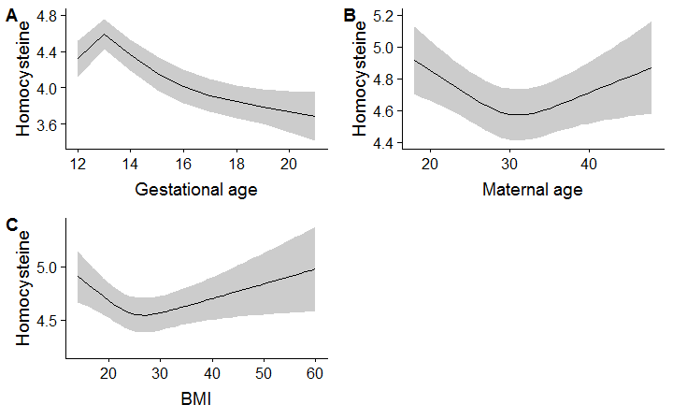
Figure S1: For the multivariable model reported in Table S1, associations between homocysteine and continuous variables modeled as a restricted cubic spline: A) gestational age at blood work with five knots at 12.1, 12.4, 12.8, 13.4, and 19; B) maternal age with three knots at 24, 30, and 37; and C) BMI with three knots at 19.6, 23.5, and 32.2. Shaded area represents 95% CI.

Table S2: Multivariable linear regression analysis of the determinants of plasma homocysteine, with the dependent variable as a continuous z-score calculated from homocysteine mean and SD for gestational week at recruitment (n=7587)
Variable | Effect (95% CI) |  | p-value †
Demographic characteristics
Age (rcs, three knots) |  |  | 0.0014
34 versus 27 years | -0.014 | (-0.048, 0.021)
Race |  |  | <0.0001
Caucasian | Reference
African | -0.285 | (-0.438, -0.133)
Middle eastern | -0.348 | (-0.472, -0.225)
Asian | -0.365 | (-0.460, -0.270)
Other | -0.309 | (-0.475, -0.144)
Education |  |  | 0.4297
College/University completed versus less than completed | -0.024 | (-0.082, 0.035)
Health indicators
BMI (rcs, 3 knots) |  |  | 0.0082
27.3 versus 21.1 kg/m² | -0.059 | (-0.098, -0.021)
Diabetes |  |  | 0.6017
Yes versus no | -0.047 | (-0.225, 0.130)
Chronic hypertension |  |  | 0.0001
Yes versus no | 0.408 | (0.208, 0.609)
Pregnancy characteristics
Nulliparous |  |  | <0.0001
Yes versus no | 0.121 | (0.068, 0.173)
Smoking |  |  | <0.0001
No | Reference
Second-hand | 0.265 | (0.105, 0.425)
Med/light smoker (<10 cigarettes per day) | 0.324 | (0.228, 0.420)
Heavy smoker (>10 cigarettes per day) | 0.682 | (0.556, 0.808)
Hormonal birth control prior to conception |  |  | 0.2208
No | Reference
Oral | -0.033 | (-0.082, 0.016)
Injection or IUD | 0.072 | (-0.070, 0.214)
History of PMC (Preeclampsia, placental abruption, SGA, stillbirth/loss) |  |  | 0.0170
Yes versus no | -0.089 | (-0.161, -0.016)
Folic acid supplementation |  |  | <0.0001
No | Reference
>0 and < 1 mg | -0.251 | (-0.356, -0.147)
>1 mg | -0.268 | (-0.386, -0.151)
Homocysteine metabolism
Gestational age at blood work (linear) |  |  | 0.5637
13.4 versus 12.4 weeks | -0.004 | (-0.017, 0.009)
Serum folate (rcs, five knots) |  |  | <0.0001
45.1 versus 30.6 nmol/L | 0.106 | (0.048, 0.164)
† Wald test of most meaningful hypotheses, pooled across multiple imputation datasets

Table S3: Multivariable logistic regression analysis of the determinants of plasma homocysteine, with the binary dependent variable as plasma homocysteine greater than the 90th percentile for gestational week at recruitment (n=7587)
Variable | Effect (95% CI) |  | p-value †
Demographic characteristics
Age (linear) |  |  | 0.4675
34 versus 27 years | 0.966 | (0.881, 1.060)
Race |  |  | <0.0001
Caucasian | Reference
African | 0.511 | (0.318, 0.822)
Middle eastern | 0.416 | (0.265, 0.653)
Asian | 0.491 | (0.357, 0.676)
Other | 0.565 | (0.335, 0.953)
Education |  |  | 0.4195
College/University completed versus less than completed | 0.939 | (0.806, 1.094)
Health indicators
BMI (rcs, three knots) |  |  | 0.0356
27.3 versus 21.1 kg/m² | 0.880 | (0.794, 0.976)
Diabetes |  |  | 0.1742
Yes versus no | 1.371 | (0.870, 2.162)
Chronic hypertension |  |  | 0.0010
Yes versus no | 2.215 | (1.377, 3.565)
Pregnancy characteristics
Nulliparous |  |  | 0.0012
Yes versus no | 1.268 | (1.098, 1.465)
Smoking |  |  | <0.0001
No | Reference
Second-hand | 1.409 | (0.953, 2.082)
Med/light smoker (<10 cigarettes per day) | 1.666 | (1.323, 2.098)
Heavy smoker (>10 cigarettes per day) | 2.346 | (1.761, 3.125)
Hormonal birth control prior to conception |  |  | 0.0563
No | Reference
Oral | 0.858 | (0.749, 0.982)
Injection or IUD | 1.118 | (0.787, 1.590)
History of PMC (Preeclampsia, placental abruption, IUGR, stillbirth, loss) |  |  | 0.1605
Yes versus no | 0.862 | (0.700, 1.061)
Folic acid supplementation |  |  | 0.0003
Yes versus no | 0.626 | (0.486, 0.807)
Homocysteine metabolism
Gestational age at blood work (rcs, four knots) |  |  | <0.0001
13.4 versus 12.4 weeks | 0.702 | (0.612, 0.804)
Serum folate (rcs, 5 knots) |  |  | <0.0001
45.3 versus 30.7 nmol/L | 1.038 | (0.883, 1.220)
† Wald test of most meaningful hypotheses, pooled across multiple imputation datasets

