SUPPLEMENTARY MATERIALS

S1- Supplementary Material 1

Final equation for the predictive model of severe food insecurity (SFI)

Ln(π_{i}/1-π_{i}) = -0.654 - 0.026 (Rondônia) + 0.571 (Acre) + 0.348 (Amazonas) + 0.515 (Roraima) + 0.856 (Pará) + 0.651 (Amapá) + 0.260 (Tocantins) + 1.083 (Maranhão) + 0.630 (Piauí) + 0.710 (Ceará) + 0.705 (Rio Grande do Norte) + 0.278 (Paraíba) + 0.176 (Pernambuco) + 0.657 (Alagoas) + 0.359 (Sergipe) + 0.702 (Bahia) + 0.112 (Minas Gerais) + 0.136 (Espírito Santo) + 0.033 (Rio de Janeiro) - 0.027 (São Paulo) - 0.129 (Paraná) - 0.276 (Rio Grande do Sul) + 0.41 (Mato Grosso do Sul) - 0.362 (Mato Grosso) + 0.448 (Goiás) + 0.101 (Distrito Federal) + 0.057 (total inhabitants) 0.290 (total rooms) + 0.308(rented house) + 0.131 (transferred house) + 1.091 (other housing conditions) – 0.494 (rural) – 0.003 (household income per capita) + 0.395 (female) – 0.136 (head of household 1 year of education) – 0.203 (head of household 2 years of education) – 0.314 (head of household 3 years of education) – 0.511 (head of household 4 years of education) – 0.637 (head of household 5 years of education) – 0.615 (head of household 6 years of education) – 0.698 (head of household 7 years of education) – 0.809 (head of household 8 years of education)– 0.947 (head of household 9 years of education) – 0.834 (head of household 10 years of education) – 1.227 (head of household 11 years of education) – 1.414 (head of household 12 years of education) – 0.950 (head of household 13 years of education) – 1.572 (head of household 14 years of education) – 1.224 (head of household 15 years or more of education) + 0.089 (head of household without occupation) + 0.104 (septic tank) + 0.401 (precarious sewer or none) + 0.242 (no electricity)

S2- Supplementary Material 2

Results of tests of model adequacy

Nagelkerke´s pseudo R² Test = 0,227

ROC curve = 0,835

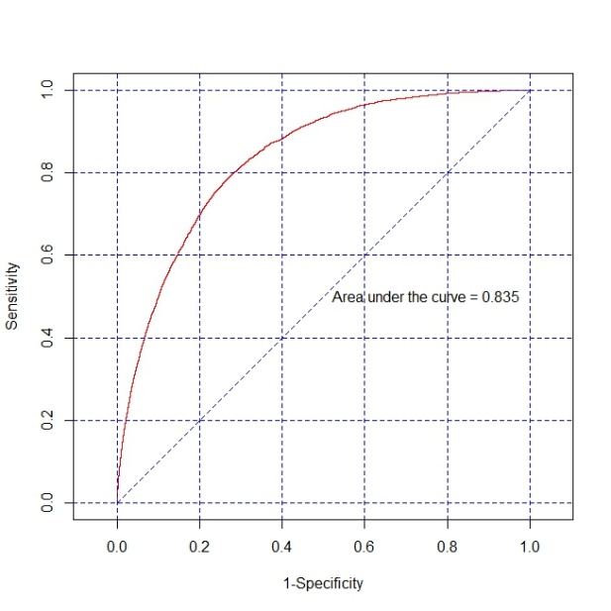
Graph 1 - S1: ROC curve of the final model for IAG prediction.
S3- Supplementary Material 3

Table 1 – S2. Average intake of energy and nutrients by sex, age group, and SFI quartile. Brazil, 2008-2009.

Sex/Age | Quartile 1 |  |  | Quartile 4 |  |  |  | Confidence Intervals 95%
 | N | Usual  Intake | SE* | N | Usual  Intake | SE* | Difference between Q1 and Q4 (%) | Q1 | Q4
ENERGY (kcal)
Female
10-18 | 548 | 2,097.2 | 52.9 | 1145 | 1,747.3 | 28.0 | -16.7 | 1993,5-2200,9 | 1692,4-1802,2
19-59 | 3080 | 1,786.3 | 14.1 | 2556 | 1,591.7 | 18.5 | -10.9 | 1758,7-1813,9 | 1555,4-1628,0
≥ 60 | 630 | 1,580.8 | 42.8 | 444 | 1,454.7 | 25.1 | -8.0† | 1496,9-1664,7 | 1405,5-1503,9
Male
10-18 | 539 | 2,278.6 | 7.0 | 1214 | 1,837.2 | 50.0 | -19.4 | 2264,9-2292,3 | 1739,2-1935,2
19-59 | 2885 | 2,241.6 | 23.5 | 2250 | 1,969.9 | 31.4 | -12.1 | 2195,5-2287,7 | 1908,4-2031,4
≥ 60 | 570 | 1,987.3 | 41.1 | 330 | 1,729.8 | 39.3 | -13.0 | 1906,7-2067,9 | 1652,8-1806,8
PROTEINS (g)
Female
10-18 | 548 | 79.1 | 2.2 | 1145 | 70.1 | 1.3 | -11.4 | 74,8-83,4 | 67,6-72,6
19-59 | 3080 | 74.2 | 0.4 | 2556 | 67.7 | 1.1 | -8.8 | 73,4-75,0 | 65,5-69,9
≥ 60 | 630 | 67.4 | 1.6 | 444 | 67.5 | 3.0 | +0.1† | 64,3-70,5 | 61,6-73,4
Male
10-18 | 539 | 87.3 | 2.3 | 1214 | 74.8 | 1.7 | -14.3 | 82,8-91,8 | 71,5-78,1
19-59 | 2885 | 94.8 | 0.5 | 2250 | 88.1 | 1.4 | -7.1 | 93,8-95,8 | 85,4-90,8
≥ 60 | 570 | 87.2 | 1.9 | 330 | 78.2 | 2.1 | -10.3 | 83,5-90,9 | 74,1-82,3
CARBOHYDRATES (g)
Female
10-18 | 548 | 292.6 | 6.3 | 1145 | 249.6 | 5.8 | -14.7 | 280,3-304,9 | 238,2-261,0
19-50 | 3080 | 244.1 | 2.4 | 2556 | 225.5 | 2.8 | -7.6 | 239,4-248,8 | 220,0-231,0
≥ 60 | 630 | 220.7 | 5.6 | 444 | 203.5 | 2.5 | -7.8 | 209,7-231,7 | 198,6-208,4
Male
10-18 | 539 | 313.8 | 6.2 | 1214 | 265.2 | 7.4 | -15.5 | 301,6-326,0 | 250,7-279,7
19-50 | 2885 | 298.8 | 3.6 | 2250 | 273.9 | 5.1 | -8.3 | 291,7-305,9 | 263,9-283,9
≥ 60 | 570 | 267.4 | 6.3 | 330 | 237.0 | 4.5 | -11.4 | 255,1-279,7 | 228,2-245,8
TOTAL LIPIDS (g)
Female
10-18 | 548 | 69.6 | 2.1 | 1145 | 51.2 | 0.8 | -26.4 | 65,5-73,7 | 49,6-52,8
19-59 | 3080 | 57.5 | 0.8 | 2556 | 45.3 | 0.6 | -21.2 | 55,9-59,1 | 44,1-46,5
≥ 60 | 630 | 49.2 | 1.7 | 444 | 39.9 | 1.5 | -18.9 | 45,9-52,5 | 37,0-42,8
Male
10-18 | 539 | 75.4 | 2.1 | 1214 | 50.8 | 1.8 | -32.6 | 71,3-79,5 | 47,3-54,3
19-59 | 2885 | 71.3 | 0.9 | 2250 | 53.4 | 0.9 | -25.1 | 69,5-73,1 | 51,6-55,2
≥ 60 | 570 | 61.3 | 1.3 | 330 | 48.0 | 1.3 | -21.7 | 58,8-63,8 | 45,5-50,5
FIBER (g)
Female
10-18 | 548 | 17.5 | 0.5 | 1145 | 18.3 | 0.3 | +4.6† | 16,5-18,1 | 17,7-18,9
19-59 | 3080 | 17.8 | 0.2 | 2556 | 17.6 | 0.2 | -1.1† | 17,4-18,2 | 17,2-18,0
≥ 60 | 630 | 18.1 | 0.2 | 444 | 16.6 | 0.4 | -8.3 | 17,7-18,9 | 15,8-17,4
Male
10-18 | 539 | 20.3 | 0.8 | 1214 | 20.2 | 0.4 | -0.5† | 18,7-21,1 | 19,4-21,0
19-59 | 2885 | 21.9 | 0.3 | 2250 | 22.8 | 0.3 | +4.1† | 21,3-22,5 | 22,2-23,4
≥ 60 | 570 | 21.8 | 1.2 | 330 | 20.3 | 0.5 | -6.9† | 19,4-22,8 | 19,3-21,3
* SE = standard error
† Difference between the average consumption of quartile 1 and 4 was not significant - 95% CI

