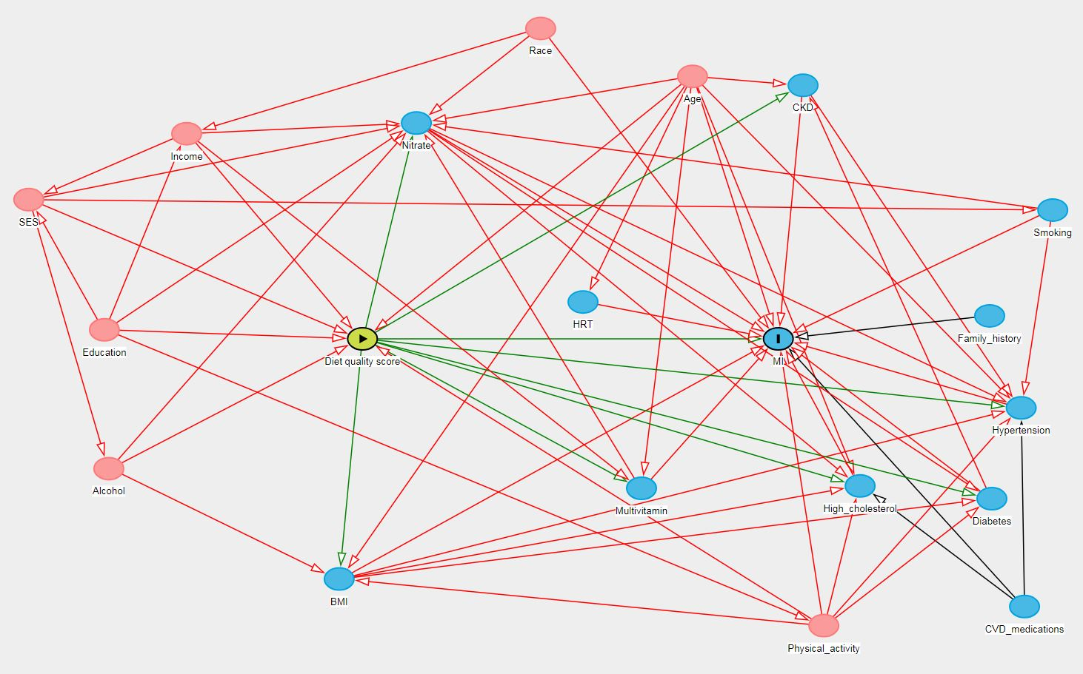
Supplementary Figure 1. Directed Acyclic Graph (DAG) for identification of co-variate selection. Variables highlighted in pink are confounding the relationship between diet quality and cardiovascular disease. These confounding variables include: Race, Age, Income, SES, education, alcohol and physical activity. All confounding variables have been considered in our multi-variate model, except alcohol as it has been considered already with the use of diet quality scores.

Table S1. Criteria for calculating the Australian Recommended Food Score (ARFS)
ARFS  sub-group | DQSE item | Level of Intake | Scoring
Vegetables (max score=22) | How many serves of vegetables/d | > 4 serves /d | 1
 |  | ≤ 4 serves/d | 0
 | Potato | >1 serve/wk | 1
 |  | ≤1 serve/wk | 0
 | Tomato sauce | >1 serve/wk | 1
 |  | ≤1 serve/wk | 0
 | Fresh/tinned tomato | >1 serve/wk | 1
 |  | ≤1 serve/wk | 0
 | Capsicum | >1 serve/wk | 1
 |  | ≤1 serve/wk | 0
 | Lettuce/salad greens | >1 serve/wk | 1
 |  | ≤1 serve/wk | 0
 | Cucumber | >1 serve/wk | 1
 |  | ≤1 serve/wk | 0
 | Celery | >1 serve/wk | 1
 |  | ≤1 serve/wk | 0
 | Beetroot | >1 serve/wk | 1
 |  | ≤1 serve/wk | 0
 | Carrot | >1 serve/wk | 1
 |  | ≤1 serve/wk | 0
 | Cabbage/ Brussel sprouts | >1 serve/wk | 1
 |  | ≤1 serve/wk | 0
 | Cauliflower | >1 serve/wk | 1
 |  | ≤1 serve/wk | 0
 | Broccoli | >1 serve/wk | 1
 |  | ≤1 serve/wk | 0
 | Spinach | >1 serve/wk | 1
 |  | ≤1 serve/wk | 0
 | Peas | >1 serve/wk | 1
 |  | ≤1 serve/wk | 0
 | Green Beans | >1 serve/wk | 1
 |  | ≤1 serve/wk | 0
 | Beans/Bean spouts | >1 serve/wk | 1
 |  | ≤1 serve/wk | 0
 | Pumpkin | >1 serve/wk | 1
 |  | ≤1 serve/wk | 0
 | Onions | >1 serve/wk | 1
 |  | ≤1 serve/wk | 0
 | Garlic | >1 serve/wk | 1
 |  | ≤1 serve/wk | 0
 | Mushrooms | >1 serve/wk | 1
 |  | ≤1 serve/wk | 0
 | Zucchini | >1 serve/wk | 1
 |  | ≤1 serve/wk | 0
Fruit  (max score=14) | How many serves of fruit/d | > 2 serves /d | 1
 |  | ≤ 2 serves/d | 0
 | Fruit Juice | >1 serve/wk | 1
 |  | ≤1 serve/wk | 0
 | Tinned/frozen fruit | >1 serve/wk | 1
 |  | ≤1 serve/wk | 0
 | Oranges | >1 serve/wk | 1
 |  | ≤1 serve/wk | 0
 | Apples | >1 serve/wk | 1
 |  | ≤1 serve/wk | 0
 | Pears | >1 serve/wk | 1
 |  | ≤1 serve/wk | 0
 | Banana | >1 serve/wk | 1
 |  | ≤1 serve/wk | 0
 | Melon | >1 serve/wk | 1
 |  | ≤1 serve/wk | 0
 | Pineapple | >1 serve/wk | 1
 |  | ≤1 serve/wk | 0
 | Strawberries | >1 serve/wk | 1
 |  | ≤1 serve/wk | 0
 | Apricots | >1 serve/wk | 1
 |  | ≤1 serve/wk | 0
 | Peaches | >1 serve/wk | 1
 |  | ≤1 serve/wk | 0
 | Mango | >1 serve/wk | 1
 |  | ≤1 serve/wk | 0
 | Avocado | >1 serve/wk | 1
 |  | ≤1 serve/wk | 0
Grains  (max score=14) | Consume high fiber white bread | Yes | 1
 |  | No | 0
 | Consume wholemeal bread | Yes | 1
 |  | No | 0
 | Consume rye bread | Yes | 1
 |  | No | 0
 | Consume multi-grain bread | Yes | 1
 |  | No | 0
 | How many slices of bread/d | ≥4 slices/d | 1
 |  | <4 slices/d | 0
 | All bran | >1 serve/wk | 1
 |  | ≤1 serve/wk | 0
 | Sultana bran | >1 serve/wk | 1
 |  | ≤1 serve/wk | 0
 | Weetbix | >1 serve/wk | 1
 |  | ≤1 serve/wk | 0
 | Rice | >1 serve/wk | 1
 |  | ≤1 serve/wk | 0
 | Pasta/Noodles | >1 serve/wk | 1
 |  | ≤1 serve/wk | 0
 | Vegemite | >1 serve/wk | 1
 |  | ≤1 serve/wk | 0
 | Cornflakes | >1 serve/wk | 1
 |  | ≤1 serve/wk | 0
 | Porridge | >1 serve/wk | 1
 |  | ≤1 serve/wk | 0
 | Muesli | >1 serve/wk | 1
 |  | ≤1 serve/wk | 0
Dairy  (max score=7) | Consume reduced fat or skim milk | Yes | 1
 |  | No | 0
 | Consume soy milk | Yes | 1
 |  | No | 0
 | Consume low fat cheese | Yes | 1
 |  | No | 0
 | How much milk/d | >500 ml/d | 1
 |  | ≤500 ml/d | 0
 | Cheese | <1 serve/wk | 1
 |  | ≥1 serve/wk | 0
 | Ice-cream | <1 serve/wk | 1
 |  | ≥1 serve/wk | 0
 | Yoghurt | >1 serve/wk | 1
 |  | ≤1 serve/wk | 0
Nuts/beans/soy/egg (max score=7) | Nuts | >1 serve/wk | 1
 |  | ≤1 serve/wk | 0
 | Peanut Butter | >1 serve/wk | 1
 |  | ≤1 serve/wk | 0
 | Baked beans | >1 serve/wk | 1
 |  | ≤1 serve/wk | 0
 | Soy/tofu | >1 serve/wk | 1
 |  | ≤1 serve/wk | 0
 | Soy milk | Yes | 1
 |  | No | 0
 | Other Beans | >1 serve/wk | 1
 |  | ≤1 serve/wk | 0
 | Eggs | 1-5 eggs/wk | 1
 |  | <1 or >5 eggs/wk | 0
Meat  (max score=5) | Beef | 1-4 serves/wk | 1
 |  | <1 or >4 serves/wk | 0
 | Veal | 1-4 serves/wk | 1
 |  | <1 or >4 serves/wk | 0
 | Lamb | 1-4 serves/wk | 1
 |  | <1 or >4 serves/wk | 0
 | Pork | 1-4 serves/wk | 1
 |  | <1 or >4 serves/wk | 0
 | Chicken | 1-4 serves/wk | 1
 |  | <1 or >4 serves/wk | 0
Fish  (max score=2) | Fish | 1-4 serves/wk | 1
 |  | <1 or >4 serves/wk | 0
 | Tinned Fish | 1-4 serves/wk | 1
 |  | <1 or >4 serves/wk | 0
Fat  (max score=1) | Consume Poly-unsaturated, Mono-unsaturated spread or do not use spread | Yes | 1
 |  | No | 0
Alcohol  (max score=2) | How often is alcohol consumed | 1-4 days/wk | 1
 |  | <1 or >4 days/wk | 0
 | How many when alcohol is consumed | 1-2 standard drinks | 1
 |  | <1 or >2 standard drinks | 0

Table S2. Criteria for calculating the Mediterranean Diet Score (MDS)
Food Group | Level of Intake | Scoring
Vegetables | >250 gm/d | 2
 | 100-250 gm/d | 1
 | <100 gm/d | 0
Fruit and Nuts | >300 gm/d | 2
 | 150-300 gm/d | 1
 | <150 gm/d | 0
Legumes | >140 gm/d | 2
 | 70-140 gm/d | 1
 | <70 gm/d | 0
Grains | >195 gm/d | 2
 | 130-195 gm/d | 1
 | <130 gm/d | 0
Meat | >120 gm/d | 0
 | 80-120 gm/d | 1
 | <80 gm/d | 2
Fish | >250 gm/d | 2
 | 100-250 gm/d | 1
 | <100 gm/d | 0
Dairy | >270 gm/d | 1
 | 180-270 gm/d | 2
 | <180 gm/d | 0
Alcohol | >24 gm/d | 0
 | 12-24 gm/d | 2
 | <12 gm/d | 1
Use Mono-unsaturated fat | Yes | 1
 | No | 0

