Supplementary Material – Preliminary Scales/Items and Final Survey
Supplemental Table 1. Item Response Theory parameters and descriptives for the items in the preliminary fruit and vegetable barriers scale
Item | Slope parameter | Threshold parameter spread | Mean ± SD | Percent missing | Item Information Curve (IIC)
1. FV too much time to prepare | 2.09 | -0.51-4.32 | 2.19 ± 1.28 | 1.22 | 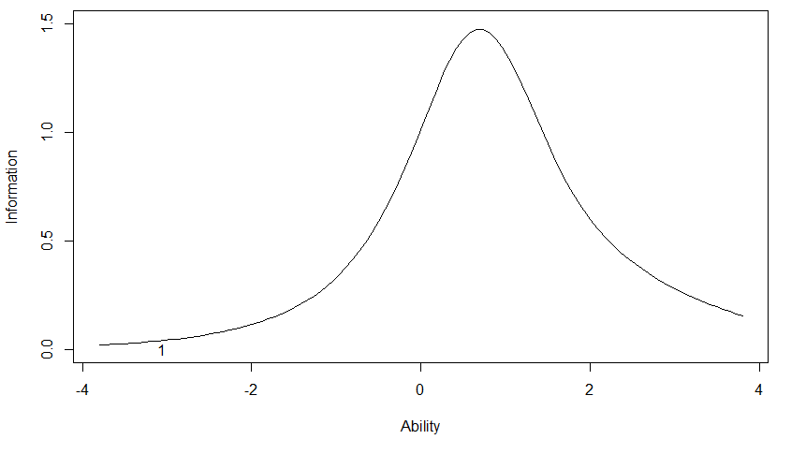
2. Don’t know how to choose fresh FV | 2.76 | -0.51-5.28 | 2.08 ± 1.21 | 2.03 | 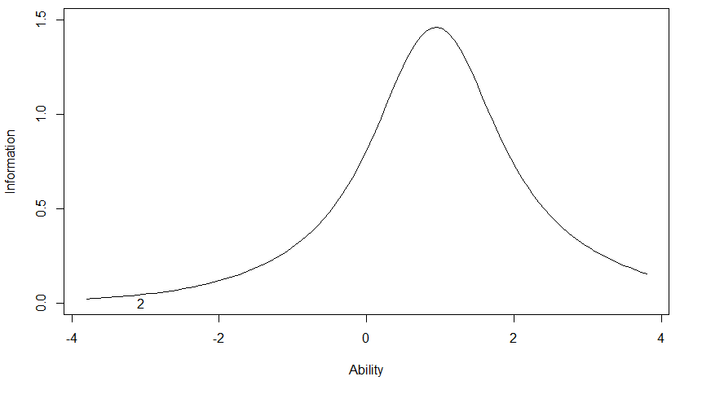
3. Don’t know how to cook FV | 2.21 | -0.29-4.60 | 1.95 ± 1.15 | 0.00 | 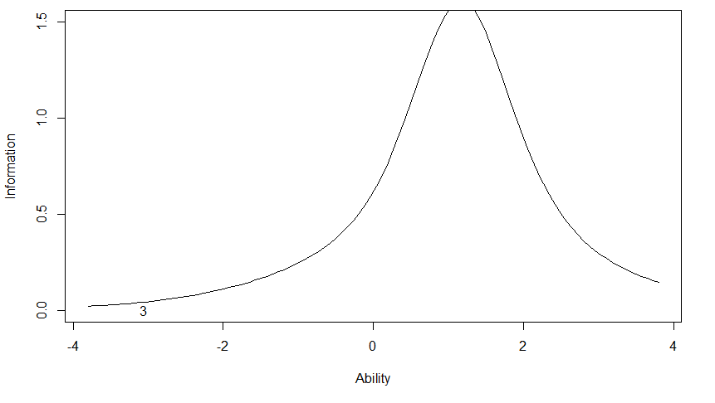
4. FV are not filling | 3.02 | -1.44-5.94 | 2.06 ± 1.15 | 0.81 | 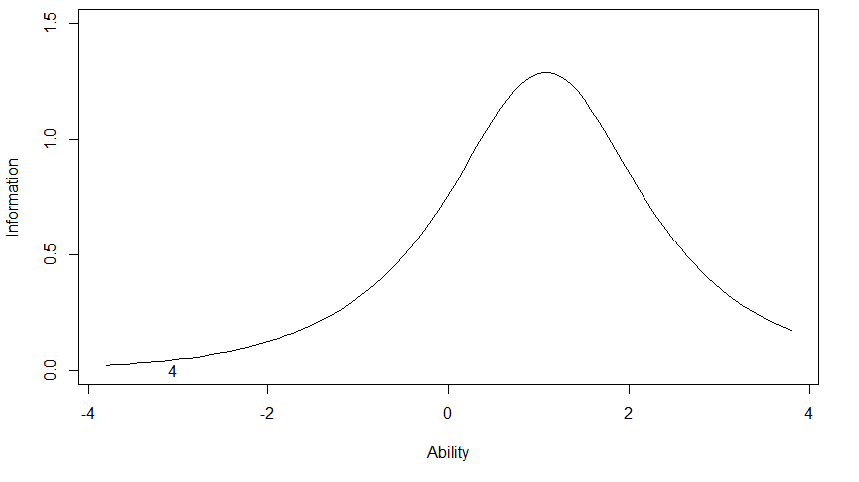
5. Restaurants don’t serve FV | 2.06 | -1.44-5.15 | 2.24 ± 1.10 | 4.48 | 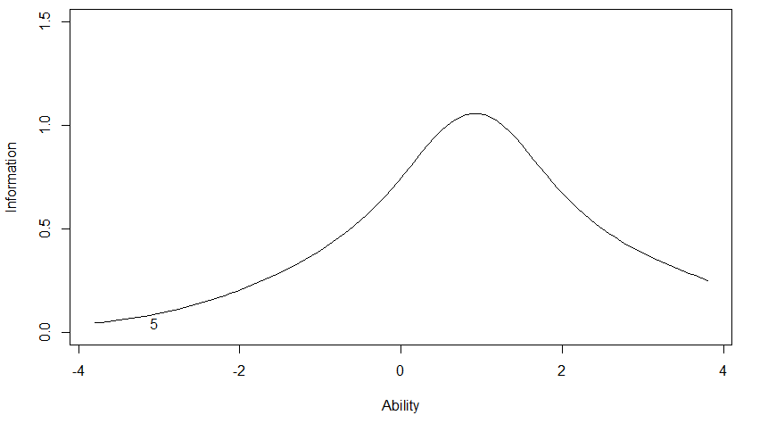
6. Fruits contain too much sugar | 1.45 | -1.25-4.00 | 2.23 ± 1.09 | 5.28 | 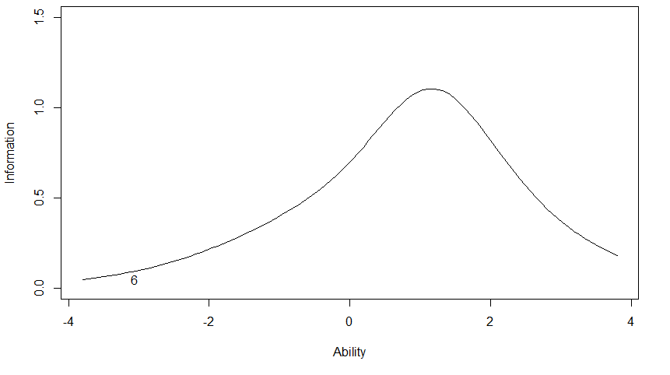
7. Don’t think of FV | 2.04 | -1.37-4.17 | 2.37 ± 1.24 | 5.28 | 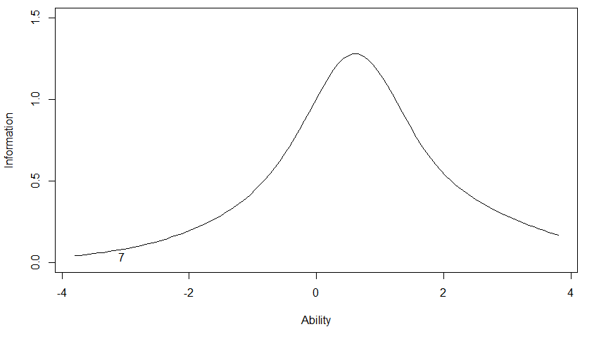
8. FV cost too much | 1.26 | -1.42-3.07 | 2.61 ± 1.28 | 8.94 | 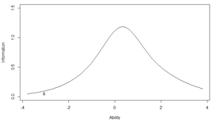

Supplemental Table 2. Item Response Theory parameters and descriptives for the items in the preliminary attitudes on food pantry fruits and vegetables scale
Item | Slope parameter | Threshold parameter spread | Mean ± SD | Percent missing | Item Information Curve (IIC)
9. Enjoy new FV at food pantry | 1.53 | -4.23-1.39 | 3.91 ± 0.98 | 2.03 | 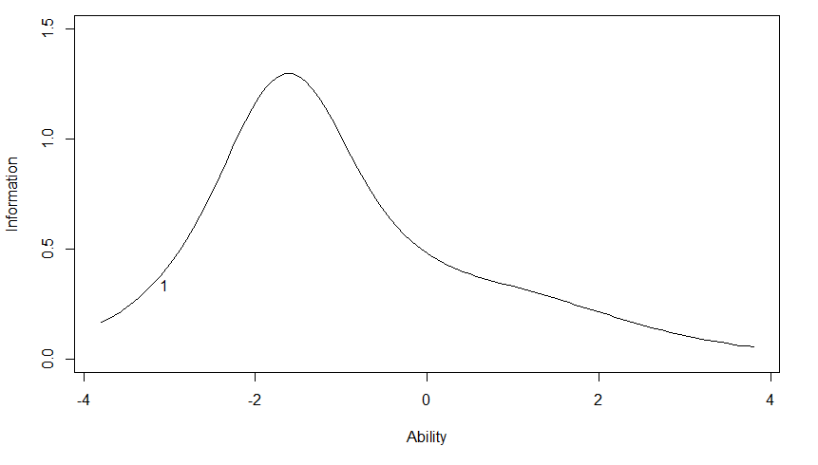
10. Familiar with FV at food pantry | 1.87 | -5.19-1.99 | 3.81 ± 0.93 | 2.85 | 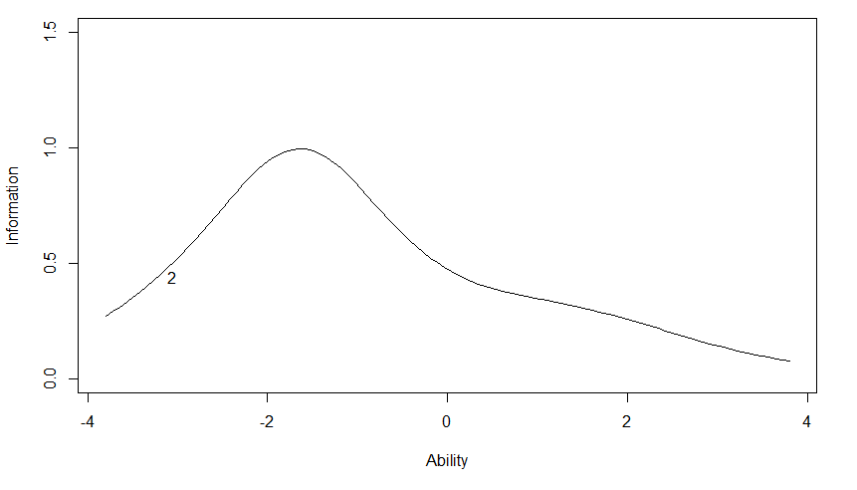
11. Trust FV at food pantry | 3.71 | -7.95-2.69 | 3.93 ± 0.87 | 2.03 | 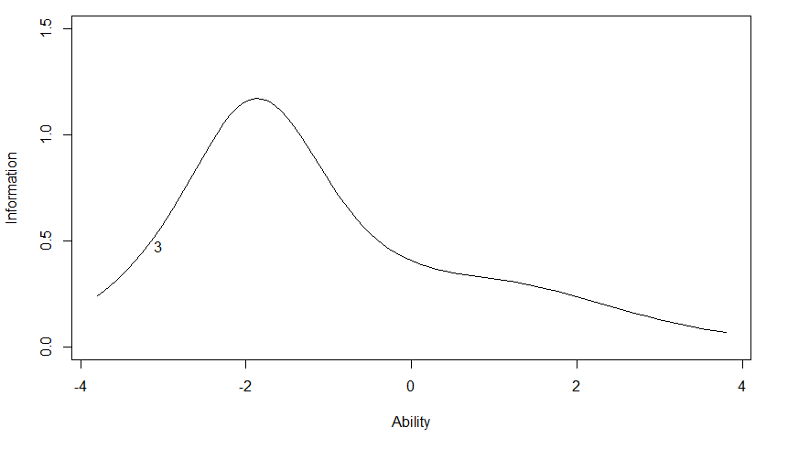
12. FV are of good quality at food pantry | 3.68 | -8.45-2.27 | 3.95 ± 0.88 | 1.63 | 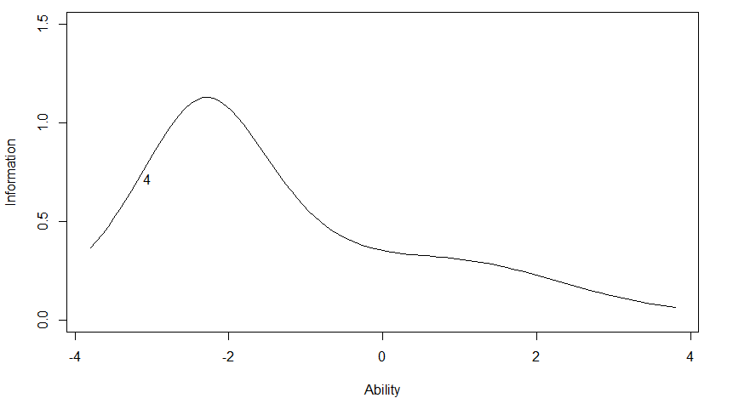
13. FV taste good at food pantry | 7.64 | -17.71- 4.69 | 4.03 ± 0.77 | 2.44 | 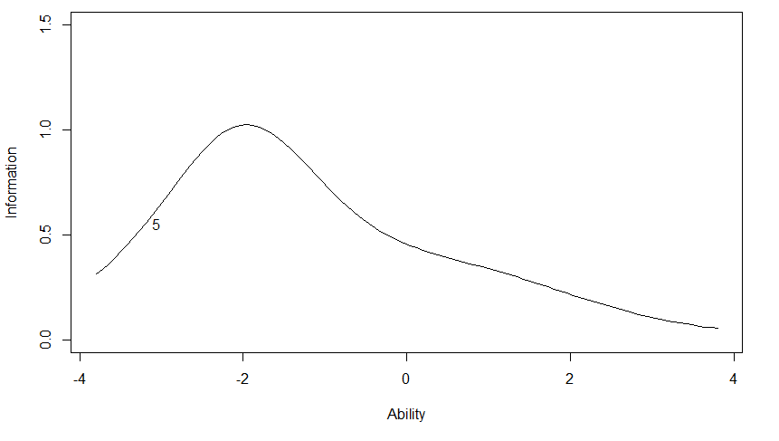
Family likes FV from food pantry (Excluded from final survey) | 0.76 | -2.86-1.06 | 3.66 ± 1.20 | 3.66 | 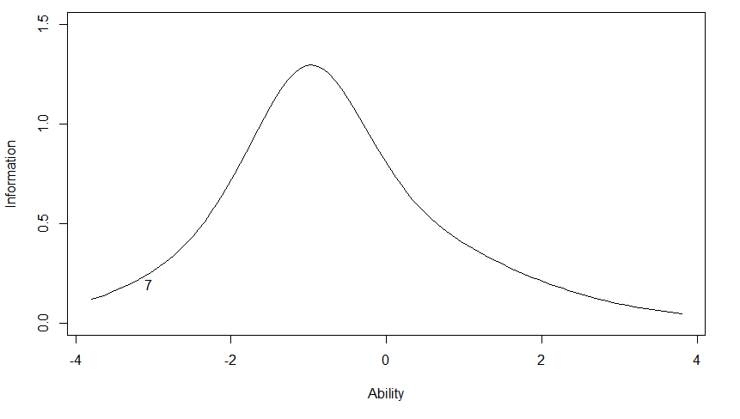
FV don’t spoil before eating from food pantry  (Excluded from final survey) | 0.90 | -3.62-1.94 | 3.35 ± 1.09 | 2.44 | 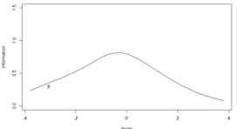

Supplemental Table 3. Item Response Theory parameters and descriptives for the items in the preliminary attitudes on grocery store fruits and vegetables scale
Item | Slope parameter | Threshold parameter spread | Mean ± SD | Percent missing | Item Information Curve (IIC)
14. Enjoy new FV at grocery store | 1.60 | -3.76-1.27 | 3.81 ± 1.08 | 0.00 | 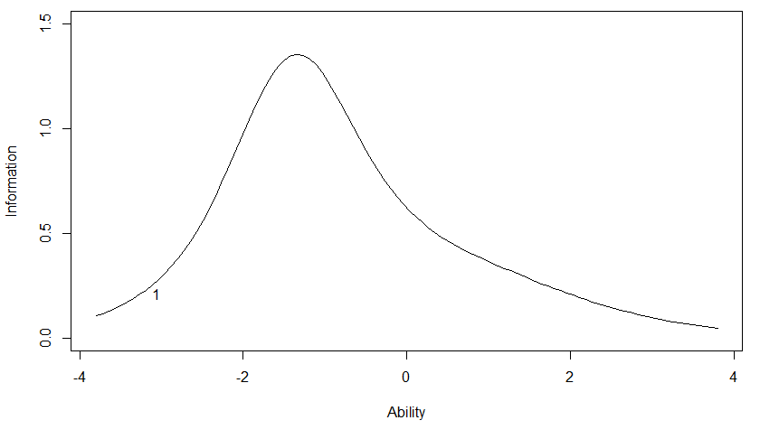
15. Familiar with FV at grocery store | 2.69 | -5.54- 2.07 | 3.85 ± 0.97 | 3.66 | 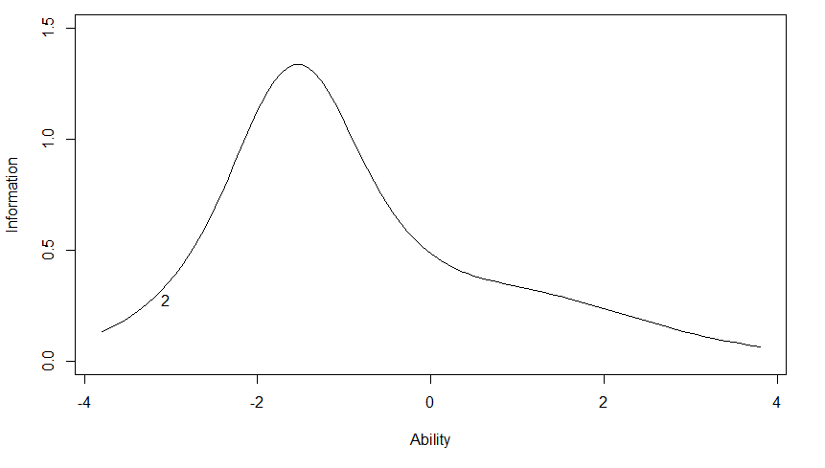
16. Trust FV at grocery store | 3.57 | -6.61-3.06 | 3.73 ± 1.01 | 0.41 | 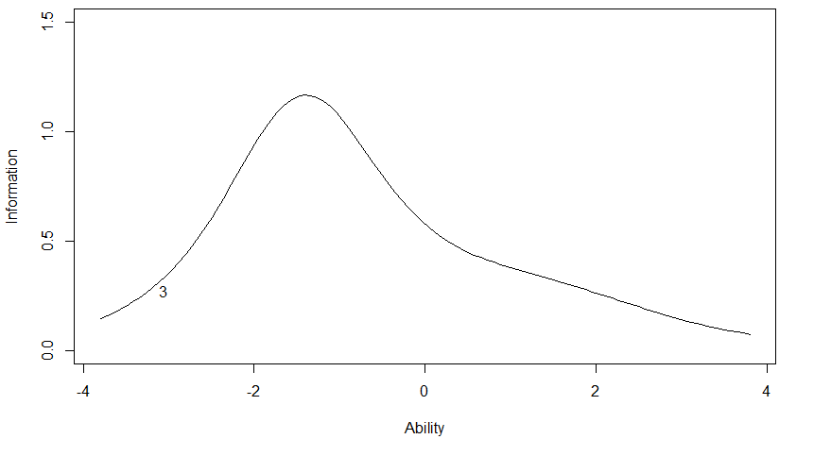
17. FV are of good quality at grocery store | 4.15 | -8.43-3.27 | 3.78 ± 0.96 | 0.41 | 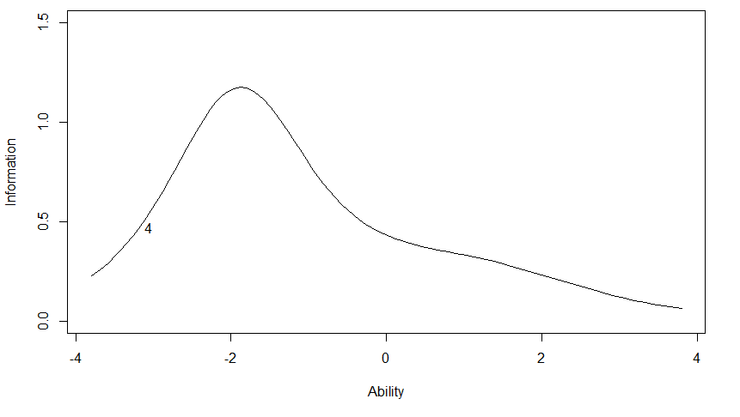
18. FV taste good at grocery store | 2.26 | -5.57-1.86 | 3.94 ± 0.86 | 6.91 | 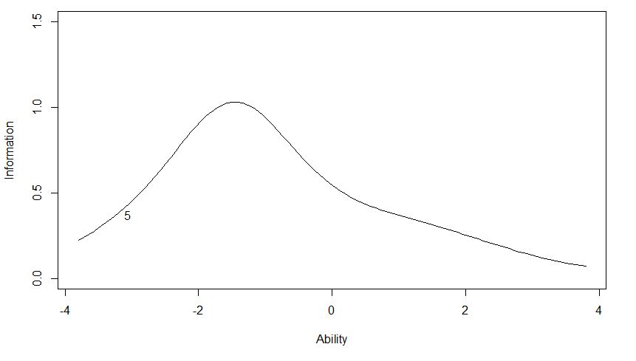
Family likes FV from grocery store  (Excluded from final survey) | 0.63 | -3.60-0.66 | 3.91 ± 1.08 | 12.20 | 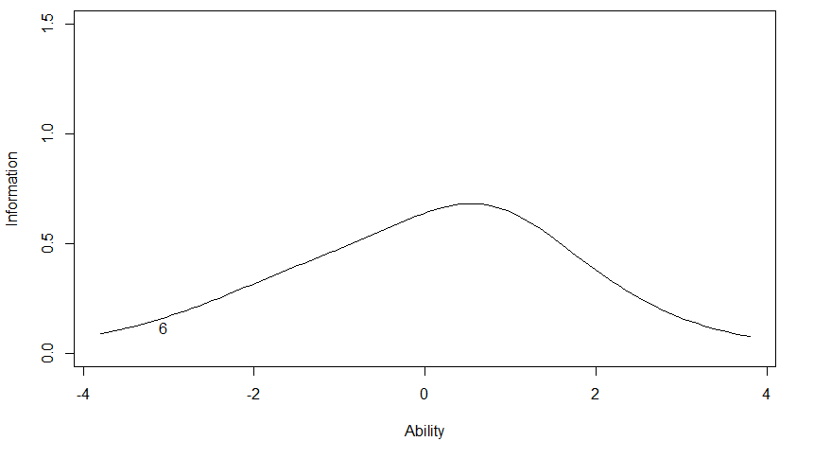
FV don’t spoil before eating from grocery store  (Excluded from final survey) | 0.21 | -2.28-2.06 | 3.03 ± 1.17 | 6.50 | 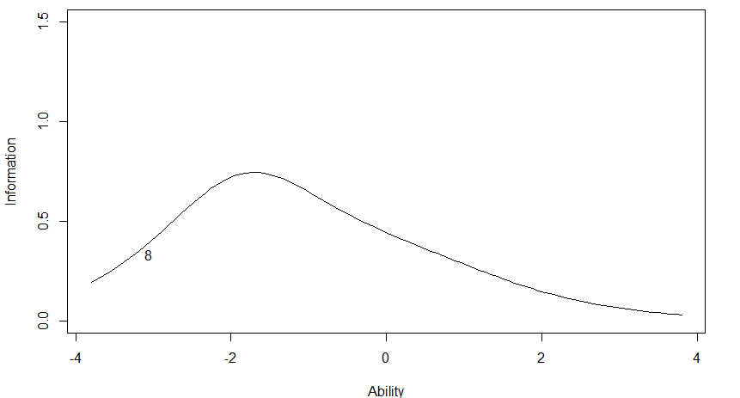

Supplemental Table 4. Item Response Theory parameters and descriptives for the preliminary healthy home food availability scale
Item | Slope parameter | Threshold parameter spread | Mean ± SD | Percent missing | Item Information Curve (IIC)
19. FV at home | 4.26 | -10.23-1.23 | 3.93 ± 1.05 | 1.22 | 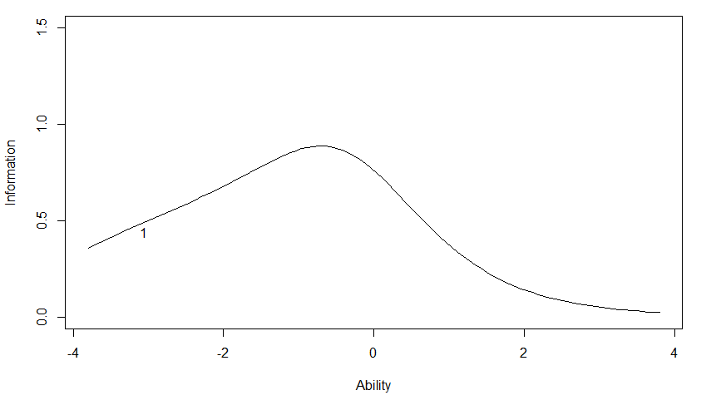
20. Lean meats at home | 1.78 | -4.65-0.96 | 3.89 ± 1.06 | 2.03 | 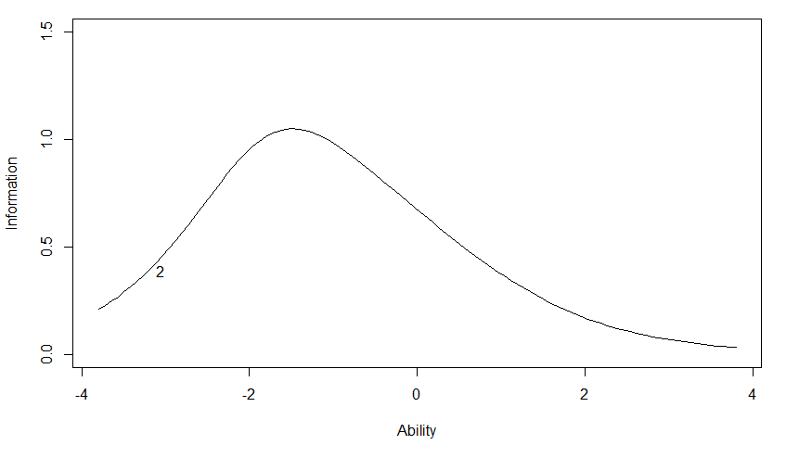
21. Whole grains at home | 1.46 | -3.37-1.15 | 3.56 ± 1.23 | 2.85 | 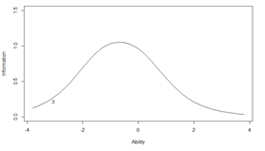

Supplemental Table 5. Item Response Theory parameters and descriptives for the preliminary unhealthy home food availability scale
Item | Slope parameter | Threshold parameter spread | Mean ± SD | Percent missing | Item Information Curve (IIC)
22. Sweets at home | 1.80 | -3.29-3.24 | 2.94 ± 1.08 | 2.85 | 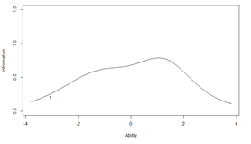
23. Sugary drinks at home | 3.28 | -2.45-4.39 | 2.66 ± 1.31 | 2.03 | 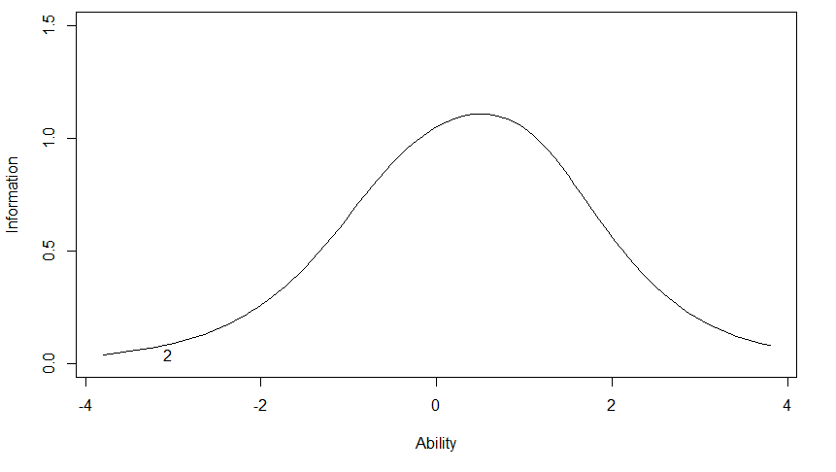
24. Regular chips at home | 2.57 | -3.04-4.18 | 2.72 ± 1.17 | 2.44 | 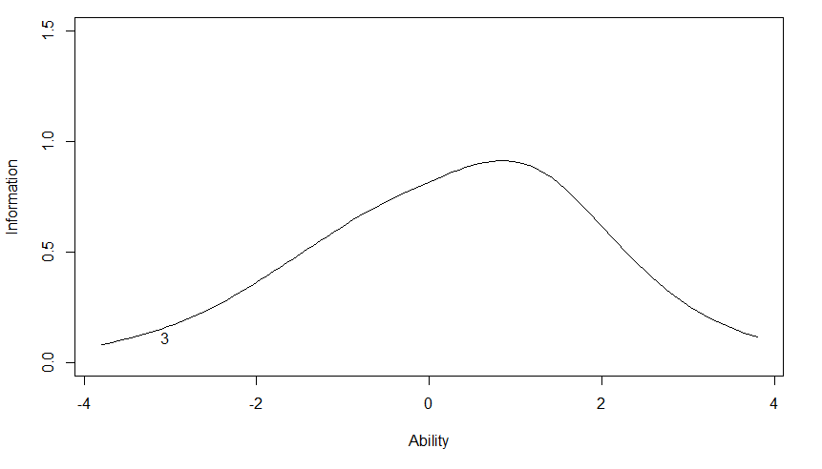

Supplemental Table 6. Item Response Theory parameters and descriptives for the healthy food pantry availability scale
Item | Slope parameter | Threshold parameter spread | Mean ± SD | Percent missing | Item Information Curve (IIC)
25. FV at pantry | 2.31 | -6.72-0.47 | 4.04 ± 1.00 | 2.44 | 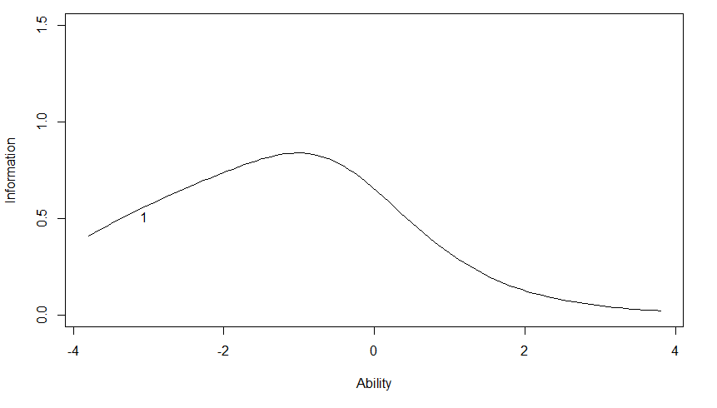
26. Lean meats at pantry | 2.80 | -5.23-1.08 | 3.85 ± 1.15 | 3.25 | 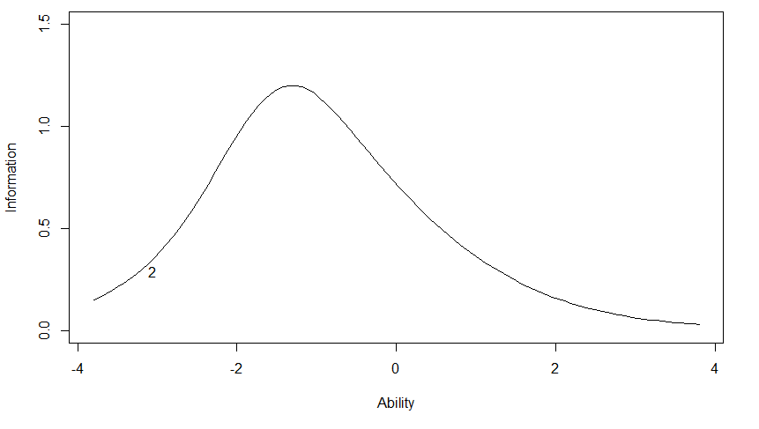
27. Whole grains at pantry | 2.83 | -6.35-0.98 | 3.91 ± 1.06 | 2.44 | 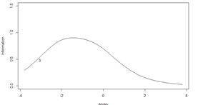

Supplemental Table 7. Item Response Theory parameters and descriptives for the unhealthy food pantry availability scale
Item | Slope parameter | Threshold parameter spread | Mean ± SD | Percent missing | Item Information Curve (IIC)
28. Sweets at pantry | 3.05 | -3.70-2.50 | 3.22 ± 1.30 | 2.85 | 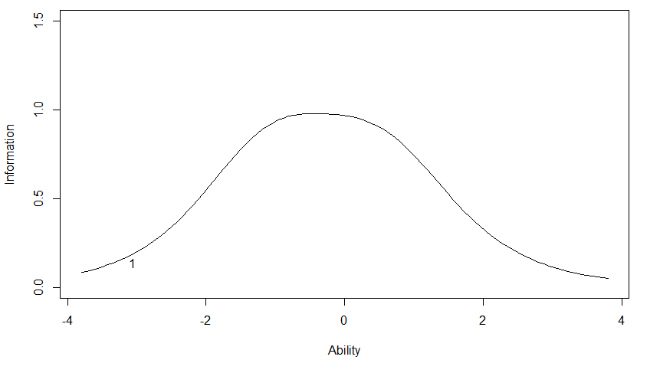
29. Sugary drinks at pantry | 6.36 | -5.60-5.79 | 2.87 ± 1.32 | 3.25 | 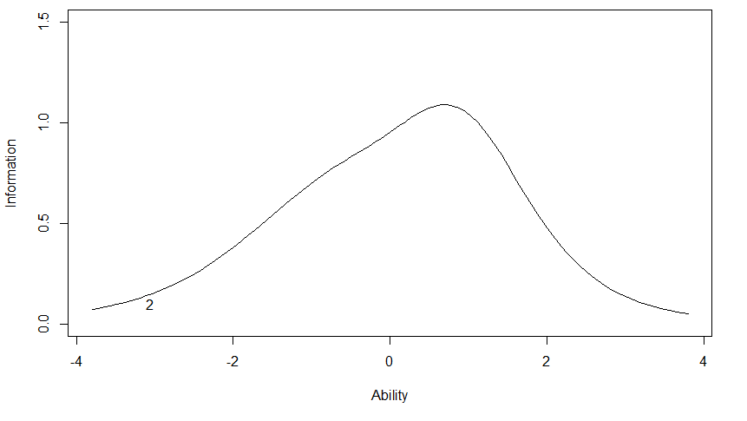
30. Regular chips at pantry | 3.81 | -3.38-4.06 | 2.75 ± 1.32 | 4.47 | 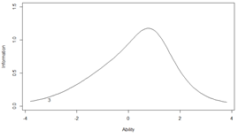

Final survey in English
Final FRESH Foods Survey items assessed in this study

PROMPT: The following questions ask about fruits and vegetables. There are lots of things that keep people from eating more fruits and vegetables. Please select how true each of these are for YOU.

1. I would eat more fruits and vegetables if they took less time to prepare.
- Strongly disagree
- Disagree
- Neither agree nor disagree
- Agree
- Strongly agree
- Does not apply to me

2. I would eat more fruits and vegetables if I knew how to choose FRESH fruits and vegetables.
- Strongly disagree
- Disagree
- Neither agree nor disagree
- Agree
- Strongly agree
- Does not apply to me

3. I would eat more fruits and vegetables if I knew how to cook or prepare them.
- Strongly disagree
- Disagree
- Neither agree nor disagree
- Agree
- Strongly agree
- Does not apply to me

4. I would eat more fruits and vegetables if they were more filling.
- Strongly disagree
- Disagree
- Neither agree nor disagree
- Agree
- Strongly agree
- Does not apply to me

5. I would eat more fruits and vegetables if the restaurants I go to would serve them.
- Strongly disagree
- Disagree
- Neither agree nor disagree
- Agree
- Strongly agree
- Does not apply to me

6. I would eat more fruits if they didn’t contain too much sugar for me.
- Strongly disagree
- Disagree
- Neither agree nor disagree
- Agree
- Strongly agree
- Does not apply to me

7. I would eat more fruits and vegetables if I thought about them more when looking for something to eat.
- Strongly disagree
- Disagree
- Neither agree nor disagree
- Agree
- Strongly agree
- Does not apply to me

8. I would eat more fruits and vegetables if they did not cost too much money.
- Strongly disagree
- Disagree
- Neither agree nor disagree
- Agree
- Strongly agree
- Does not apply to me

PROMPT: For the following questions, please think about THIS FOOD PANTRY or the place you are now. Please think back over your experiences here, and answer these questions for THIS FOOD PANTRY.

9. I enjoy trying NEW fruits and vegetables that I have not tried before from THIS FOOD PANTRY.
- Strongly disagree
- Disagree
- Neither agree nor disagree
- Agree
- Strongly agree
- Does not apply to me

10. The fruits and vegetables at THIS FOOD PANTRY are ones that I am used to eating.
- Strongly disagree
- Disagree
- Neither agree nor disagree
- Agree
- Strongly agree
- Does not apply to me

11. I trust the fruits and vegetables from THIS FOOD PANTRY.
- Strongly disagree
- Disagree
- Neither agree nor disagree
- Agree
- Strongly agree
- Does not apply to me

12. The fruits and vegetables at THIS FOOD PANTRY are of good quality.
- Strongly disagree
- Disagree
- Neither agree nor disagree
- Agree
- Strongly agree
- Does not apply to me

13. I think the fruits and vegetables from THIS FOOD PANTRY taste good.
- Strongly disagree
- Disagree
- Neither agree nor disagree
- Agree
- Strongly agree
- Does not apply to me

PROMPT: For the following questions, please think about the GROCERY STORE where you purchase most of your fruits and vegetables. This may include places such as supermarkets, corner stores, discount superstores, farmer’s markets, or similar stores.
DO NOT include food you received from a food pantry, feeding program, or a food bank.

14. I enjoy trying NEW fruits and vegetables from the GROCERY STORE.
- Strongly disagree
- Disagree
- Neither agree nor disagree
- Agree
- Strongly agree
- Does not apply to me

15. The fruits and vegetables at the GROCERY STORE are ones that I am used to eating.
- Strongly disagree
- Disagree
- Neither agree nor disagree
- Agree
- Strongly agree
- Does not apply to me

16. I trust the fruits and vegetables from the GROCERY STORE.
- Strongly disagree
- Disagree
- Neither agree nor disagree
- Agree
- Strongly agree
- Does not apply to me

17. The fruits and vegetables from the GROCERY STORE are of good quality.
- Strongly disagree
- Disagree
- Neither agree nor disagree
- Agree
- Strongly agree
- Does not apply to me

18. I think fruits and vegetables from the GROCERY STORE taste good.
- Strongly disagree
- Disagree
- Neither agree nor disagree
- Agree
- Strongly agree
- Does not apply to me

PROMPT: For the following questions, please think about the foods and drinks available IN YOUR HOME (or the place where you lived the most of the time) during the PAST THREE MONTHS.

19. FRUITS AND/OR VEGETABLES. COUNT fresh, frozen, canned, and dried fruit and/or vegetables.
- Never
- Rarely
- Sometimes
- Often
- Always

20. LEAN MEATS such as poultry (chicken, turkey, etc.), seafood (not fried), 90% or above lean ground beef, and canned chicken or tuna.
- Never
- Rarely
- Sometimes
- Often
- Always

21. WHOLE GRAINS such as 100% whole grain/whole wheat bread, oatmeal, whole grain/whole wheat pasta, and brown rice. DON’T COUNT white rice, regular pasta, or white bread.
- Never
- Rarely
- Sometimes
- Often
- Always

22. SWEETS like candy, cookies, cake, and ice cream.
- Never
- Rarely
- Sometimes
- Often
- Always

23. SUGARY DRINKS like regular soda, sports drinks, fruit drinks, sweetened teas, and other drinks with added sugar.
- Never
- Rarely
- Sometimes
- Often
- Always

24. Regular potato CHIPS, corn chips, or cheese puffs like Lays, Doritos, and Cheetos.
- Never
- Rarely
- Sometimes
- Often
- Always

PROMPT: During the PAST 3 MONTHS, how often were the following foods and drinks available at THIS FOOD PANTRY? Include all foods and drinks available whether you select them or not.

25. FRUITS AND/OR VEGETABLES. COUNT fresh, frozen, canned, and dried fruit and/or vegetables.
- Never
- Rarely
- Sometimes
- Often
- Always

26. LEAN MEATS such as poultry (chicken, turkey, etc.), seafood (not fried), 90% or above lean ground beef, and canned chicken or tuna.
- Never
- Rarely
- Sometimes
- Often
- Always

27. WHOLE GRAINS such as 100% whole grain/whole wheat bread, oatmeal, whole grain/whole wheat pasta, and brown rice. DON’T COUNT white rice, regular pasta, or white bread.
- Never
- Rarely
- Sometimes
- Often
- Always

28. SWEETS like candy, cookies, cake, and ice cream.
- Never
- Rarely
- Sometimes
- Often
- Always

29. SUGARY DRINKS like regular soda, sports drinks, fruit drinks, sweetened teas, and other drinks with added sugar.
- Never
- Rarely
- Sometimes
- Often
- Always

30. Regular potato CHIPS, corn chips, or cheese puffs like Lays, Doritos, and Cheetos.
- Never
- Rarely
- Sometimes
- Often
- Always

PROMPT: Please indicate how much you agree or disagree with the following statement.

31. I feel confident in my ability to eat fruits and vegetables every day.
- Strongly disagree
- Somewhat disagree
- Neither agree nor disagree
- Somewhat agree
- Strongly agree
- Does not apply to me

PROMPT: The following questions ask about what you DRANK DURING THE PAST week. Be sure to count what you drank at home, work, restaurants, or anywhere else.

32. DURING THE PAST WEEK, how many times did you drink SWEETENED FRUIT DRINKS and TEAS like Capri Sun, Sunny D, Arizona Tea, Kool-Aid, or other sweetened fruit drinks or teas.
DON’T COUNT 100% pure fruit juice or zero calorie or diet drinks.
- I did not drink any sweetened fruit drinks or teas during the past week
- 1-3 times in the past week
- 4-6 times in the past week
- 1 time a day
- 2 times a day
- 3 or more times a day

33. DURING THE PAST WEEK, how many times did you drink 100% PURE FRUIT JUICE like orange, apple, grape, or other 100% fruit juice.
DON’T COUNT fruit-flavored drinks with added sugar like Capri Sun, Sunny D, or other fruit-flavored drinks.
- I did not drink any 100% fruit juice during the past week
- 1-3 times in the past week
- 4-6 times in the past week
- 1 time a day
- 2 times a day
- 3 or more times a day

34. DURING THE PAST WEEK, how many times did you drink regular SODA or pop like Coke, Pepsi, Sprite, Dr. Pepper, or other regular soda?
DON’T COUNT diet or zero calorie sodas.
- I did not drink any soda or pop during the past week
- 1-3 times in the past week
- 4-6 times in the past week
- 1 time a day
- 2 times a day
- 3 or more times a day

35. DURING THE PAST WEEK, how many times did you drink ENERGY DRINKS like Rockstar, Red Bull, or other energy drinks? These drinks usually have caffeine and added sugar.
DON’T COUNT diet or zero calorie energy drinks.
- I did not drink any energy drinks during the past week
- 1-3 times in the past week
- 4-6 times in the past week
- 1 time a day
- 2 times a day
- 3 or more times a day

36. DURING THE PAST WEEK, how many times did you drink SPORTS DRINKS like Gatorade, Powerade, or other sports drinks?
DON’T COUNT low-calorie or diet sports drinks like G2, Powerade Zero, or other low-calorie sports drinks.
- I did not drink any sports drinks during the past week
- 1-3 times in the past week
- 4-6 times in the past week
- 1 time a day
- 2 times a day
- 3 or more times a day

37. DURING THE PAST WEEK, how many times did you drink any WATER that was not sweetened like tap water, filtered water, bottled water, sparkling water, or carbonated water?
- I did not drink any water during the past week
- 1-3 times in the past week
- 4-6 times in the past week
- 1 time a day
- 2 times a day
- 3 or more times a day

38. DURING THE PAST WEEK, how many times did you drink non-flavored or non-sweetened almond milk, soy milk, rice milk, or some other type of milk that comes from a plant (or have it on your cereal)?
COUNT any non-flavored or non-sweetened milk that comes from a plant such as almonds, soy, rice, etc.
DON’T COUNT cow’s milk of any type (e.g., skim, 1%, 2%, or whole milk, etc.) OR small amounts of milk added to coffee or tea.
- I did not drink any plant-based milk during the past week
- 1-3 times in the past week
- 4-6 times in the past week
- 1 time a day
- 2 times a day
- 3 or more times a day

39. DURING THE PAST WEEK, how many times did you drink MILK (or have it on your cereal)?
COUNT regular, white cow’s milk, skim, 1%, 2%, or whole milk.
DON’T COUNT flavored or sweetened milk OR small amounts of milk added to coffee or tea.
- I did not drink any milk during the past week
- 1-3 times in the past week
- 4-6 times in the past week
- 1 time a day
- 2 times a day
- 3 or more times a day

PROMPT: The following questions (43-62) are about foods you normally eat. Think about the foods you ate DURING THE PAST WEEK including all the meals and snacks you ate from the time you got up until you went to bed. Be sure to count foods you ate at home, work, restaurants, or anywhere else.

40. DURING THE PAST WEEK, how many times did you eat FRUIT like apples, bananas, oranges, melon, or any other fruit?
COUNT fresh, frozen, canned, and dried fruit.
DON’T COUNT juices.
- I did not eat any fruit during the past week
- 1-3 times in the past week
- 4-6 times in the past week
- 1 time a day
- 2 times a day
- 3 or more times a day

41. DURING THE PAST WEEK, how many times did you eat GREEN SALAD with lettuce and with or without other vegetables?
- I did not eat any green salad during the past week
- 1-3 times in the past week
- 4-6 times in the past week
- 1 time a day
- 2 times a day
- 3 or more times a day

42. DURING THE PAST WEEK, how many times did you eat FRIED POTATOES like French fries, tater tots, hash brown potatoes, or other fried potatoes?
- I did not eat any fried potatoes during the past week
- 1-3 times in the past week
- 4-6 times in the past week
- 1 time a day
- 2 times a day
- 3 or more times a day

43. DURING THE PAST WEEK, how many times did you eat any OTHER KIND OF POTATOES that aren’t fried like baked, boiled, mashed, or potatoes used in soups and stews?
- I did not eat any other types of potatoes during the past week
- 1-3 times in the past week
- 4-6 times in the past week
- 1 time a day
- 2 times a day
- 3 or more times a day

44. DURING THE PAST WEEK, how many times did you eat VEGETABLES that are not deep-fried? These are vegetables like carrots, broccoli, collards, green beans, corn, or other vegetables that are not deep-fried.
COUNT canned, frozen, or fresh vegetables.
ALSO COUNT vegetables that are raw, boiled, broiled, baked, grilled, stir-fried, or microwaved.
- I did not eat any non-fried vegetables during the past week
- 1-3 times in the past week
- 4-6 times in the past week
- 1 time a day
- 2 times a day
- 3 or more times a day

45. DURING THE PAST WEEK, how many times did you eat COOKED BEANS, like refried beans, baked beans, pinto beans, black beans, or other cooked beans?
COUNT canned or dry beans.
DON’T COUNT green beans or string beans.
- I did not eat any cooked beans during the past week
- 1-3 times in the past week
- 4-6 times in the past week
- 1 time a day
- 2 times a day
- 3 or more times a day

46. DURING THE PAST WEEK, how many times did you eat PIZZA like frozen, fast food, or homemade pizza?
- I did not eat any pizza during the past week
- 1-3 times in the past week
- 4-6 times in the past week
- 1 time a day
- 2 times a day
- 3 or more times a day

47. DURING THE PAST WEEK, how many times did you eat tacos, burritos, nachos, or other dishes like these?
- I did not eat any of these dishes during the past week
- 1-3 times in the past week
- 4-6 times in the past week
- 1 time a day
- 2 times a day
- 3 or more times a day

48. DURING THE PAST WEEK, how many times did you eat foods that you HEAT AND SERVE or ones that you make from a box like macaroni and cheese, Hamburger Helper, fried mozzarella sticks, Hot Pockets, TV dinners, frozen meals, or other heat and serve meals?
- I did not eat any foods that you heat and serve during the past week
- 1-3 times in the past week
- 4-6 times in the past week
- 1 time a day
- 2 times a day
- 3 or more times a day

49. DURING THE PAST WEEK, how many times did you eat PROCESSED MEAT like bologna or other kinds of lunch-meat, deli-meat, hot dogs, bacon, or other processed meat?
- I did not eat any processed meat during the past week
- 1-3 times in the past week
- 4-6 times in the past week
- 1 time a day
- 2 times a day
- 3 or more times a day

50. DURING THE PAST WEEK, how many times did you eat HAMBURGERS OR CHEESEBURGERS?
COUNT homemade burgers, burgers from a restaurant, or fast food burgers like Big Macs, Whoppers, or other burgers.
- I did not eat any hamburgers or cheeseburgers during the past week
- 1-3 times in the past week
- 4-6 times in the past week
- 1 time a day
- 2 times a day
- 3 or more times a day

51. DURING THE PAST WEEK, how many times did you eat FRIED CHICKEN like chicken nuggets, breaded chicken strips, or breaded chicken patties?
COUNT fried chicken that is homemade, from a restaurant, or fast food such as Popeye’s, KFC, and other fried chicken.
- I did not eat any fried chicken during the past week
- 1-3 times in the past week
- 4-6 times in the past week
- 1 time a day
- 2 times a day
- 3 or more times a day

52. DURING THE PAST WEEK, how many times did you eat WHOLE GRAIN BREAD like whole grain toast, whole grain rolls, or whole grain sandwich bread?
COUNT 100% whole wheat, rye, and pumpernickel bread and other whole grain breads.
DON’T COUNT white bread.
- I did not eat any whole grain bread during the past week
- 1-3 times in the past week
- 4-6 times in the past week
- 1 time a day
- 2 times a day
- 3 or more times a day

53. DURING THE PAST WEEK, how many times did you eat COOKED WHOLE GRAINS like whole wheat pasta, oatmeal, brown rice, or other cooked whole grains?
DON’T COUNT white rice or regular pasta.
- I did not eat any cooked whole grains during the past week
- 1-3 times in the past week
- 4-6 times in the past week
- 1 time a day
- 2 times a day
- 3 or more times a day

54. DURING THE PAST WEEK, how many times did you eat any type of CANDY OR CHOCOLATE?
COUNT candy bars, lollipops/suckers, sour candies, and other candies or chocolates.
- I did not eat any candy or chocolate during the past week
- 1-3 times in the past week
- 4-6 times in the past week
- 1 time a day
- 2 times a day
- 3 or more times a day

55. DURING THE PAST WEEK, how many times did you eat ice cream or other FROZEN DESSERTS like frozen yogurt, ice cream bars, or other frozen desserts?
DON’T COUNT sugar-free kinds.
- I did not eat any frozen desserts during the past week
- 1-3 times in the past week
- 4-6 times in the past week
- 1 time a day
- 2 times a day
- 3 or more times a day

56. DURING THE PAST WEEK, how many times did you eat cookies, cakes, cupcakes, donuts, brownies, pop-tarts, or other sugary snacks and dessert foods?
COUNT homemade sugary snacks and dessert foods or packaged treats like Little Debbie, Hostess, and other store-bought and homemade sugary snacks and dessert foods.
DON’T COUNT frozen desserts or sugar-free kinds.
- I did not eat any of these foods during the past week
- 1-3 times in the past week
- 4-6 times in the past week
- 1 time a day
- 2 times a day
- 3 or more times a day

57. DURING THE PAST WEEK, how many times did you eat regular potato chips, corn chips, or cheese puffs like Lays, Doritos, Cheetos, or other chips?
DON’T COUNT baked chips or pretzels.
- I did not eat any chips during the past week
- 1-3 times in the past week
- 4-6 times in the past week
- 1 time a day
- 2 times a day
- 3 or more times a day

58. DURING THE PAST WEEK, how many times did you eat SUGARY CEREALS like Cap’n Crunch, Froot Loops, Frosted Flakes, or other sugary cereals?
DON’T COUNT non-sugarcoated cereals like Shredded Wheat or regular Cheerios.
- I did not eat any sugary cereals during the past week
- 1-3 times in the past week
- 4-6 times in the past week
- 1 time a day
- 2 times a day
- 3 or more times a day

59. DURING THE PAST WEEK, how many times did you eat PLAIN NON-SUGARY CEREALS like regular Cheerios, Chex, Corn Flakes, or other breakfast cereals that are not as high in sugar?
DON’T COUNT sugary cereals like Froot Loops or Frosted Flakes, or other sugary cereals.
- I did not eat any non-sugary cereals during the past week
- 1-3 times in the past week
- 4-6 times in the past week
- 1 time a day
- 2 times a day
- 3 or more times a day

