Online Supplementary Material to
Associations between Dietary Patterns and Hypertension among Adults in Jilin Province: A Structural Equation Modelling Approach
- Food group and Food items
According to the similarities in food nutrient profiles and culinary usage, the 89 food items in the FFQ were categorized into 19 food groups to reduce the complexity of the data (Table 1). This regrouping of food items was based on the previous study with modification.
Table 1 Food group and food items used in dietary pattern analysis
Food group | Food items
White wine | White wine
Beer | Beer
Seasoning | Sichuan Pepper, soy sauce, vinegar, aginomoto, cooking wine
Cooked vegetables | Cucumber, eggplant, leek, garlic moss, celery, spinach, beans, cabbage, turnip, turnip, carrot, pumpkin, seaweed, seaweed, pepper, potato
Raw vegetables | Lettuce, cucumber, tomato, cilantro
Pickles | Spicy cabbage, radish salted vegetables, turnip vegetables, mustard, pickles, pickles, pickled radishes
Rice | Rice, porridge
Salt | Salt
Oil | Vegetable oil, animal oil
Sugar | Sugar
Lean meats | Beef, pork, mutton, dog meat, chicken, duck
Drinks | Carbonated drinks, juice
Pasta | Corn flour, soba noodles, steamed bread, noodles, oil cake, dumplings, bread, and cake
Eggs | Eggs, duck eggs, goose eggs, quail eggs
Fishes | Chinese mackerel, ba fish, herring, sword fish, yellow croaker, mingtai fish, carp, carp, loach, squid, shrimp, crab
Soy products | Tofu, soy milk, bean sprouts
Milk | Milk, ice cream
Biscuits | Cookies, chocolate
Fruits | Melon, grape, watermelon, apple, pear, persimmon, peach, banana, orange
- scree plot
After evaluating the eigenvalues, the scree plot test (Figure 1) and interpretability, factors with eigenvalues ≥1.0 were retained, and individual food items with a factor loading ≥0.3 were considered to significantly contribute to the pattern in this study.
Figure
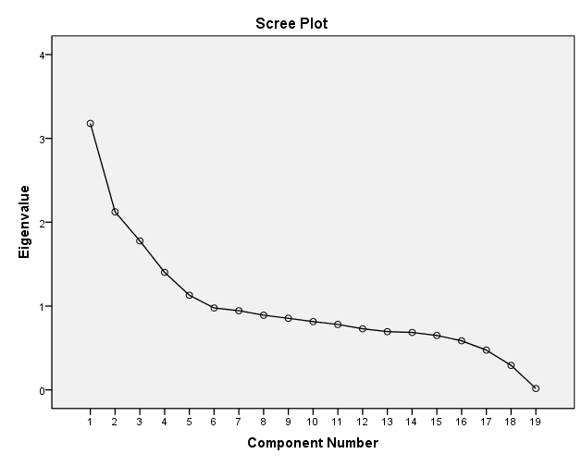
Figure 1 The screen plot test

