Appendix

Appendix Table 1: Sample size in 2014-2016 Gallup World Poll surveys
Appendix Table 2: Questions used to measure mental well-being, food insecurity and social support
Appendix Table 3: Unadjusted relationships between food insecurity, social support types and mental well-being in Sub-Saharan Africa using random-effect random slope model at country level
Appendix Table 4: Adjusted relationships between food insecurity, social support types and mental well-being in Sub-Saharan Africa using random-effect random slope model at country level
Appendix Table 5: Distribution of demographic variables of the included and excluded sample
Appendix Table 6: Adjusted relationship between food insecurity, social support types and positive experience index (derived from at least 4 items) in Sub-Saharan Africa using random-effect random slope model at country level

Appendix Figure 1: Eigenvalues estimated from Principal Component Analysis and parallel analysis among the six social support variables
Appendix Figure 2: Country-specific univariate association between social support and Negative Experience Index
Appendix Figure 3: Country-specific univariate association between social support and Positive Experience Index
Appendix Figure 4: Country-specific univariate association between FIES score and mental well-being

Appendix Table 1: Sample size in 2014-2016 Gallup World Poll surveys
Country | 2014 | 2015 | 2016 | Country total
Angola | 1000 | 0 | 0 | 1,000
Benin | 1000 | 1000 | 1000 | 3,000
Botswana | 1000 | 1000 | 1000 | 3,000
Burkina Faso | 1000 | 1000 | 1000 | 3,000
Burundi | 1000 | 0 | 0 | 1,000
Cameroon | 1000 | 1000^{b} | 1000^{b} | 3,000
Central African Rep | 0 | 0 | 1000e | 1,000
Chad | 1000^{c} | 1000^{c} | 1000^{c} | 3,000
Congo Brazzaville | 1000 | 1000 | 1000 | 3,000
Congo Kinshasa | 1000^{b} | 1000^{b} | 1000^{c} | 3,000
Ethiopia | 1004 | 1000ª | 1000 | 3,004
Gabon | 1008 | 1000 | 1000 | 3,008
Ghana | 1000 | 1000 | 1000 | 3,000
Guinea | 1000 | 1000 | 1000 | 3,000
Ivory Coast | 1000 | 1000 | 1000 | 3,000
Kenya | 1000 | 1000 | 1000 | 3,000
Lesotho | 0 | 0 | 1000 | 1,000
Liberia | 1000 | 1000 | 1000 | 3,000
Madagascar | 1008^{d} | 1000^{c} | 1000^{c} | 3,008
Malawi | 1000 | 1000 | 1000 | 3,000
Mali | 1000^{c} | 1000^{c} | 1000^{c} | 3,000
Mauritania | 1000 | 1000 | 1000 | 3,000
Mauritius | 1000 | 0 | 1000 | 2,000
Mozambique | 0 | 1000 | 0 | 1,000
Namibia | 1000 | 0 | 0 | 1,000
Niger | 1008 | 1000 | 1000 | 3,008
Nigeria | 1000ª | 1000ª | 1000ª | 3,000
Rwanda | 1000 | 1000 | 1000 | 3,000
Senegal | 1000^{f} | 1000 | 1000 | 3,000
Sierra Leone | 1008 | 1000 | 1000 | 3,008
Somalia | 1000^{d} | 1000^{d} | 1191^{d} | 3,191
South Africa | 1000 | 1000 | 1000 | 3,000
South Sudan | 1000e | 1000^{d} | 1000e | 3,000
Sudan | 1000^{d} | 0 | 0 | 1,000
Tanzania | 1008 | 1000 | 1000 | 3,008
Togo | 1000 | 1000 | 1000 | 3,000
Uganda | 1000 | 1000 | 1000 | 3,000
Zambia | 1000 | 1000 | 1000 | 3,000
Zimbabwe | 1000 | 1000 | 1000 | 3,000
Year total | 36,044 | 32,000 | 34,191 | 102,235
a. Percent of total population excluded due to security concerns was less than 10%.
b. Percent of total population excluded due to security concerns was 10-19%.
c. Percent of total population excluded due to security concerns was 20-29%.
d. Percent of total population excluded due to security concerns was 30-39%.
e. Percent of total population excluded due to security concerns was 40-44%.
f. The sample has a larger- than- expected proportion of respondents that who have reported completing secondary education when compared with the data used for post-stratification weighting.

Appendix Table 2: Questions used to measure mental well-being, food insecurity and social support
Module / domain | Label used in analysis or question # | Text | Response options
Negative Experience Index | NEI | Now, please think about yesterday, from the morning until the end of the day. Think about where you were, what you were doing, who you were with, and how you felt.
 | 1 | Did you experience physical pain during a lot of the day yesterday? | Yes/ No/ DK/ RF
 | 2 | Did you experience worry during a lot of the day yesterday? | Yes/ No/ DK/ RF
 | 3 | Did you experience sadness during a lot of the day yesterday? | Yes/ No/ DK/ RF
 | 4 | Did you experience stress during a lot of the day yesterday? | Yes/ No/ DK/ RF
 | 5 | Did you experience anger during a lot of the day yesterday? | Yes/ No/ DK/ RF
Positive Experience Index | PEI | Now, please think about yesterday, from the morning until the end of the day. Thank you where you were, what you were doing, who you were with, and how you felt.
 | 1 | Did you feel well-rested yesterday? | Yes/ No/ DK/ RF
 | 2 | Were you treated with respect all day yesterday? | Yes/ No/ DK/ RF
 | 3 | Did you smile or laugh a lot yesterday? | Yes/ No/ DK/ RF
 | 4 | Did you learn or do something interesting yesterday? | Yes/ No/ DK/ RF
 | 5 | Did you experience enjoyment during a lot of the day yesterday? | Yes/ No/ DK/ RF
Food Insecurity Experience Scale | FIES | Now I would like to ask you some questions about food. During the last 12 months, was there a time when:
 | 1 | …you were worried you would not have enough food to eat because of a lack of money or other resources? | Yes/ No/ DK/ RF
 | 2 | …you were unable to eat healthy and nutritious food because of a lack of money or other resources? | Yes/ No/ DK/ RF
 | 3 | …you ate only a few kinds of foods because of a lack of money or other resources? | Yes/ No/ DK/ RF
 | 4 | …you had to skip a meal because there was not enough money or other resources to get food? | Yes/ No/ DK/ RF
 | 5 | …you ate less than you thought you should because of a lack of money or other resources? | Yes/ No/ DK/ RF
 | 6 | …your household ran out of food because of a lack of money or other resources? | Yes/ No/ DK/ RF
 | 7 | …you were hungry but did not eat because of there was not enough money or other resources for food? | Yes/ No/ DK/ RF
 | 8 | …you went without eating for a whole day because of a lack of money or other resources? | Yes/ No/ DK/ RF
Social support | SS
 | Perceived | If you were in trouble, do you have relatives or friends you can count on to help you whenever you need them, or not? | Yes/ No/ DK/ RF
 | Foreign perceived | Do you have relatives or friends who are living in another country whom you can count on to help you when you need them, or not? | Yes/ No/ DK/ RF
 | Received | In the past 12 months, did this household receive help in the form of money or goods from another individual? | Yes/ No/ DK/ RF
 | Given | In the past 12 months, did this household send help in the form of money or goods to another individual? | Yes/ No/ DK/ RF
 | Integrative | In the city or area where you live, are you satisfied or dissatisfied with the opportunities to meet people and make friends | Satisfied/ Dissatisfied/ DK/ RF
 | Emotional | Thinking about your life in general, please rate your level of agreement with each of the following using a five-point scale: Your friends and family give you positive energy every day | Strongly disagree/ Disagree/ Neutral/ Agree/ Strongly agree/ DK/ RF
DK, Don't know; RF, refused.

Appendix Table 3: Unadjusted relationship between food insecurity, social support types and mental well-being in Sub-Saharan Africa using random-effect random slope model at country level
 |  | Perceived | Foreign perceived | Received | Given | Integrative | Emotional
Negative Experience Index (NEI)
 | N | 96491 | 63965 | 94545 | 94146 | 94455 | 64193
 | Marginal function
 | Difference in mean experience score (ref. group = without type of social support) | -4.06 (-5.45, -2.68) | -0.62 (-1.79, 0.54) | 0.93 (-0.07, 1.94) | 0.52 (-0.50, 1.54) | -4.69 (-6.02, -3.35) | -3.30 (-4.65, -1.95)
 | FIES score (ref. = FIES is 0)
 | FIES = 1-3 | 6.23 (4.86, 7.60) | 6.64 (5.72, 7.57) | 6.39 (5.63, 7.15) | 6.41 (5.66, 7.16) | 5.18 (3.97, 6.39) | 6.57 (5.34, 7.79)
 | FIES = 4-6 | 13.54 (12.30, 14.78) | 12.90 (12.02, 13.78) | 13.51 (12.79, 14.22) | 13.12 (12.41, 13.83) | 12.11 (10.98, 13.25) | 13.21 (12.08, 14.35)
 | FIES = 7-8 | 23.70 (22.56, 24.84) | 21.52 (20.70, 22.35) | 22.88 (22.22, 23.54) | 22.47 (21.81, 23.14) | 21.92 (20.86, 22.99) | 22.93 (21.87, 23.99)
 | Food insecurity and social support interaction (ref. = FIES is 0)
 | FIES = 1-3 | 0.16 (-1.35, 1.67) | 0.32 (-1.02, 1.67) | 0.46 (-0.74, 1.66) | 0.55 (-0.65, 1.76) | 1.77 (0.38, 3.15) | -0.01 (-1.47, 1.45)
 | FIES = 4-6 | -1.21 (-2.59, 0.18) | 0.16 (-1.15, 1.47) | -0.56 (-1.71, 0.59) | 0.30 (-0.87, 1.46) | 1.19 (-0.11, 2.49) | -0.97 (-2.35, 0.41)
 | FIES = 7-8 | -4.71 (-6.00, -3.43) | -2.69 (-3.96, -1.42) | -3.35 (-4.45, -2.26) | -2.35 (-3.47, -1.24) | -0.75 (-1.96, 0.47) | -5.06 (-6.37, -3.76)
 | Constant | 22.91 (20.71, 25.11) | 19.11 (17.22, 21.00) | 19.17 (17.25, 21.09) | 19.36 (17.47, 21.25) | 23.07 (20.98, 25.16) | 21.27 (19.18, 23.37)
 | Random effect (variance)
 | Random slope | 7.01 (3.94, 12.47) | 4.97 (2.58, 9.56) | 2.81 (1.32, 5.97) | 3.26 (1.60, 6.64) | 8.08 (4.55, 14.32) | 7.42 (4.02, 13.71)
 | Random intercept | 38.64 (24.43, 61.13) | 30.19 (18.91, 48.19) | 34.66 (22.07, 54.44) | 33.21 (21.15, 52.16) | 36.39 (22.92, 57.79) | 34.97 (21.75, 56.24)
 | Residual | 807.06 (799.89, 814.30) | 776.13 (767.66, 784.68) | 815.05 (807.73, 822.43) | 814.64 (807.31, 822.04) | 809.22 (801.95, 816.56) | 770.45 (762.06, 778.93)
Appendix Table 3 (cont')
 |  | Perceived | Foreign perceived | Received | Given | Integrative | Emotional
Positive Experience Index (PEI)
 | N | 63339 | 63015 | 62073 | 61812 | 62197 | 63294
 | Marginal function
 | Difference in mean experience score (ref. group = without type of social support) | 8.10 (6.50, 9.71) | 4.07 (2.91, 5.24) | 0.20 (-1.12, 1.51) | 1.69 (0.53, 2.85) | 10.00 (8.55, 11.45) | 10.18 (8.62, 11.73)
 | FIES score (ref. = FIES is 0)
 | FIES = 1-3 | -4.13 (-5.68, -2.59) | -5.73 (-6.65, -4.81) | -6.02 (-6.90, -5.13) | -5.78 (-6.65, -4.92) | -3.92 (-5.27, -2.57) | -4.30 (-5.50, -3.10)
 | FIES = 4-6 | -7.26 (-8.67, -5.85) | -9.04 (-9.91, -8.17) | -9.99 (-10.84, -9.15) | -10.20 (-11.03, -9.38) | -7.85 (-9.12, -6.57) | -7.85 (-8.97, -6.74)
 | FIES = 7-8 | -13.83 (-15.13, -12.53) | -15.45 (-16.27, -14.63) | -16.24 (-17.03, -15.46) | -16.00 (-16.77, -15.22) | -14.65 (-15.85, -13.46) | -14.99 (-16.04, -13.94)
 | Food insecurity and social support interaction (ref. = FIES is 0)
 | FIES = 1-3 | -1.60 (-3.30, 0.11) | 0.54 (-0.78, 1.87) | 0.41 (-0.94, 1.77) | 0.28 (-1.09, 1.66) | -1.95 (-3.49, -0.40) | -1.22 (-2.65, 0.21)
 | FIES = 4-6 | -2.06 (-3.64, -0.48) | -0.08 (-1.38, 1.22) | 0.83 (-0.49, 2.15) | 2.41 (1.07, 3.75) | -1.52 (-2.99, -0.05) | -0.87 (-2.23, 0.49)
 | FIES = 7-8 | 0.53 (-0.95, 2.01) | 3.40 (2.14, 4.66) | 2.85 (1.57, 4.14) | 4.36 (3.04, 5.68) | 0.87 (-0.52, 2.26) | 2.95 (1.66, 4.24)
 | Constant | 70.25 (68.12, 72.37) | 74.93 (73.19, 76.67) | 76.93 (75.44, 78.43) | 76.26 (74.75, 77.78) | 69.29 (67.37, 71.22) | 69.50 (67.55, 71.45)
 | Random effect (variance)
 | Random slope | 10.55 (5.60, 19.90) | 5.17 (2.73, 9.78) | 7.81 (3.84, 15.88) | 4.39 (1.82, 10.60) | 8.83 (4.86, 16.06) | 13.50 (7.79, 23.40)
 | Random intercept | 31.34 (18.84, 52.13) | 24.92 (15.50, 40.07) | 18.12 (11.26, 29.17) | 18.60 (11.58, 29.89) | 26.73 (16.35, 43.70) | 29.62 (18.21, 48.18)
 | Residual | 746.87 (738.68, 755.15) | 749.23 (741.00, 757.56) | 755.03 (746.67, 763.48) | 754.16 (745.79, 762.62) | 735.80 (727.66, 744.03) | 730.89 (722.88, 738.99)

Appendix Table 4: Adjusted relationship between food insecurity, social support types and mental well-being in Sub-Saharan Africa using random-effect random slope model at country levelª
 |  | Perceived | Foreign perceived | Received | Given | Integrative | Emotional
Negative Experience Index (NEI)
 | N | 90399 | 59011 | 88776 | 88426 | 88525 | 59213
 | Marginal function
 | Difference in mean experience score (ref. group = without type of social support) | -3.16 (-4.52, -1.81) | -0.17 (-1.29, 0.96) | 1.11 (0.11, 2.11) | 0.61 (-0.43, 1.66) | -4.62 (-5.95, -3.28) | -2.63 (-3.93, -1.33)
 | FIES score (ref. = FIES is 0)
 | FIES = 1-3 | 5.68 (4.32, 7.05) | 6.24 (5.31, 7.17) | 5.62 (4.85, 6.38) | 5.73 (4.98, 6.48) | 4.96 (3.74, 6.17) | 6.36 (5.14, 7.58)
 | FIES = 4-6 | 12.16 (10.92, 13.41) | 11.75 (10.86, 12.64) | 11.86 (11.13, 12.59) | 11.43 (10.70, 12.15) | 10.94 (9.79, 12.08) | 12.38 (11.23, 13.52)
 | FIES = 7-8 | 21.45 (20.30, 22.60) | 19.11 (18.24, 19.97) | 19.99 (19.29, 20.68) | 19.57 (18.87, 20.26) | 19.35 (18.27, 20.44) | 20.66 (19.57, 21.75)
 | Food insecurity and social support interaction (ref. = FIES is 0)
 | FIES = 1-3 | 0.28 (-1.23, 1.78) | 0.51 (-0.84, 1.85) | 0.95 (-0.25, 2.15) | 0.83 (-0.38, 2.04) | 1.29 (-0.09, 2.67) | -0.12 (-1.57, 1.34)
 | FIES = 4-6 | -1.02 (-2.41, 0.37) | 0.19 (-1.13, 1.51) | -0.24 (-1.39, 0.92) | 0.87 (-0.31, 2.05) | 0.69 (-0.61, 2.00) | -1.31 (-2.70, 0.07)
 | FIES = 7-8 | -4.76 (-6.06, -3.47) | -2.18 (-3.47, -0.89) | -2.79 (-3.91, -1.68) | -1.65 (-2.79, -0.51) | -1.00 (-2.23, 0.22) | -4.80 (-6.12, -3.48)
 | Constant | 12.85 (10.12, 15.58) | 2.69 (-0.87, 6.25) | 9.84 (7.29, 12.39) | 9.97 (7.43, 12.51) | 13.46 (10.80, 16.12) | 3.70 (0.05, 7.36)
 | Random effect (variance)
 | Random slope | 5.99 (3.28, 10.93) | 3.75 (1.80, 7.84) | 2.58 (1.16, 5.70) | 3.46 (1.67, 7.18) | 7.80 (4.33, 14.06) | 5.88 (2.97, 11.64)
 | Random intercept | 40.00 (25.11, 63.73) | 34.41 (21.12, 56.05) | 37.33 (23.60, 59.03) | 36.66 (23.18, 57.99) | 37.88 (23.65, 60.67) | 37.80 (23.02, 62.08)
 | Residual | 778.75 (771.60, 785.97) | 738.37 (729.98, 746.85) | 784.74 (777.47, 792.08) | 784.34 (777.06, 791.69) | 778.03 (770.81, 785.32) | 734.24 (725.92, 742.66)
Appendix Table 4 (cont')
 |  | Perceived | Foreign perceived | Received | Given | Integrative | Emotional
Positive Experience Index (PEI)
 | N | 58403 | 58138 | 57408 | 57188 | 57366 | 58380
 | Marginal function
 | Difference in mean experience score (ref. group = without type of social support) | 6.81 (5.18, 8.44) | 2.87 (1.70, 4.04) | 0.08 (-1.28, 1.43) | 0.84 (-0.35, 2.03) | 9.27 (7.78, 10.76) | 9.12 (7.48, 10.75)
 | FIES score (ref. = FIES is 0)
 | FIES = 1-3 | -3.49 (-5.04, -1.93) | -4.84 (-5.78, -3.91) | -4.92 (-5.82, -4.02) | -4.87 (-5.75, -4.00) | -3.15 (-4.51, -1.78) | -3.60 (-4.81, -2.38)
 | FIES = 4-6 | -5.89 (-7.32, -4.46) | -7.57 (-8.46, -6.67) | -8.06 (-8.93, -7.18) | -8.56 (-9.41, -7.71) | -6.71 (-8.02, -5.41) | -6.54 (-7.68, -5.40)
 | FIES = 7-8 | -11.50 (-12.83, -10.17) | -12.88 (-13.75, -12.01) | -12.93 (-13.76, -12.09) | -13.10 (-13.93, -12.28) | -12.05 (-13.29, -10.81) | -12.55 (-13.64, -11.47)
 | Food insecurity and social support interaction (ref. = food secure)
 | FIES = 1-3 | -1.24 (-2.96, 0.48) | 0.43 (-0.92, 1.77) | 0.29 (-1.08, 1.66) | 0.28 (-1.12, 1.67) | -1.66 (-3.22, -0.10) | -1.01 (-2.46, 0.44)
 | FIES = 4-6 | -1.85 (-3.45, -0.25) | -0.10 (-1.42, 1.22) | 0.62 (-0.72, 1.96) | 2.29 (0.92, 3.67) | -0.69 (-2.18, 0.81) | -0.59 (-1.97, 0.79)
 | FIES = 7-8 | 0.87 (-0.64, 2.37) | 3.34 (2.04, 4.63) | 2.23 (0.91, 3.55) | 3.72 (2.35, 5.09) | 1.31 (-0.11, 2.72) | 3.10 (1.78, 4.43)
 | Constant | 67.48 (63.83, 71.13) | 72.41 (69.00, 75.82) | 73.48 (70.13, 76.83) | 73.29 (69.95, 76.62) | 66.76 (63.25, 70.28) | 68.48 (64.97, 71.99)
 | Random effect (variance)
 | Random slope | 10.32 (5.38, 19.80) | 4.68 (2.37, 9.26) | 8.05 (3.89, 16.64) | 4.32 (1.77, 10.58) | 9.18 (4.96, 17.00) | 14.89 (8.48, 26.15)
 | Random intercept | 32.29 (19.02, 54.84) | 25.72 (15.69, 42.14) | 20.21 (12.27, 33.27) | 20.59 (12.55, 33.78) | 27.83 (16.71, 46.35) | 30.45 (18.36, 50.49)
 | Residual | 727.96 (719.65, 736.36) | 730.59 (722.23, 739.04) | 734.26 (725.81, 742.81) | 734.82 (726.34, 743.39) | 716.11 (707.86, 724.45) | 713.85 (705.70, 722.09)
a. Adjusted for age, sex, number of children under 15, number of adults over 15, education, employment status, place of residence, country-specific income quintiles and survey month.

Appendix Table 5: Distribution of demographic variables of the excluded and included sample
 | Excluded |  | Included |  | p-valueª
 | N | % or mean (SE) | N | % or mean (SE)
FIES score range |  |  |  |  | <0.001
0 | 186 | 12.8 | 21426 | 20.1
1-3 | 190 | 14.6 | 17915 | 17.9
4-6 | 278 | 22.7 | 22534 | 23.4
7-8 | 613 | 49.9 | 35843 | 38.6
Social support
Perceived (%) | 3031 | 66.6 | 69826 | 70.5 | <0.001
Foreign perceived (%) | 1006 | 38.5 | 25780 | 37.3 | <0.001
Received (%) | 1677 | 39.9 | 33651 | 34.2 | <0.001
Given (%) | 1371 | 32.2 | 30529 | 30.1 | <0.001
Integrative (%) | 2686 | 67.3 | 69171 | 72.4 | <0.001
Emotional (%) | 1417 | 54.1 | 41026 | 62.6 | <0.001
Mental well-being
NEI | 38731 | 34.7 (0.26) | 63504 | 30.2 (0.21) | <0.001
PEI | 5438 | 57.8 (0.74) | 96797 | 67.8 (0.16) | <0.001
Characteristics of survey respondents
Age | 4517 | 33.8 (0.33) | 97718 | 34.1 (0.07) | 0.27
Male (%) | 2311 | 50.3 | 47683 | 48.9 | 0.39
Married (%) | 2186 | 48.3 | 50460 | 52.5 | <0.001
Education (%) |  |  |  |  | 0.05
Elementary education or less | 2573 | 71.2 | 53152 | 66.0
Secondary | 1602 | 26.4 | 39260 | 31.4
College | 187 | 2.4 | 4073 | 2.6
Place of residency (%) |  |  |  |  | <0.001
A rural area or on a farm | 1379 | 32.1 | 33393 | 36.1
A small town or village | 1949 | 44.0 | 38441 | 39.4
A large city | 914 | 18.7 | 17865 | 16.8
A suburb of a large city | 266 | 5.1 | 7898 | 7.7
# of children under 15 | 4480 | 3.2 (0.07) | 97545 | 2.8 (0.02) | <0.001
# of people over 15 | 4501 | 4.0 (0.05) | 96734 | 3.8 (0.01) | 0.001
a. P-values of the Pearson Chi-square test for categorical variables and Wald test for continuous variables, both adjusting for survey design

Appendix Table 6: Adjusted relationship between food insecurity, social support types and positive experience index (derived from at least 4 items) in Sub-Saharan Africa using random-effect random slope model at country level
 | Perceived | Foreign perceived | Received | Given | Integrative | Emotional
N | 92316 | 60166 | 90604 | 90236 | 90193 | 60381
Marginal function
Difference in mean experience score (ref. group = without type of social support) | 7.03 (5.63, 8.42) | 2.98 (1.77, 4.19) | 0.47 (-0.66, 1.61) | 1.00 (-0.06, 2.05) | 9.14 (7.90, 10.39) | 9.46 (7.81, 11.12)
FIES score (ref. = FIES is 0)
FIES = 1-3 | -3.46 (-4.78, -2.14) | -4.74 (-5.67, -3.81) | -4.38 (-5.12, -3.65) | -4.40 (-5.13, -3.67) | -3.23 (-4.39, -2.06) | -3.43 (-4.63, -2.23)
FIES = 4-6 | -6.24 (-7.45, -5.04) | -7.47 (-8.36, -6.58) | -7.65 (-8.36, -6.95) | -8.08 (-8.78, -7.38) | -6.97 (-8.07, -5.88) | -6.31 (-7.44, -5.18)
FIES = 7-8 | -11.10 (-12.21, -9.98) | -12.72 (-13.58, -11.86) | -12.03 (-12.70, -11.36) | -12.27 (-12.94, -11.60) | -11.73 (-12.77, -10.69) | -12.35 (-13.43, -11.28)
Food insecurity and social support interaction (ref. = food secure)
FIES = 1-3 | -0.90 (-2.36, 0.56) | 0.22 (-1.11, 1.56) | -0.22 (-1.39, 0.94) | -0.09 (-1.26, 1.09) | -1.26 (-2.59, 0.07) | -1.19 (-2.63, 0.24)
FIES = 4-6 | -1.09 (-2.43, 0.25) | -0.22 (-1.53, 1.10) | 0.04 (-1.09, 1.16) | 1.53 (0.39, 2.67) | -0.21 (-1.47, 1.04) | -0.78 (-2.14, 0.59)
FIES = 7-8 | 1.17 (-0.08, 2.43) | 3.21 (1.92, 4.50) | 1.37 (0.28, 2.45) | 2.69 (1.59, 3.79) | 1.41 (0.24, 2.59) | 3.14 (1.83, 4.45)
Constant | 69.63 (67.17, 72.09) | 71.31 (67.80, 74.82) | 75.34 (73.24, 77.45) | 75.37 (73.24, 77.49) | 68.51 (66.21, 70.81) | 67.18 (63.54, 70.83)
Random effect (variance)
Random slope | 7.76 (4.27, 14.10) | 5.51 (2.85, 10.65) | 5.56 (2.58, 11.99) | 4.11 (1.92, 8.81) | 6.20 (3.42, 11.24) | 15.66 (9.01, 27.21)
Random intercept | 30.91 (18.95, 50.41) | 33.17 (20.32, 54.13) | 21.33 (13.40, 33.96) | 22.14 (13.92, 35.20) | 26.00 (16.09, 42.02) | 40.29 (24.57, 66.07)
Residual | 742.33 (735.58, 749.13) | 742.51 (734.16, 750.96) | 750.42 (743.53, 757.36) | 749.78 (742.89, 756.73) | 729.68 (722.97, 736.45) | 724.46 (716.33, 732.69)
a. Adjusted for age, sex, number of children under 15, number of adults over 15, education, employment status, place of residence, country-specific income quintiles and survey month.

Appendix Figure 1: Eigenvalues estimated from Principal Component Analysis and parallel analysis among the six social support variables

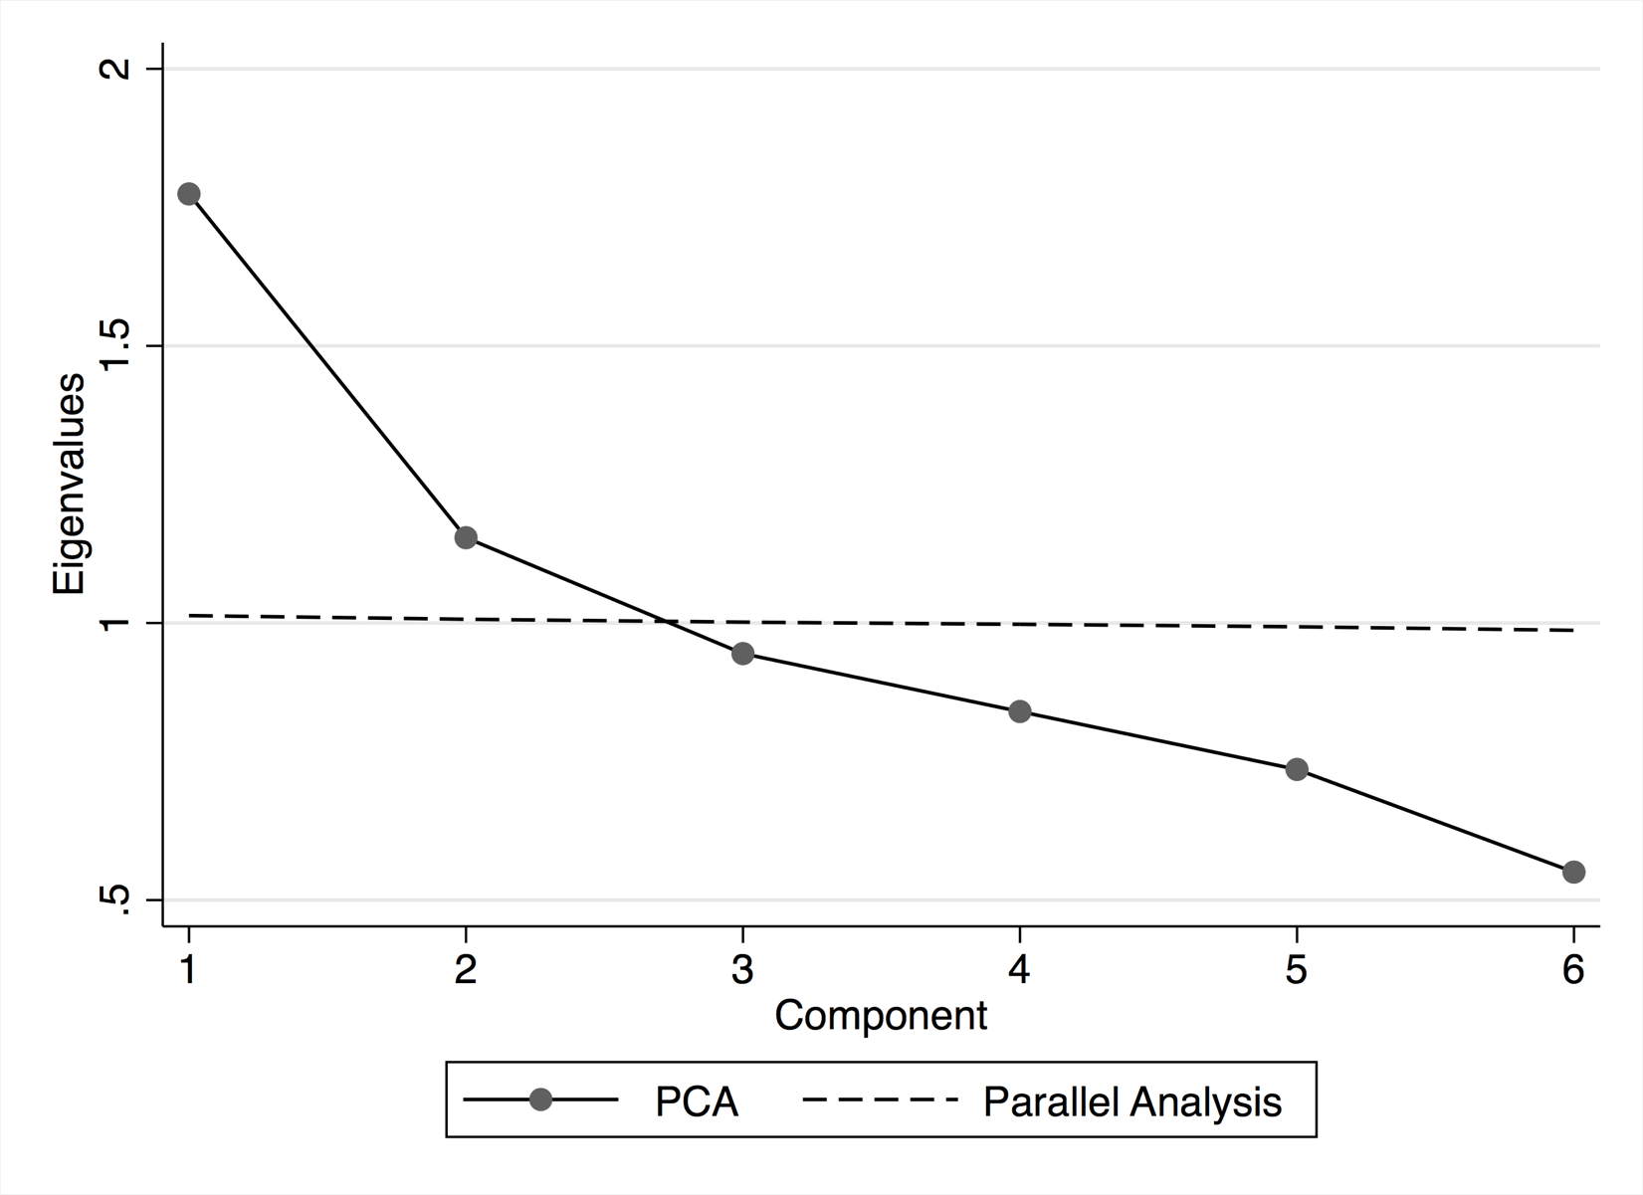
Appendix Figure 2: Country-specific univariate association between social support and Negative Experience Index
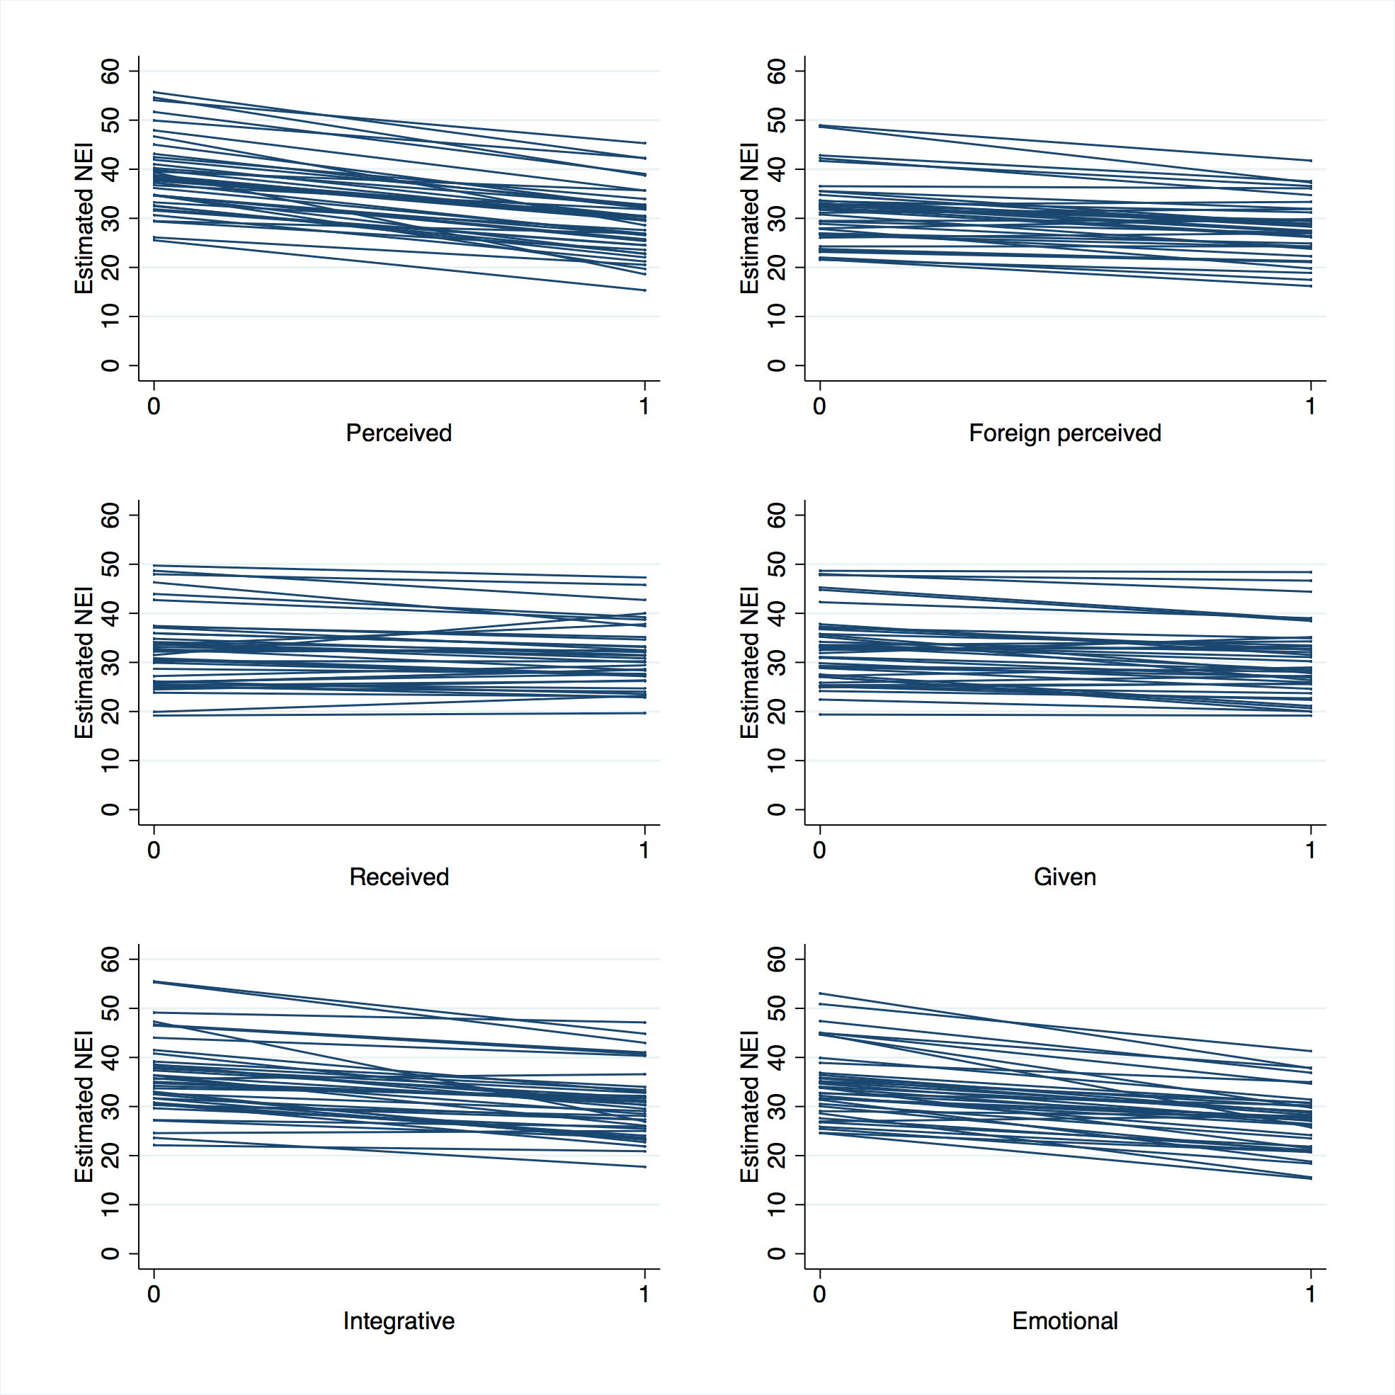

Appendix Figure 3: Country-specific univariate association between social support and Positive Experience Index
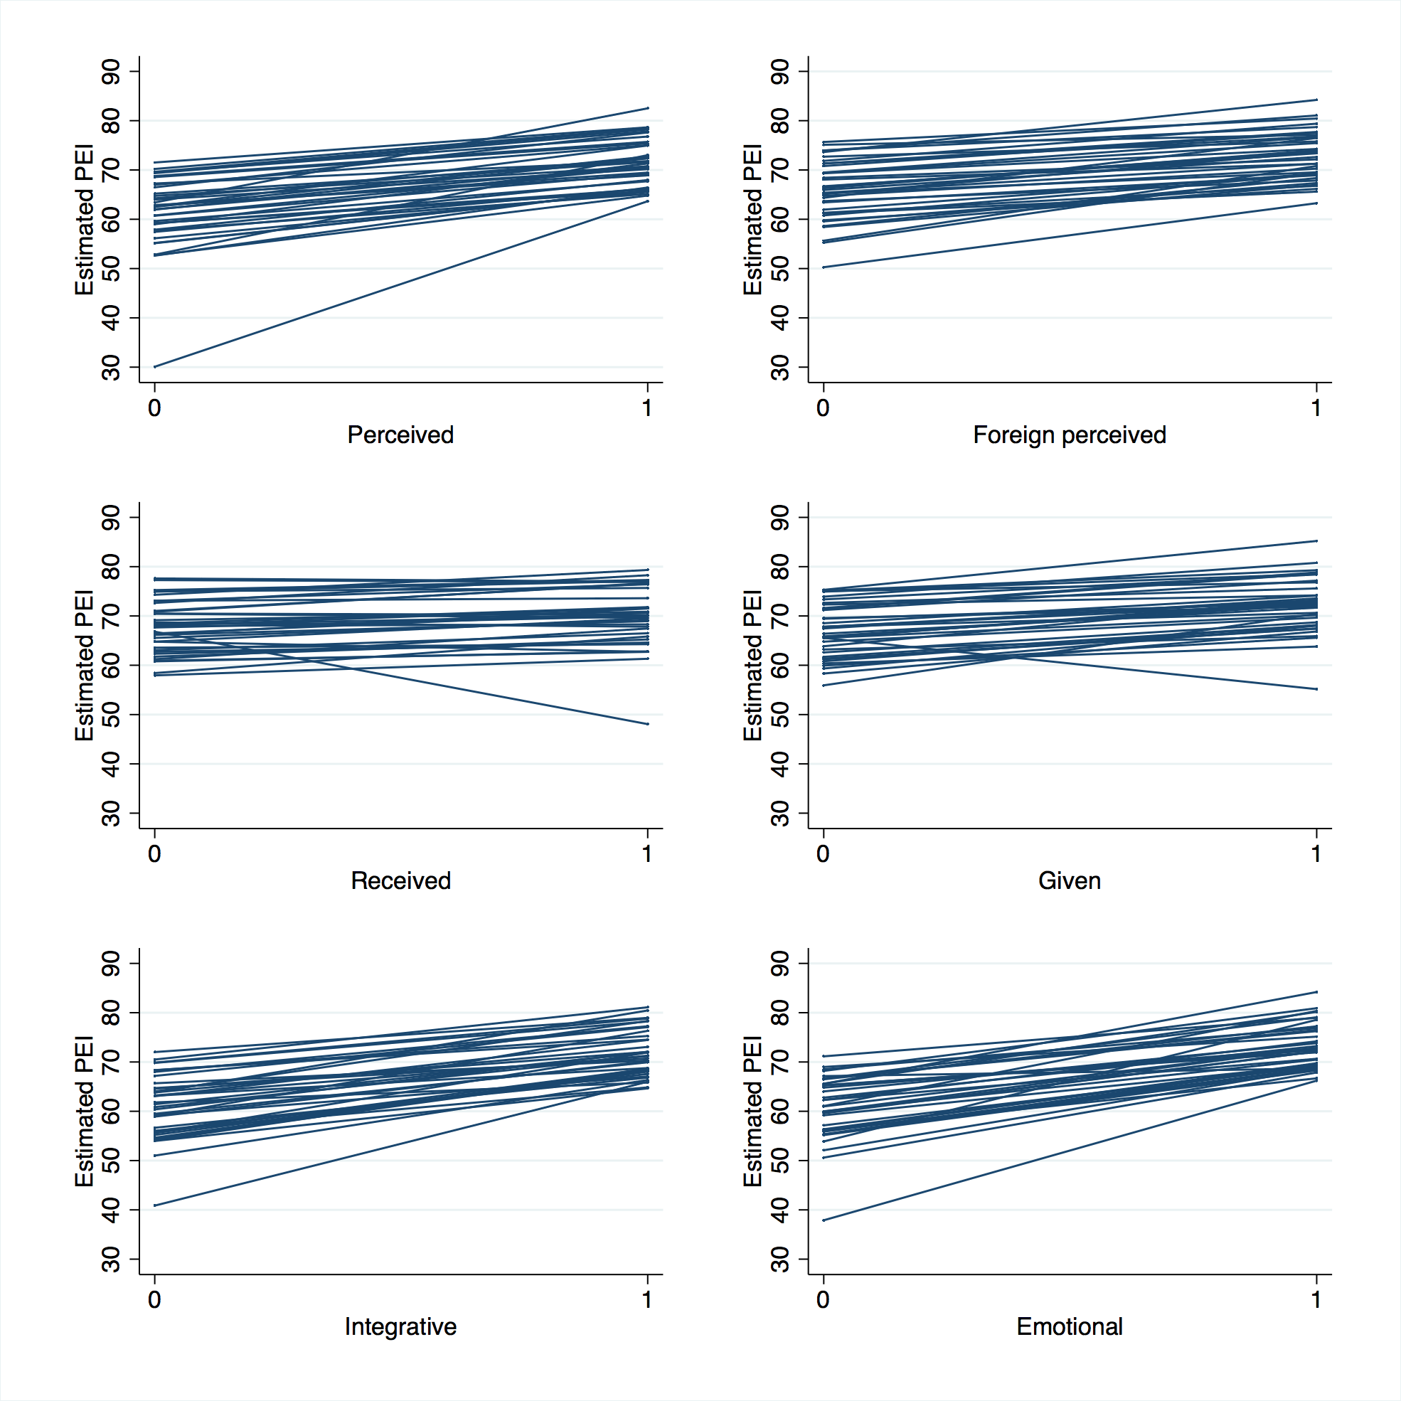

Appendix Figure 4: Country-specific univariate association between FIES score and mental well-being

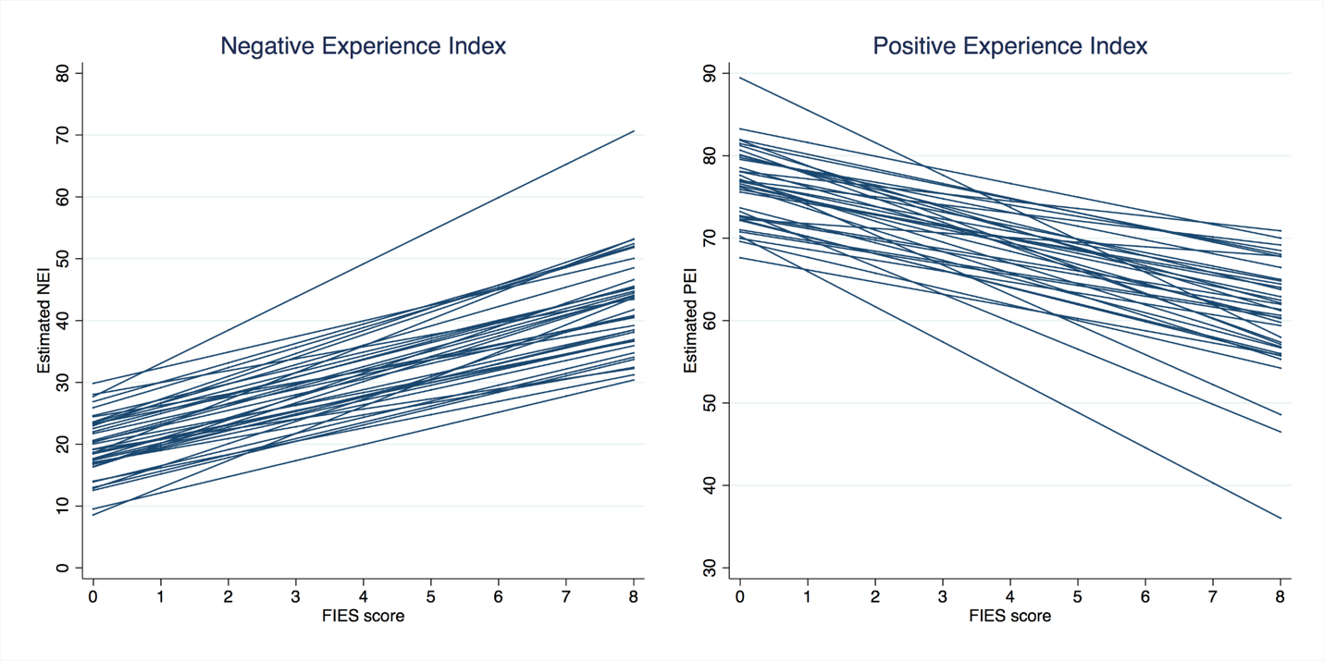

Appendix Figure 5: The marginal effect of food insecurity and types of social support on Positive Experience Index in sub-Saharan Africa, excluding Burundi and Sudan. The relationship is adjusted for respondent’s age, sex, number of children under 15, number of adults over 15, education, employment status, place of residence, country-specific income quintiles and survey month. 