**Supplemental Table 1.** Crude and energy-adjusted† nutrient intakes and Spearman's correlation coefficients estimated by the three-day dietary records and brief-type self-administered diet history questionnaire among the 80 very old men and women





BDHQ, brief-type self-administered diet history questionnaire; DR, dietary records; IQR, interquartile range.

†Energy adjustment was performed according to the density method.

‡Sum of eicosapentaenoic acid, docosapentaenoic acid, and docosahexaenoic acid.

§Sum of retinol, β-carotene/12, α-carotene/24, and cryptoxanthin/24.

||Sum of β-carotene and α-carotene/2 and cryptoxanthin/2.

Significantly different between the DR and BDHQ: \**P*<0.05, \*\**P*<0.01, \*\*\**P*<0.001 (Wilcoxon signed-rank test).

**Supplemental Table 2.** Crude and energy-adjusted† food group intakes and Spearman's correlation coefficients estimated by the three-day dietary records and brief-type self-administered diet history questionnaire among the 80 very old men and women



BDHQ, brief-type self-administered diet history questionnaire; DR, dietary records; IQR, interquartile range.

†Energy adjustment was performed according to the density method.

Significantly different between the DRs+ and BDHQ: \**P*<0.05, \*\**P*<0.01, \*\*\**P*<0.001 (Wilcoxon signed-rank test).

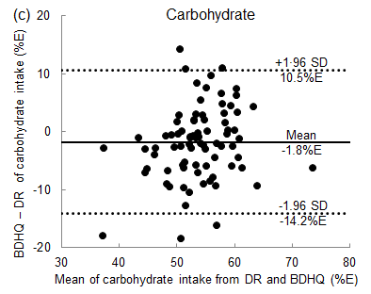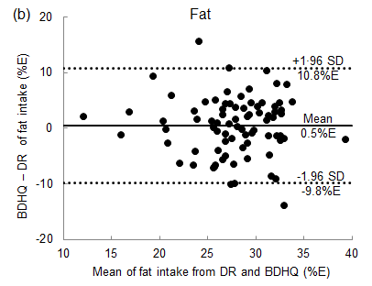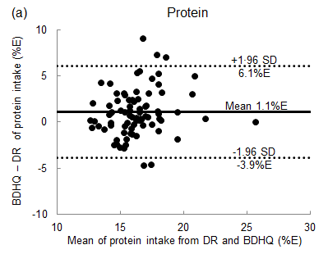

**Supplemental Fig. 1.** Bland-Altman plots for agreement between energy-adjusted macronutrient intakes (%E) estimated using a three-day dietary records and brief-type self-administered diet history questionnaire among the 80 very old men and women. Energy adjustment was performed according to the density method. BDHQ, brief-type self-administered diet history questionnaire; DR, dietary record; SD, standard deviation; %E, % energy.